1 | Draft the given plan, elevation and section of a single room with furniture arrangement with proper dimension  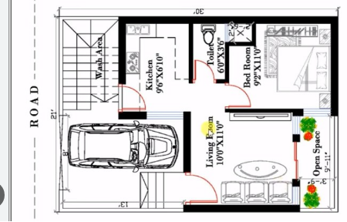

ALLOCATION OF MARKS

SNo | Descriptions |  | Max. Marks | Marks Awarded
1 | Detailed Plan with furniture layout |  | 60
2 | Section (any one ) |  | 15
 | Elevation ( any one side ) |  | 15
4 | Viva voce |  | 10
TOTAL |  |  | 100
Internal Examiner |  | External Examiner

