1 | Design of a Single bedroom multi-story apartment (G+ 4) that fits within a Conner plot sized 4800 sq ft land area with adjacent 30m wide road, considering privacy, space optimization, sustainability, and functionality. The solution should combine modern architecture with practical considerations for a diverse range of residents, offering comfort, flexibility, and environmental responsibility.  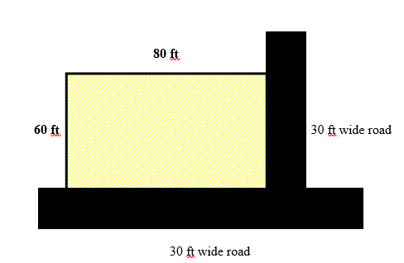  - Site Requirements :-  - Parking for car and two wheeler  - Landscape  - Transformer location  - Individual Unit Requirements :-  - Living room  - Dining room  - Master bedroom attach toilet  - Common toilet  - Kitchen

ALLOCATION OF MARKS

SNo | Descriptions |  | Max. Marks | Marks Awarded
1 | Site Plan / Bubble Diagram / Zoning |  | 30
2 | Detailed Plan with dimension |  | 40
3 | Furniture layout / Sketches |  | 10
4 | Section / Elevation |  | 10
5 | Viva Voce |  | 10
TOTAL |  |  | 100
Internal Examiner |  | External Examiner

