1 | Lap Joint - Arc Welding (Raw Material: 40 mm X 10 mm MS ﬂat)  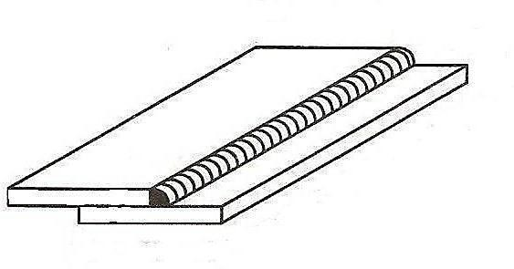

ALLOCATION OF MARKS

SNo | Descriptions |  | Max. Marks | Marks Awarded
1 | Aim & Tools required |  | 10
2 | Procedure |  | 20
3 | Preparation |  | 20
4 | Welding / Cutting/ Joining |  | 20
5 | Accuracy / Tool Handling / Finish / Result |  | 20
6 | Viva Voce |  | 10
TOTAL |  |  | 100
Internal Examiner |  | External Examiner

2 | T-Joint -Arc Welding (RawMaterial:40 mm X 10 mm MS ﬂat)  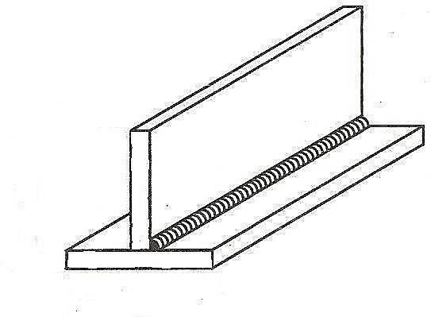

ALLOCATION OF MARKS

SNo | Descriptions |  | Max. Marks | Marks Awarded
1 | Aim & Tools required |  | 10
2 | Procedure |  | 20
3 | Preparation |  | 20
4 | Welding / Cutting/ Joining |  | 20
5 | Accuracy / Tool Handling / Finish / Result |  | 20
6 | Viva Voce |  | 10
TOTAL |  |  | 100
Internal Examiner |  | External Examiner

3 | Butt Joint-TIG / MIG Welding (Raw Material: MS Pipe / MS Square tube)  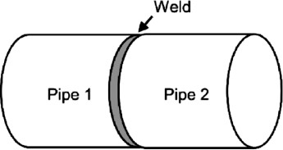

ALLOCATION OF MARKS

SNo | Descriptions |  | Max. Marks | Marks Awarded
1 | Aim & Tools required |  | 10
2 | Procedure |  | 20
3 | Preparation |  | 20
4 | Welding / Cutting/ Joining |  | 20
5 | Accuracy / Tool Handling / Finish / Result |  | 20
6 | Viva Voce |  | 10
TOTAL |  |  | 100
Internal Examiner |  | External Examiner

4 | Proﬁle cutting- Circular proﬁle -cutting Gas cutting  ( Raw Material : 100 x 100mm x 6mm M.S. ﬂat)  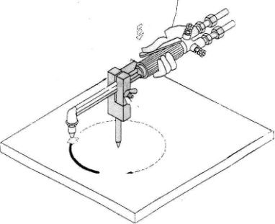

ALLOCATION OF MARKS

SNo | Descriptions |  | Max. Marks | Marks Awarded
1 | Aim & Tools required |  | 10
2 | Procedure |  | 20
3 | Preparation |  | 20
4 | Welding / Cutting/ Joining |  | 20
5 | Accuracy / Tool Handling / Finish / Result |  | 20
6 | Viva Voce |  | 10
TOTAL |  |  | 100
Internal Examiner |  | External Examiner

5 | Lap joint - Gas Welding- (Raw Material: 10G Mild Steel)

ALLOCATION OF MARKS

SNo | Descriptions |  | Max. Marks | Marks Awarded
1 | Aim & Tools required |  | 10
2 | Procedure |  | 20
3 | Preparation |  | 20
4 | Welding / Cutting/ Joining |  | 20
5 | Accuracy / Tool Handling / Finish / Result |  | 20
6 | Viva Voce |  | 10
TOTAL |  |  | 100
Internal Examiner |  | External Examiner

6 | Spot welding - Lap joint - Make a tray / dustpan and join the vulnerable points (Minimum 8 Points) (Raw Material: GI/MS Sheet 22 G)  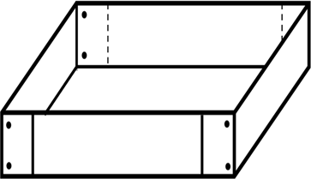

ALLOCATION OF MARKS

SNo | Descriptions |  | Max. Marks | Marks Awarded
1 | Aim & Tools required |  | 10
2 | Procedure |  | 20
3 | Preparation |  | 20
4 | Welding / Cutting/ Joining |  | 20
5 | Accuracy / Tool Handling / Finish / Result |  | 20
6 | Viva Voce |  | 10
TOTAL |  |  | 100
Internal Examiner |  | External Examiner

7 | Solder as per the given circuit diagram / Battery pack with series and parallel connections.  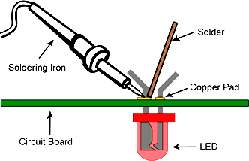

ALLOCATION OF MARKS

SNo | Descriptions |  | Max. Marks | Marks Awarded
1 | Aim & Tools required |  | 10
2 | Procedure |  | 20
3 | Preparation |  | 20
4 | Welding / Cutting/ Joining |  | 20
5 | Accuracy / Tool Handling / Finish / Result |  | 20
6 | Viva Voce |  | 10
TOTAL |  |  | 100
Internal Examiner |  | External Examiner

8 | Braze the joints of the copper tube. Prepare the tube with Cutting, bending, ﬂaring,  Swaging and pinching practice.  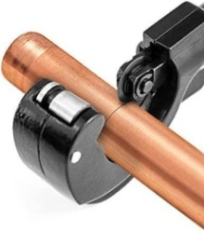  Cutting, bending, ﬂaring, Swaging and pinching practice using copper tube.  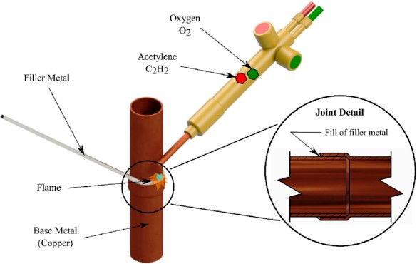  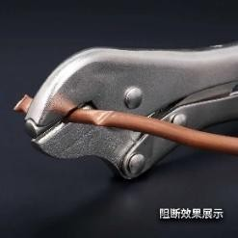  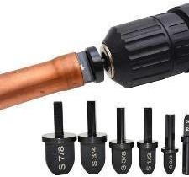  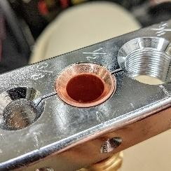  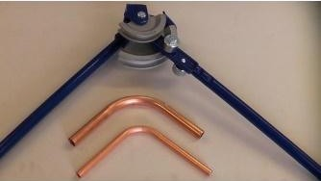

ALLOCATION OF MARKS

SNo | Descriptions |  | Max. Marks | Marks Awarded
1 | Aim & Tools required |  | 10
2 | Procedure |  | 20
3 | Preparation |  | 20
4 | Welding / Cutting/ Joining |  | 20
5 | Accuracy / Tool Handling / Finish / Result |  | 20
6 | Viva Voce |  | 10
TOTAL |  |  | 100
Internal Examiner |  | External Examiner

9 | Dismantle and Assemble the Bolt/Nut using wrench power tools. (Pneumatic / Electric). (Sample Exercise Flange / Cylinder head / Remove Tire from the vehicle disc / etc…)  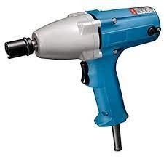  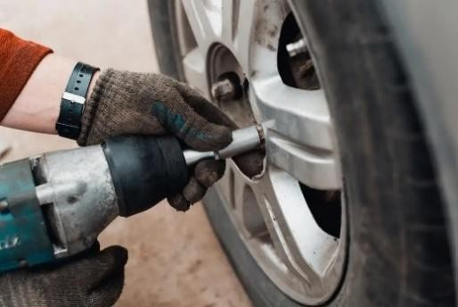

ALLOCATION OF MARKS

SNo | Descriptions |  | Max. Marks | Marks Awarded
1 | Aim & Tools required |  | 10
2 | Procedure |  | 20
3 | Preparation |  | 20
4 | Welding / Cutting/ Joining |  | 20
5 | Accuracy / Tool Handling / Finish / Result |  | 20
6 | Viva Voce |  | 10
TOTAL |  |  | 100
Internal Examiner |  | External Examiner

10 | Proﬁle cutting – Using Jigsaw. (Raw Material: 100 x 100 mm X 6 mm M.S.Flat / Wood)  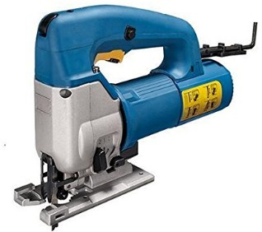  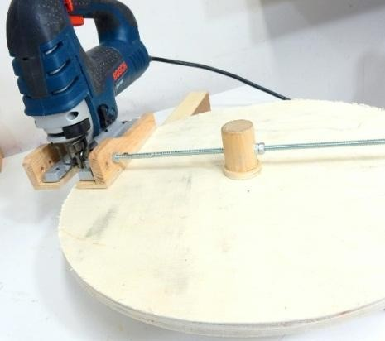

ALLOCATION OF MARKS

SNo | Descriptions |  | Max. Marks | Marks Awarded
1 | Aim & Tools required |  | 10
2 | Procedure |  | 20
3 | Preparation |  | 20
4 | Welding / Cutting/ Joining |  | 20
5 | Accuracy / Tool Handling / Finish / Result |  | 20
6 | Viva Voce |  | 10
TOTAL |  |  | 100
Internal Examiner |  | External Examiner

