1 | PART A  Draw the front view of the assembled drawing of the components with dimensions.  PART B  Detailed drawings of the machine components will be given to students to create the solid modeling and assemble using any CAD software in the computer and take the print out.  Sleeve and Cotter Joint.  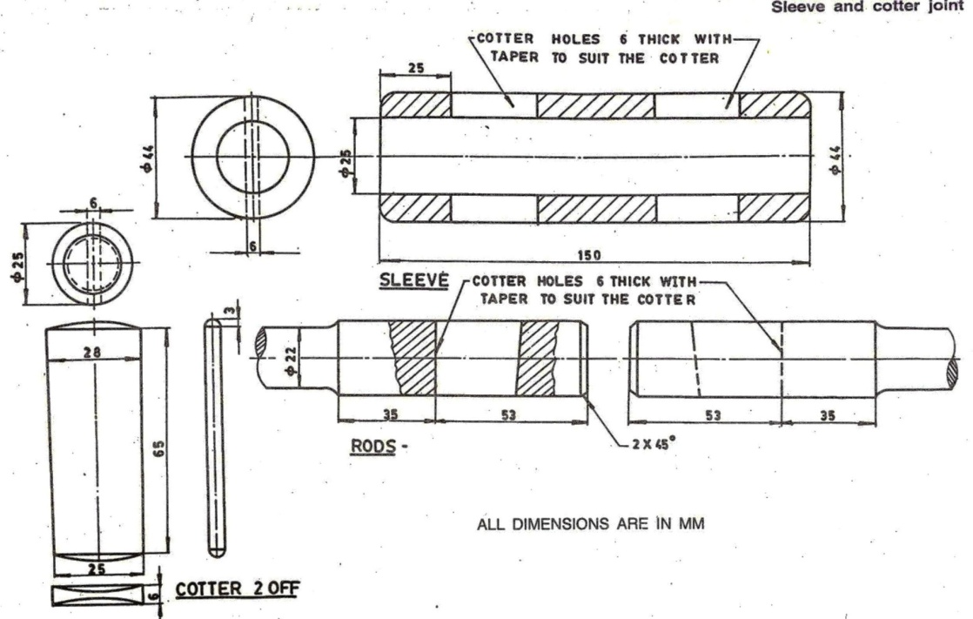

ALLOCATION OF MARKS

Sl.No | Description | Marks
PART A – Drafting Practices
1 | Command / Creation | 10
2 | 2D View with Dimensions | 15
3 | Printout | 5
PART B – Solid modelling Practices
4 | Creation Part Modelling | 10
5 | CAD Modelling (3D) | 15
6 | Assembly of the parts | 20
7 | Printout | 5
8 | Written test | 10
9 | Viva Voce | 10
Total Marks |  | 100

2 | PART A  Draw the front view of the assembled drawing of the components with dimensions.  PART B  Detailed drawings of the machine components will be given to students to create the solid modeling and assemble using any CAD software in the computer and take the printout  Plummer Block.  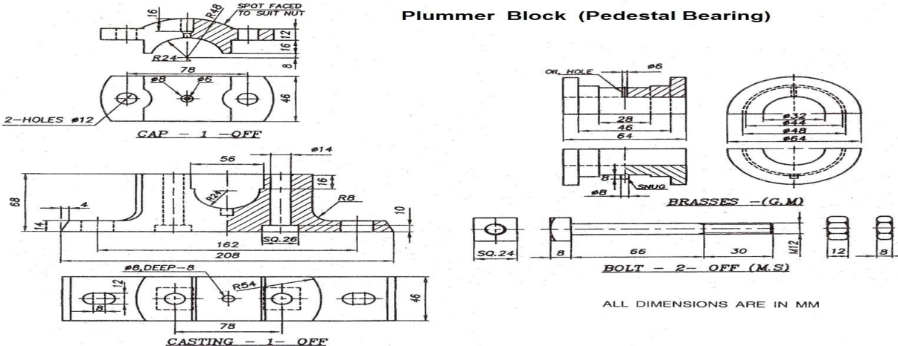

ALLOCATION OF MARKS

Sl.No | Description | Marks
PART A – Drafting Practices
1 | Command / Creation | 10
2 | 2D View with Dimensions | 15
3 | Printout | 5
PART B – Solid modelling Practices
4 | Creation Part Modelling | 10
5 | CAD Modelling (3D) | 15
6 | Assembly of the parts | 20
7 | Printout | 5
8 | Written test | 10
9 | Viva Voce | 10
Total Marks |  | 100

3 | PART A  Draw the front view of the assembled drawing of the components with dimensions.  PART B  Detailed drawings of the machine components will be given to students to create the solid modeling and assemble using any CAD software in the computer and take the print out.  .Flange Coupling.  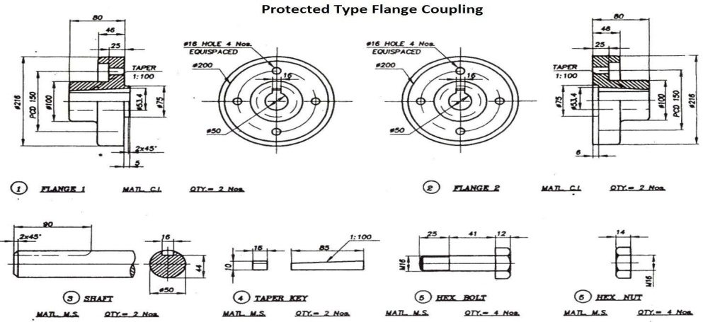

ALLOCATION OF MARKS

Sl.No | Description | Marks
PART A – Drafting Practices
1 | Command / Creation | 10
2 | 2D View with Dimensions | 15
3 | Printout | 5
PART B – Solid modelling Practices
4 | Creation Part Modelling | 10
5 | CAD Modelling (3D) | 15
6 | Assembly of the parts | 20
7 | Printout | 5
8 | Written test | 10
9 | Viva Voce | 10
Total Marks |  | 100

4 | PART A  Draw the front view of the assembled drawing of the components with dimensions.  PART B  Detailed drawings of the machine components will be given to students to create the solid modeling and assemble using any CAD software in the computer and take the print out  Bushed Bearing.  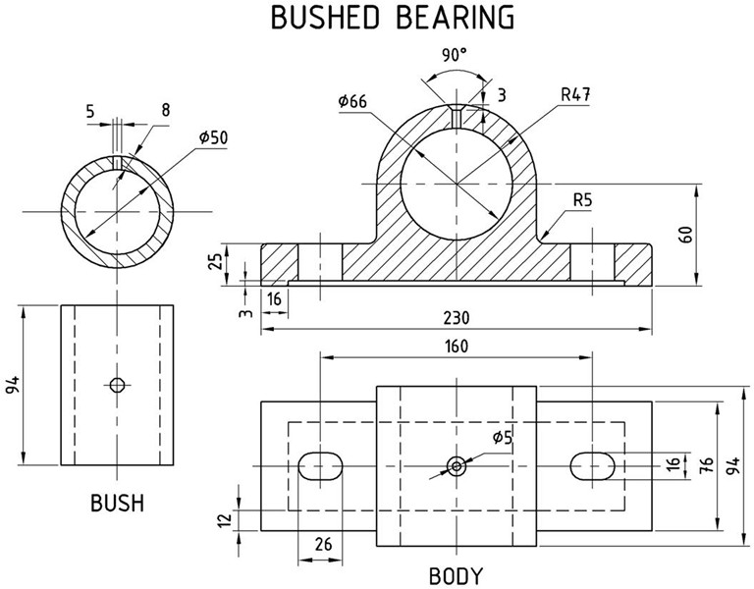

ALLOCATION OF MARKS

Sl.No | Description | Marks
PART A – Drafting Practices
1 | Command / Creation | 10
2 | 2D View with Dimensions | 15
3 | Printout | 5
PART B – Solid modelling Practices
4 | Creation Part Modelling | 10
5 | CAD Modelling (3D) | 15
6 | Assembly of the parts | 20
7 | Printout | 5
8 | Written test | 10
9 | Viva Voce | 10
Total Marks |  | 100

