1 | Grooving and Taper Turning.  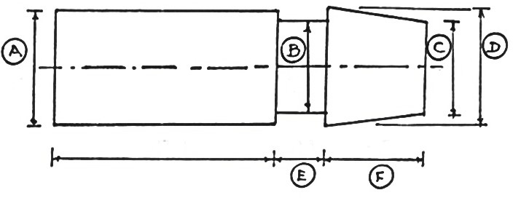

ALLOCATION OF MARKS

SNo | Descriptions |  | Max. Marks | Marks Awarded
1 | Aim/Tools required |  | 5
2 | Preparation/Procedure |  | 20
3 | Operation/Machining/Measurements |  | 25
4 | Finish/Dimensions |  | 10
5 | Written Test(MCQ question) |  | 30
6 | Viva voce |  | 10
TOTAL |  |  | 100
Internal Examiner |  | External Examiner

2 | LH Thread cutting.  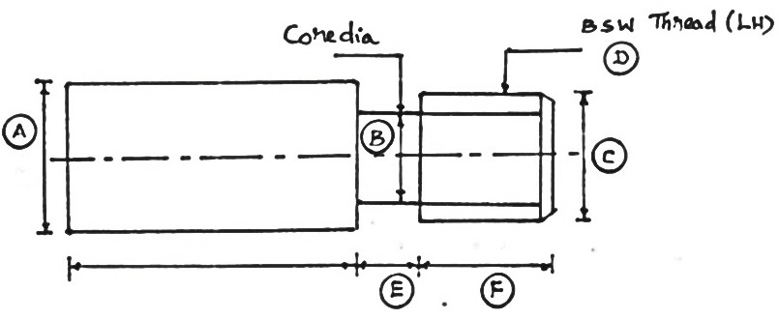

ALLOCATION OF MARKS

SNo | Descriptions |  | Max. Marks | Marks Awarded
1 | Aim/Tools required |  | 5
2 | Preparation/Procedure |  | 20
3 | Operation/Machining/Measurements |  | 25
4 | Finish/Dimensions |  | 10
5 | Written Test(MCQ question) |  | 30
6 | Viva voce |  | 10
TOTAL |  |  | 100
Internal Examiner |  | External Examiner

3 | RH Thread cutting  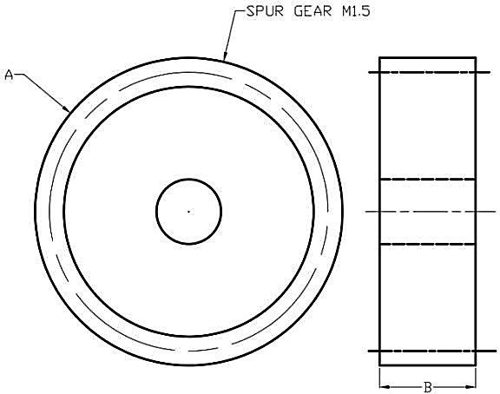

ALLOCATION OF MARKS

SNo | Descriptions |  | Max. Marks | Marks Awarded
1 | Aim/Toolsrequired |  | 5
2 | Preparation/Procedure |  | 20
3 | Operation/Machining/Measurements |  | 25
4 | Finish/Dimensions |  | 10
5 | Written Test(MCQ question) |  | 30
6 | Viva voce |  | 10
TOTAL |  |  | 100
Internal Examiner |  | External Examiner

4 | 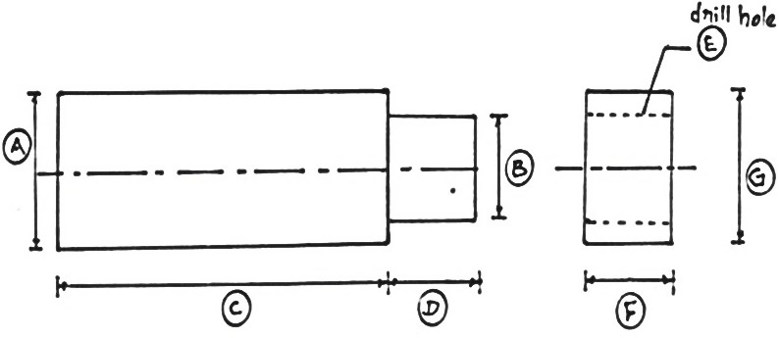  Bush:Turning&Drilling

ALLOCATION OF MARKS

SNo | Descriptions |  | Max. Marks | Marks Awarded
1 | Aim/Toolsrequired |  | 5
2 | Preparation/Procedure |  | 20
3 | Operation/Machining/Measurements |  | 25
4 | Finish/Dimensions |  | 10
5 | Written Test (MCQ question) |  | 30
6 | Viva voce |  | 10
TOTAL |  |  | 100
Internal Examiner |  | External Examiner

5 | 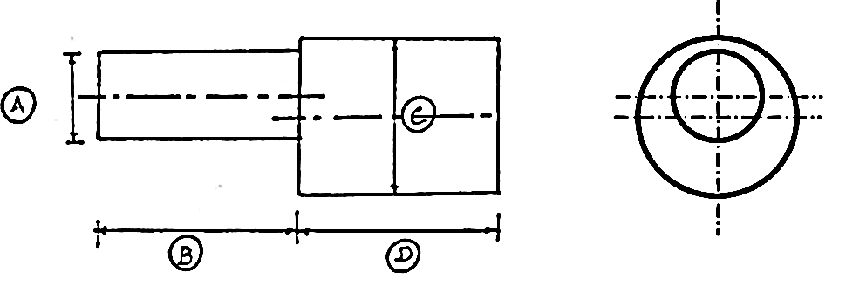  EccentricTurning.

ALLOCATION OF MARKS

SNo | Descriptions |  | Max. Marks | Marks Awarded
1 | Aim/Toolsrequired |  | 5
2 | Preparation/Procedure |  | 20
3 | Operation/Machining/Measurements |  | 25
4 | Finish/Dimensions |  | 10
5 | Written Test(MCQ question) |  | 30
6 | Viva voce |  | 10
TOTAL |  |  | 100
Internal Examiner |  | External Examiner

6 | Make Spur Gear using milling machine by simple Indexing

ALLOCATION OF MARKS

SNo | Descriptions |  | Max. Marks | Marks Awarded
1 | Aim/Toolsrequired |  | 5
2 | Preparation/Procedure |  | 20
3 | Operation/Machining/Measurements |  | 25
4 | Finish/Dimensions |  | 10
5 | Written Test(MCQ question) |  | 30
6 | Viva voce |  | 10
TOTAL |  |  | 100
Internal Examiner |  | External Examiner

7 | 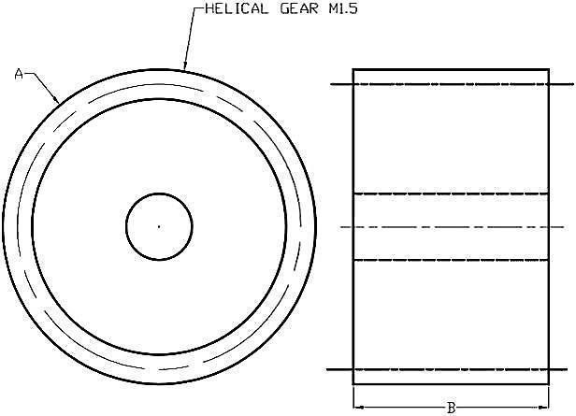  Make heklical gear using milling machine.

ALLOCATION OF MARKS

SNo | Descriptions |  | Max. Marks | Marks Awarded
1 | Aim/Toolsrequired |  | 5
2 | Preparation/Procedure |  | 20
3 | Operation/Machining/Measurements |  | 25
4 | Finish/Dimensions |  | 10
5 | Written Test(MCQ question) |  | 30
6 | Viva voce |  | 10
TOTAL |  |  | 100
Internal Examiner |  | External Examiner

8 | Grind a plain surface using surface Grinder  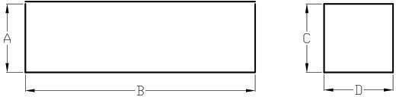

ALLOCATION OF MARKS

SNo | Descriptions |  | Max. Marks | Marks Awarded
1 | Aim/Toolsrequired |  | 5
2 | Preparation/Procedure |  | 20
3 | Operation/Machining/Measurements |  | 25
4 | Finish/Dimensions |  | 10
5 | Written Test(MCQ question) |  | 30
6 | Viva voce |  | 10
TOTAL |  |  | 100
Internal Examiner |  | External Examiner

9 | Make progressive type plug gauge using cylindrical grinding machine  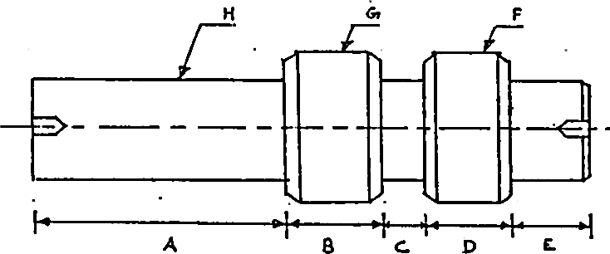

ALLOCATION OF MARKS

SNo | Descriptions |  | Max. Marks | Marks Awarded
1 | Aim/Toolsrequired |  | 5
2 | Preparation/Procedure |  | 20
3 | Operation/Machining/Measurements |  | 25
4 | Finish/Dimensions |  | 10
5 | Written Test(MCQ question) |  | 30
6 | Viva voce |  | 10
TOTAL |  |  | 100
Internal Examiner |  | External Examiner

10 | Make a turning tool/milling cutter using tool and cutter grinder.  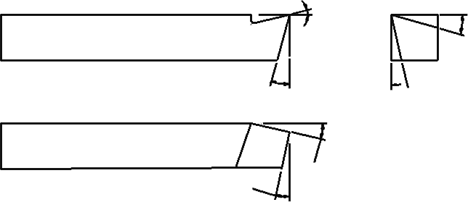

ALLOCATION OF MARKS

SNo | Descriptions |  | Max. Marks | Marks Awarded
1 | Aim/Toolsrequired |  | 5
2 | Preparation/Procedure |  | 20
3 | Operation/Machining/Measurements |  | 25
4 | Finish/Dimensions |  | 10
5 | Written Test(MCQ question) |  | 30
6 | Viva voce |  | 10
TOTAL |  |  | 100
Internal Examiner |  | External Examiner

