1 | CNC Turning Machine Material: M.S / Aluminium / Acrylic ﬁbre / Plastic  Using Linear and Circular interpolation - Create a part program and produce component in the Machine.  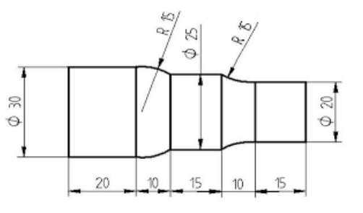

ALLOCATION OF MARKS

SNo | Descriptions |  | Max. Marks | Marks Awarded
1 | Aim & Tools required |  | 10
2 | Writing CNC Program / Modelling |  | 20
3 | Simulation / Slicing |  | 20
4 | Editing in the machine or simulator / Interfacing |  | 30
5 | Finish / Output |  | 10
6 | Viva Voce |  | 10
TOTAL |  |  | 100
Internal Examiner |  | External Examiner

2 | Using Stock removal cycle – Create a part program for multiple turning operations and produce component in the Machine.  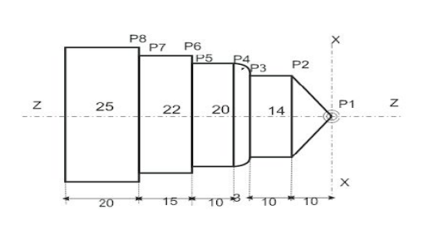

ALLOCATION OF MARKS

SNo | Descriptions |  | Max. Marks | Marks Awarded
1 | Aim & Tools required |  | 10
2 | Writing CNC Program / Modelling |  | 20
3 | Simulation / Slicing |  | 20
4 | Editing in the machine or simulator / Interfacing |  | 30
5 | Finish / Output |  | 10
6 | Viva Voce |  | 10
TOTAL |  |  | 100
Internal Examiner |  | External Examiner

3 | Using Stock removal cycle – Create a part program for multiple turning operations and produce component in the Machine.

ALLOCATION OF MARKS

SNo | Descriptions |  | Max. Marks | Marks Awarded
1 | Aim & Tools required |  | 10
2 | Writing CNC Program / Modelling |  | 20
3 | Simulation / Slicing |  | 20
4 | Editing in the machine or simulator / Interfacing |  | 30
5 | Finish / Output |  | 10
6 | Viva Voce |  | 10
TOTAL |  |  | 100
Internal Examiner |  | External Examiner

4 | Using Linear interpolation and Circular interpolation – Create a part program for grooving and produce component in the Machine.  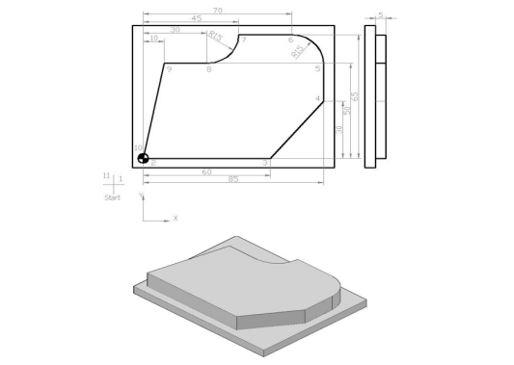

ALLOCATION OF MARKS

SNo |  | Descriptions |  | Max. Marks | Marks Awarded
1 |  | Aim & Tools required |  | 10
2 |  | Writing CNC Program / Modelling |  | 20
3 |  | Simulation / Slicing |  | 20
4 |  | Editing in the machine or simulator / Interfacing |  | 30
5 |  | Finish / Output |  | 10
6 |  | Viva Voce |  | 10
TOTAL |  |  |  | 100
Internal Examiner |  |  | External Examiner
5 | Using canned cycle - Create a part program for drilling produce component in the Machine.  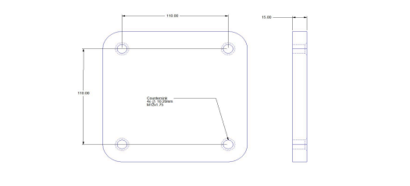

ALLOCATION OF MARKS

SNo | Descriptions |  | Max. Marks | Marks Awarded
1 | Aim & Tools required |  | 10
2 | Writing CNC Program / Modelling |  | 20
3 | Simulation / Slicing |  | 20
4 | Editing in the machine or simulator / Interfacing |  | 30
5 | Finish / Output |  | 10
6 | Viva Voce |  | 10
TOTAL |  |  | 100
Internal Examiner |  | External Examiner

6 | Using subprogram - Create a part program and produce the component in the Machine.  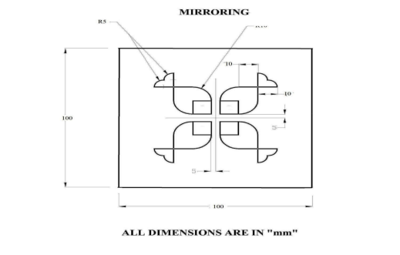

ALLOCATION OF MARKS

SNo | Descriptions |  | Max. Marks | Marks Awarded
1 | Aim & Tools required |  | 10
2 | Writing CNC Program / Modelling |  | 20
3 | Simulation / Slicing |  | 20
4 | Editing in the machine or simulator / Interfacing |  | 30
5 | Finish / Output |  | 10
6 | Viva Voce |  | 10
TOTAL |  |  | 100
Internal Examiner |  | External Examiner

7 | Model the given engineering component and prepare the .stl ﬁle to print using a 3D printer or simulator. - Geneva Wheel

ALLOCATION OF MARKS

SNo | Descriptions |  | Max. Marks | Marks Awarded
1 | Aim & Tools required |  | 10
2 | Writing CNC Program / Modelling |  | 20
3 | Simulation / Slicing |  | 20
4 | Editing in the machine or simulator / Interfacing |  | 30
5 | Finish / Output |  | 10
6 | Viva Voce |  | 10
TOTAL |  |  | 100
Internal Examiner |  | External Examiner

8 | Model the given engineering component and prepare the .stl ﬁle to print using a 3D printer or simulator. - C Clamp with V Block.

ALLOCATION OF MARKS

SNo | Descriptions |  | Max. Marks | Marks Awarded
1 | Aim & Tools required |  | 10
2 | Writing CNC Program / Modelling |  | 20
3 | Simulation / Slicing |  | 20
4 | Editing in the machine or simulator / Interfacing |  | 30
5 | Finish / Output |  | 10
6 | Viva Voce |  | 10
TOTAL |  |  | 100
Internal Examiner |  | External Examiner

9 | Position and record the point to point motion of the robot arm or in a simulator. (5 Positions)

ALLOCATION OF MARKS

SNo | Descriptions |  | Max. Marks | Marks Awarded
1 | Aim & Tools required |  | 10
2 | Writing CNC Program / Modelling |  | 20
3 | Simulation / Slicing |  | 20
4 | Editing in the machine or simulator / Interfacing |  | 30
5 | Finish / Output |  | 10
6 | Viva Voce |  | 10
TOTAL |  |  | 100
Internal Examiner |  | External Examiner

10 | Position and record the continuous motion of the robot arm or in a simulator. (The proﬁle should have Straight line, Circular and inclined line)

ALLOCATION OF MARKS

SNo | Descriptions |  | Max. Marks | Marks Awarded
1 | Aim & Tools required |  | 10
2 | Writing CNC Program / Modelling |  | 20
3 | Simulation / Slicing |  | 20
4 | Editing in the machine or simulator / Interfacing |  | 30
5 | Finish / Output |  | 10
6 | Viva Voce |  | 10
TOTAL |  |  | 100
Internal Examiner |  | External Examiner

