1 | Write a Part Program for producing the component shown below in the turning center, simulate it and produce the component – Using Linear and Circular Interpolation. Raw Material Size: φ 30 mm dia x 41 mm length. Component Diagram:  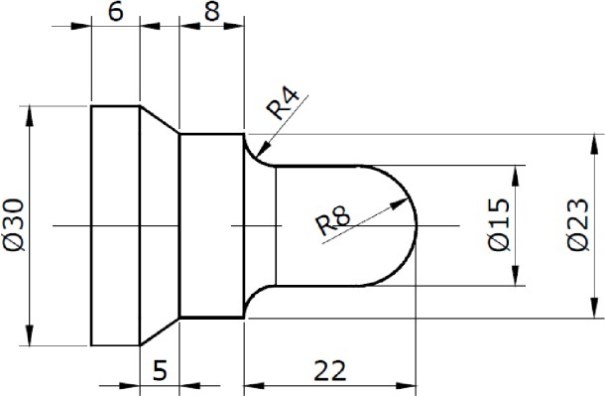

ALLOCATION OF MARKS

 | Sl. No | Description |  | Marks
 | 1 | Aim &Tools Required |  | 10
 | 2 | Writing Part Program |  | 20
 | 3 | Simulation |  | 10
 | 4 | Editing Program in machine and Component |  | 20
 | 5 | Written Test(Theory Portions) |  | 30
 | 6 | Viva Voce |  | 10
Total |  |  | 100

2 | Write a Part Program for producing the component shown below in the turning center, simulate it and produce the component – Using Box turning cycle, Facing cycle, and Grooving cycle (G90, G94, and G75). Raw Material Size: φ 30 mm dia x 70 mm length  ComponentDiagram:Note:Facing0.5mm(20 mmto19.5mm)  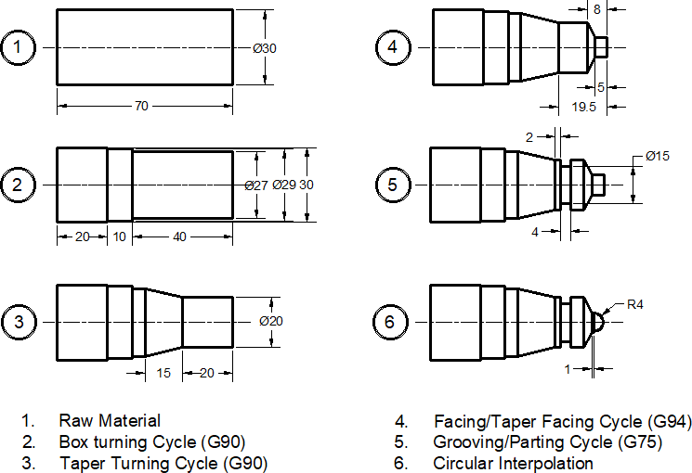

ALLOCATION OF MARKS

 | Sl. No | Description |  | Marks
 | 1 | Aim &Tools Required |  | 10
 | 2 | Writing Part Program |  | 20
 | 3 | Simulation |  | 10
 | 4 | Editing Program in machine and Component |  | 20
 | 5 | Written Test(Theory Portions) |  | 30
 | 6 | Viva Voce |  | 10
Total |  |  | 100

3 | Write a Part Program for producing the component shown below in the turning center, simulate it and produce the component – Using the threading cycle (G92/G76).  Raw Material Size: φ25mmdiax70mmlength  Component Diagram:  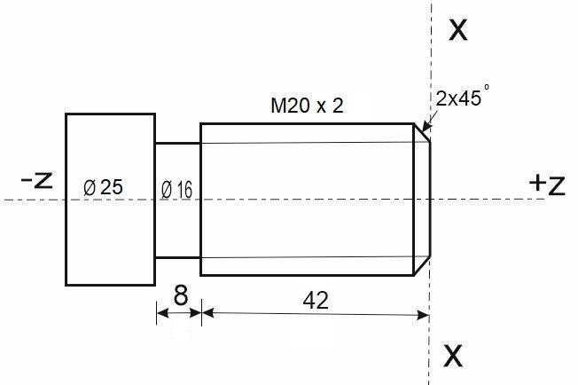

ALLOCATION OF MARKS

 | Sl. No | Description |  | Marks
 | 1 | Aim &Tools Required |  | 10
 | 2 | Writing Part Program |  | 20
 | 3 | Simulation |  | 10
 | 4 | Editing Program in machine and Component |  | 20
 | 5 | Written Test(Theory Portions) |  | 30
 | 6 | Viva Voce |  | 10
Total |  |  | 100

4 | Write a Part Program for producing the component shown below in the turning center, simulate it and produce the component – Using multiple turning cycle (G70 & G71).  RawMaterialSize:φ30mmdiax41mmlength  Component Diagram:

ALLOCATION OF MARKS

 | Sl. No | Description |  | Marks
 | 1 | Aim &Tools Required |  | 10
 | 2 | Writing Part Program |  | 20
 | 3 | Simulation |  | 10
 | 4 | Editing Program in machine and Component |  | 20
 | 5 | Written Test(Theory Portions) |  | 30
 | 6 | Viva Voce |  | 10
Total |  |  | 100

5 | Write a Part Program for producing the component shown below in the turning center, simulate it and produce the component – Using Peck drilling and Boring cycles (G74 & G90)  Raw Material Size: φ30mmdiax70mmlength  Component Diagram:  Steps: (1). Pilot Drill – 3 mm dia, (2). Drill 10 mm dia, (3).Boringto15 mm dia, (4). Taper Boring to 21 mm dia  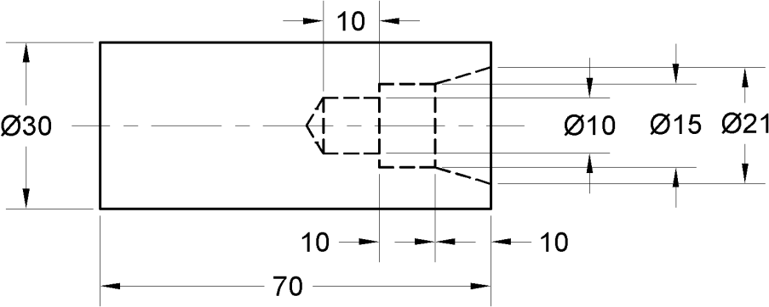

ALLOCATION OF MARKS

 | Sl. No | Description |  | Marks
 | 1 | Aim &Tools Required |  | 10
 | 2 | Writing Part Program |  | 20
 | 3 | Simulation |  | 10
 | 4 | Editing Program in machine and Component |  | 20
 | 5 | Written Test(Theory Portions) |  | 30
 | 6 | Viva Voce |  | 10
Total |  |  | 100

6 | Write a Part Program for producing the component shown below in the Machining center, simulate it and produce the component – Using Linear and Circular Interpolation  RawMaterialSize:100mmx100mmx15mm  Component Diagram:  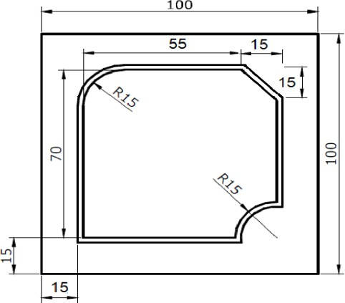

ALLOCATION OF MARKS

 | Sl. No | Description |  | Marks
 | 1 | Aim &Tools Required |  | 10
 | 2 | Writing Part Program |  | 20
 | 3 | Simulation |  | 10
 | 4 | Editing Program in machine and Component |  | 20
 | 5 | Written Test(Theory Portions) |  | 30
 | 6 | Viva Voce |  | 10
Total |  |  | 100

7 | Write a Part Program for producing the component shown below in the Machining center, simulate it and produce the component – Using Peck drilling, Reaming, Tapping and counter-sinking cycles  Raw Material Size:80mmx80mmx20mm  Component Diagram:  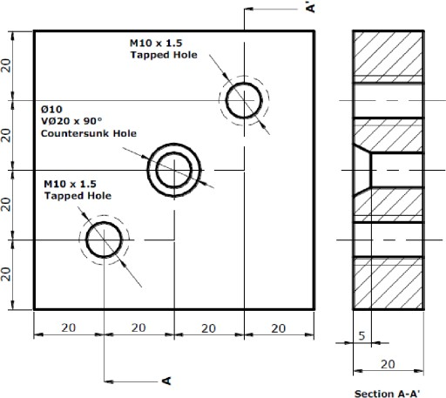

ALLOCATION OF MARKS

 | Sl. No | Description |  | Marks
 | 1 | Aim &Tools Required |  | 10
 | 2 | Writing Part Program |  | 20
 | 3 | Simulation |  | 10
 | 4 | Editing Program in machine and Component |  | 20
 | 5 | Written Test(Theory Portions) |  | 30
 | 6 | Viva Voce |  | 10
Total |  |  | 100

8 | Write a Part Program for producing the component shown below in the Machining center, simulate it and produce the component – Using Mirroring function  RawMaterialSize:120mmx120mmx20mm  Component Diagram:  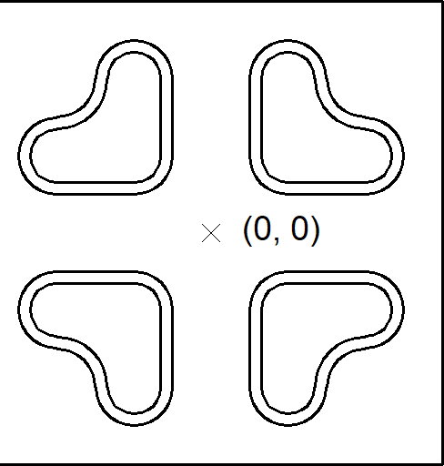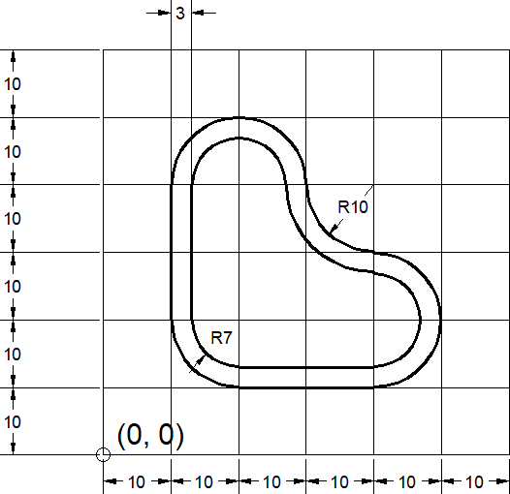

ALLOCATION OF MARKS

 | Sl. No | Description |  | Marks
 | 1 | Aim &Tools Required |  | 10
 | 2 | Writing Part Program |  | 20
 | 3 | Simulation |  | 10
 | 4 | Editing Program in machine and Component |  | 20
 | 5 | Written Test(Theory Portions) |  | 30
 | 6 | Viva Voce |  | 10
Total |  |  | 100

9 | Write a Part Program for producing the component shown below in the Machining center, simulate it and produce the component – Using Circular and Rectangular Pocketing  RawMaterialSize:100mmx100 mmx20mm  Component Diagram:  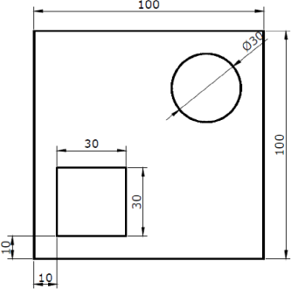

ALLOCATION OF MARKS

 | Sl. No | Description |  | Marks
 | 1 | Aim &Tools Required |  | 10
 | 2 | Writing Part Program |  | 20
 | 3 | Simulation |  | 10
 | 4 | Editing Program in machine and Component |  | 20
 | 5 | Written Test(Theory Portions) |  | 30
 | 6 | Viva Voce |  | 10
Total |  |  | 100

