1 | Part drawing of the knuckle joint is given in the figure. Assemble the parts and draw the Front view / Sectional front view.  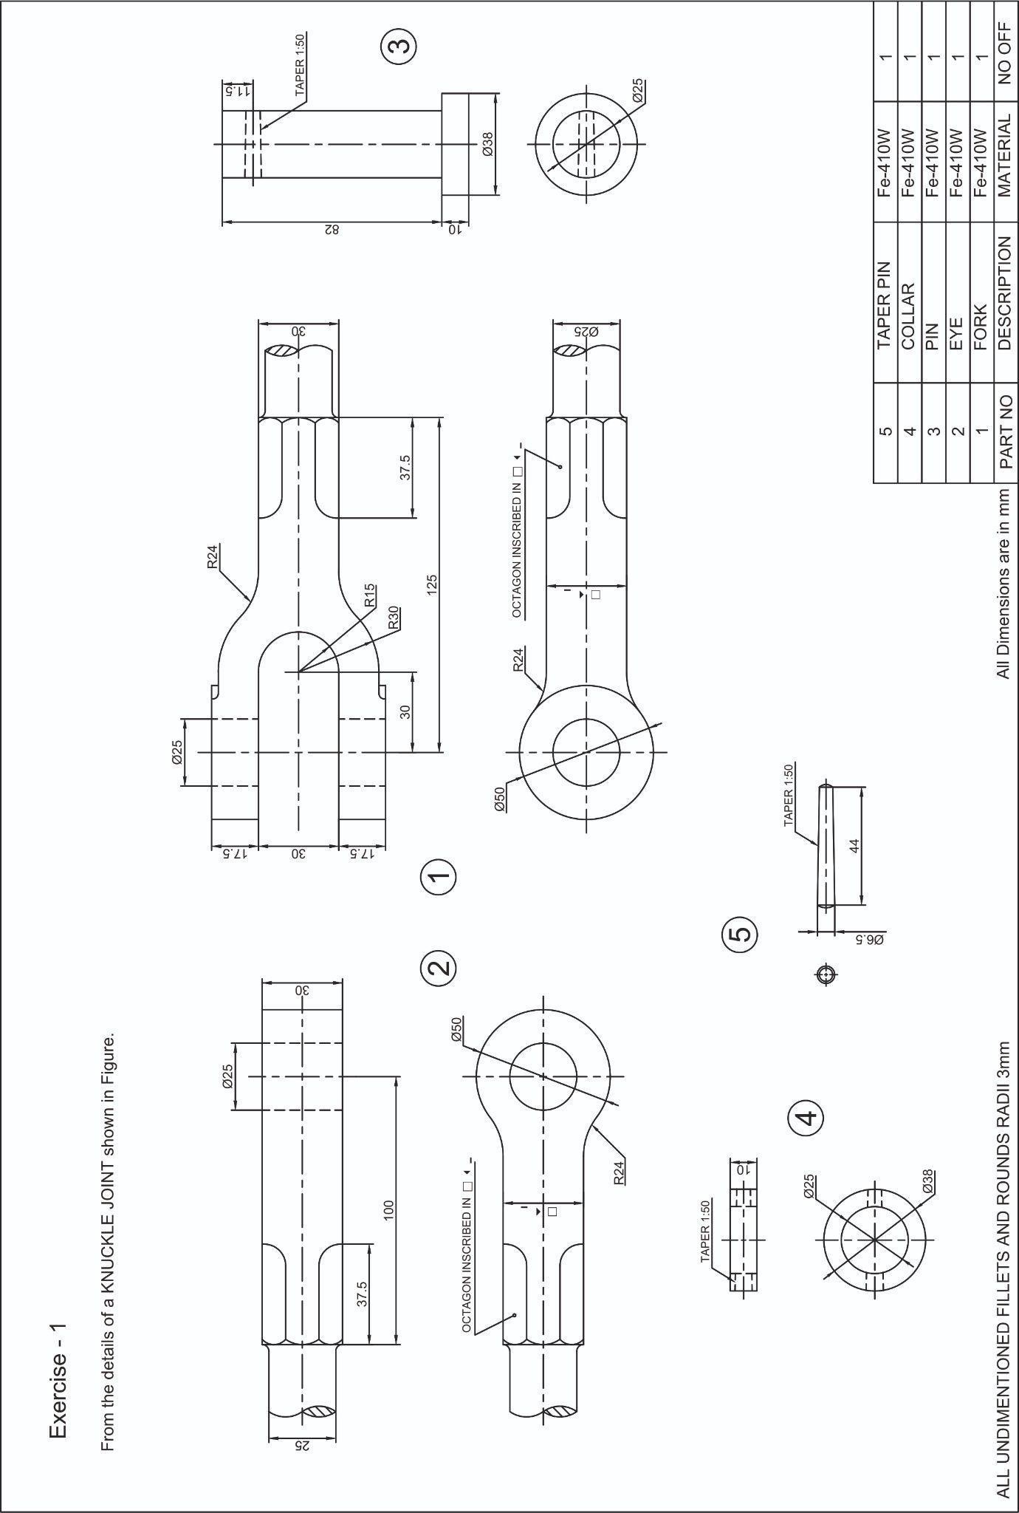

ALLOCATION OF MARKS

SNo | Descriptions |  | Max. Marks | Marks Awarded
1 | Manual Assemble Drawing - Sectional Front View /Half sectional Front view - Drawing Sheet |  | 25
2 | CADAssemble2DViewswithDimensions. (Sectional Front View/Half sectional Front  View) |  | 25
3 | Neatness/Printout |  | 10
4 | Written Test |  | 30
5 | Viva Voce |  | 10
TOTAL |  |  | 100
Internal Examiner |  | External Examiner

2 | Part drawing of the Universal coupling is given in the figure. Assemble the parts and draw the Front view / Sectional front view  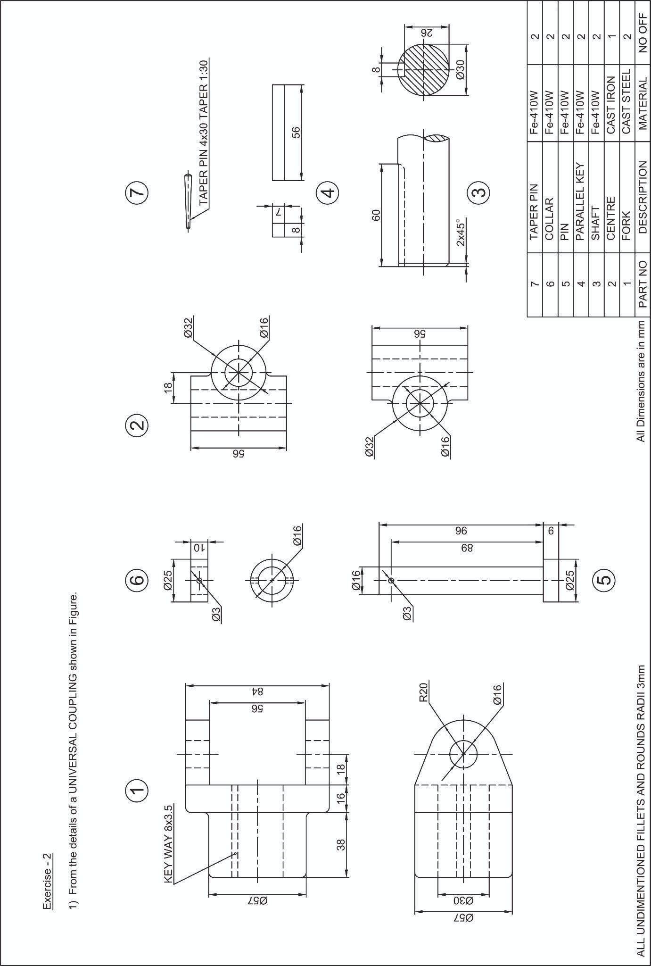

ALLOCATION OF MARKS

SNo | Descriptions |  | Max. Marks | Marks Awarded
1 | Manual Assemble Drawing - Sectional Front View /Half sectional Front view - Drawing Sheet |  | 25
2 | CADAssemble2DViewswithDimensions. (Sectional Front View/Half sectional Front  View) |  | 25
3 | Neatness/Printout |  | 10
4 | Written Test |  | 30
5 | Viva Voce |  | 10
TOTAL |  |  | 100
Internal Examiner |  | External Examiner

3 | Part drawing of the Screw jack is given in the figure. Assemble the parts and draw the Front view / Sectional front view.  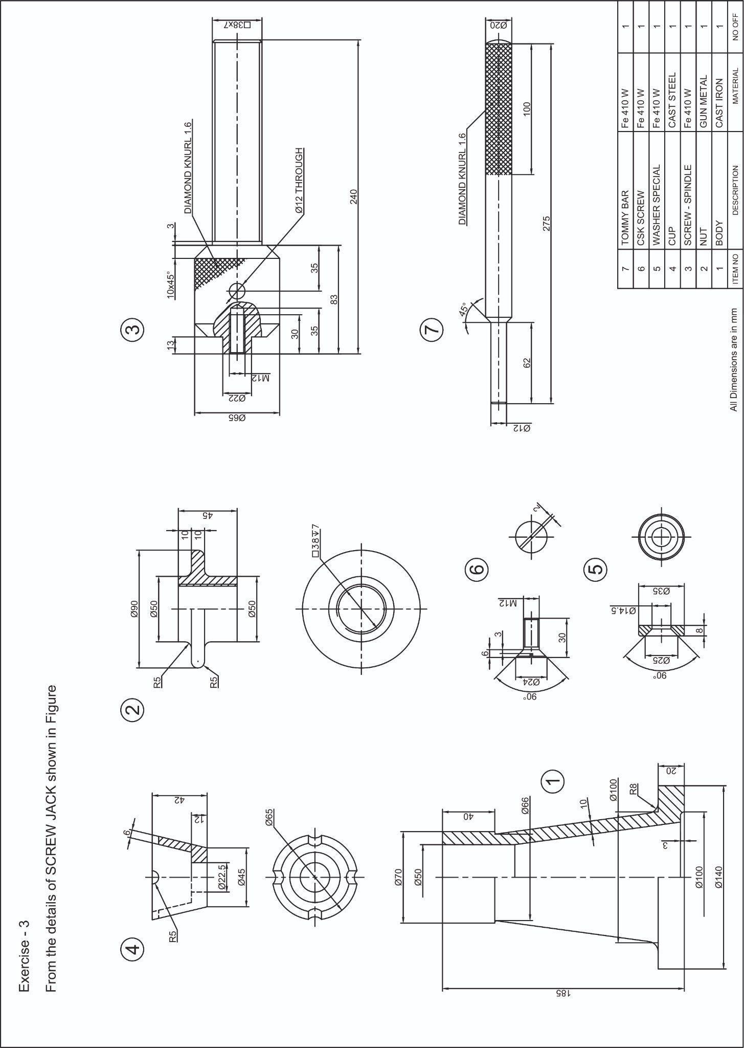

ALLOCATION OF MARKS

SNo | Descriptions |  | Max. Marks | Marks Awarded
1 | Manual Assemble Drawing - Sectional Front View /Half sectional Front view - Drawing Sheet |  | 25
2 | CADAssemble2DViewswithDimensions. (Sectional Front View/Half sectional Front  View) |  | 25
3 | Neatness/Printout |  | 10
4 | Written Test |  | 30
5 | Viva Voce |  | 10
TOTAL |  |  | 100
Internal Examiner |  | External Examiner

4 | Part drawing of the Piston with piston pin assembly is given in the figure. Assemble the parts and draw the Front view / Sectional front view.  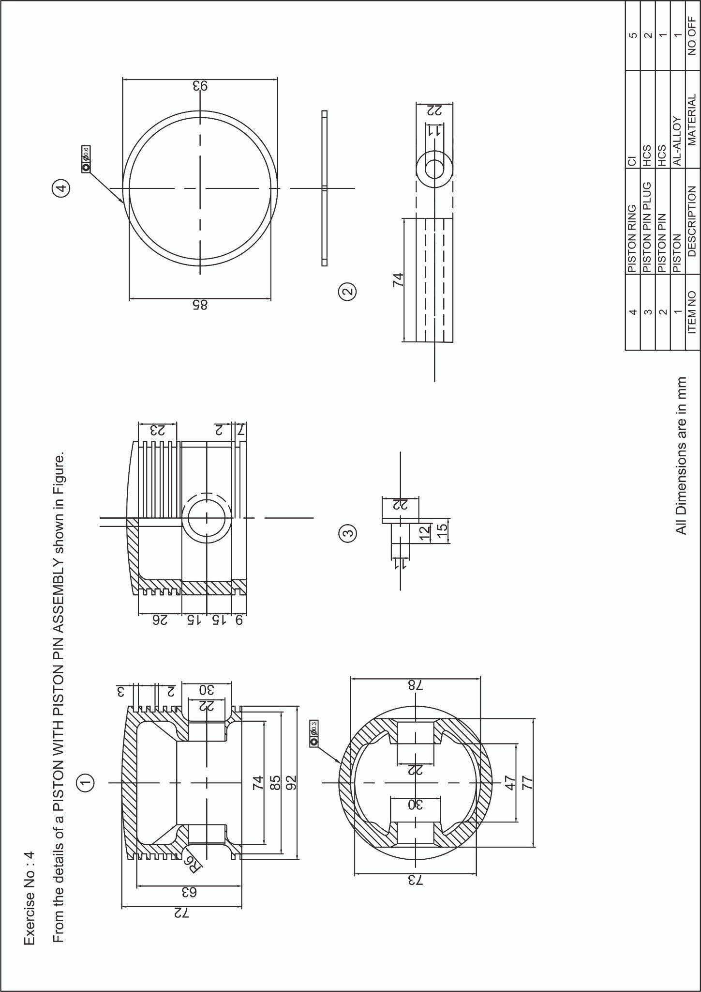

ALLOCATION OF MARKS

SNo |  | Descriptions |  | Max. Marks | Marks Awarded
1 |  | Manual Assemble Drawing - Sectional Front View /Half sectional Front view - Drawing Sheet |  | 25
2 |  | CADAssemble2DViewswithDimensions. (Sectional Front View/Half sectional Front  View) |  | 25
3 |  | Neatness/Printout |  | 10
4 |  | Written Test |  | 30
5 |  | Viva Voce |  | 10
TOTAL |  |  |  | 100
Internal Examiner |  |  | External Examiner
5 | Part drawing of the drawing Connecting rod assembly is given in the figure. Assemble the parts and draw the Front view / Sectional front view  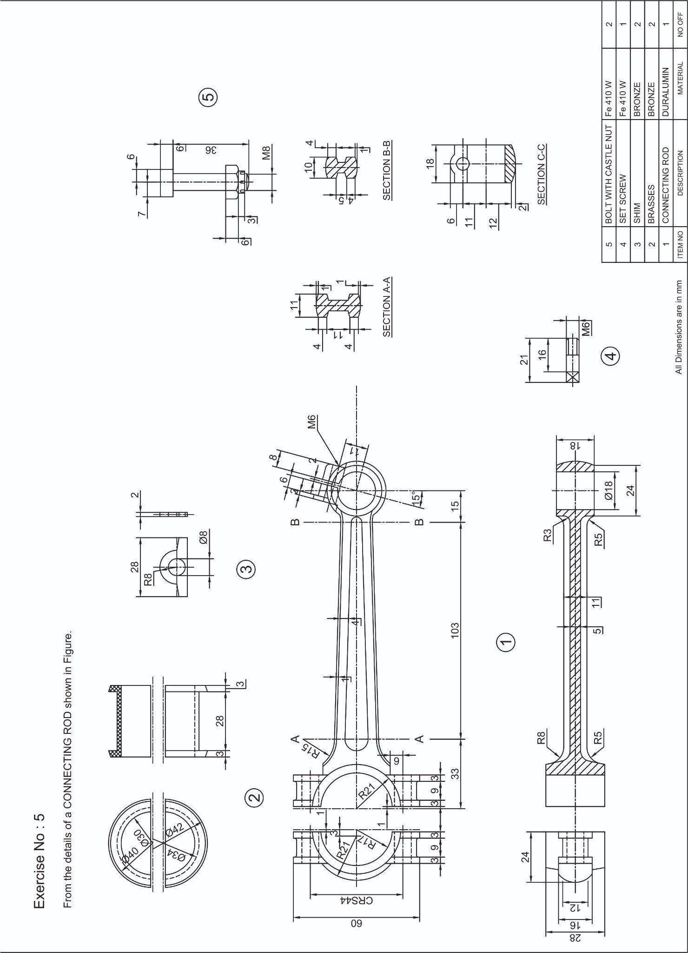

ALLOCATION OF MARKS

SNo |  | Descriptions |  | Max. Marks | Marks Awarded
1 |  | Manual Assemble Drawing - Sectional Front View /Half sectional Front view - Drawing Sheet |  | 25
2 |  | CADAssemble2DViewswithDimensions. (Sectional Front View/Half sectional Front  View) |  | 25
3 |  | Neatness/Printout |  | 10
4 |  | Written Test |  | 30
5 |  | Viva Voce |  | 10
TOTAL |  |  |  | 100
Internal Examiner |  |  | External Examiner
6 | Part drawing of the Balanced Crankshaft assembly is given in the figure. Assemble the parts and draw the Front view / Sectional front view  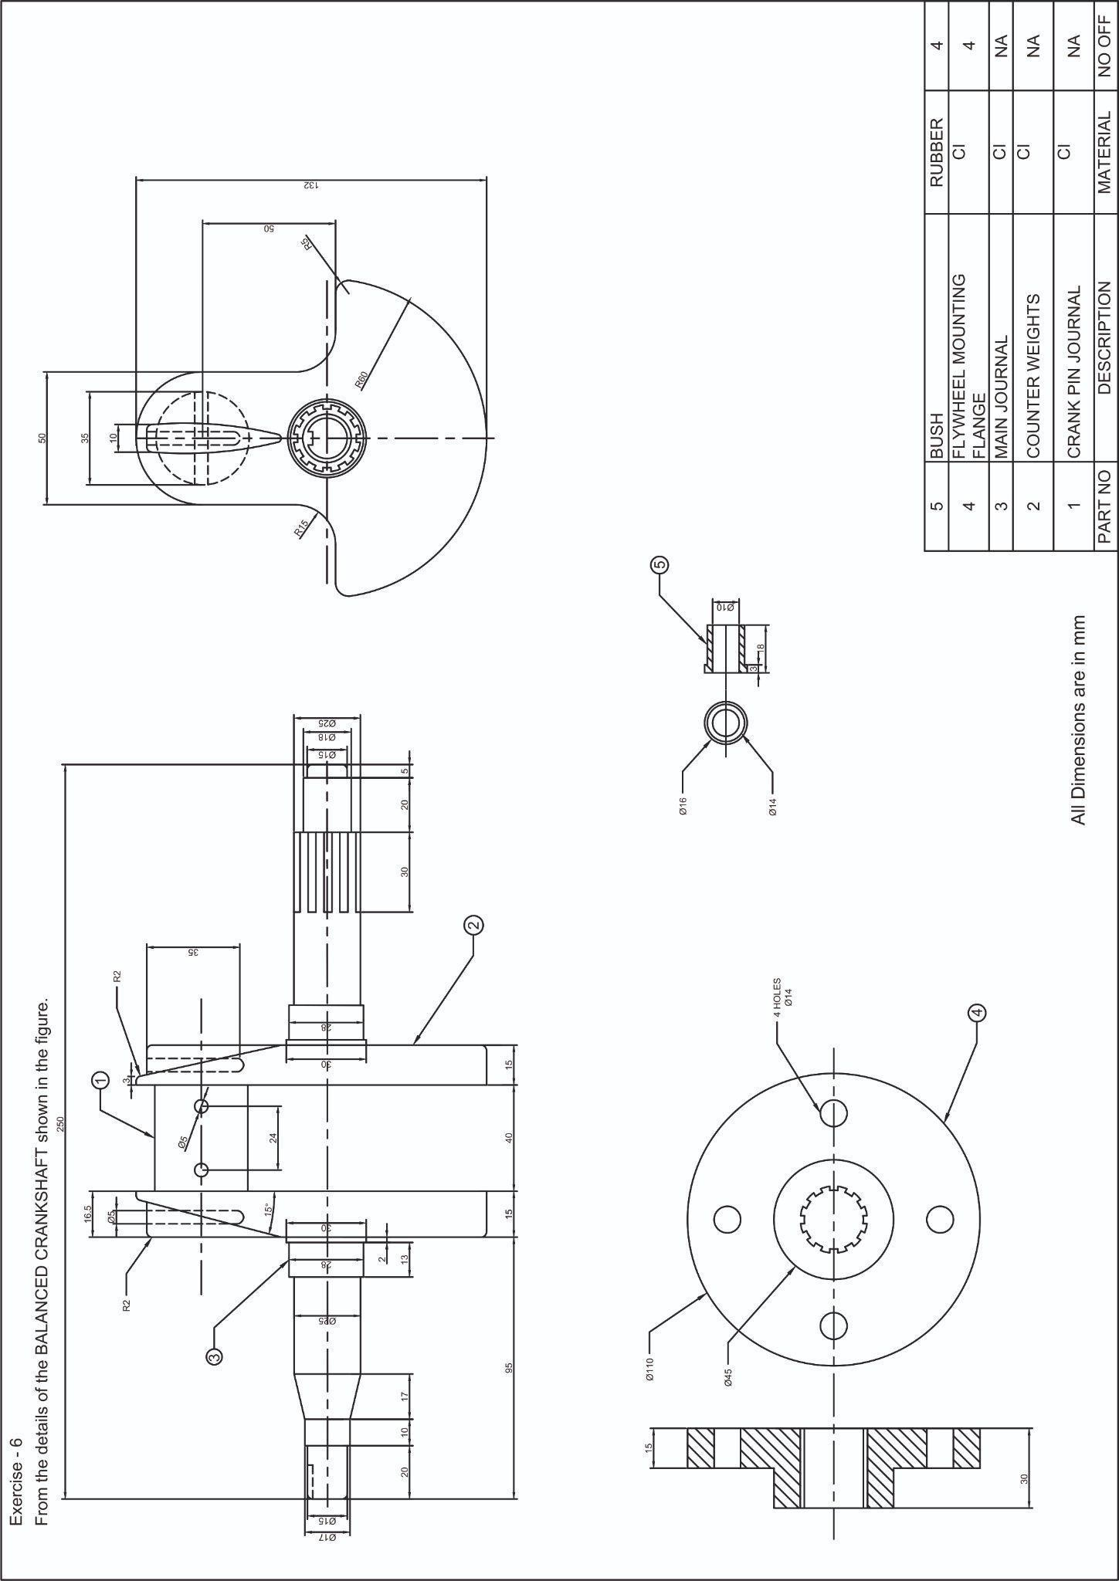

ALLOCATION OF MARKS

SNo | Descriptions |  | Max. Marks | Marks Awarded
1 | Manual Assemble Drawing - Sectional Front View /Half sectional Front view - Drawing Sheet |  | 25
2 | CADAssemble2DViewswithDimensions. (Sectional Front View/Half sectional Front  View) |  | 25
3 | Neatness/Printout |  | 10
4 | Written Test |  | 30
5 | Viva Voce |  | 10
TOTAL |  |  | 100
Internal Examiner |  | External Examiner

