1 | Perform Arc welding to make a Butt Joint with the given Mild Steel. (Raw Material: 25 mm x 6 mm MS flat – 2 Nos.)

ALLOCATION OF MARKS

SNo |  | Descriptions |  | Max. Marks | Marks Awarded
1 |  | Aim & Tools required |  | 10
2 |  | Preparation/Procedure |  | 20
3 |  | Dimensions |  | 20
4 |  | Finish/Output |  | 10
5 |  | Written test (Theory Portions only) |  | 30
6 |  | Viva Voce |  | 10
TOTAL |  |  |  | 100
Internal Examiner |  |  | External Examiner
2 | Perform Gas welding to make a Lap Joint with the given sheet. (Raw Material: 16G MS sheet – 2 Nos.)

ALLOCATION OF MARKS

SNo | Descriptions |  | Max. Marks | Marks Awarded
1 | Aim & Tools required |  | 10
2 | Preparation/Procedure |  | 20
3 | Dimensions |  | 20
4 | Finish/Output |  | 10
5 | Written test (Theory Portions only) |  | 30
6 | Viva Voce |  | 10
TOTAL |  |  | 100
Internal Examiner |  | External Examiner

3 | Make the model as per the given sketch by Step turning and Taper turning operations in a Lathe. (Raw Material: Ø32mm M.S rod)  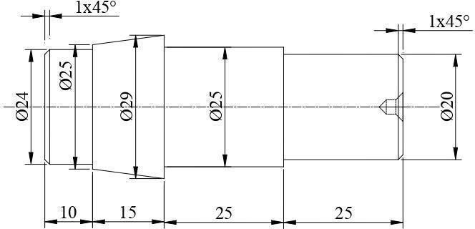

ALLOCATION OF MARKS

SNo | Descriptions |  | Max. Marks | Marks Awarded
1 | Aim & Tools required |  | 10
2 | Preparation/Procedure |  | 20
3 | Dimensions |  | 20
4 | Finish/Output |  | 10
5 | Written test (Theory Portions only) |  | 30
6 | Viva Voce |  | 10
TOTAL |  |  | 100
Internal Examiner |  | External Examiner

4 | 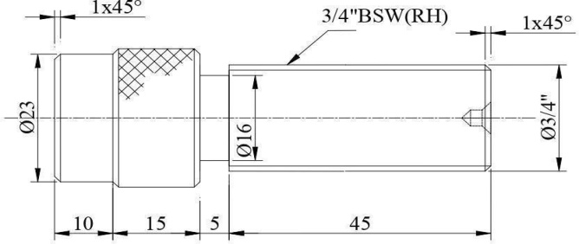  Make the model as per the given sketch by Knurling and BSW Thread cutting operations in a Lathe. (Raw Material: Ø32 mm M.S rod)

ALLOCATION OF MARKS

SNo | Descriptions |  | Max. Marks | Marks Awarded
1 | Aim & Tools required |  | 10
2 | Preparation/Procedure |  | 20
3 | Dimensions |  | 20
4 | Finish/Output |  | 10
5 | Written test (Theory Portions only) |  | 30
6 | Viva Voce |  | 10
TOTAL |  |  | 100
Internal Examiner |  | External Examiner

5 | Make a spur gear by differential indexing method as per the Figure using Milling Machine.  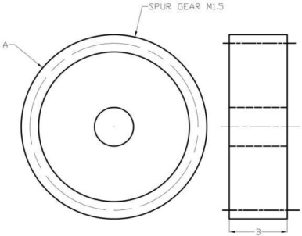

ALLOCATION OF MARKS

SNo | Descriptions |  | Max. Marks | Marks Awarded
1 | Aim & Tools required |  | 10
2 | Preparation/Procedure |  | 20
3 | Dimensions |  | 20
4 | Finish/Output |  | 10
5 | Written test (Theory Portions only) |  | 30
6 | Viva Voce |  | 10
TOTAL |  |  | 100
Internal Examiner |  | External Examiner

6 | 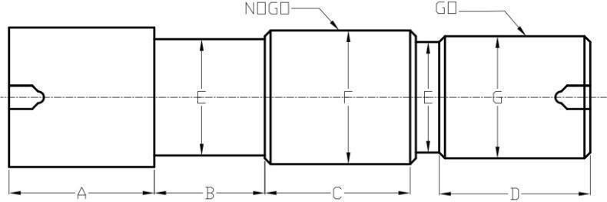  Make a Helical gear by differential indexing method as per the Figure using Milling Machine

ALLOCATION OF MARKS

SNo | Descriptions |  | Max. Marks | Marks Awarded
1 | Aim & Tools required |  | 10
2 | Preparation/Procedure |  | 20
3 | Dimensions |  | 20
4 | Finish/Output |  | 10
5 | Written test (Theory Portions only) |  | 30
6 | Viva Voce |  | 10
TOTAL |  |  | 100
Internal Examiner |  | External Examiner

7 | Make a progressive type plug gauge as per the Figure using Cylindrical Grinding Machine

ALLOCATION OF MARKS

SNo | Descriptions |  | Max. Marks | Marks Awarded
1 | Aim & Tools required |  | 10
2 | Preparation/Procedure |  | 20
3 | Dimensions |  | 20
4 | Finish/Output |  | 10
5 | Written test (Theory Portions only) |  | 30
6 | Viva Voce |  | 10
TOTAL |  |  | 100
Internal Examiner |  | External Examiner

8 | Make a turning tool as per Figure using Tool and Cutter Grinder  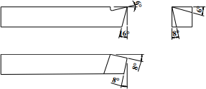

ALLOCATION OF MARKS

SNo | Descriptions |  | Max. Marks | Marks Awarded
1 | Aim & Tools required |  | 10
2 | Preparation/Procedure |  | 20
3 | Dimensions |  | 20
4 | Finish/Output |  | 10
5 | Written test (Theory Portions only) |  | 30
6 | Viva Voce |  | 10
TOTAL |  |  | 100
Internal Examiner |  | External Examiner

9 | Make the component in the CNC Turning Centre.  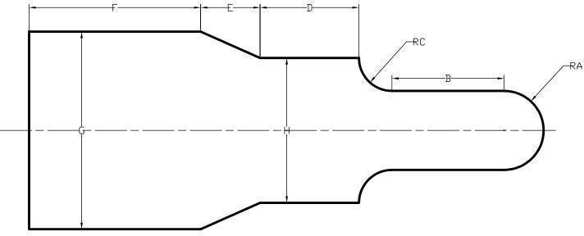

ALLOCATION OF MARKS

SNo | Descriptions |  | Max. Marks | Marks Awarded
1 | Aim & Tools required |  | 10
2 | Preparation/Procedure |  | 20
3 | Dimensions |  | 20
4 | Finish/Output |  | 10
5 | Written test (Theory Portions only) |  | 30
6 | Viva Voce |  | 10
TOTAL |  |  | 100
Internal Examiner |  | External Examiner

10 | Make the component in the CNC Milling Centre.  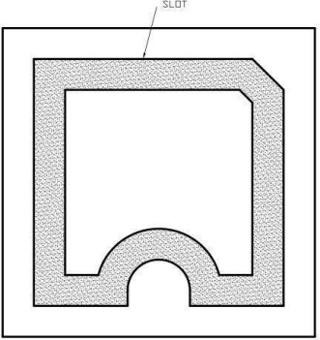

ALLOCATION OF MARKS

SNo | Descriptions |  | Max. Marks | Marks Awarded
1 | Aim & Tools required |  | 10
2 | Preparation/Procedure |  | 20
3 | Dimensions |  | 20
4 | Finish/Output |  | 10
5 | Written test (Theory Portions only) |  | 30
6 | Viva Voce |  | 10
TOTAL |  |  | 100
Internal Examiner |  | External Examiner

