1 | Modelling of piston assembly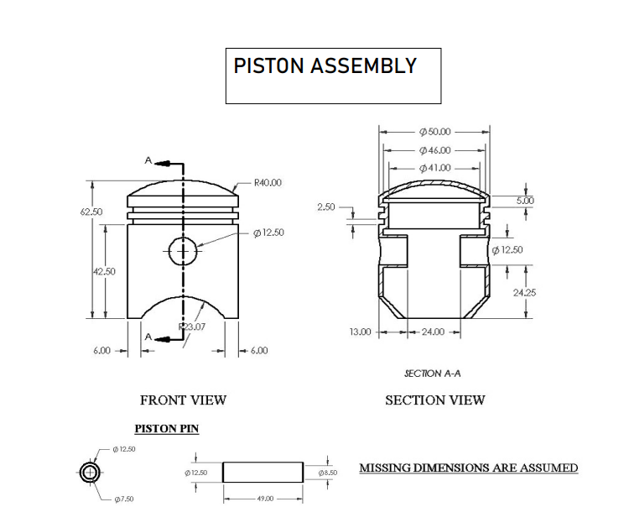

ALLOCATION OF MARKS

SNo | Descriptions |  | Max. Marks | Marks Awarded
1 | Creation Part Modelling |  | 25
2 | Assembled Solid Modelling |  | 25
3 | Printout |  | 10
4 | Written test(Theory Portions only) |  | 30
5 | Viva Voce |  | 10
TOTAL |  |  | 100
Internal Examiner |  | External Examiner

2 | Modelling of the connecting rod assembly  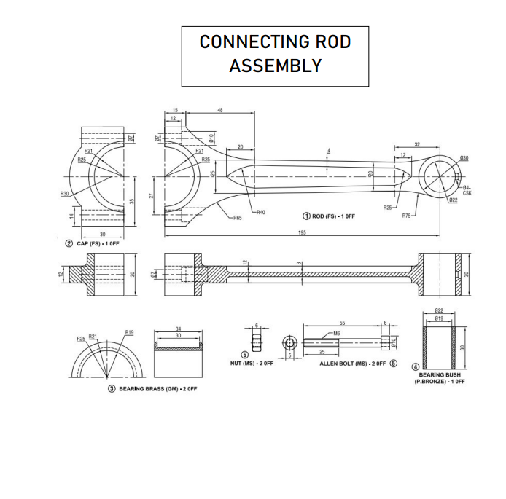

ALLOCATION OF MARKS

SNo |  | Descriptions |  | Max. Marks | Marks Awarded
1 |  | Creation Part Modelling |  | 25
2 |  | Assembled Solid Modelling |  | 25
3 |  | Printout |  | 10
4 |  | Written test(Theory Portions only) |  | 30
5 |  | Viva Voce |  | 10
TOTAL |  |  |  | 100
Internal Examiner |  |  | External Examiner
3 | Modelling of crank shaft assembly.  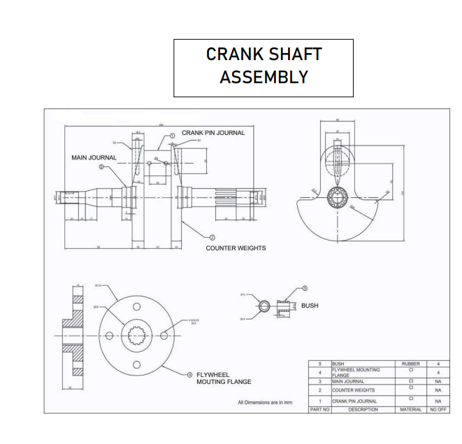

ALLOCATION OF MARKS

SNo |  | Descriptions |  | Max. Marks | Marks Awarded
1 |  | Creation Part Modelling |  | 25
2 |  | Assembled Solid Modelling |  | 25
3 |  | Printout |  | 10
4 |  | Written test(Theory Portions only) |  | 30
5 |  | Viva Voce |  | 10
TOTAL |  |  |  | 100
Internal Examiner |  |  | External Examiner
4 | Modelling of cylinder block assembly (Single cylinder)  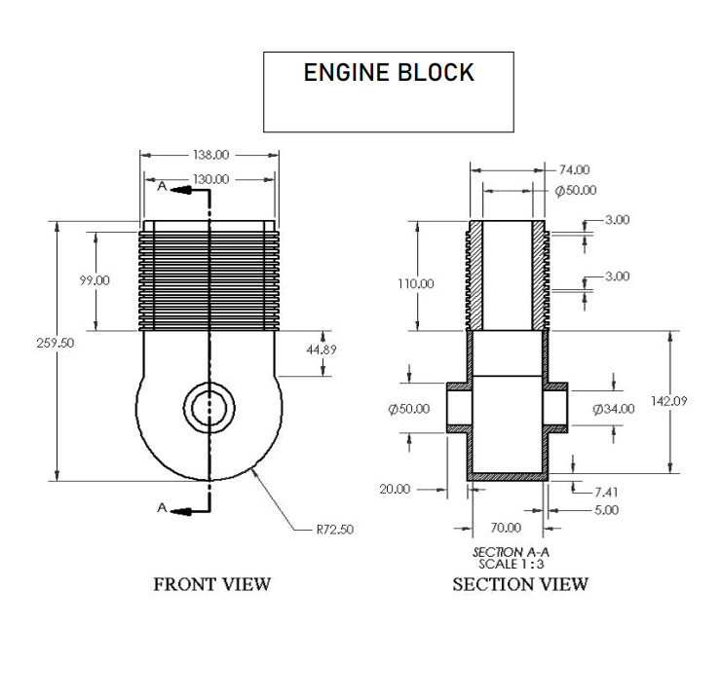

ALLOCATION OF MARKS

SNo | Descriptions |  | Max. Marks | Marks Awarded
1 | Creation Part Modelling |  | 25
2 | Assembled Solid Modelling |  | 25
3 | Printout |  | 10
4 | Written test(Theory Portions only) |  | 30
5 | Viva Voce |  | 10
TOTAL |  |  | 100
Internal Examiner |  | External Examiner

