1 | Design &Draw a poultry house. (MANUAL &CAD)  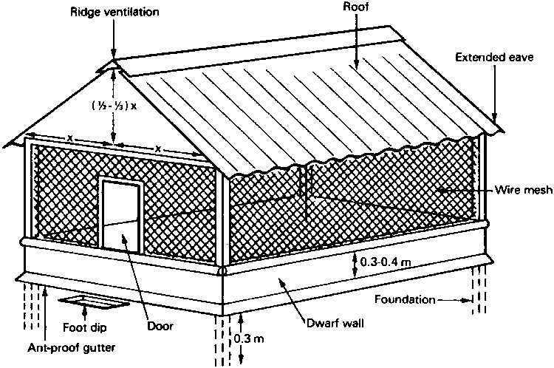

ALLOCATION OF MARKS

SNo | Descriptions |  | Max. Marks | Marks Awarded
1 | Aim and procedure |  | 20
2 | Tabulation & formulae |  | 20
3 | Observation |  | 20
4 | Calculation |  | 20
TOTAL |  |  | 100
Internal Examiner |  | External Examiner

2 | Design & Draw of a sheep or goat house. (MANUAL &CAD)  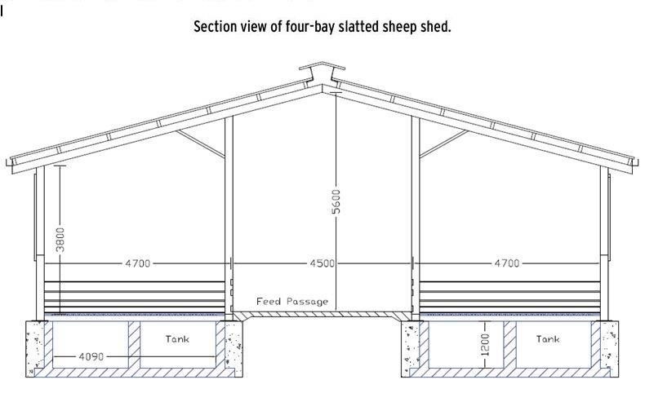

ALLOCATION OF MARKS

SNo | Descriptions |  | Max. Marks | Marks Awarded
1 | Aim and procedure |  | 20
2 | Tabulation & formulae |  | 20
3 | Observation |  | 20
4 | Calculation |  | 20
TOTAL |  |  | 100
Internal Examiner |  | External Examiner

3 | Design & Draw of ventilation system for dairy and poultry house. (MANUAL &CAD)  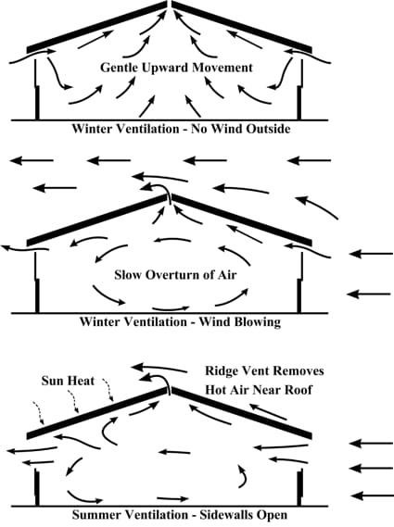

ALLOCATION OF MARKS

SNo | Descriptions |  | Max. Marks | Marks Awarded
1 | Aim and procedure |  | 20
2 | Tabulation & formulae |  | 20
3 | Observation |  | 20
4 | Calculation |  | 20
TOTAL |  |  | 100
Internal Examiner |  | External Examiner

4 | Design& Draw of silos – over ground storages or warehouse. (MANUAL &CAD)  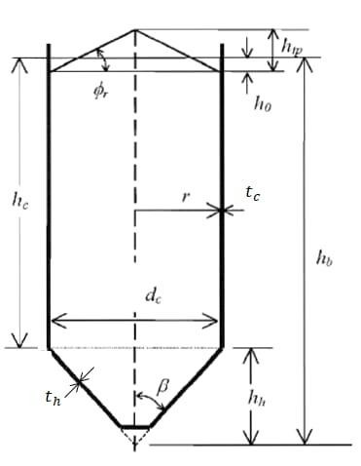

ALLOCATION OF MARKS

SNo | Descriptions |  | Max. Marks | Marks Awarded
1 | Aim and procedure |  | 20
2 | Tabulation & formulae |  | 20
3 | Observation |  | 20
4 | Calculation |  | 20
TOTAL |  |  | 100
Internal Examiner |  | External Examiner

5 | Design & Draw of farm fencing system. (MANUAL &CAD)  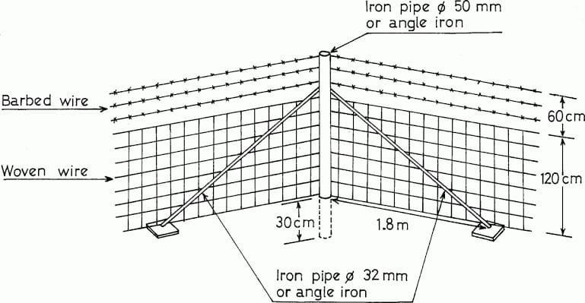

ALLOCATION OF MARKS

SNo | Descriptions |  | Max. Marks | Marks Awarded
1 | Aim and procedure |  | 20
2 | Tabulation & formulae |  | 20
3 | Observation |  | 20
4 | Calculation |  | 20
TOTAL |  |  | 100
Internal Examiner |  | External Examiner

6 | Design& Draw of stanchion barn  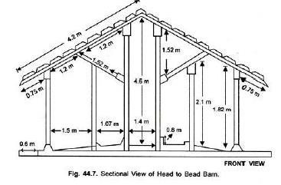

ALLOCATION OF MARKS

SNo | Descriptions |  | Max. Marks | Marks Awarded
1 | Aim and procedure |  | 20
2 | Tabulation & formulae |  | 20
3 | Observation |  | 20
4 | Calculation |  | 20
TOTAL |  |  | 100
Internal Examiner |  | External Examiner

