1 | Prepare the green sand moulding using any one Solid Pattern in the foundry

ALLOCATION OF MARKS

 | Sl. No | Description |  | Marks
 | 1 | Aim, procedure and sketch |  | 10
 | 2 | Job preparation and marking |  | 20
 | 3 | Setting and operation |  | 40
 | 4 | Dimension and surface finish |  | 20
 | 5 | Viva Voce |  | 10
Total |  |  | 100

2 | Prepare the specimen and make the corner joint by the Gas Welding. (Raw material 25mm X 25mm X 05mm MS)

ALLOCATION OF MARKS

 | Sl. No | Description |  | Marks
 | 1 | Aim, procedure and sketch |  | 10
 | 2 | Job preparation and marking |  | 20
 | 3 | Setting and operation |  | 40
 | 4 | Dimension and surface finish |  | 20
 | 5 | Viva Voce |  | 10
Total |  |  | 100

3 | Prepare the specimen and make the bushing using lathe.  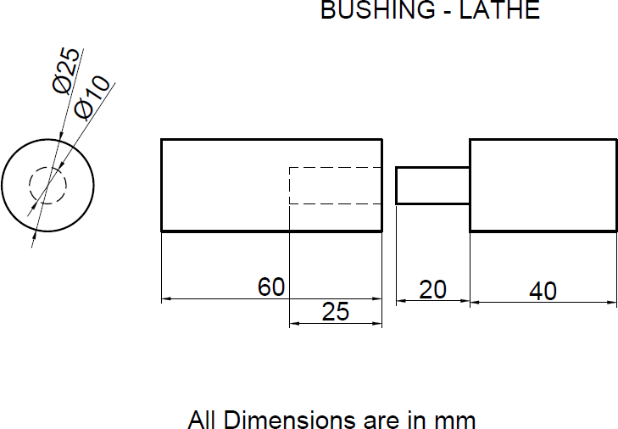

ALLOCATION OF MARKS

 | Sl. No | Description |  | Marks
 | 1 | Aim, procedure and sketch |  | 10
 | 2 | Job preparation and marking |  | 20
 | 3 | Setting and operation |  | 40
 | 4 | Dimension and surface finish |  | 20
 | 5 | Viva Voce |  | 10
Total |  |  | 100

4 | Prepare the specimen and make the threading by the lathe.  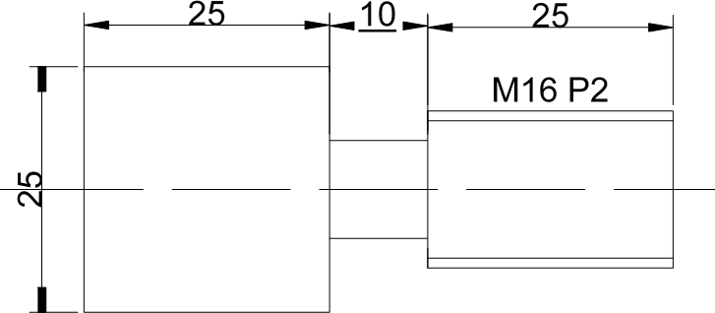

ALLOCATION OF MARKS

 | Sl. No | Description |  | Marks
 | 1 | Aim, procedure and sketch |  | 10
 | 2 | Job preparation and marking |  | 20
 | 3 | Setting and operation |  | 40
 | 4 | Dimension and surface finish |  | 20
 | 5 | Viva Voce |  | 10
Total |  |  | 100

5 | Prepare the specimen and make the Eccentric turning as shown in figure using the Lathe  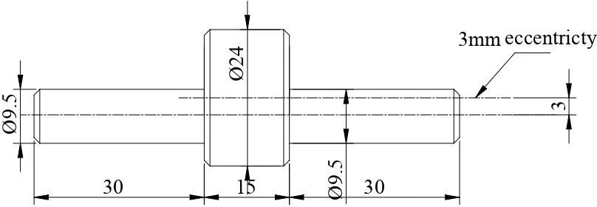

ALLOCATION OF MARKS

 | Sl. No | Description |  | Marks
 | 1 | Aim, procedure and sketch |  | 10
 | 2 | Job preparation and marking |  | 20
 | 3 | Setting and operation |  | 40
 | 4 | Dimension and surface finish |  | 20
 | 5 | Viva Voce |  | 10
Total |  |  | 100

6 | Make groove cut using slotting machine. Use raw material MS ϕ30mm x 30 mm  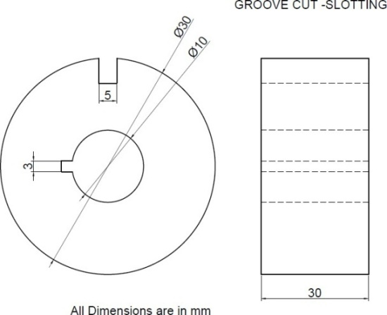

ALLOCATION OF MARKS

 | Sl. No | Description |  | Marks
 | 1 | Aim, procedure and sketch |  | 10
 | 2 | Job preparation and marking |  | 20
 | 3 | Setting and operation |  | 40
 | 4 | Dimension and surface finish |  | 20
 | 5 | Viva Voce |  | 10
Total |  |  | 100

7 | Make a turning tool using tool and cutter grinder. (MS:13mm X 13mm X 75mm)  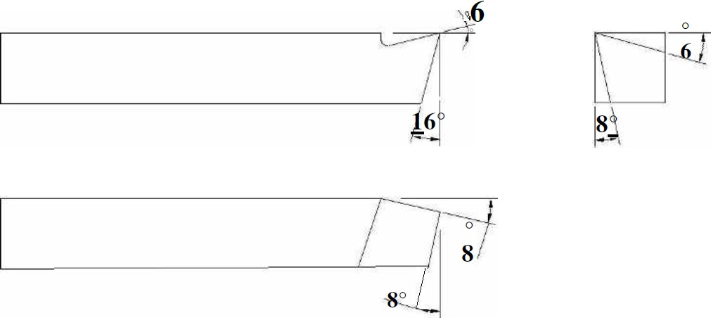

ALLOCATION OF MARKS

 | Sl. No | Description |  | Marks
 | 1 | Aim, procedure and sketch |  | 10
 | 2 | Job preparation and marking |  | 20
 | 3 | Setting and operation |  | 40
 | 4 | Dimension and surface finish |  | 20
 | 5 | Viva Voce |  | 10
Total |  |  | 100

8 | Groove Milling.  Make a V-block using milling. Use a square block (MS: 30 mm X 30 mm)  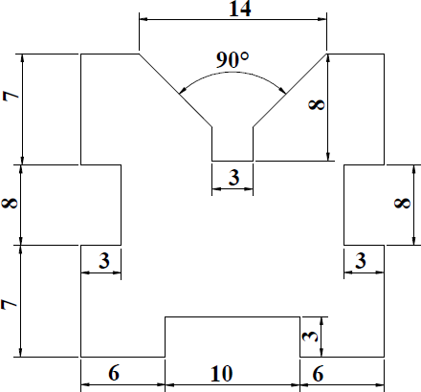

ALLOCATION OF MARKS

 | Sl. No | Description |  | Marks
 | 1 | Aim, procedure and sketch |  | 10
 | 2 | Job preparation and marking |  | 20
 | 3 | Setting and operation |  | 40
 | 4 | Dimension and surface finish |  | 20
 | 5 | Viva Voce |  | 10
Total |  |  | 100

9 | Using linear and circular interpolation – create part program and produce component CNC lathe machine. Material: MS / acrylic fiber.  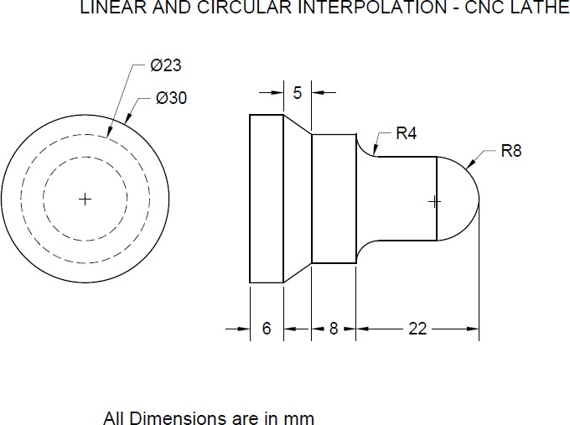

ALLOCATION OF MARKS

 | Sl. No | Description |  | Marks
 | 1 | Aim, procedure and sketch |  | 10
 | 2 | Job preparation and marking |  | 20
 | 3 | Setting and operation |  | 40
 | 4 | Dimension and surface finish |  | 20
 | 5 | Viva Voce |  | 10
Total |  |  | 100

10 | Using linear and circular interpolation – create part program and produce component in the CNC milling machine. Material: MS / acrylic fiber.  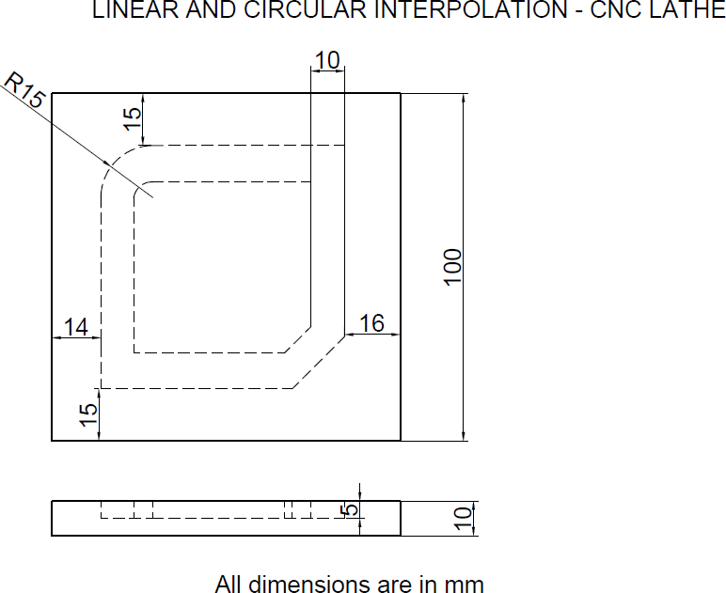

ALLOCATION OF MARKS

 | Sl. No | Description |  | Marks
 | 1 | Aim, procedure and sketch |  | 10
 | 2 | Job preparation and marking |  | 20
 | 3 | Setting and operation |  | 40
 | 4 | Dimension and surface finish |  | 20
 | 5 | Viva Voce |  | 10
Total |  |  | 100

