1
  (A) Make a Grooving and Taper Turning for the given component in center lathe.
  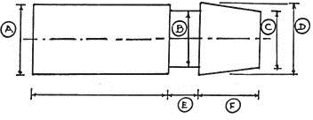
  (B) Using linear and circular interpolation create a part program and produce a
  component in the CNC Turning center.
  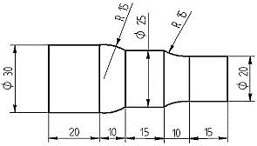
  ALL DIMENSIONS ARE in mm.

ALLOCATION OF MARKS

SNo | Descriptions |  | Max. Marks | Marks Awarded
1 | Aim &Tools required Part (A&B) |  | 10
2 | Preparation/Procedure Part (A&B) |  | 20
3 | Operation/Machining/Dimensions Part (A&B) |  | 40
4 | Surface Finish |  | 10
5 | Finish/Output |  | 10
6 | Viva Voce |  | 10
TOTAL |  |  | 100
Internal Examiner |  | External Examiner

2
  (A) Make a Thread cutting for the given component in center lathe.
  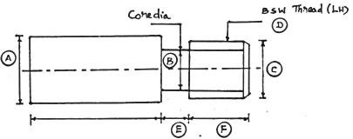
  (B) Using canned cycle create a part program for thread cutting, grooving and produce a
  component in the CNC Turning center.
  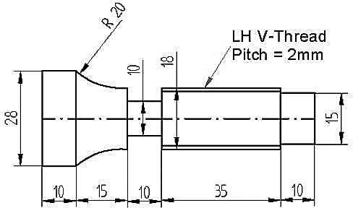
  ALL DIMENSIONS ARE in mm

ALLOCATION OF MARKS

SNo |  | Descriptions |  | Max. Marks | Marks Awarded
1 |  | Aim &Tools required Part (A&B) |  | 10
2 |  | Preparation/Procedure Part (A&B) |  | 20
3 |  | Operation/Machining/Dimensions Part (A&B) |  | 40
4 |  | Surface Finish |  | 10
5 |  | Finish/Output |  | 10
6 |  | Viva Voce |  | 10
TOTAL |  |  |  | 100
Internal Examiner |  |  | External Examiner
3
  (A) Make Spur Gear using Horizontal milling machine by simple Indexing
  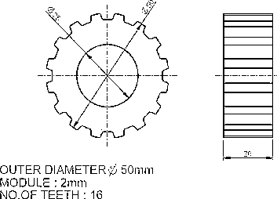
  (B)Using linear interpolation and circular interpolation, create a part program for contour
  machining in the VMC.
  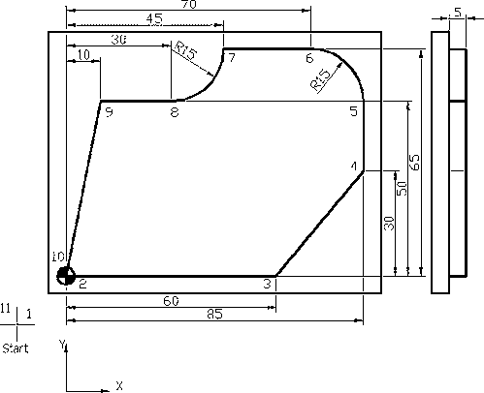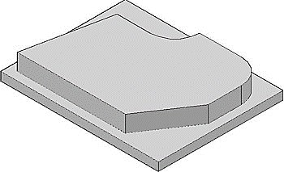
  ALL DIMENSIONS ARE in mm.

ALLOCATION OF MARKS
SNo | Descriptions |  | Max. Marks | Marks Awarded
1 | Aim &Tools required Part (A&B) |  | 10
2 | Preparation/Procedure Part (A&B) |  | 20
3 | Operation/Machining/Dimensions Part (A&B) |  | 40
4 | Surface Finish |  | 10
5 | Finish/Output |  | 10
6 | Viva Voce |  | 10
TOTAL |  |  | 100
Internal Examiner |  | External Examiner

4
  - Grind a plain surface using surface Grinder.
  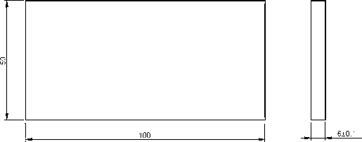
  - Using canned cycle create a part program for a drilling operation in the VMC.
  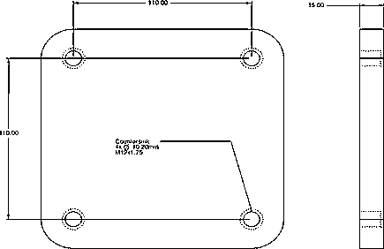
  ALL DIMENSIONS ARE in mm.

ALLOCATION OF MARKS

SNo | Descriptions |  | Max. Marks | Marks Awarded
1 | Aim &Tools required Part (A&B) |  | 10
2 | Preparation/Procedure Part (A&B) |  | 20
3 | Operation/Machining/Dimensions Part (A&B) |  | 40
4 | Surface Finish |  | 10
5 | Finish/Output |  | 10
6 | Viva Voce |  | 10
TOTAL |  |  | 100
Internal Examiner |  | External Examiner

5
  A) Make a turning tool using a tool and cutter grinder
  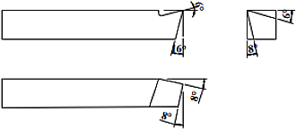
  (B) Using subprogram create a part program and produce the component in the VMC.
  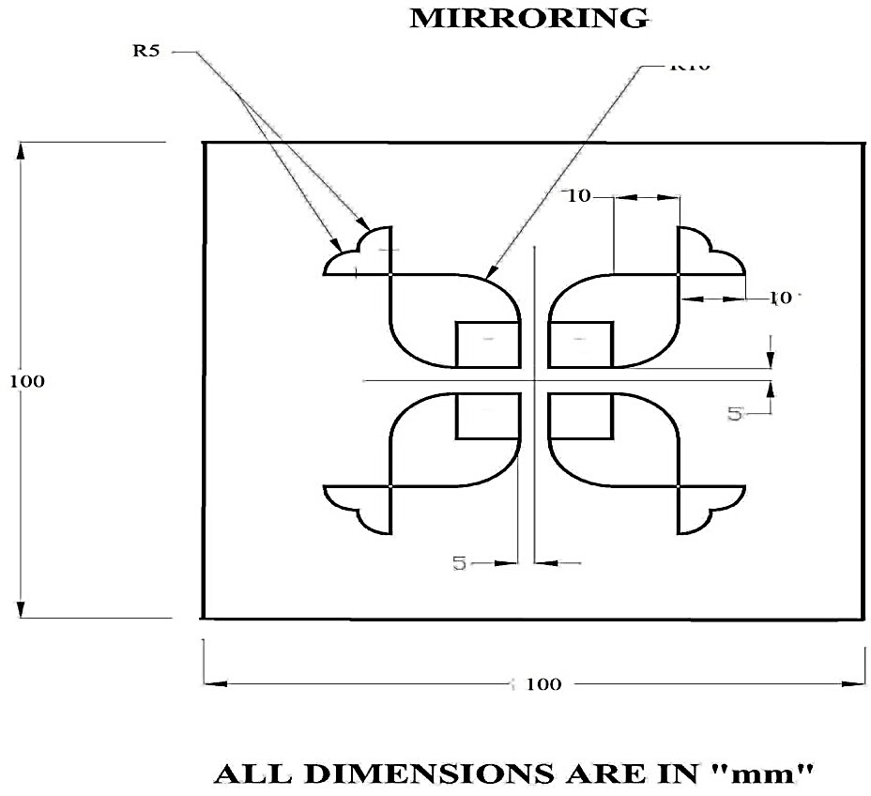

ALLOCATION OF MARKS
SNo | Descriptions |  | Max. Marks | Marks Awarded
1 | Aim &Tools required Part (A&B) |  | 10
2 | Preparation/Procedure Part (A&B) |  | 20
3 | Operation/Machining/Dimensions Part (A&B) |  | 40
4 | Surface Finish |  | 10
5 | Finish/Output |  | 10
6 | Viva Voce |  | 10
TOTAL |  |  | 100
Internal Examiner |  | External Examiner

6
  (A) Make a hexagonal shape component using the shaper machine from the given work
  piece.
  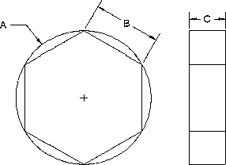
  (B) Model the given engineering component and print using a 3D printer.- Geneva Wheel

ALLOCATION OF MARKS

SNo | Descriptions |  | Max. Marks | Marks Awarded
1 | Aim &Tools required Part (A&B) |  | 10
2 | Preparation/Procedure Part (A&B) |  | 20
3 | Operation/Machining/Dimensions Part (A&B) |  | 40
4 | Surface Finish |  | 10
5 | Finish/Output |  | 10
6 | Viva Voce |  | 10
TOTAL |  |  | 100
Internal Examiner |  | External Examiner

