1 | Design and draft a plate jig to drill holes in the given component.  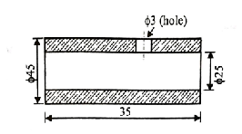

ALLOCATION OF MARKS

SNo |  | Descriptions |  | Max. Marks | Marks Awarded
1 |  | Aim |  | 5
2 |  | Calculation |  | 15
3 |  | Drawing |  | 40
4 |  | Viva |  | 10
5 |  | Written test |  | 30
TOTAL |  |  |  | 100
Internal Examiner |  |  | External Examiner
2 | Design a leaf jig for drilling two holes of 10mm diameter on the given component  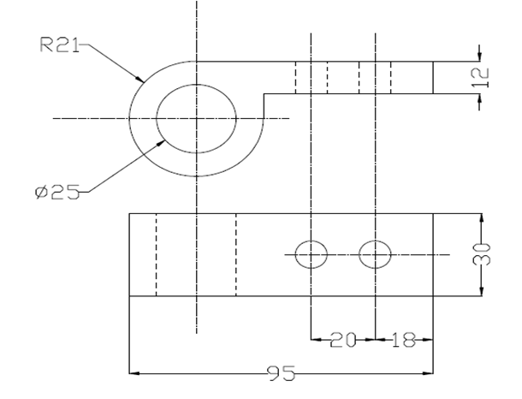

ALLOCATION OF MARKS

SNo |  | Descriptions |  | Max. Marks | Marks Awarded
1 |  | Aim |  | 5
2 |  | Calculation |  | 15
3 |  | Drawing |  | 40
4 |  | Viva |  | 10
5 |  | Written test |  | 30
TOTAL |  |  |  | 100
Internal Examiner |  |  | External Examiner
3 | Design and draft an indexing jig to drill holes of 10 mm diameter in the given component  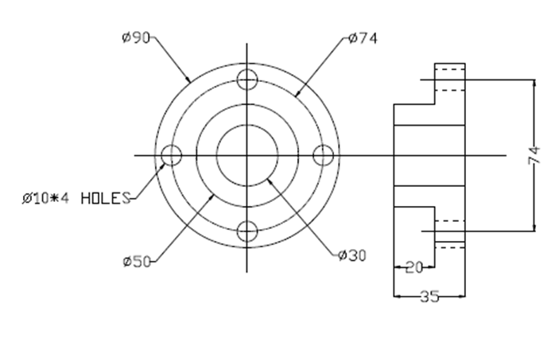

ALLOCATION OF MARKS

SNo | Descriptions |  | Max. Marks | Marks Awarded
1 | Aim |  | 5
2 | Calculation |  | 15
3 | Drawing |  | 40
4 | Viva |  | 10
5 | Written test |  | 30
TOTAL |  |  | 100
Internal Examiner |  | External Examiner

4 | Design and draft a plain milling fixture to machine the given component  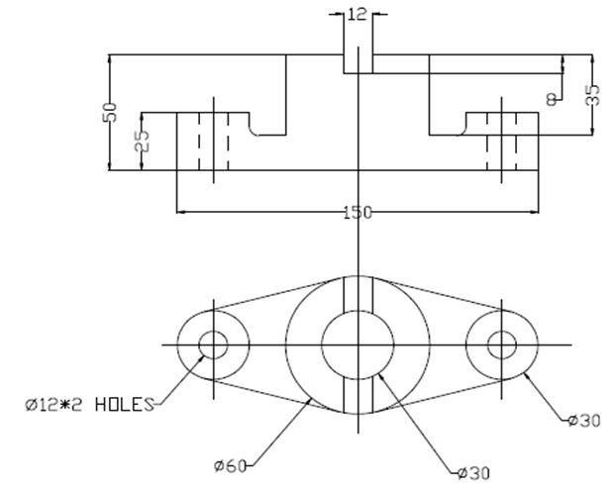

ALLOCATION OF MARKS

SNo |  | Descriptions |  | Max. Marks | Marks Awarded
1 |  | Aim |  | 5
2 |  | Calculation |  | 15
3 |  | Drawing |  | 40
4 |  | Viva |  | 10
5 |  | Written test |  | 30
TOTAL |  |  |  | 100
Internal Examiner |  |  | External Examiner
5 | Design and draft a string milling fixture to machine the given component.  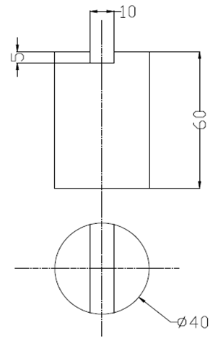

ALLOCATION OF MARKS

SNo |  | Descriptions |  | Max. Marks | Marks Awarded
1 |  | Aim |  | 5
2 |  | Calculation |  | 15
3 |  | Drawing |  | 40
4 |  | Viva |  | 10
5 |  | Written test |  | 30
TOTAL |  |  |  | 100
Internal Examiner |  |  | External Examiner
6 | From a mild steel sheet of 3 mm thick, 50 mm wide and 2 m long. Determine (i) strip layout (ii) number of parts that can be punched from the strip (iii)Percentage of stock used. Component may be chosen

ALLOCATION OF MARKS

SNo | Descriptions |  | Max. Marks | Marks Awarded
1 | Aim |  | 5
2 | Calculation |  | 15
3 | Drawing |  | 40
4 | Viva |  | 10
5 | Written test |  | 30
TOTAL |  |  | 100
Internal Examiner |  | External Examiner

7 | Design and draft a progressive die to make washer having 15 mm internal hole and 30 mm outside diameter which is to be made from 1.5 mm thick strip of C20 steel.

ALLOCATION OF MARKS

SNo | Descriptions |  | Max. Marks | Marks Awarded
1 | Aim |  | 5
2 | Calculation |  | 15
3 | Drawing |  | 40
4 | Viva |  | 10
5 | Written test |  | 30
TOTAL |  |  | 100
Internal Examiner |  | External Examiner

8 | Design and draft a compound die to make washer having 20 mm internal hole and 50 mm outside diameter which is to be made from 1.5 mm thick strip of C20 steel.

ALLOCATION OF MARKS

SNo | Descriptions |  | Max. Marks | Marks Awarded
1 | Aim |  | 5
2 | Calculation |  | 15
3 | Drawing |  | 40
4 | Viva |  | 10
5 | Written test |  | 30
TOTAL |  |  | 100
Internal Examiner |  | External Examiner

9 | Design and draft a drawing die to make a cup having 50 mm diameter and 75 mm deep is to be drawn from 2mm thick drawing steel with a tensile strength of 300 N/mm²

ALLOCATION OF MARKS

SNo | Descriptions |  | Max. Marks | Marks Awarded
1 | Aim |  | 5
2 | Calculation |  | 15
3 | Drawing |  | 40
4 | Viva |  | 10
5 | Written test |  | 30
TOTAL |  |  | 100
Internal Examiner |  | External Examiner

10 | A sheet metal workshop requires an edge-bending die for bending a 2 mm thick mild steel sheet to 90°. The die assembly consists of a punch, die block, pressure pad, guide pillars, and a bolster plate. Draw the detailed assembled view of the edge-bending die, clearly labeling all components.

ALLOCATION OF MARKS

SNo | Descriptions |  | Max. Marks | Marks Awarded
1 | Aim |  | 5
2 | Calculation |  | 15
3 | Drawing |  | 40
4 | Viva |  | 10
5 | Written test |  | 30
TOTAL |  |  | 100
Internal Examiner |  | External Examiner

