1 | Write the command and draw the 2D view of the assemble drawing of spigot joint as per the detail drawing.  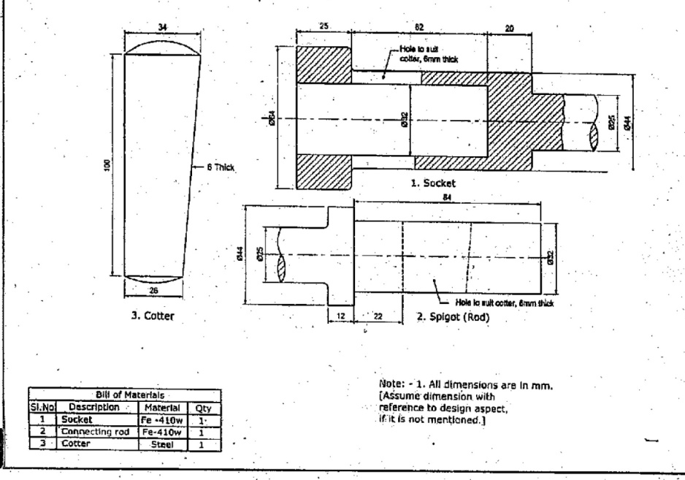

ALLOCATION OF MARKS

SNo |  | Descriptions |  | Max. Marks | Marks Awarded
1 |  | Aim & Procedure |  | 5
2 |  | CAD command |  | 20
3 |  | Diagram |  | 25
4 |  | Output/Result |  | 10
5 |  | Written Test |  | 30
6 |  | Viva Voce |  | 10
TOTAL |  |  |  | 100
Internal Examiner |  |  | External Examiner
2 | Write the command and draw the 2D view of the assemble drawing of Knuckle joint as per the detail drawing  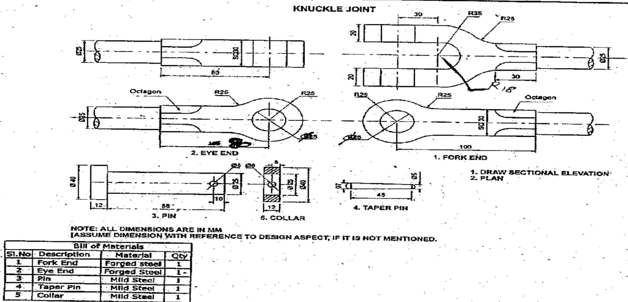

ALLOCATION OF MARKS

SNo | Descriptions |  | Max. Marks | Marks Awarded
1 | Aim & Procedure |  | 5
2 | CAD command |  | 20
3 | Diagram |  | 25
4 | Output/Result |  | 10
5 | Written Test |  | 30
6 | Viva Voce |  | 10
TOTAL |  |  | 100
Internal Examiner |  | External Examiner

3 | Write the command and draw the 2D view of the assemble drawing Protected type flanged coupling as per the detail drawing  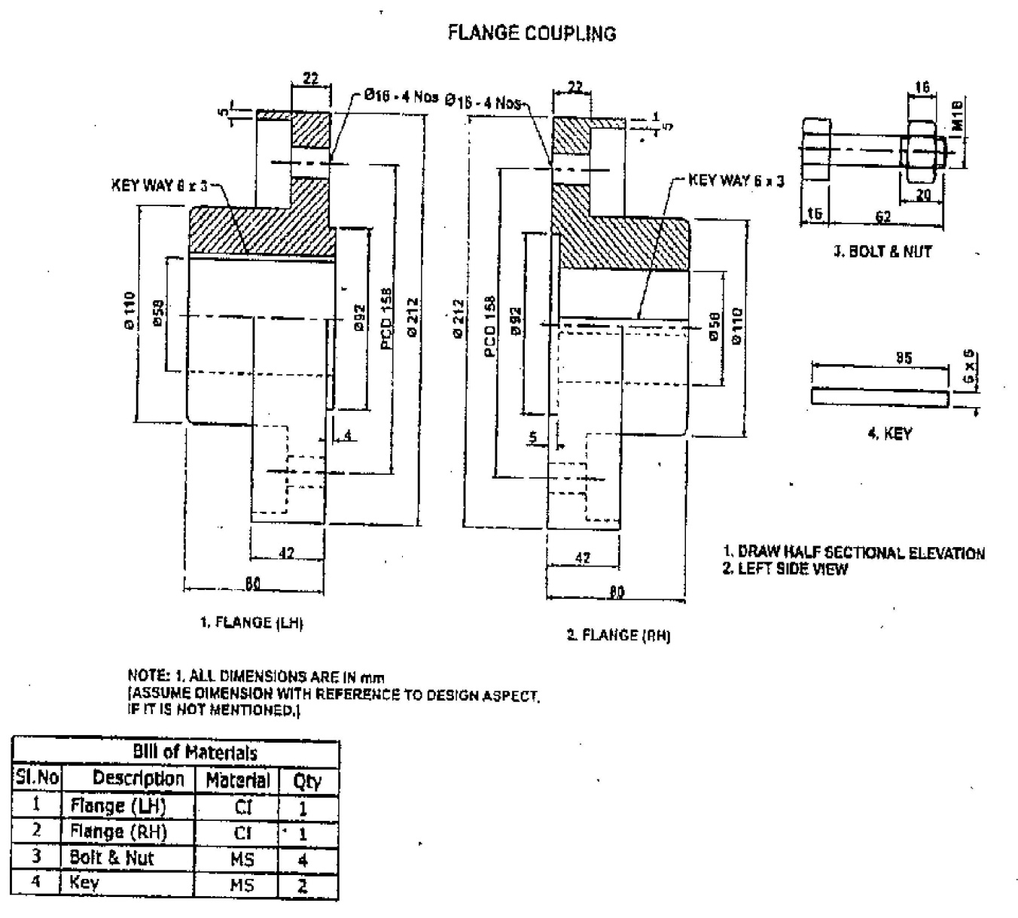

ALLOCATION OF MARKS

SNo |  | Descriptions |  | Max. Marks | Marks Awarded
1 |  | Aim & Procedure |  | 5
2 |  | CAD command |  | 20
3 |  | Diagram |  | 25
4 |  | Output/Result |  | 10
5 |  | Written Test |  | 30
6 |  | Viva Voce |  | 10
TOTAL |  |  |  | 100
Internal Examiner |  |  | External Examiner
4 | Write the command and draw the 2D view of the assemble drawing Universal coupling as per the detail drawing  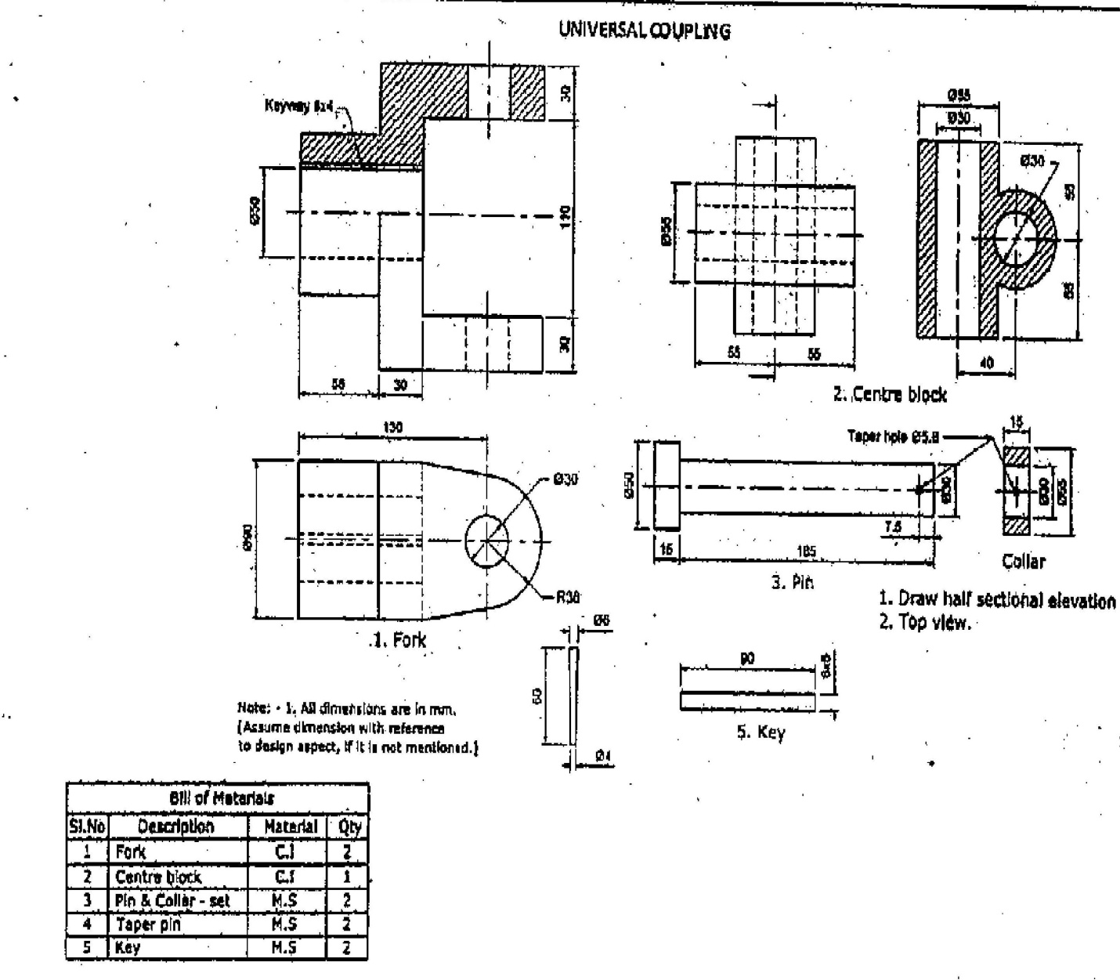

ALLOCATION OF MARKS

SNo |  | Descriptions |  | Max. Marks | Marks Awarded
1 |  | Aim & Procedure |  | 5
2 |  | CAD command |  | 20
3 |  | Diagram |  | 25
4 |  | Output/Result |  | 10
5 |  | Written Test |  | 30
6 |  | Viva Voce |  | 10
TOTAL |  |  |  | 100
Internal Examiner |  |  | External Examiner
5 | Write the command and draw the 2D view of the assemble drawing Connecting rod as per the detail drawing  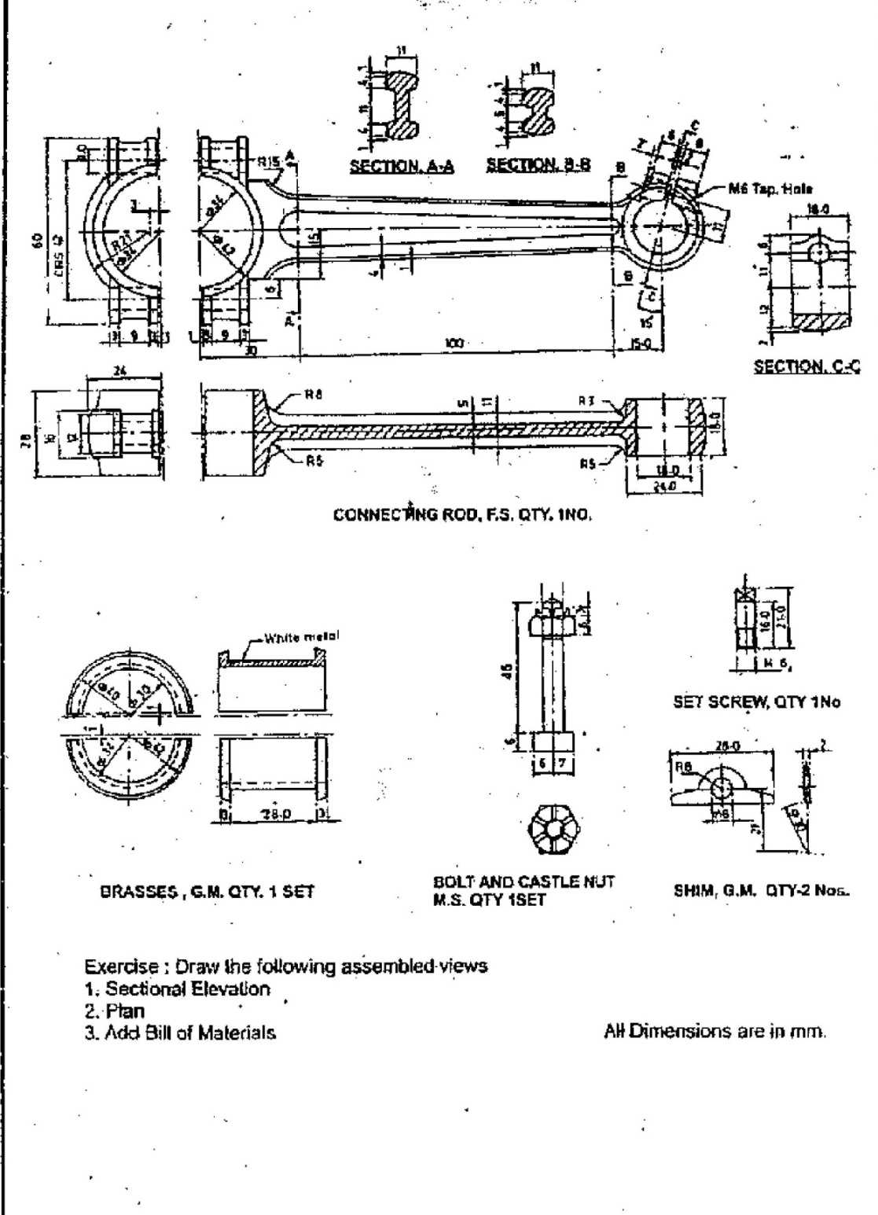

ALLOCATION OF MARKS

SNo | Descriptions |  | Max. Marks | Marks Awarded
1 | Aim & Procedure |  | 5
2 | CAD command |  | 20
3 | Diagram |  | 25
4 | Output/Result |  | 10
5 | Written Test |  | 30
6 | Viva Voce |  | 10
TOTAL |  |  | 100
Internal Examiner |  | External Examiner

6 | Write the command and draw the 2D view of the assemble drawing Feed check valve as per the detail drawing  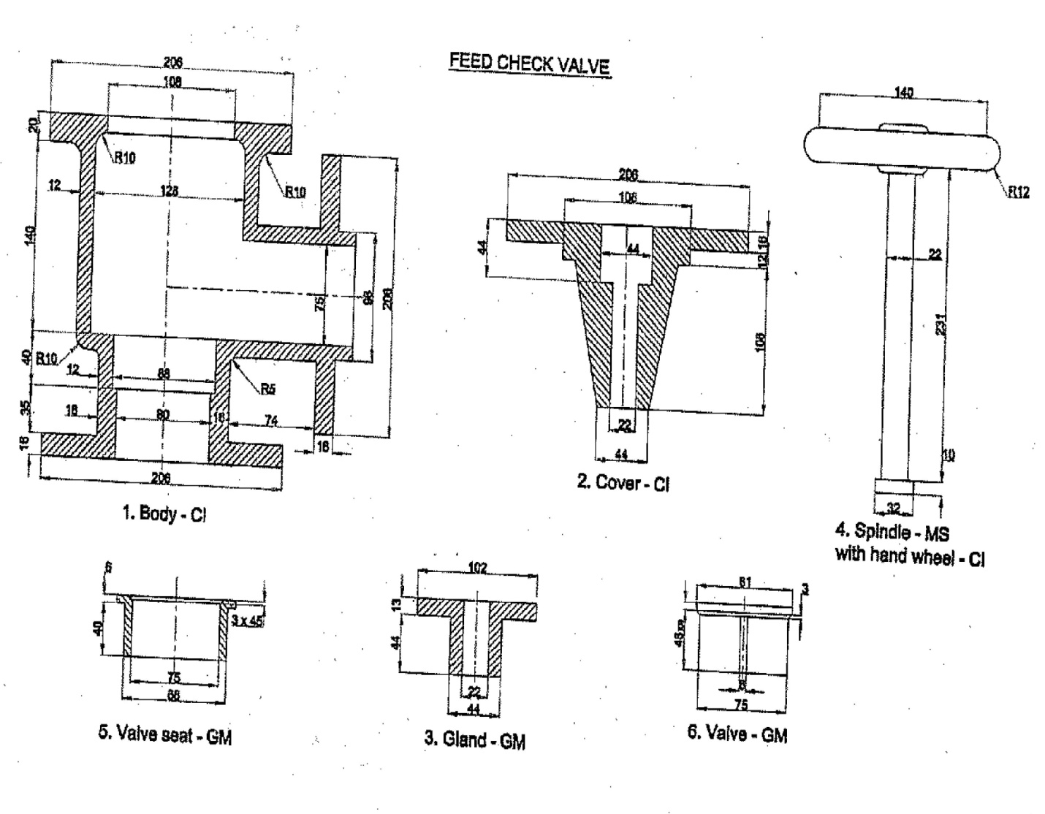

ALLOCATION OF MARKS

SNo |  | Descriptions |  | Max. Marks | Marks Awarded
1 |  | Aim & Procedure |  | 5
2 |  | CAD command |  | 20
3 |  | Diagram |  | 25
4 |  | Output/Result |  | 10
5 |  | Written Test |  | 30
6 |  | Viva Voce |  | 10
TOTAL |  |  |  | 100
Internal Examiner |  |  | External Examiner
7 | Write the command and draw the 2D view of the assemble drawing Blow off cock as per the detail drawing  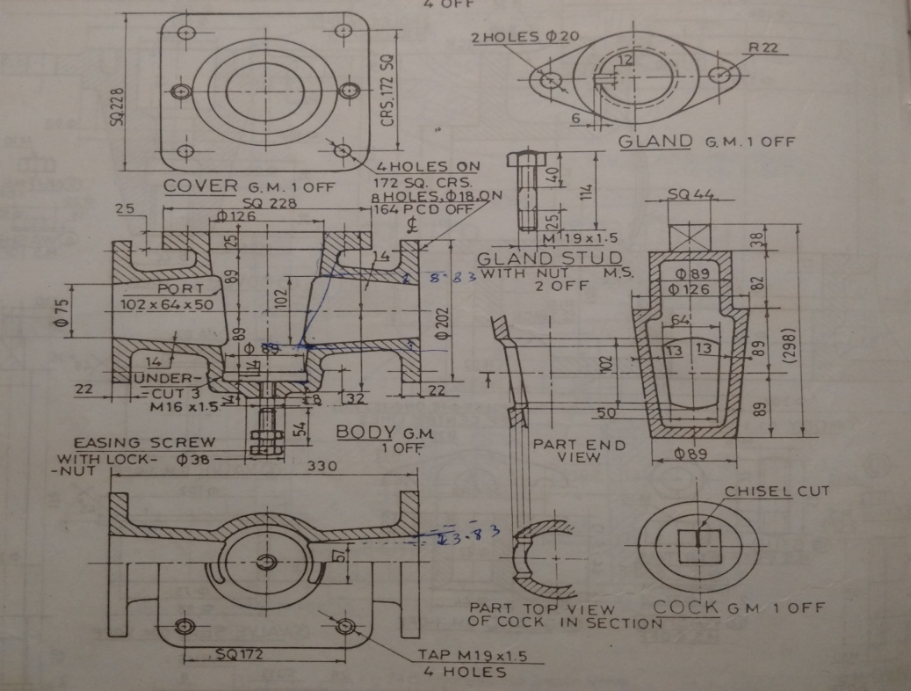

ALLOCATION OF MARKS

SNo |  | Descriptions |  | Max. Marks | Marks Awarded
1 |  | Aim & Procedure |  | 5
2 |  | CAD command |  | 20
3 |  | Diagram |  | 25
4 |  | Output/Result |  | 10
5 |  | Written Test |  | 30
6 |  | Viva Voce |  | 10
TOTAL |  |  |  | 100
Internal Examiner |  |  | External Examiner
8 | Write the command and draw the 3D view of the assemble drawing Geneva wheel as per the detail drawing  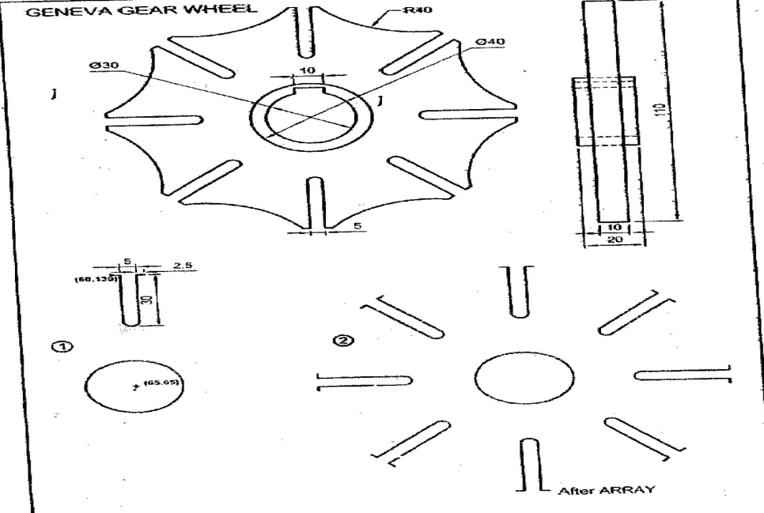

ALLOCATION OF MARKS

SNo | Descriptions |  | Max. Marks | Marks Awarded
1 | Aim & Procedure |  | 5
2 | CAD command |  | 20
3 | Diagram |  | 25
4 | Output/Result |  | 10
5 | Written Test |  | 30
6 | Viva Voce |  | 10
TOTAL |  |  | 100
Internal Examiner |  | External Examiner

9 | Write the command and draw the 3D view of the assemble drawing Machined block as per the detail drawing  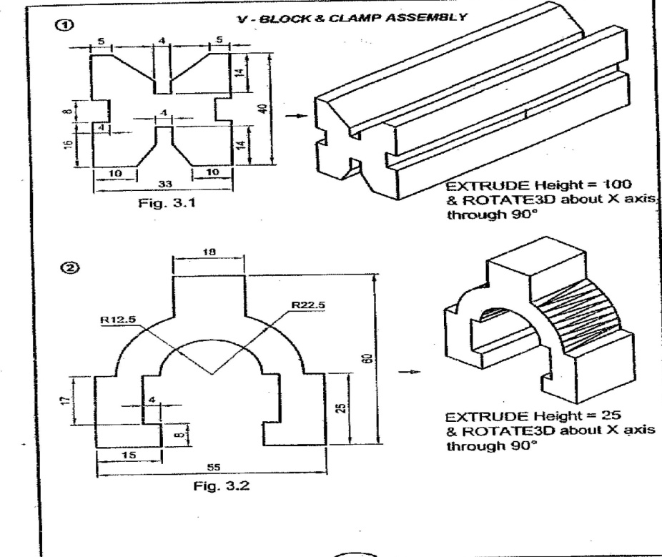

ALLOCATION OF MARKS

SNo | Descriptions |  | Max. Marks | Marks Awarded
1 | Aim & Procedure |  | 5
2 | CAD command |  | 20
3 | Diagram |  | 25
4 | Output/Result |  | 10
5 | Written Test |  | 30
6 | Viva Voce |  | 10
TOTAL |  |  | 100
Internal Examiner |  | External Examiner

10 | 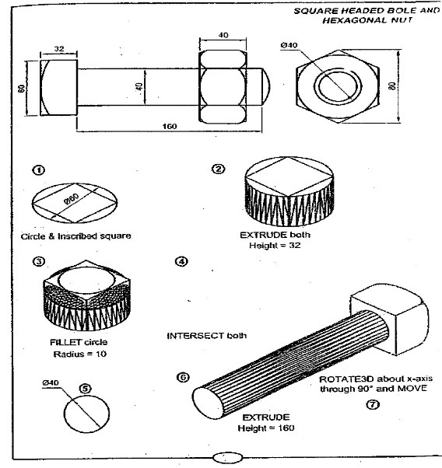  Write the command and draw the 3D view of the assemble drawing Square head bolt and nut as per the detail drawing

ALLOCATION OF MARKS

SNo | Descriptions |  | Max. Marks | Marks Awarded
1 | Aim & Procedure |  | 5
2 | CAD command |  | 20
3 | Diagram |  | 25
4 | Output/Result |  | 10
5 | Written Test |  | 30
6 | Viva Voce |  | 10
TOTAL |  |  | 100
Internal Examiner |  | External Examiner

11 | Write the command and draw the 3D view of the assemble drawing Piston and piston rings as per the detail drawing  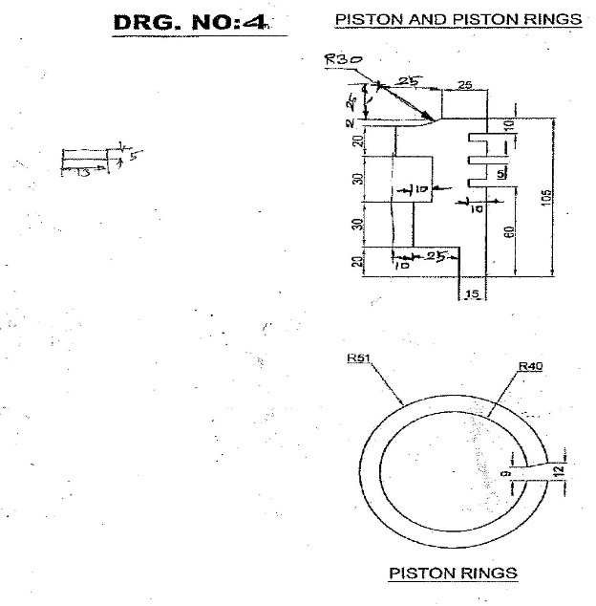

ALLOCATION OF MARKS

SNo | Descriptions |  | Max. Marks | Marks Awarded
1 | Aim & Procedure |  | 5
2 | CAD command |  | 20
3 | Diagram |  | 25
4 | Output/Result |  | 10
5 | Written Test |  | 30
6 | Viva Voce |  | 10
TOTAL |  |  | 100
Internal Examiner |  | External Examiner

