1 | Lap joint Arc Welding (Raw Material: 40 mm x 10 mm MS flat)  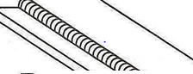

ALLOCATION OF MARKS

SNo | Descriptions |  | Max. Marks | Marks Awarded
1 | Aim & Apparatus Required |  | 05
2 | Program |  | 20
3 | Execution |  | 20
4 | Output / Result |  | 25
5 | MCQ from Theory Portions |  | 20
6 | Viva Voce |  | 10
TOTAL |  |  | 100
Internal Examiner |  | External Examiner

2 | T- Joint - Arc Welding (Raw Material: 40 mm x 10 mm MS flat)  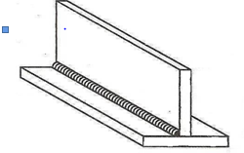

ALLOCATION OF MARKS

SNo | Descriptions |  | Max. Marks | Marks Awarded
1 | Aim & Apparatus Required |  | 05
2 | Program |  | 20
3 | Execution |  | 20
4 | Output / Result |  | 25
5 | MCQ from Theory Portions |  | 20
6 | Viva Voce |  | 10
TOTAL |  |  | 100
Internal Examiner |  | External Examiner

3 | Butt Joint - TIG / MIG Welding (Raw Material: MS Pipe / MS Square tube)  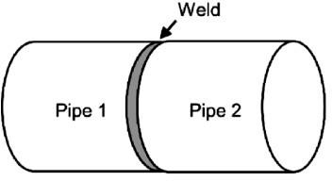

ALLOCATION OF MARKS

SNo | Descriptions |  | Max. Marks | Marks Awarded
1 | Aim & Apparatus Required |  | 05
2 | Program |  | 20
3 | Execution |  | 20
4 | Output / Result |  | 25
5 | MCQ from Theory Portions |  | 20
6 | Viva Voce |  | 10
TOTAL |  |  | 100
Internal Examiner |  | External Examiner

4 | Profile cutting- Circular profile -cutting Gas cutting  ( Raw Material : 100x100mmx6mm M.S. flat)  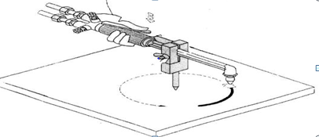

ALLOCATION OF MARKS

SNo | Descriptions |  | Max. Marks | Marks Awarded
1 | Aim & Apparatus Required |  | 05
2 | Program |  | 20
3 | Execution |  | 20
4 | Output / Result |  | 25
5 | MCQ from Theory Portions |  | 20
6 | Viva Voce |  | 10
TOTAL |  |  | 100
Internal Examiner |  | External Examiner

5 | Lap joint - Gas Welding- (Raw Material: 16G MS sheet)  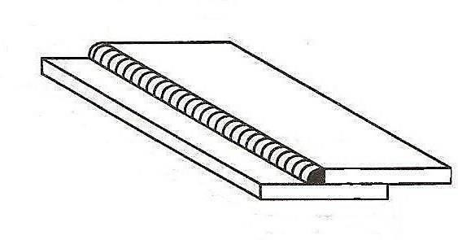

ALLOCATION OF MARKS

SNo | Descriptions |  | Max. Marks | Marks Awarded
1 | Aim & Apparatus Required |  | 05
2 | Program |  | 20
3 | Execution |  | 20
4 | Output / Result |  | 25
5 | MCQ from Theory Portions |  | 20
6 | Viva Voce |  | 10
TOTAL |  |  | 100
Internal Examiner |  | External Examiner

6 | Spot welding - Lap joint - Make a tray / dustpan and join the vulnerable points (Minimum8 Points) (Raw Material: GI/MS Sheet 22 G)

ALLOCATION OF MARKS

SNo | Descriptions |  | Max. Marks | Marks Awarded
1 | Aim & Apparatus Required |  | 05
2 | Program |  | 20
3 | Execution |  | 20
4 | Output / Result |  | 25
5 | MCQ from Theory Portions |  | 20
6 | Viva Voce |  | 10
TOTAL |  |  | 100
Internal Examiner |  | External Examiner

7 | Solder as per the given circuit diagram / Battery pack with series and parallel connections.  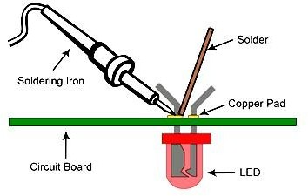

ALLOCATION OF MARKS

SNo | Descriptions |  | Max. Marks | Marks Awarded
1 | Aim & Apparatus Required |  | 05
2 | Program |  | 20
3 | Execution |  | 20
4 | Output / Result |  | 25
5 | MCQ from Theory Portions |  | 20
6 | Viva Voce |  | 10
TOTAL |  |  | 100
Internal Examiner |  | External Examiner

8 | Braze the joints of the copper tube. Prepare the tube with Cutting, bending, flaring, Swaging and pinching practice.  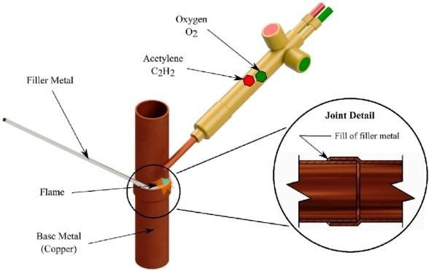  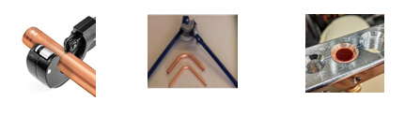  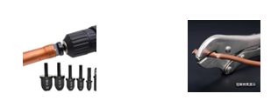

ALLOCATION OF MARKS

SNo | Descriptions |  | Max. Marks | Marks Awarded
1 | Aim & Apparatus Required |  | 05
2 | Program |  | 20
3 | Execution |  | 20
4 | Output / Result |  | 25
5 | MCQ from Theory Portions |  | 20
6 | Viva Voce |  | 10
TOTAL |  |  | 100
Internal Examiner |  | External Examiner

9 | Dismantle and Assemble the Bolt/Nut using wrench power tools. (Pneumatic / Electric). (Sample Exercise Flange / Cylinder head / Remove Tire from the disc / etc…)  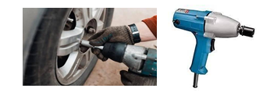

ALLOCATION OF MARKS

SNo | Descriptions |  | Max. Marks | Marks Awarded
1 | Aim & Apparatus Required |  | 05
2 | Program |  | 20
3 | Execution |  | 20
4 | Output / Result |  | 25
5 | MCQ from Theory Portions |  | 20
6 | Viva Voce |  | 10
TOTAL |  |  | 100
Internal Examiner |  | External Examiner

10 | Profile cutting – Using Jigsaw. (Raw Material: 100 x 100 mm X 6 mm M.S. Flat / Wood)  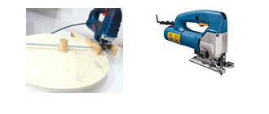

ALLOCATION OF MARKS

SNo | Descriptions |  | Max. Marks | Marks Awarded
1 | Aim & Apparatus Required |  | 05
2 | Program |  | 20
3 | Execution |  | 20
4 | Output / Result |  | 25
5 | MCQ from Theory Portions |  | 20
6 | Viva Voce |  | 10
TOTAL |  |  | 100
Internal Examiner |  | External Examiner

