1 | Ortho graphic top view of the robotic/mechanical links.  Links: Links is used in a manufacturing automation cell to perform task of lifting and inserting palettes in a CNC machine (especially in a manufacturing process). Geometric tolerances, dimensioning, and GD&T are included in the 2D engineering drawings.  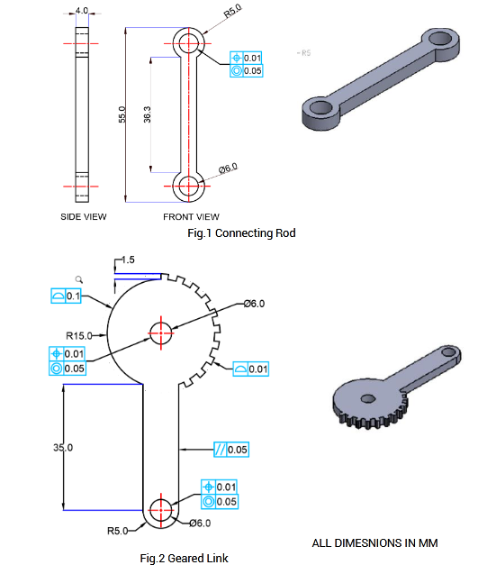

ALLOCATION OF MARKS

SNo | Descriptions |  | Max. Marks | Marks Awarded
1 | Drawing Component / Assembly / Layout / Circuit |  | 55
2 | Blocks, Layers, Annotations / Symbols |  | 25
3 | Printout |  | 10
4 | Viva voce |  | 10
TOTAL |  |  | 100
Internal Examiner |  | External Examiner

2 | Ortho graphic top view of the robotic/mechanical joints.  Joints:Itconnectstwoshafts/linksandalsoprovidessupporttoholdthedrive mechanism  and actuator  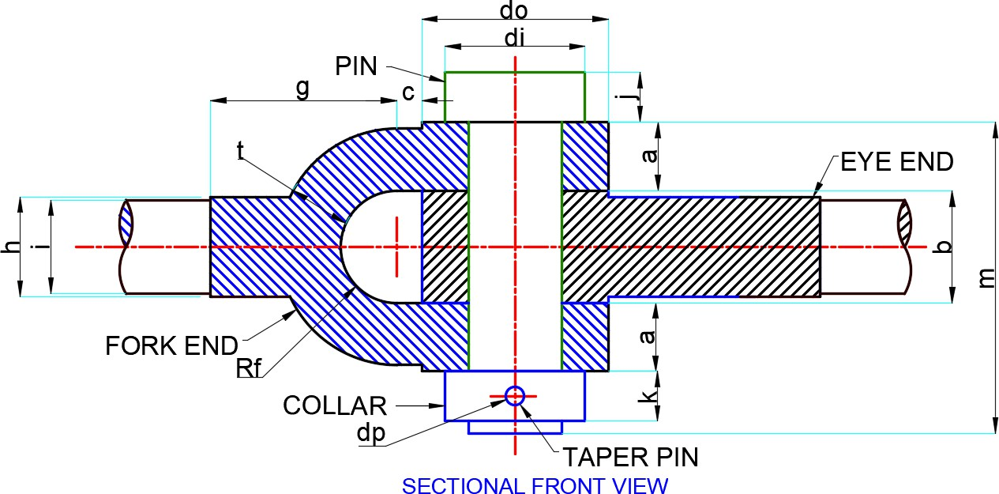  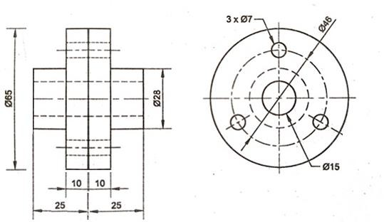
  Dimension  Variable | Value  (mm)
  a | 22
  do | 60
  b | 36
  c | 8
  Rf | R18
  t | 20
  di | 45
  g | 60
  h | 32
  i | 30
  J,k | 16
  dp | Ф6
  m | 100

ALLOCATION OF MARKS

SNo |  | Descriptions |  | Max. Marks | Marks Awarded
1 |  | Drawing Component / Assembly / Layout / Circuit |  | 55
2 |  | Blocks, Layers, Annotations / Symbols |  | 25
3 |  | Printout |  | 10
4 |  | Viva voce |  | 10
TOTAL |  |  |  | 100
Internal Examiner |  |  | External Examiner
3 | Ortho graphic top view of the robotic/mechanical gripper.  Gripper (End effector): Grippers are mainly used to hold and move objects from one place to another. The two finger gripper is that it is simple and multidisciplinary in its tasks.  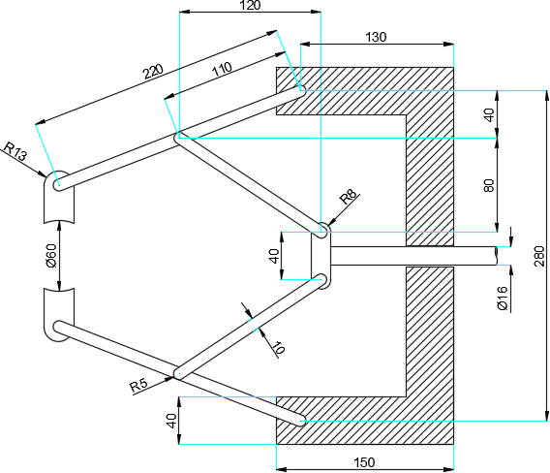  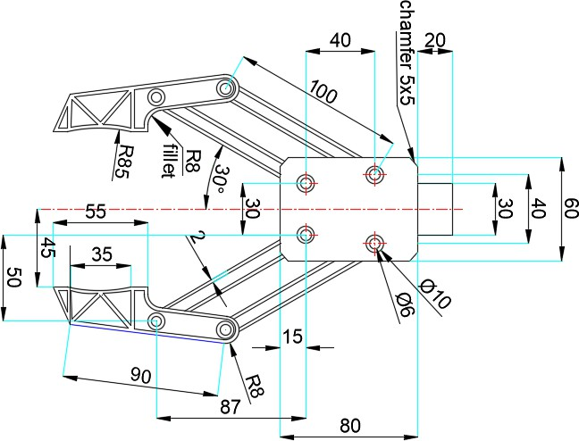

ALLOCATION OF MARKS

SNo |  | Descriptions |  | Max. Marks | Marks Awarded
1 |  | Drawing Component / Assembly / Layout / Circuit |  | 55
2 |  | Blocks, Layers, Annotations / Symbols |  | 25
3 |  | Printout |  | 10
4 |  | Viva voce |  | 10
TOTAL |  |  |  | 100
Internal Examiner |  |  | External Examiner
4 | Ortho graphic view of any two threaded fasteners.  Threaded Fastener: Screwed or threaded fasteners such as machine screws, bolts and nuts are used to join machine parts. They allow for both permanent and removable connections.  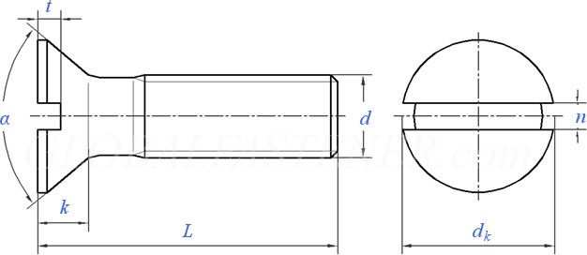  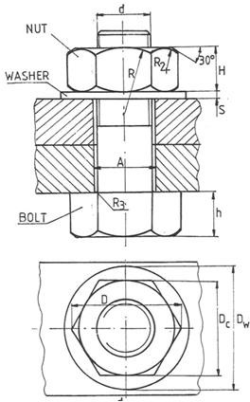

ALLOCATION OF MARKS

SNo | Descriptions |  | Max. Marks | Marks Awarded
1 | Drawing Component / Assembly / Layout / Circuit |  | 55
2 | Blocks, Layers, Annotations / Symbols |  | 25
3 | Printout |  | 10
4 | Viva voce |  | 10
TOTAL |  |  | 100
Internal Examiner |  | External Examiner

5 | 2Dmodelingofthecamandfollowermechanism.  Cam and follower: A cam mechanism generally comprises three elements, a cam, a follower and a fixed frame. A cam is a component that gives a specific motion, by its rotation, to the follower. A follower is a component which is in reciprocating or swinging motion.
  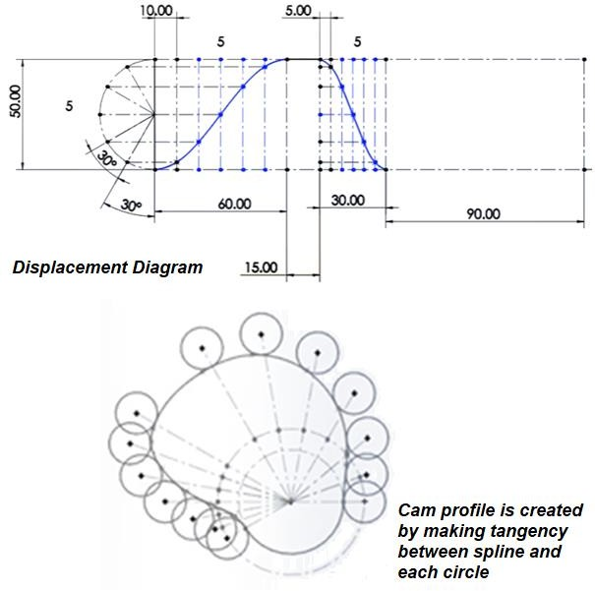  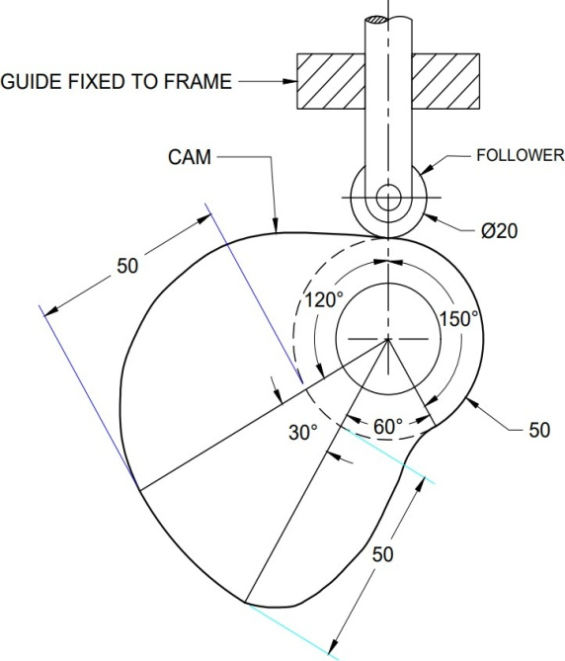 | 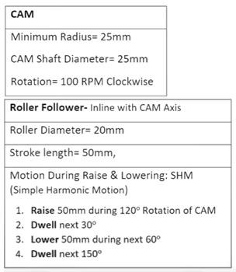

ALLOCATION OF MARKS

SNo | Descriptions |  | Max. Marks | Marks Awarded
1 | Drawing Component / Assembly / Layout / Circuit |  | 55
2 | Blocks, Layers, Annotations / Symbols |  | 25
3 | Printout |  | 10
4 | Viva voce |  | 10
TOTAL |  |  | 100
Internal Examiner |  | External Examiner

6 | Draw the assembly of an induction motor end elevation top half in section  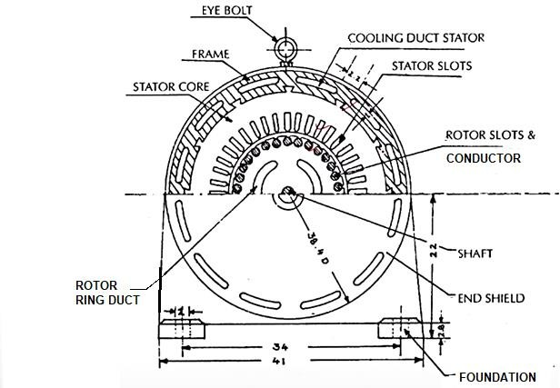

ALLOCATION OF MARKS

SNo | Descriptions |  | Max. Marks | Marks Awarded
1 | Drawing Component / Assembly / Layout / Circuit |  | 55
2 | Blocks, Layers, Annotations / Symbols |  | 25
3 | Printout |  | 10
4 | Viva voce |  | 10
TOTAL |  |  | 100
Internal Examiner |  | External Examiner

7 | Create the single line diagram of electrical symbols (switch ,wire, contactor, motor, transformer) using layers and block.  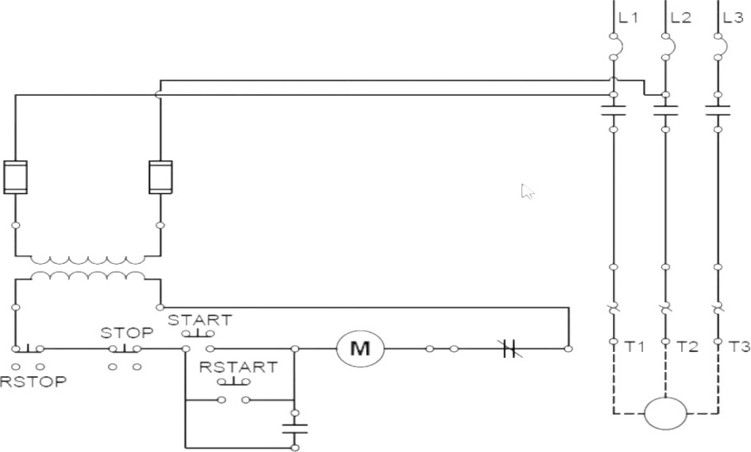  Single-Line Diagram: A diagram which shows, by means of single lines and electrical symbols, electric circuit or system of circuits and the component devices.

ALLOCATION OF MARKS

SNo | Descriptions |  | Max. Marks | Marks Awarded
1 | Drawing Component / Assembly / Layout / Circuit |  | 55
2 | Blocks, Layers, Annotations / Symbols |  | 25
3 | Printout |  | 10
4 | Viva voce |  | 10
TOTAL |  |  | 100
Internal Examiner |  | External Examiner

8 | Create a single-line diagram of an electrical circuit using the available components in the library or outsourcing on the web.  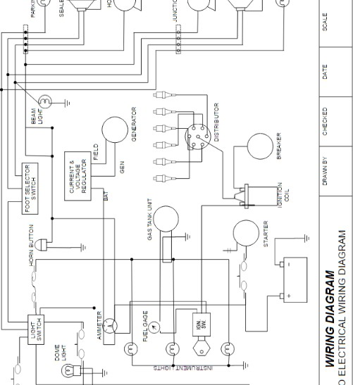

ALLOCATION OF MARKS

SNo | Descriptions |  | Max. Marks | Marks Awarded
1 | Drawing Component / Assembly / Layout / Circuit |  | 55
2 | Blocks, Layers, Annotations / Symbols |  | 25
3 | Printout |  | 10
4 | Viva voce |  | 10
TOTAL |  |  | 100
Internal Examiner |  | External Examiner

9 | Robotic work cell Layout/Plan using a block diagram  Robotic work cell: It is a complete system that includes the robot, controller, and other peripherals such as a part positioner (palletizer) ,storage manipulator(ASRS), CNC/DNC and safety environment.  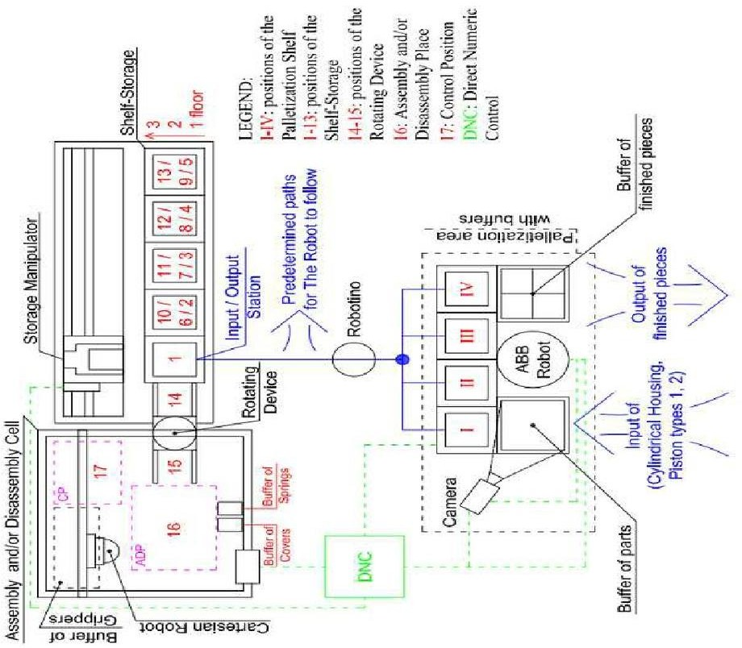

ALLOCATION OF MARKS

SNo | Descriptions |  | Max. Marks | Marks Awarded
1 | Drawing Component / Assembly / Layout / Circuit |  | 55
2 | Blocks, Layers, Annotations / Symbols |  | 25
3 | Printout |  | 10
4 | Viva voce |  | 10
TOTAL |  |  | 100
Internal Examiner |  | External Examiner

10 | Prepare a single line diagram of PLC panel wiring consists of the main breaker switch, bus bar, circuit breakers, relays, contactors, PLC, fuses, SMPS, terminal boards, utility sockets, and earthing points.  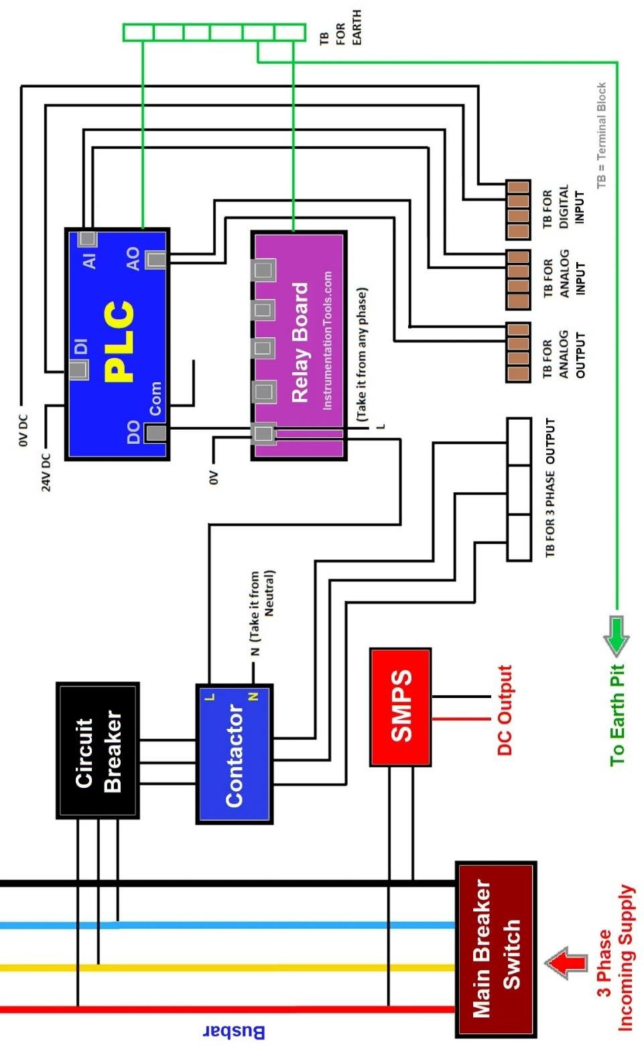

ALLOCATION OF MARKS

SNo | Descriptions |  | Max. Marks | Marks Awarded
1 | Drawing Component / Assembly / Layout / Circuit |  | 55
2 | Blocks, Layers, Annotations / Symbols |  | 25
3 | Printout |  | 10
4 | Viva voce |  | 10
TOTAL |  |  | 100
Internal Examiner |  | External Examiner

