1 | Make the following job sin the lathe. Raw material: M.S. Round Rod  Grooving and Taper Turning
  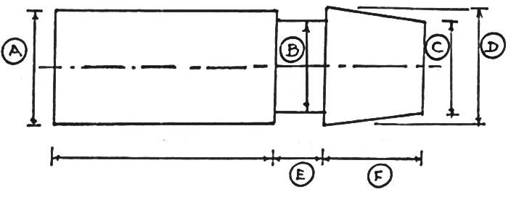 | 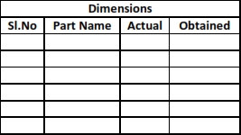

ALLOCATION OF MARKS

SNo | Descriptions |  | Max. Marks | Marks Awarded
1 | Aim & Tools required |  | 10
2 | Procedure |  | 20
3 | Preparation |  | 20
4 | Lathe/Milling/Grinding |  | 20
5 | Accuracy/Tool Handling/Finish/ Result |  | 20
6 | Viva Voce |  | 10
TOTAL |  |  | 100
Internal Examiner |  | External Examiner

2 | 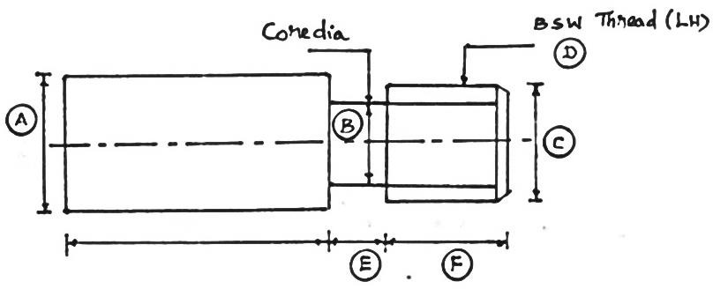LH Thread cutting

ALLOCATION OF MARKS

SNo | Descriptions |  | Max. Marks | Marks Awarded
1 | Aim & Tools required |  | 10
2 | Procedure |  | 20
3 | Preparation |  | 20
4 | Lathe/Milling/Grinding |  | 20
5 | Accuracy/Tool Handling/Finish/ Result |  | 20
6 | Viva Voce |  | 10
TOTAL |  |  | 100
Internal Examiner |  | External Examiner

3 | 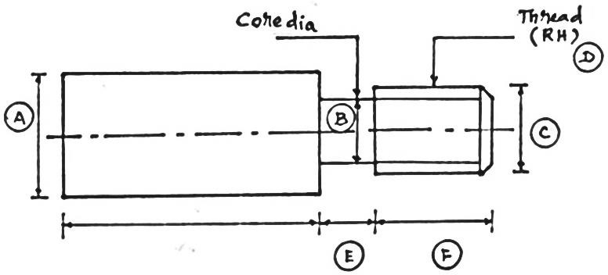  RH Thread cutting

ALLOCATION OF MARKS

SNo | Descriptions |  | Max. Marks | Marks Awarded
1 | Aim & Tools required |  | 10
2 | Procedure |  | 20
3 | Preparation |  | 20
4 | Lathe/Milling/Grinding |  | 20
5 | Accuracy/Tool Handling/Finish/ Result |  | 20
6 | Viva Voce |  | 10
TOTAL |  |  | 100
Internal Examiner |  | External Examiner

4 | Bush: Turning & Drilling  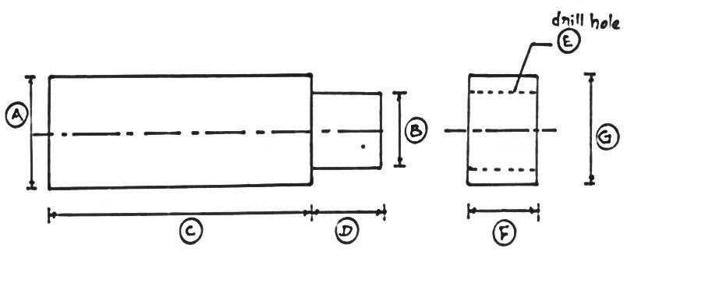

ALLOCATION OF MARKS

SNo | Descriptions |  | Max. Marks | Marks Awarded
1 | Aim & Tools required |  | 10
2 | Procedure |  | 20
3 | Preparation |  | 20
4 | Lathe/Milling/Grinding |  | 20
5 | Accuracy/Tool Handling/Finish/ Result |  | 20
6 | Viva Voce |  | 10
TOTAL |  |  | 100
Internal Examiner |  | External Examiner

5 | Eccentric Turning.  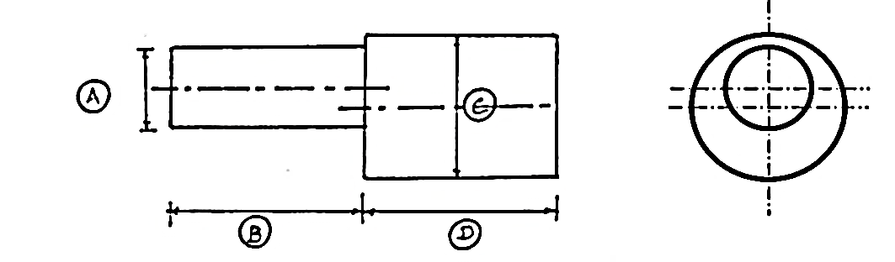

ALLOCATION OF MARKS

SNo | Descriptions |  | Max. Marks | Marks Awarded
1 | Aim & Tools required |  | 10
2 | Procedure |  | 20
3 | Preparation |  | 20
4 | Lathe/Milling/Grinding |  | 20
5 | Accuracy/Tool Handling/Finish/ Result |  | 20
6 | Viva Voce |  | 10
TOTAL |  |  | 100
Internal Examiner |  | External Examiner

6 | Make the following job sin the milling machine. Raw material: M.S. Round Rod  Make Spur Gear using milling machine by simple Indexing  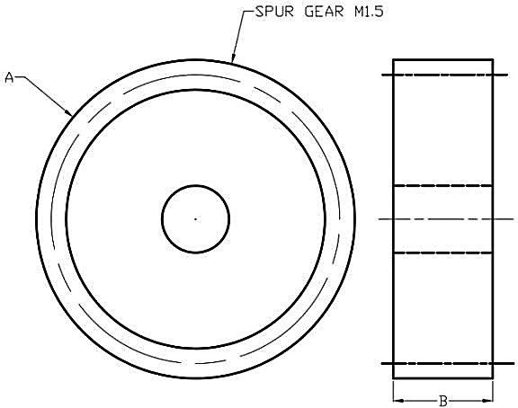

ALLOCATION OF MARKS

SNo | Descriptions |  | Max. Marks | Marks Awarded
1 | Aim & Tools required |  | 10
2 | Procedure |  | 20
3 | Preparation |  | 20
4 | Lathe/Milling/Grinding |  | 20
5 | Accuracy/Tool Handling/Finish/ Result |  | 20
6 | Viva Voce |  | 10
TOTAL |  |  | 100
Internal Examiner |  | External Examiner

7 | Make helical gear using milling machine  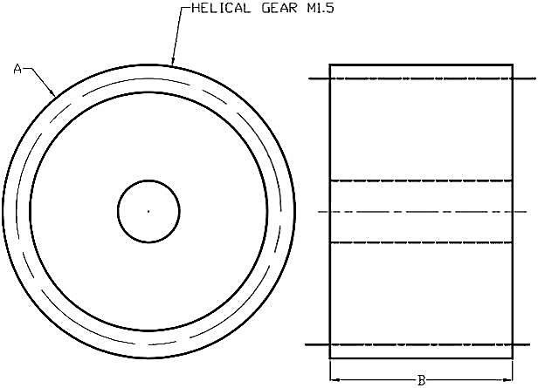

ALLOCATION OF MARKS

SNo | Descriptions |  | Max. Marks | Marks Awarded
1 | Aim & Tools required |  | 10
2 | Procedure |  | 20
3 | Preparation |  | 20
4 | Lathe/Milling/Grinding |  | 20
5 | Accuracy/Tool Handling/Finish/ Result |  | 20
6 | Viva Voce |  | 10
TOTAL |  |  | 100
Internal Examiner |  | External Examiner

8 | Grind a plain surface using surface Grinder  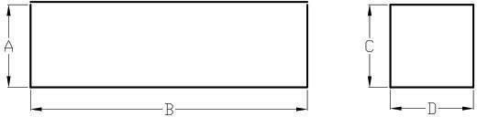

ALLOCATION OF MARKS

SNo | Descriptions |  | Max. Marks | Marks Awarded
1 | Aim & Tools required |  | 10
2 | Procedure |  | 20
3 | Preparation |  | 20
4 | Lathe/Milling/Grinding |  | 20
5 | Accuracy/Tool Handling/Finish/ Result |  | 20
6 | Viva Voce |  | 10
TOTAL |  |  | 100
Internal Examiner |  | External Examiner

9 | Make progressive type pluggauge using cylindrical grinding machine  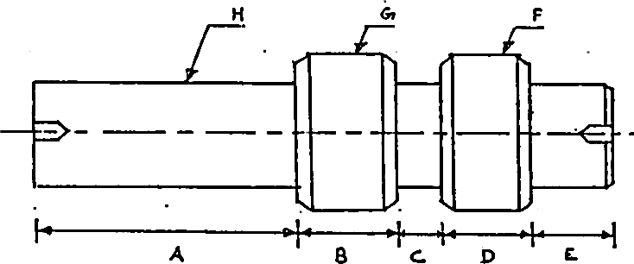

ALLOCATION OF MARKS

SNo | Descriptions |  | Max. Marks | Marks Awarded
1 | Aim & Tools required |  | 10
2 | Procedure |  | 20
3 | Preparation |  | 20
4 | Lathe/Milling/Grinding |  | 20
5 | Accuracy/Tool Handling/Finish/ Result |  | 20
6 | Viva Voce |  | 10
TOTAL |  |  | 100
Internal Examiner |  | External Examiner

10 | Make a turning tool/milling cutter using tool and cutter grinder  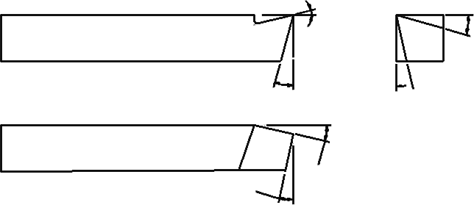

ALLOCATION OF MARKS

SNo | Descriptions |  | Max. Marks | Marks Awarded
1 | Aim & Tools required |  | 10
2 | Procedure |  | 20
3 | Preparation |  | 20
4 | Lathe/Milling/Grinding |  | 20
5 | Accuracy/Tool Handling/Finish/ Result |  | 20
6 | Viva Voce |  | 10
TOTAL |  |  | 100
Internal Examiner |  | External Examiner

