1 | - Arc welding(RawMaterial:25mmx6mmMS flat) Tee joint  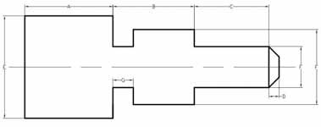  - Step turning and Grove Cutting

ALLOCATION OF MARKS

SNo | Descriptions |  | Max. Marks | Marks Awarded
PARTA–Welding
1 | Aim &Tools required |  | 05
2 | Preparation/Procedure |  | 15
3 | Welding/Cutting/Joining |  | 15
4 | Finish |  | 10
PARTB–Lathe
1 | Aim &Tools required |  | 05
2 | Preparation/Procedure |  | 15
3 | Machining |  | 15
4 | Finish |  | 10
5 | Viva Voice |  | 10
TOTAL |  |  | 100
Internal Examiner |  | External Examiner

2 | - Arc welding(RawMaterial:25mmx6mmMSflat) Open corner joint  - Step turning and Taper turning  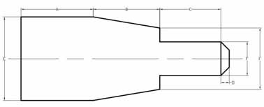

ALLOCATION OF MARKS

SNo | Descriptions |  | Max. Marks | Marks Awarded
PARTA–Welding
1 | Aim &Tools required |  | 05
2 | Preparation/Procedure |  | 15
3 | Welding/Cutting/Joining |  | 15
4 | Finish |  | 10
PARTB–Lathe
1 | Aim &Tools required |  | 05
2 | Preparation/Procedure |  | 15
3 | Machining |  | 15
4 | Finish |  | 10
5 | Viva Voice |  | 10
TOTAL |  |  | 100
Internal Examiner |  | External Examiner

3 | - TIG/ MIG Welding(RawMaterial:25mmx10mmMSflat) Butt Joint  - Step turning and Knurling  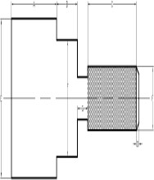

ALLOCATION OF MARKS

SNo | Descriptions |  | Max. Marks | Marks Awarded
PARTA–Welding
1 | Aim &Tools required |  | 05
2 | Preparation/Procedure |  | 15
3 | Welding/Cutting/Joining |  | 15
4 | Finish |  | 10
PARTB–Lathe
1 | Aim &Tools required |  | 05
2 | Preparation/Procedure |  | 15
3 | Machining |  | 15
4 | Finish |  | 10
5 | Viva Voice |  | 10
TOTAL |  |  | 100
Internal Examiner |  | External Examiner

4 | - Gas Welding (RawMaterial:16GMS sheet) Lap joint  - LH/RH Thread cutting  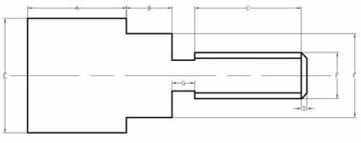

ALLOCATION OF MARKS

SNo | Descriptions |  | Max. Marks | Marks Awarded
PARTA–Welding
1 | Aim &Tools required |  | 05
2 | Preparation/Procedure |  | 15
3 | Welding/Cutting/Joining |  | 15
4 | Finish |  | 10
PARTB–Lathe
1 | Aim &Tools required |  | 05
2 | Preparation/Procedure |  | 15
3 | Machining |  | 15
4 | Finish |  | 10
5 | Viva Voice |  | 10
TOTAL |  |  | 100
Internal Examiner |  | External Examiner

5 | - Gas cutting: (100x100mmx6mm M.S.Flat) Profile cutting–circular profile  - Bush: Turning and Drilling  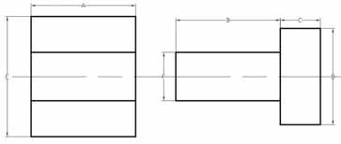

ALLOCATION OF MARKS

SNo | Descriptions |  | Max. Marks | Marks Awarded
PARTA–Welding
1 | Aim &Tools required |  | 05
2 | Preparation/Procedure |  | 15
3 | Welding/Cutting/Joining |  | 15
4 | Finish |  | 10
PARTB–Lathe
1 | Aim &Tools required |  | 05
2 | Preparation/Procedure |  | 15
3 | Machining |  | 15
4 | Finish |  | 10
5 | Viva Voice |  | 10
TOTAL |  |  | 100
Internal Examiner |  | External Examiner

6 | - Spot welding:(GI/MSSheet22G) Lap joint  - Eccentric turning  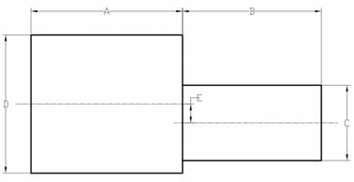

ALLOCATION OF MARKS

SNo | Descriptions |  | Max. Marks | Marks Awarded
PARTA–Welding
1 | Aim &Tools required |  | 05
2 | Preparation/Procedure |  | 15
3 | Welding/Cutting/Joining |  | 15
4 | Finish |  | 10
PARTB–Lathe
1 | Aim &Tools required |  | 05
2 | Preparation/Procedure |  | 15
3 | Machining |  | 15
4 | Finish |  | 10
5 | Viva Voice |  | 10
TOTAL |  |  | 100
Internal Examiner |  | External Examiner

