1
  PART A sleeve and Cotter Joint
  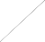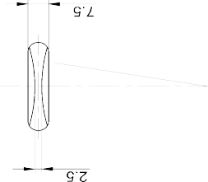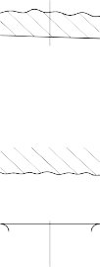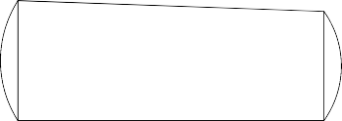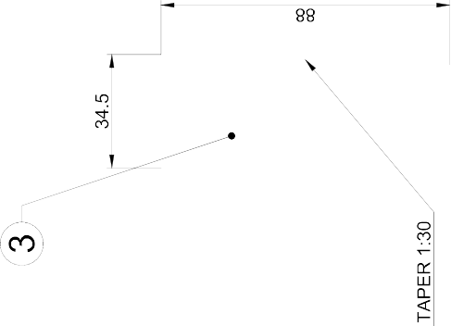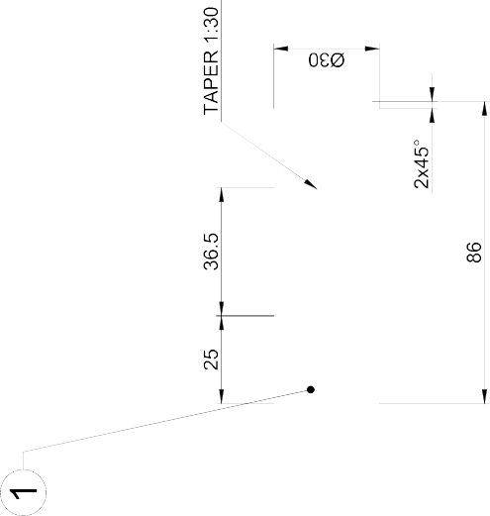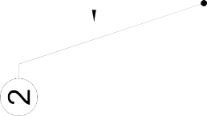
  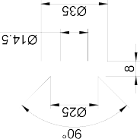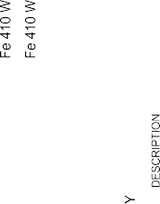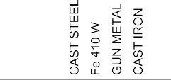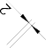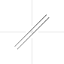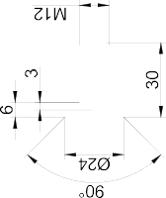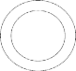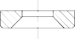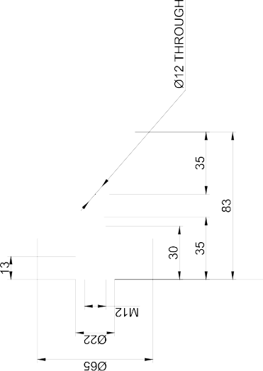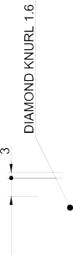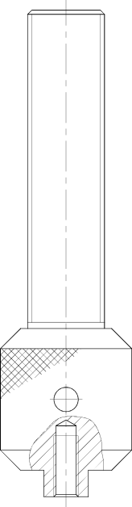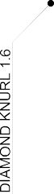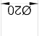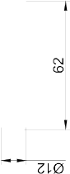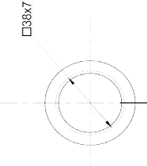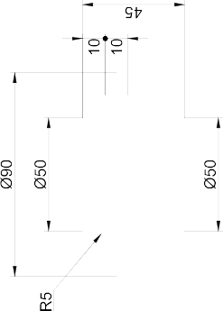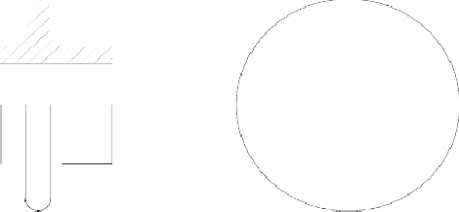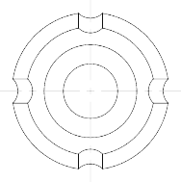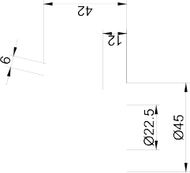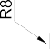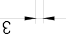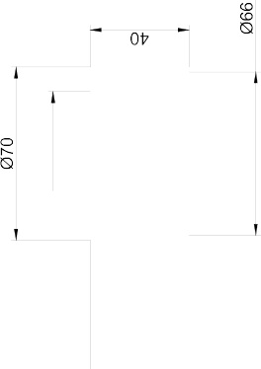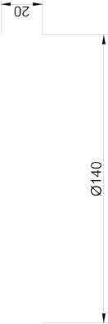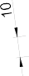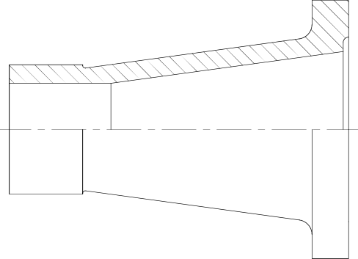PART B. Screw jack

ALLOCATION OF MARKS
SNo | Descriptions |  | Max. Marks | Marks Awarded
1 | Drafting (Part A & Part B) |  | 40
2 | Assembly(Part A & Part B) |  | 30
3 | Dimensioning (Part A & Part B) |  | 10
4 | Print Out |  | 10
5 | Viva Voice |  | 10
TOTAL |  |  | 100
Internal Examiner |  | External Examiner

2 | PART A Plummer Block  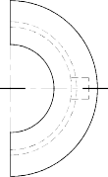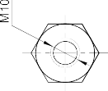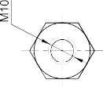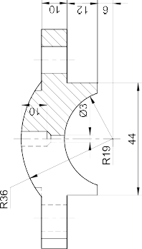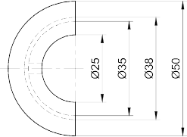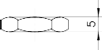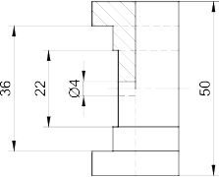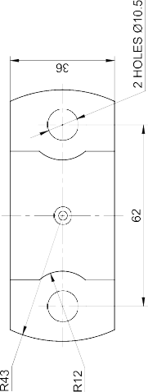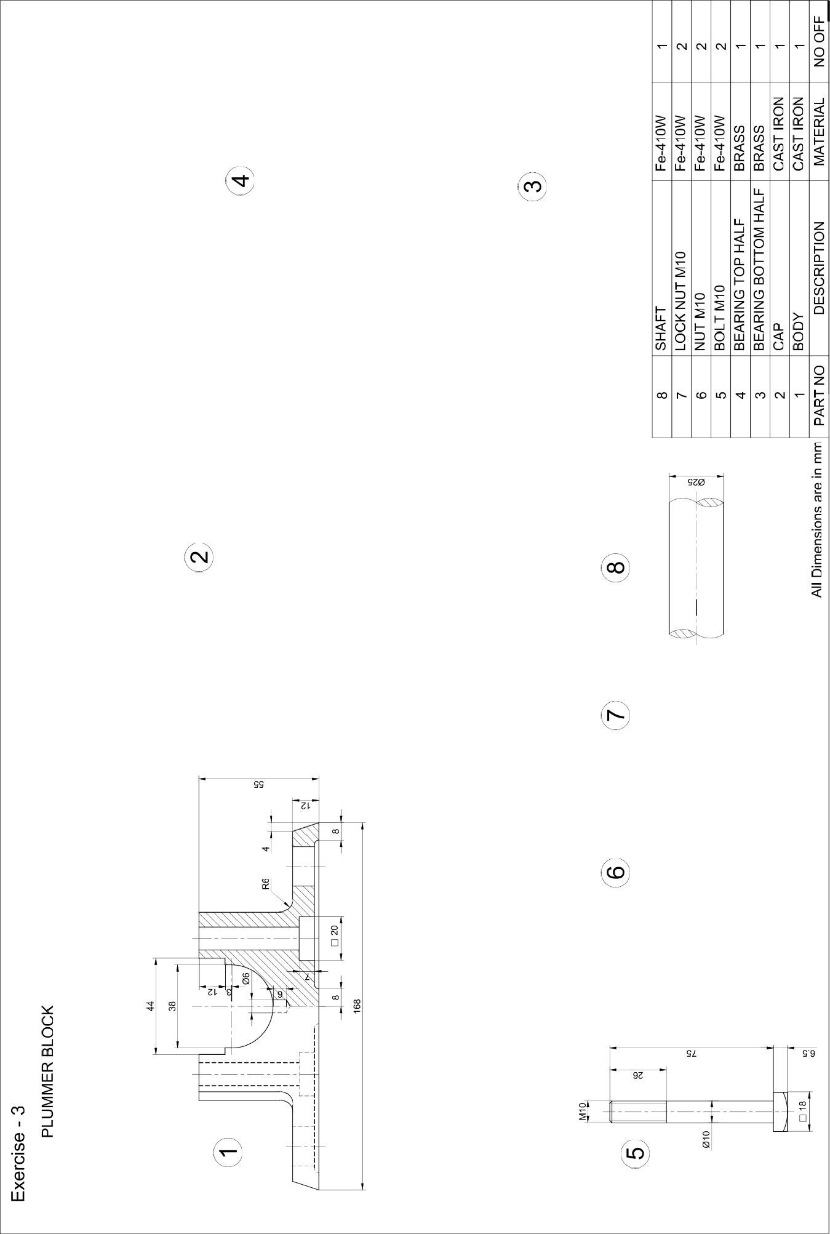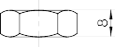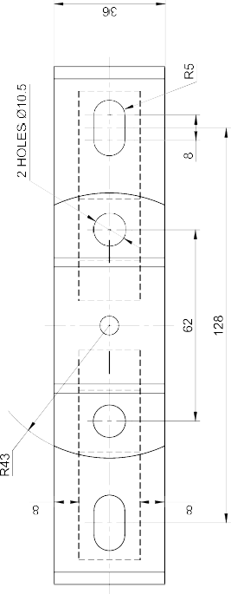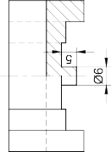  PART B Simple Eccentric  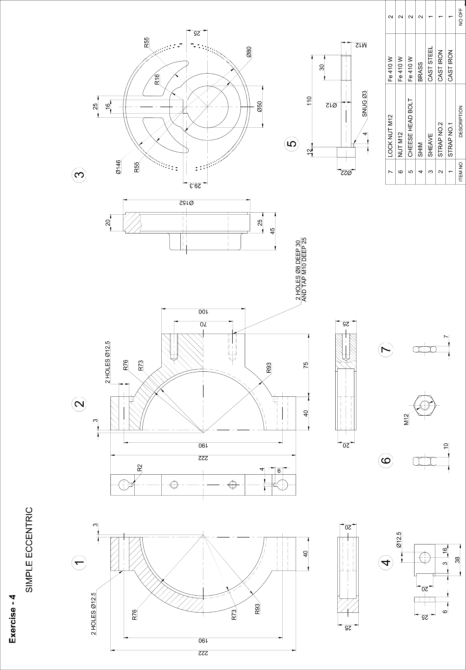

ALLOCATION OF MARKS

S No |  | Descriptions |  | Max. Marks | Marks Awarded
1 |  | Drafting (Part A & Part B) |  | 40
2 |  | Assembly(Part A & Part B) |  | 30
3 |  | Dimensioning (Part A & Part B) |  | 10
4 |  | Print Out |  | 10
5 |  | Viva Voice |  | 10
TOTAL |  |  |  | 100
Internal Examiner |  |  | External Examiner
3 | PART A. Flange Coupling  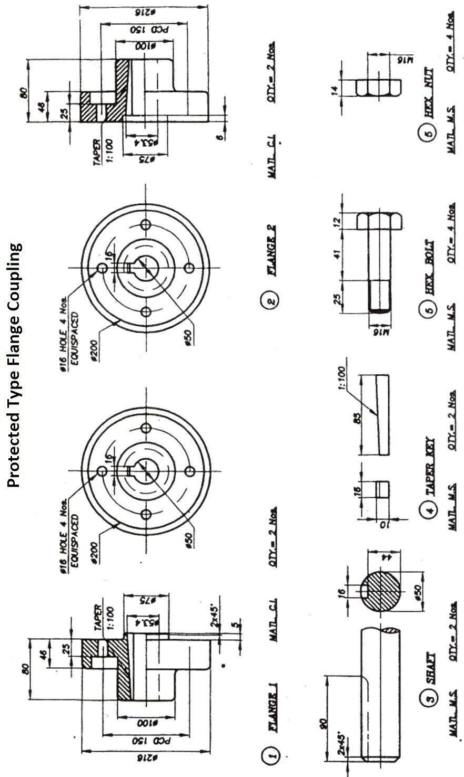  PART B. Machine Vice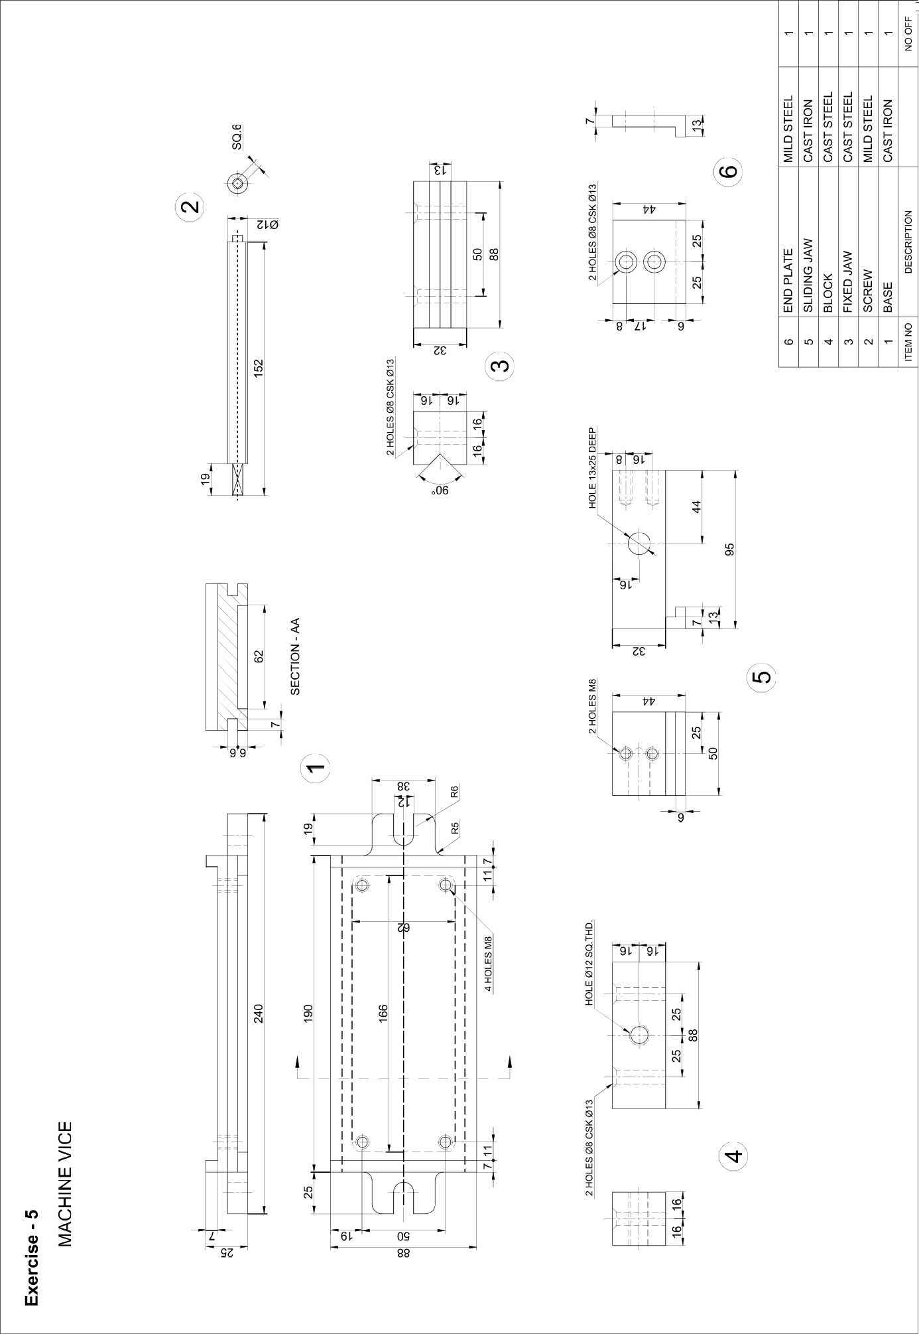

ALLOCATION OF MARKS

S No | Descriptions |  | Max. Marks | Marks Awarded
1 | Drafting (Part A & Part B) |  | 40
2 | Assembly(Part A & Part B) |  | 30
3 | Dimensioning (Part A & Part B) |  | 10
4 | Print Out |  | 10
5 | Viva Voice |  | 10
TOTAL |  |  | 100
Internal Examiner |  | External Examiner

4 | PART A. Bushed Bearing  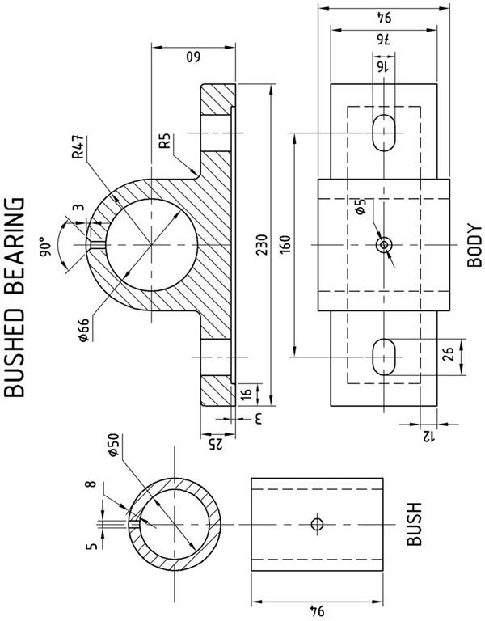  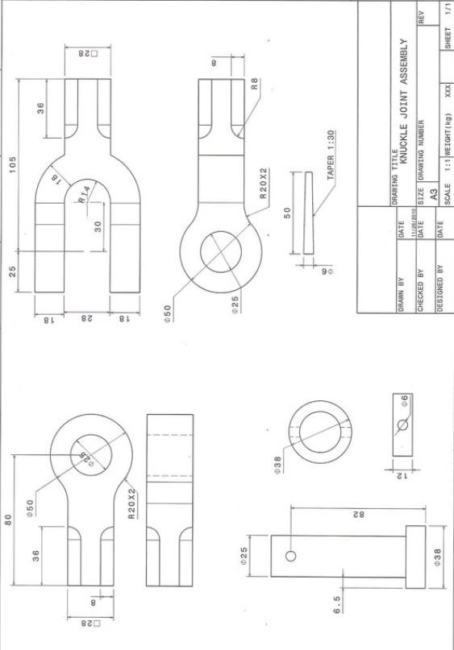PART B. Knuckle Joint

ALLOCATION OF MARKS

S No | Descriptions |  | Max. Marks | Marks Awarded
1 | Drafting (Part A & Part B) |  | 40
2 | Assembly(Part A & Part B) |  | 30
3 | Dimensioning (Part A & Part B) |  | 10
4 | Print Out |  | 10
5 | Viva Voice |  | 10
TOTAL |  |  | 100
Internal Examiner |  | External Examiner

5 | PART A. Flange Coupling  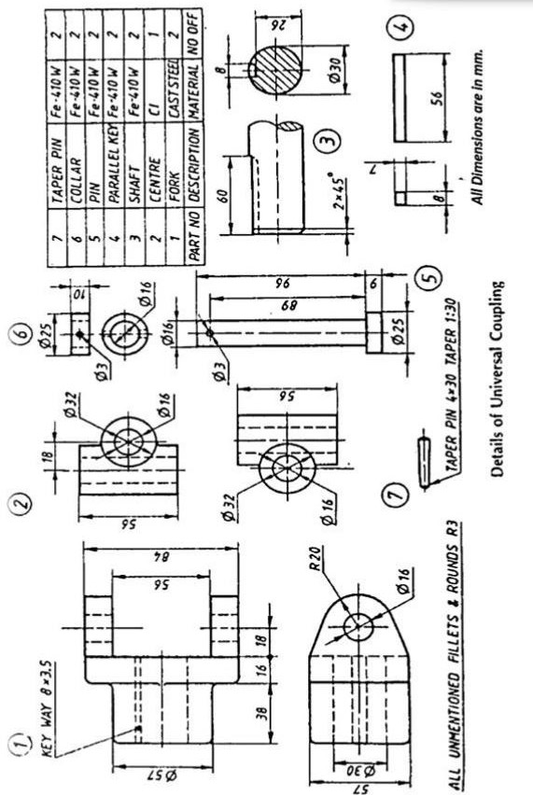  PART B. Universal Coupling

ALLOCATION OF MARKS

S No | Descriptions |  | Max. Marks | Marks Awarded
1 | Drafting (Part A & Part B) |  | 40
2 | Assembly(Part A & Part B) |  | 30
3 | Dimensioning (Part A & Part B) |  | 10
4 | Print Out |  | 10
5 | Viva Voice |  | 10
TOTAL |  |  | 100
Internal Examiner |  | External Examiner

