1 | Assemble the Gib and Cotter joint using any 3D modelling software.  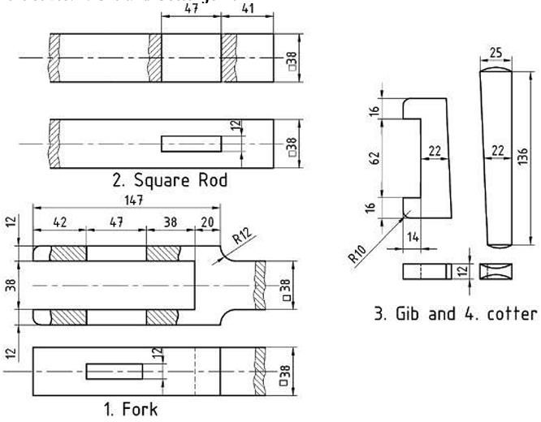

ALLOCATION OF MARKS

SNo | Descriptions |  | Max. Marks | Marks Awarded
1 | Aim & Commands Used |  | 10
2 | Modelling |  | 35
3 | Assembly/3D Printing |  | 35
4 | Printout/Finish |  | 10
5 | Viva Voce |  | 10
TOTAL |  |  | 100
Internal Examiner |  | External Examiner

2 | Assemble the Screw Jack using any 3D modelling software.  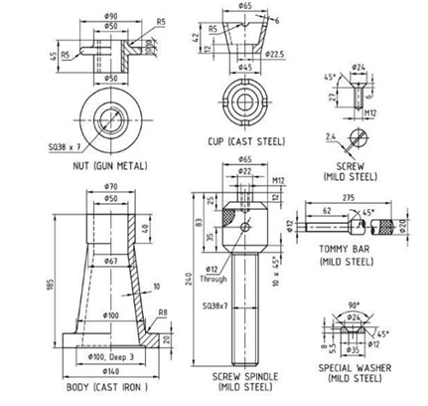

ALLOCATION OF MARKS

SNo |  | Descriptions |  | Max. Marks | Marks Awarded
1 |  | Aim & Commands Used |  | 10
2 |  | Modelling |  | 35
3 |  | Assembly/3D Printing |  | 35
4 |  | Printout/Finish |  | 10
5 |  | Viva Voce |  | 10
TOTAL |  |  |  | 100
Internal Examiner |  |  | External Examiner
3 | Assemble the revolving centre using any 3D Modelling software  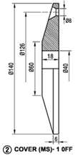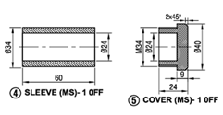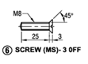  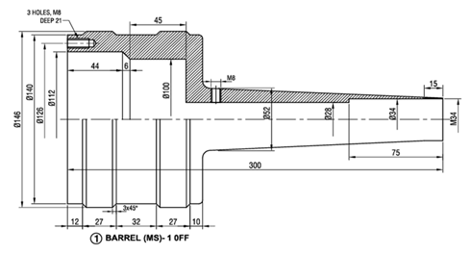  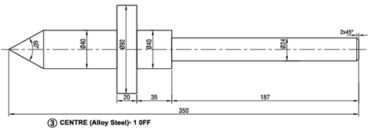

ALLOCATION OF MARKS

SNo | Descriptions |  | Max. Marks | Marks Awarded
1 | Aim & Commands Used |  | 10
2 | Modelling |  | 35
3 | Assembly/3D Printing |  | 35
4 | Printout/Finish |  | 10
5 | Viva Voce |  | 10
TOTAL |  |  | 100
Internal Examiner |  | External Examiner

4 | Assemble the universal coupling using any 3D Modelling software  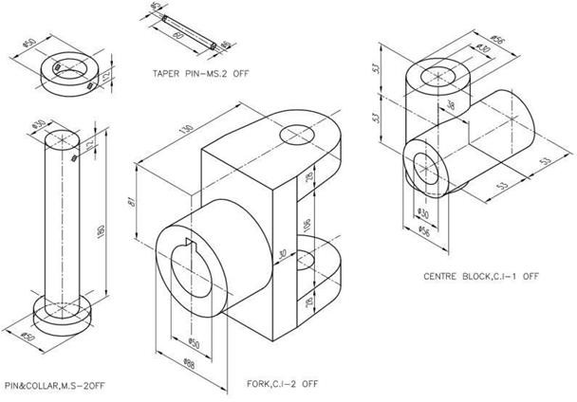

ALLOCATION OF MARKS

SNo | Descriptions |  | Max. Marks | Marks Awarded
1 | Aim & Commands Used |  | 10
2 | Modelling |  | 35
3 | Assembly/3D Printing |  | 35
4 | Printout/Finish |  | 10
5 | Viva Voce |  | 10
TOTAL |  |  | 100
Internal Examiner |  | External Examiner

5 | Assemble the Plummer block using any 3D Modelling software  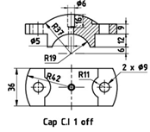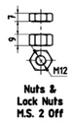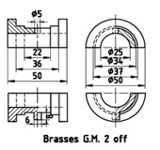  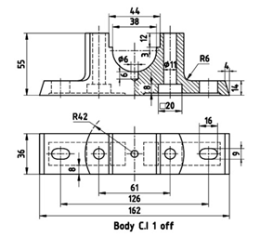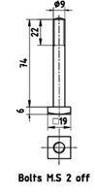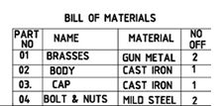

ALLOCATION OF MARKS

SNo | Descriptions |  | Max. Marks | Marks Awarded
1 | Aim & Commands Used |  | 10
2 | Modelling |  | 35
3 | Assembly/3D Printing |  | 35
4 | Printout/Finish |  | 10
5 | Viva Voce |  | 10
TOTAL |  |  | 100
Internal Examiner |  | External Examiner

6 | Assemble the machine vice using any 3D Modelling software  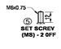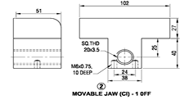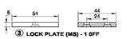  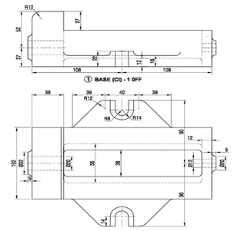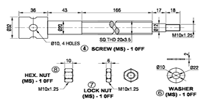

ALLOCATION OF MARKS

SNo | Descriptions |  | Max. Marks | Marks Awarded
1 | Aim & Commands Used |  | 10
2 | Modelling |  | 35
3 | Assembly/3D Printing |  | 35
4 | Printout/Finish |  | 10
5 | Viva Voce |  | 10
TOTAL |  |  | 100
Internal Examiner |  | External Examiner

