1 | Write a part program and produce a step turning component with the given dimensions in CNC LATHE machine  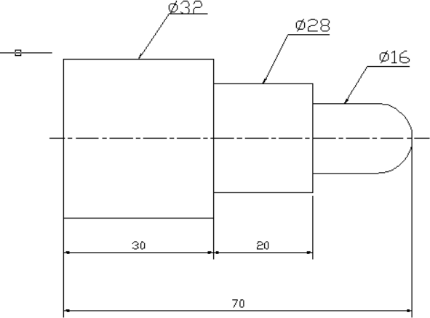

ALLOCATION OF MARKS

SNo | Descriptions |  | Max. Marks | Marks Awarded
1 | Aim & Apparatus Required |  | 10
2 | Program writing |  | 20
3 | Setting / Editing and Machining |  | 20
4 | Output / Result |  | 10
5 | Written Test (MCQ question) |  | 30
6 | Viva Voce |  | 10
TOTAL |  |  | 100
Internal Examiner |  | External Examiner

2 | Write a part program and produce a component using Forming & Grooving operations with the given dimensions in CNC LATHE machine  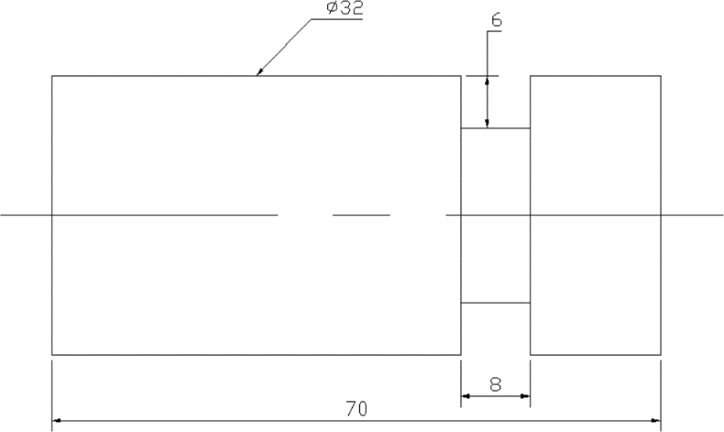

ALLOCATION OF MARKS

SNo | Descriptions |  | Max. Marks | Marks Awarded
1 | Aim & Apparatus Required |  | 10
2 | Program writing |  | 20
3 | Setting / Editing and Machining |  | 20
4 | Output / Result |  | 10
5 | Written Test (MCQ question) |  | 30
6 | Viva Voce |  | 10
TOTAL |  |  | 100
Internal Examiner |  | External Examiner

3 | Write a part program and produce a Taper Turning component with the given dimensions in CNCLATHE machine.  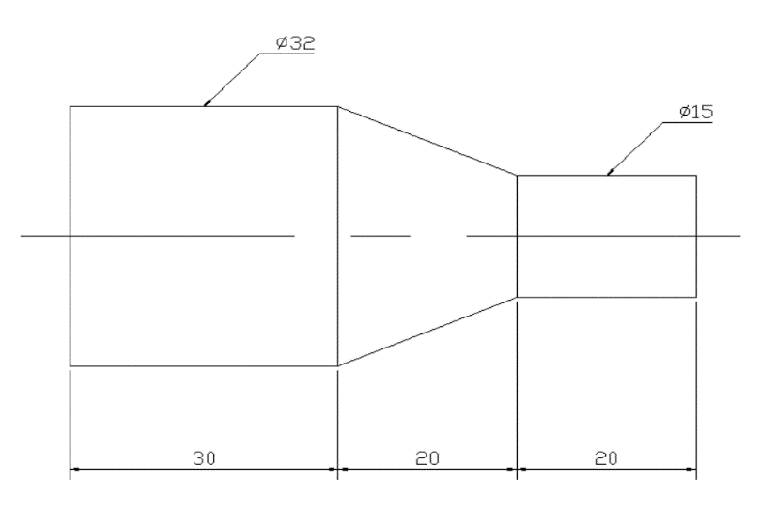

ALLOCATION OF MARKS

SNo | Descriptions |  | Max. Marks | Marks Awarded
1 | Aim & Apparatus Required |  | 10
2 | Program writing |  | 20
3 | Setting / Editing and Machining |  | 20
4 | Output / Result |  | 10
5 | Written Test (MCQ question) |  | 30
6 | Viva Voce |  | 10
TOTAL |  |  | 100
Internal Examiner |  | External Examiner

4 | Write and produce a component with the given dimensions using interpolation  Method  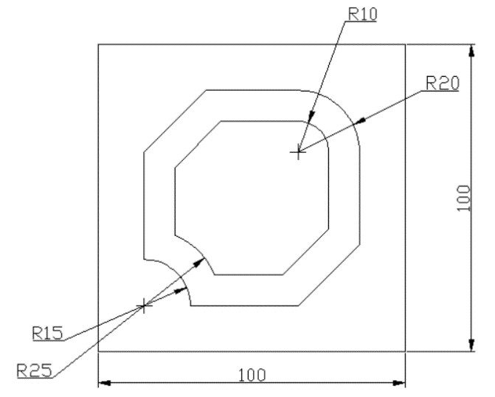

ALLOCATION OF MARKS

SNo | Descriptions |  | Max. Marks | Marks Awarded
1 | Aim & Apparatus Required |  | 10
2 | Program writing |  | 20
3 | Setting / Editing and Machining |  | 20
4 | Output / Result |  | 10
5 | Written Test (MCQ question) |  | 30
6 | Viva Voce |  | 10
TOTAL |  |  | 100
Internal Examiner |  | External Examiner

5 | Write and produce a component with the given dimensions using Mirroring method  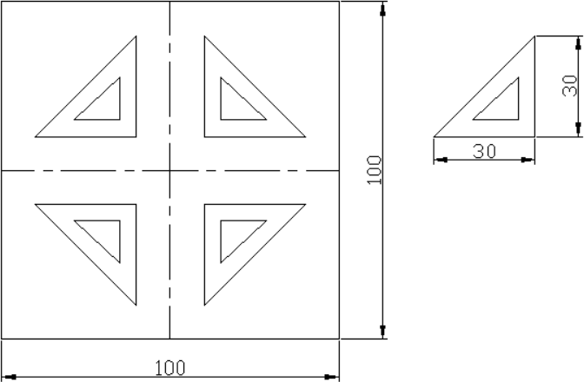

ALLOCATION OF MARKS

SNo | Descriptions |  | Max. Marks | Marks Awarded
1 | Aim & Apparatus Required |  | 10
2 | Program writing |  | 20
3 | Setting / Editing and Machining |  | 20
4 | Output / Result |  | 10
5 | Written Test (MCQ question) |  | 30
6 | Viva Voce |  | 10
TOTAL |  |  | 100
Internal Examiner |  | External Examiner

6 | Write and produce a component with the given dimensions using Drilling  operation.  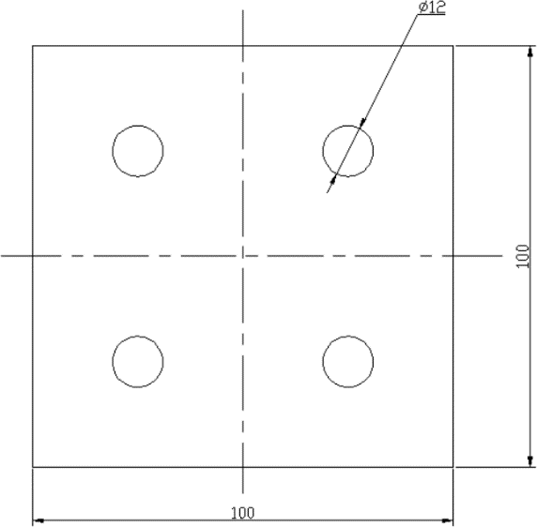

ALLOCATION OF MARKS

SNo | Descriptions |  | Max. Marks | Marks Awarded
1 | Aim & Apparatus Required |  | 10
2 | Program writing |  | 20
3 | Setting / Editing and Machining |  | 20
4 | Output / Result |  | 10
5 | Written Test (MCQ question) |  | 30
6 | Viva Voce |  | 10
TOTAL |  |  | 100
Internal Examiner |  | External Examiner

7 | Using Stock removal cycle–Create a part program for multiple turning operations and produce component in the Machine  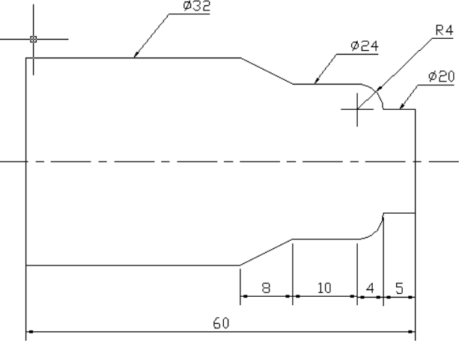

ALLOCATION OF MARKS

SNo | Descriptions |  | Max. Marks | Marks Awarded
1 | Aim & Apparatus Required |  | 10
2 | Program writing |  | 20
3 | Setting / Editing and Machining |  | 20
4 | Output / Result |  | 10
5 | Written Test (MCQ question) |  | 30
6 | Viva Voce |  | 10
TOTAL |  |  | 100
Internal Examiner |  | External Examiner

8 | Using canned cycle - Create a part program for thread cutting, grooving and produce component in the Machine  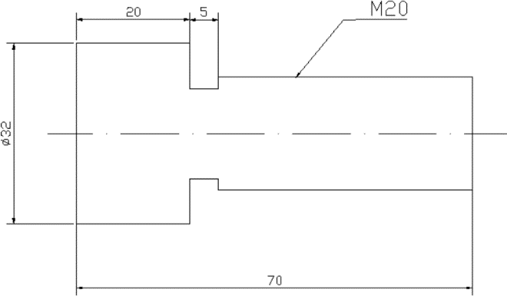

ALLOCATION OF MARKS

SNo | Descriptions |  | Max. Marks | Marks Awarded
1 | Aim & Apparatus Required |  | 10
2 | Program writing |  | 20
3 | Setting / Editing and Machining |  | 20
4 | Output / Result |  | 10
5 | Written Test (MCQ question) |  | 30
6 | Viva Voce |  | 10
TOTAL |  |  | 100
Internal Examiner |  | External Examiner

9 | Using canned cycle-Create a part program for drilling, tapping, counter sinking and produce component in the Machine  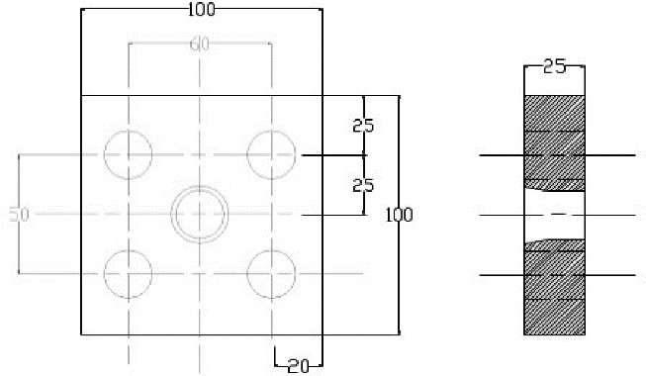

ALLOCATION OF MARKS

SNo | Descriptions |  | Max. Marks | Marks Awarded
1 | Aim & Apparatus Required |  | 10
2 | Program writing |  | 20
3 | Setting / Editing and Machining |  | 20
4 | Output / Result |  | 10
5 | Written Test (MCQ question) |  | 30
6 | Viva Voce |  | 10
TOTAL |  |  | 100
Internal Examiner |  | External Examiner

10 | Using subprogram-Create a part program and produce component in the  Machine  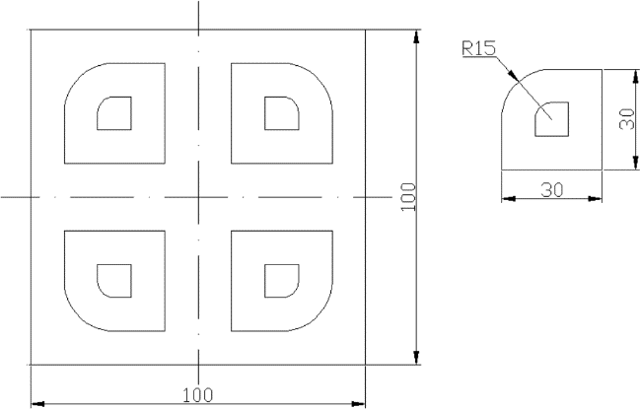

ALLOCATION OF MARKS

SNo | Descriptions |  | Max. Marks | Marks Awarded
1 | Aim & Apparatus Required |  | 10
2 | Program writing |  | 20
3 | Setting / Editing and Machining |  | 20
4 | Output / Result |  | 10
5 | Written Test (MCQ question) |  | 30
6 | Viva Voce |  | 10
TOTAL |  |  | 100
Internal Examiner |  | External Examiner

