1 | Prepare the green sand Moulding using Solid Pattern – STEPPED PULLEY

ALLOCATION OF MARKS

SNo | Descriptions |  | Max. Marks | Marks Awarded
1 | Aim & Apparatus Required |  | 5
2 | Circuit Diagram |  | 20
3 | Connections and Execution |  | 25
4 | Output / Result |  | 10
5 | Written Test (Theory Portions) |  | 30
6 | Viva Voce |  | 10
TOTAL |  |  | 100
Internal Examiner |  | External Examiner

2. | Prepare the greensand Moulding using Split Pattern–BENTPIPE WITH COREPRINT

ALLOCATION OF MARKS

SNo | Descriptions |  | Max. Marks | Marks Awarded
1 | Aim & Apparatus Required |  | 5
2 | Circuit Diagram |  | 20
3 | Connections and Execution |  | 25
4 | Output / Result |  | 10
5 | Written Test (Theory Portions) |  | 30
6 | Viva Voce |  | 10
TOTAL |  |  | 100
Internal Examiner |  | External Examiner

3. | Prepare the greensand Moulding using Loose piece Pattern–DOVETAIL

ALLOCATION OF MARKS

SNo | Descriptions |  | Max. Marks | Marks Awarded
1 | Aim & Apparatus Required |  | 5
2 | Circuit Diagram |  | 20
3 | Connections and Execution |  | 25
4 | Output / Result |  | 10
5 | Written Test (Theory Portions) |  | 30
6 | Viva Voce |  | 10
TOTAL |  |  | 100
Internal Examiner |  | External Examiner

4. | Prepare the specimen and make the Lap Joint by Arc Welding (Both side welded)

ALLOCATION OF MARKS

SNo | Descriptions |  | Max. Marks | Marks Awarded
1 | Aim & Apparatus Required |  | 5
2 | Circuit Diagram |  | 20
3 | Connections and Execution |  | 25
4 | Output / Result |  | 10
5 | Written Test (Theory Portions) |  | 30
6 | Viva Voce |  | 10
TOTAL |  |  | 100
Internal Examiner |  | External Examiner

5. | Prepare the specimen and make the T Joint by Gas Welding

ALLOCATION OF MARKS

SNo | Descriptions |  | Max. Marks | Marks Awarded
1 | Aim & Apparatus Required |  | 5
2 | Circuit Diagram |  | 20
3 | Connections and Execution |  | 25
4 | Output / Result |  | 10
5 | Written Test (Theory Portions) |  | 30
6 | Viva Voce |  | 10
TOTAL |  |  | 100
Internal Examiner |  | External Examiner

6. | Prepare the specimen and make the Joint by Spot Welding

ALLOCATION OF MARKS

SNo | Descriptions |  | Max. Marks | Marks Awarded
1 | Aim & Apparatus Required |  | 5
2 | Circuit Diagram |  | 20
3 | Connections and Execution |  | 25
4 | Output / Result |  | 10
5 | Written Test (Theory Portions) |  | 30
6 | Viva Voce |  | 10
TOTAL |  |  | 100
Internal Examiner |  | External Examiner

7. | Prepare the specimen and make the Stepturning, Facing &Chamfering as shown in figure using Lathe.  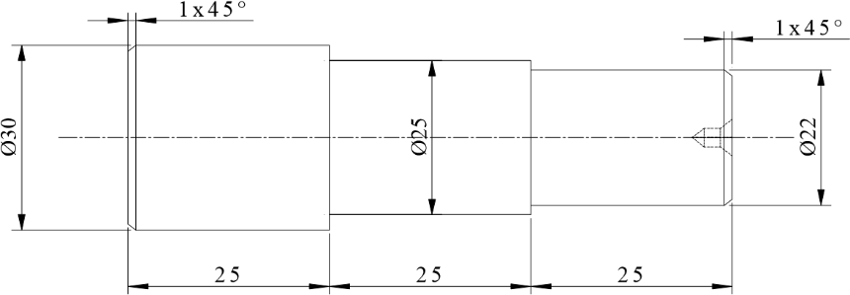

ALLOCATION OF MARKS

SNo | Descriptions |  | Max. Marks | Marks Awarded
1 | Aim & Apparatus Required |  | 5
2 | Circuit Diagram |  | 20
3 | Connections and Execution |  | 25
4 | Output / Result |  | 10
5 | Written Test (Theory Portions) |  | 30
6 | Viva Voce |  | 10
TOTAL |  |  | 100
Internal Examiner |  | External Examiner

8. | Prepare the specimen and make the Groove cutting &Taper turning as shown in figure using Lathe.  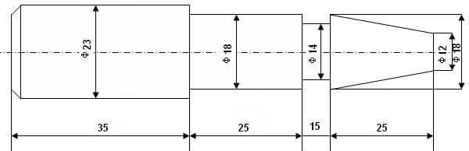

ALLOCATION OF MARKS

SNo | Descriptions |  | Max. Marks | Marks Awarded
1 | Aim & Apparatus Required |  | 5
2 | Circuit Diagram |  | 20
3 | Connections and Execution |  | 25
4 | Output / Result |  | 10
5 | Written Test (Theory Portions) |  | 30
6 | Viva Voce |  | 10
TOTAL |  |  | 100
Internal Examiner |  | External Examiner

9. | 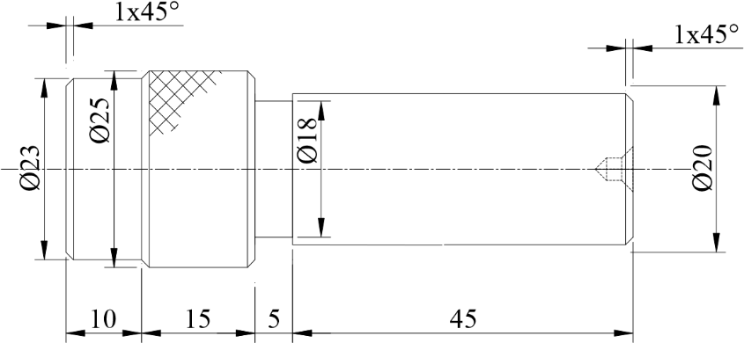  Prepare the specimen and make the Step turning, Knurling as shown in figure using Lathe.

ALLOCATION OF MARKS

SNo | Descriptions |  | Max. Marks | Marks Awarded
1 | Aim & Apparatus Required |  | 5
2 | Circuit Diagram |  | 20
3 | Connections and Execution |  | 25
4 | Output / Result |  | 10
5 | Written Test (Theory Portions) |  | 30
6 | Viva Voce |  | 10
TOTAL |  |  | 100
Internal Examiner |  | External Examiner

10. | Prepare the specimen and make the Drilling & Tapping as shown in figure using Drilling Machine.  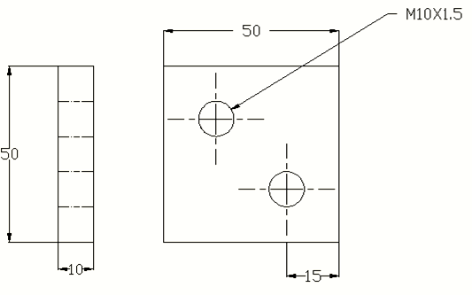

ALLOCATION OF MARKS

SNo | Descriptions |  | Max. Marks | Marks Awarded
1 | Aim & Apparatus Required |  | 5
2 | Circuit Diagram |  | 20
3 | Connections and Execution |  | 25
4 | Output / Result |  | 10
5 | Written Test (Theory Portions) |  | 30
6 | Viva Voce |  | 10
TOTAL |  |  | 100
Internal Examiner |  | External Examiner

