1. | Sleeve & Cotter joint  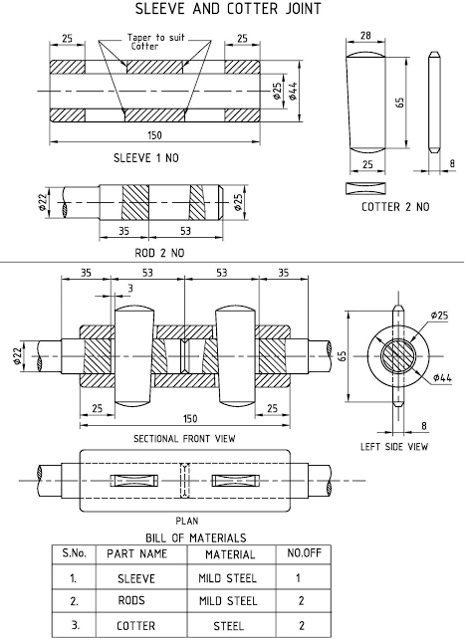

ALLOCATION OF MARKS

SNo |  | Descriptions |  | Max. Marks | Marks Awarded
1 |  | Aim & Command Required |  | 10
2 |  | Modeling (2 Views Only) |  | 60
3 |  | Bill of Material & Dimensioning |  | 20
4 |  | Viva Voce |  | 10
TOTAL |  |  |  | 100
Internal Examiner |  |  | External Examiner
2. | Screw Jack  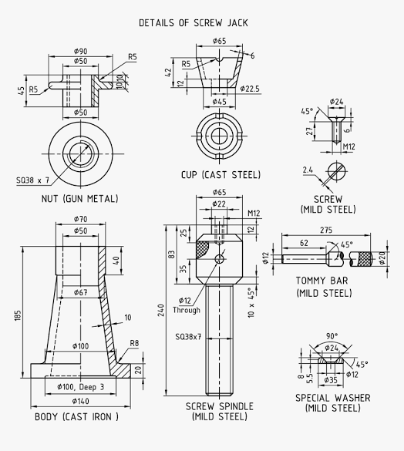  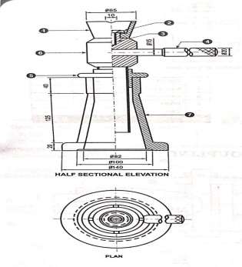

ALLOCATION OF MARKS

SNo | Descriptions |  | Max. Marks | Marks Awarded
1 | Aim & Command Required |  | 10
2 | Modeling (2 Views Only) |  | 60
3 | Bill of Material & Dimensioning |  | 20
4 | Viva Voce |  | 10
TOTAL |  |  | 100
Internal Examiner |  | External Examiner

3. | Foot step bearing  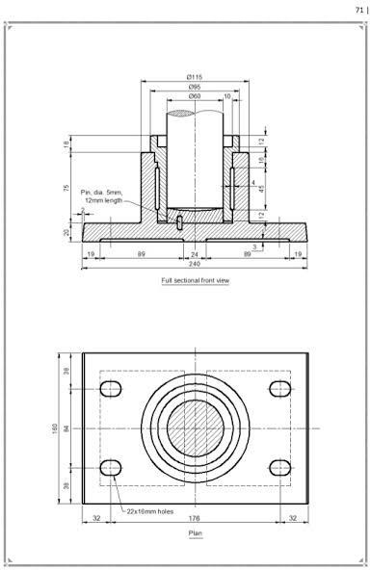  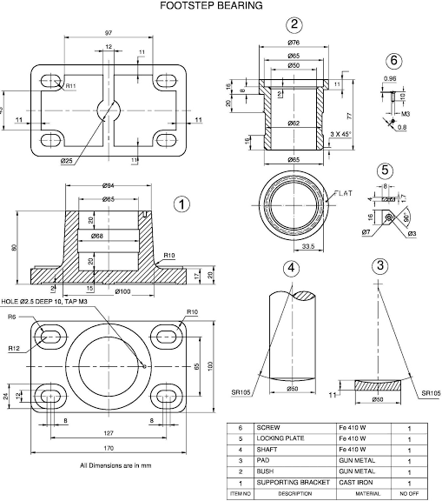

ALLOCATION OF MARKS

SNo | Descriptions |  | Max. Marks | Marks Awarded
1 | Aim & Command Required |  | 10
2 | Modeling (2 Views Only) |  | 60
3 | Bill of Material & Dimensioning |  | 20
4 | Viva Voce |  | 10
TOTAL |  |  | 100
Internal Examiner |  | External Examiner

4. | 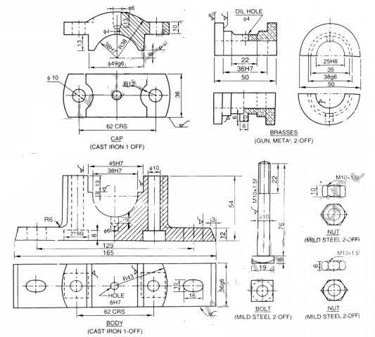  Plummer Block  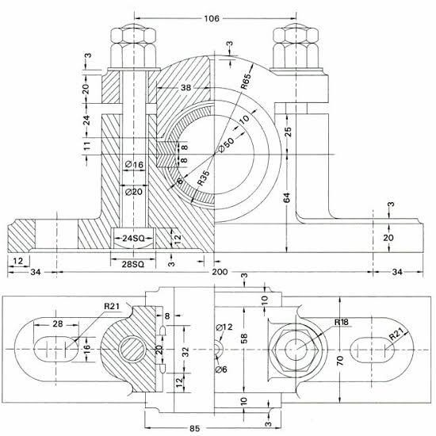

ALLOCATION OF MARKS

SNo | Descriptions |  | Max. Marks | Marks Awarded
1 | Aim & Command Required |  | 10
2 | Modeling (2 Views Only) |  | 60
3 | Bill of Material & Dimensioning |  | 20
4 | Viva Voce |  | 10
TOTAL |  |  | 100
Internal Examiner |  | External Examiner

5. | 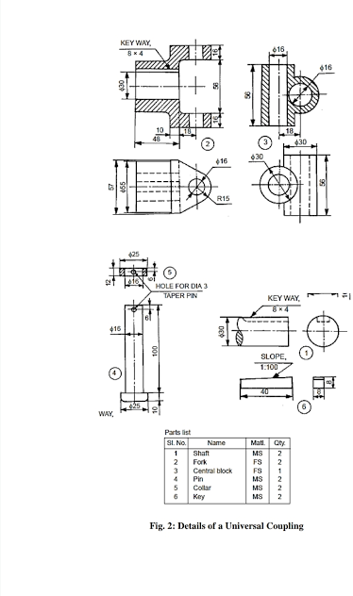  Universal Coupling  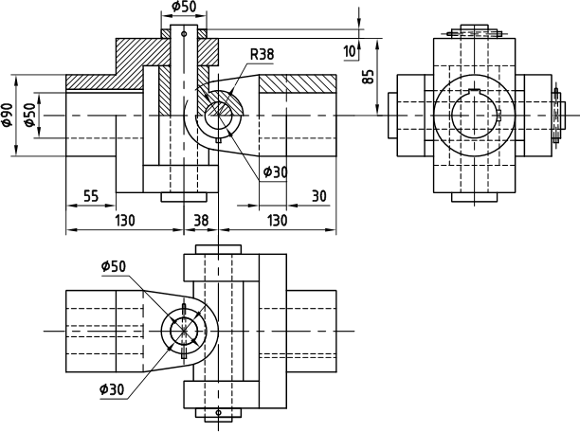

ALLOCATION OF MARKS

SNo | Descriptions |  | Max. Marks | Marks Awarded
1 | Aim & Command Required |  | 10
2 | Modeling (2 Views Only) |  | 60
3 | Bill of Material & Dimensioning |  | 20
4 | Viva Voce |  | 10
TOTAL |  |  | 100
Internal Examiner |  | External Examiner

6. | 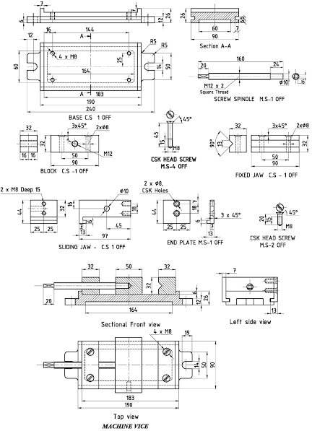  Machine Vice  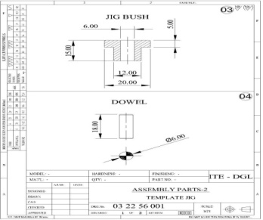  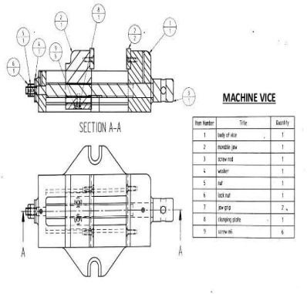

ALLOCATION OF MARKS

SNo | Descriptions |  | Max. Marks | Marks Awarded
1 | Aim & Command Required |  | 10
2 | Modeling (2 Views Only) |  | 60
3 | Bill of Material & Dimensioning |  | 20
4 | Viva Voce |  | 10
TOTAL |  |  | 100
Internal Examiner |  | External Examiner

7. | 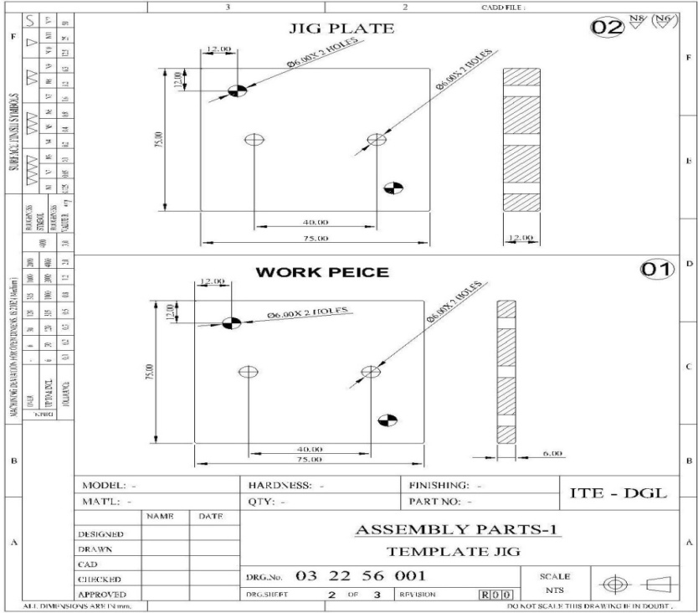  Template Drill jig

ALLOCATION OF MARKS

SNo | Descriptions |  | Max. Marks | Marks Awarded
1 | Aim & Command Required |  | 10
2 | Modeling (2 Views Only) |  | 60
3 | Bill of Material & Dimensioning |  | 20
4 | Viva Voce |  | 10
TOTAL |  |  | 100
Internal Examiner |  | External Examiner

8. | Welding fixture  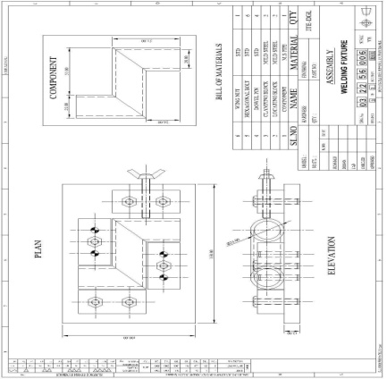  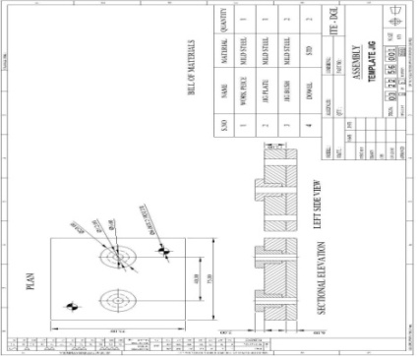  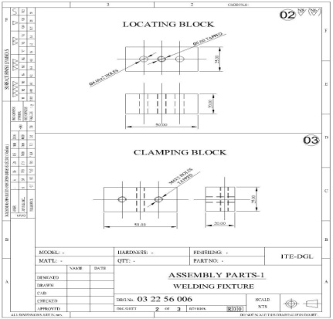

ALLOCATION OF MARKS

SNo | Descriptions |  | Max. Marks | Marks Awarded
1 | Aim & Command Required |  | 10
2 | Modeling (2 Views Only) |  | 60
3 | Bill of Material & Dimensioning |  | 20
4 | Viva Voce |  | 10
TOTAL |  |  | 100
Internal Examiner |  | External Examiner

9. | Press tool assembly-Blanking tool  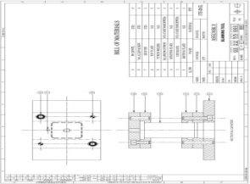  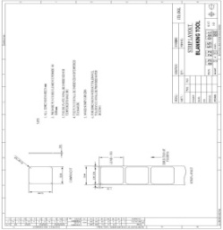  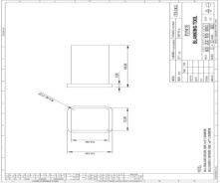  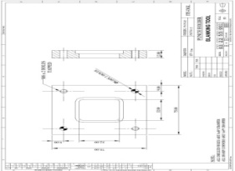  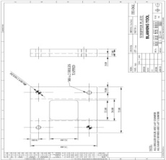  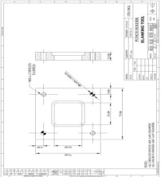  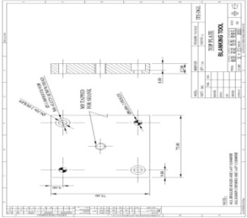  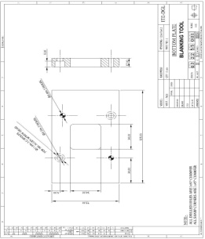

ALLOCATION OF MARKS

SNo | Descriptions |  | Max. Marks | Marks Awarded
1 | Aim & Command Required |  | 10
2 | Modeling (2 Views Only) |  | 60
3 | Bill of Material & Dimensioning |  | 20
4 | Viva Voce |  | 10
TOTAL |  |  | 100
Internal Examiner |  | External Examiner

10. | 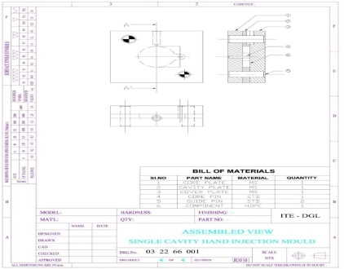  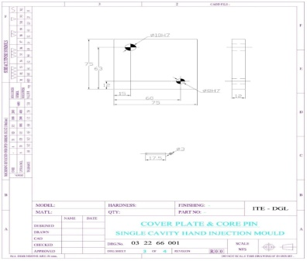  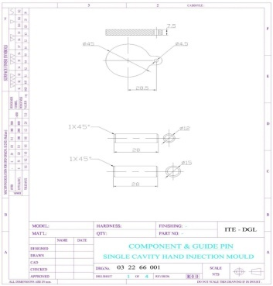  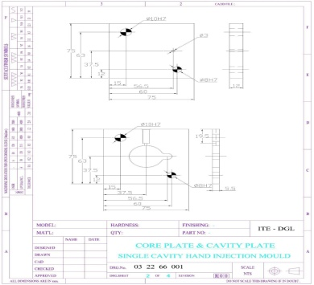  Plastic moulding tool assembly-Injection moulding tool

ALLOCATION OF MARKS

SNo | Descriptions |  | Max. Marks | Marks Awarded
1 | Aim & Command Required |  | 10
2 | Modeling (2 Views Only) |  | 60
3 | Bill of Material & Dimensioning |  | 20
4 | Viva Voce |  | 10
TOTAL |  |  | 100
Internal Examiner |  | External Examiner

