1. | A. Plain turning  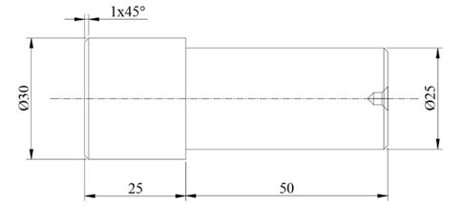
  B.. | Drilling & Tapping  Raw material 50mmX 50mmX10mmthickM.S.Flat  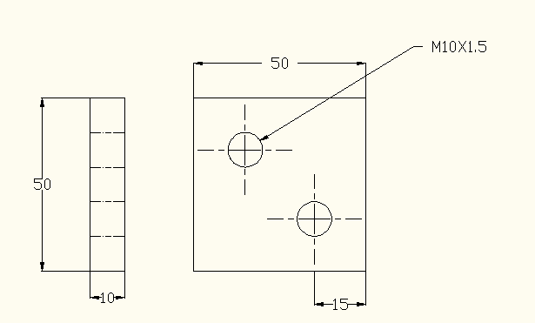

ALLOCATION OF MARKS

SNo | Descriptions |  | Max. Marks | Marks Awarded
A | Lathe Work
 | Preparation |  | 10
 | Dimensions |  | 40
 | Finishing |  | 10
B | Drilling
 | Marking |  | 15
 | Finishing |  | 15
 | Viva Voice |  | 10
TOTAL |  |  | 100
Internal Examiner |  | External Examiner

2. | A. Step turning  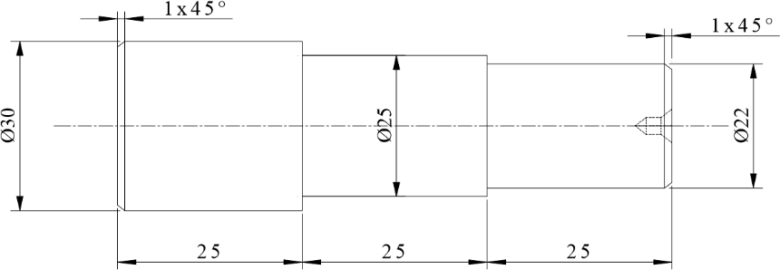
  B. | Drilling & Counter boring  Raw material 50mm X 50mm X 15mm thickM.S.Flat  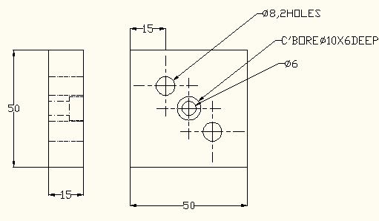

ALLOCATION OF MARKS

SNo | Descriptions |  | Max. Marks | Marks Awarded
A | Lathe Work
 | Preparation |  | 10
 | Dimensions |  | 40
 | Finishing |  | 10
B | Drilling
 | Marking |  | 15
 | Finishing |  | 15
 | Viva Voice |  | 10
TOTAL |  |  | 100
Internal Examiner |  | External Examiner

3. | A. Step and taper turning  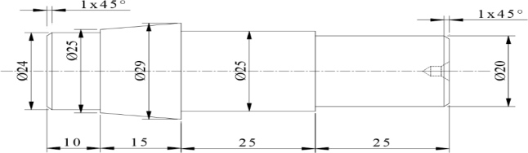
  B. | Drilling & Countersinking  Raw material 50mm X 50mm X 15mm thickM.S.Flat  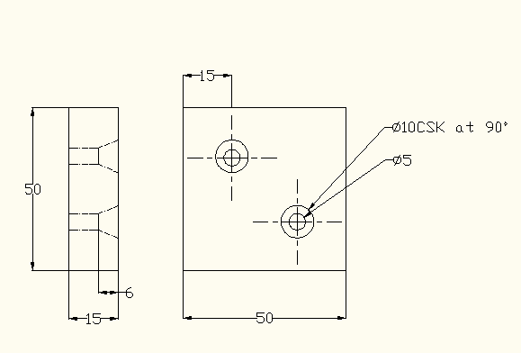

ALLOCATION OF MARKS

SNo | Descriptions |  | Max. Marks | Marks Awarded
A | Lathe Work
 | Preparation |  | 10
 | Dimensions |  | 40
 | Finishing |  | 10
B | Drilling
 | Marking |  | 15
 | Finishing |  | 15
 | Viva Voice |  | 10
TOTAL |  |  | 100
Internal Examiner |  | External Examiner

4. | Step and taper turning  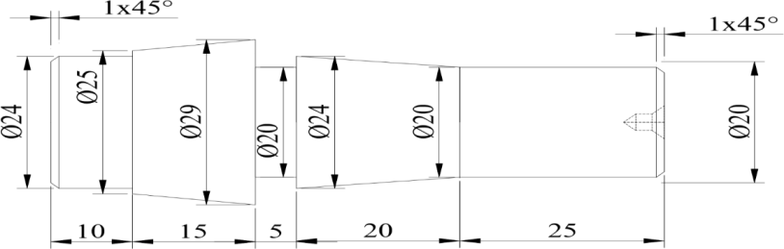  B. Drilling and Reaming  Raw material 50mmX 50mmX10mmthickM.S.Flat  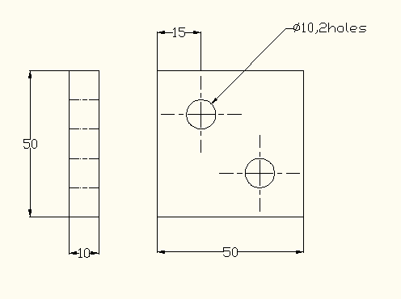

ALLOCATION OF MARKS

SNo | Descriptions |  | Max. Marks | Marks Awarded
A | Lathe Work
 | Preparation |  | 10
 | Dimensions |  | 40
 | Finishing |  | 10
B | Drilling
 | Marking |  | 15
 | Finishing |  | 15
 | Viva Voice |  | 10
TOTAL |  |  | 100
nternal Examiner |  | External Examiner

5. | A. Knurling and step turning  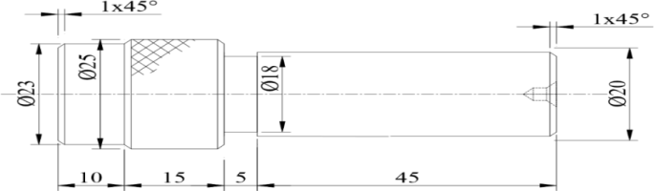  Drilling & Tapping  Raw material 50mmX 50mmX10mmthickM.S.Flat

ALLOCATION OF MARKS

SNo | Descriptions |  | Max. Marks | Marks Awarded
A | Lathe Work
 | Preparation |  | 10
 | Dimensions |  | 40
 | Finishing |  | 10
B | Drilling
 | Marking |  | 15
 | Finishing |  | 15
 | Viva Voice |  | 10
TOTAL |  |  | 100
Internal Examiner |  | External Examiner

6. | A. BSW Thread cutting  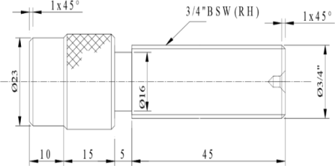
  B. | Drilling & Counter boring  Raw material 50mm X 50mm X 15mm thickM.S.Flat

ALLOCATION OF MARKS

SNo | Descriptions |  | Max. Marks | Marks Awarded
A | Lathe Work
 | Preparation |  | 10
 | Dimensions |  | 40
 | Finishing |  | 10
B | Drilling
 | Marking |  | 15
 | Finishing |  | 15
 | Viva Voice |  | 10
TOTAL |  |  | 100
Internal Examiner |  | External Examiner

7. | A. Metric thread cutting  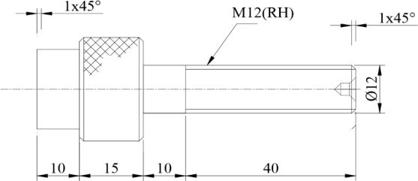  - Drilling & Countersinking  Raw material 50mm X 50mm X 15mm thickM.S.Flat
ALLOCATION OF MARKS

SNo | Descriptions |  | Max. Marks | Marks Awarded
A | Lathe Work
 | Preparation |  | 10
 | Dimensions |  | 40
 | Finishing |  | 10
B | Drilling
 | Marking |  | 15
 | Finishing |  | 15
 | Viva Voice |  | 10
TOTAL |  |  | 100
Internal Examiner |  | External Examiner

8. | A. Metric thread cutting  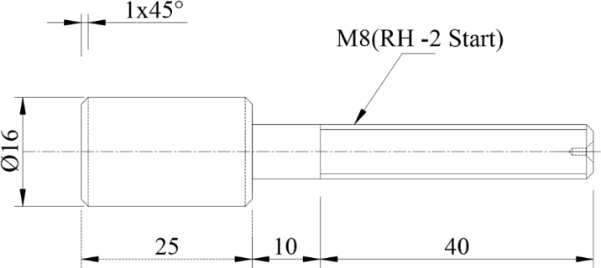
  B. | Drilling and Reaming  Raw material 50mmX 50mmX10mmthickM.S.Flat
ALLOCATION OF MARKS

SNo | Descriptions |  | Max. Marks | Marks Awarded
A | Lathe Work
 | Preparation |  | 10
 | Dimensions |  | 40
 | Finishing |  | 10
B | Drilling
 | Marking |  | 15
 | Finishing |  | 15
 | Viva Voice |  | 10
TOTAL |  |  | 100
Internal Examiner |  | External Examiner

9. | A. Shaft and bush mating  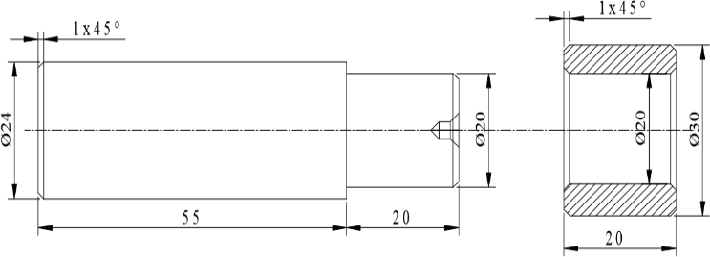  - Drilling & Tapping  Raw material 50mmX 50mmX10mmthickM.S.Flat
ALLOCATION OF MARKS

SNo | Descriptions |  | Max. Marks | Marks Awarded
A | Lathe Work
 | Preparation |  | 10
 | Dimensions |  | 40
 | Finishing |  | 10
B | Drilling
 | Marking |  | 15
 | Finishing |  | 15
 | Viva Voice |  | 10
TOTAL |  |  | 100
Internal Examiner |  | External Examiner

10. | A. Thread cutting  1x45° M20(RH)(OR)3/4"BSW  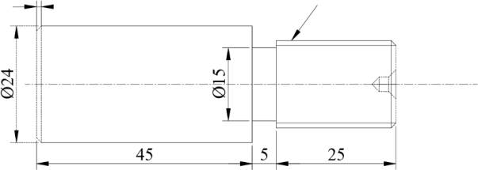
  B. | Drilling & Countersinking  Raw material 50mm X 50mm X 15mm thickM.S.Flat

ALLOCATION OF MARKS

SNo | Descriptions |  | Max. Marks | Marks Awarded
A | Lathe Work
 | Preparation |  | 10
 | Dimensions |  | 40
 | Finishing |  | 10
B | Drilling
 | Marking |  | 15
 | Finishing |  | 15
 | Viva Voice |  | 10
TOTAL |  |  | 100
Internal Examiner |  | External Examiner

11. | A. Eccentric Turning  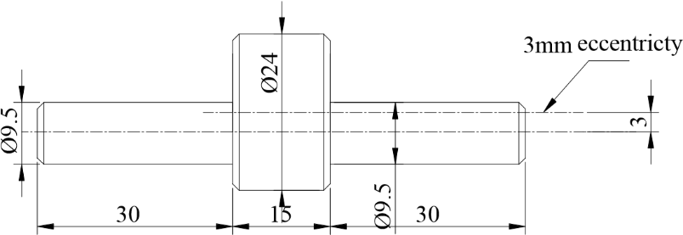
  B. | Drilling & Counter boring  Raw material 50mm X 50mm X 15mm thickM.S.Flat

ALLOCATION OF MARKS

SNo | Descriptions |  | Max. Marks | Marks Awarded
A | Lathe Work
 | Preparation |  | 10
 | Dimensions |  | 40
 | Finishing |  | 10
B | Drilling
 | Marking |  | 15
 | Finishing |  | 15
 | Viva Voice |  | 10
TOTAL |  |  | 100
Internal Examiner |  | External Examiner

