1 | Draw the Sectional Front View(Half Section) and Top View for the following given part drawing of the components in any CAD package. i) Sleeve and Cotter Joint  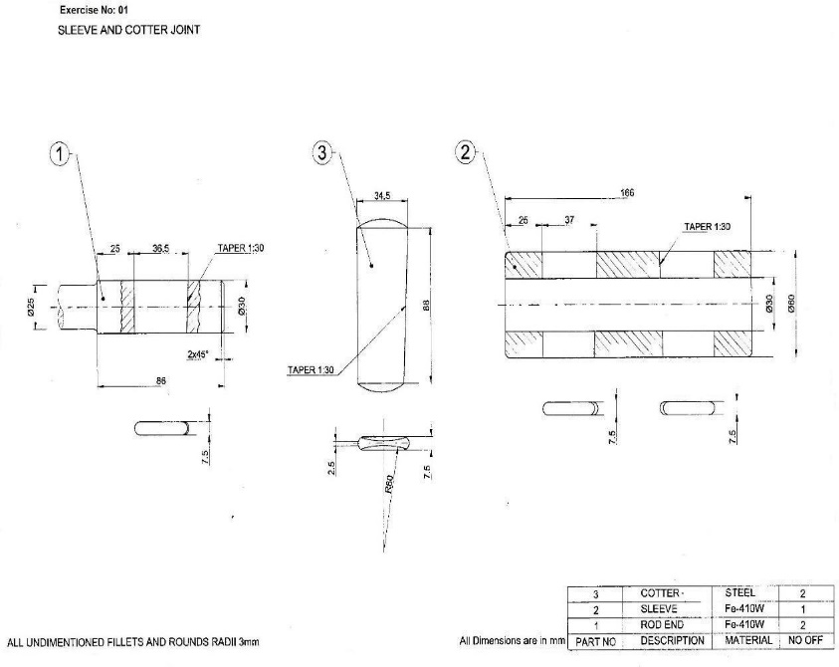

ALLOCATION OF MARKS

SNo | Descriptions |  | Max. Marks | Marks Awarded
1 | Creation of Sketch/Program writing |  | 15
2 | Modeling /Machining |  | 40
3 | Accuracy/Finishing |  | 05
4 | Written test(theory portions) |  | 30
5 | Viva voce |  | 10
TOTAL |  |  | 100
Internal Examiner |  | External Examiner

2 | Draw the Sectional Front View(Full Section)Left Side View for the following given part drawing of the components in any CAD package. i) Protected Flange Coupling  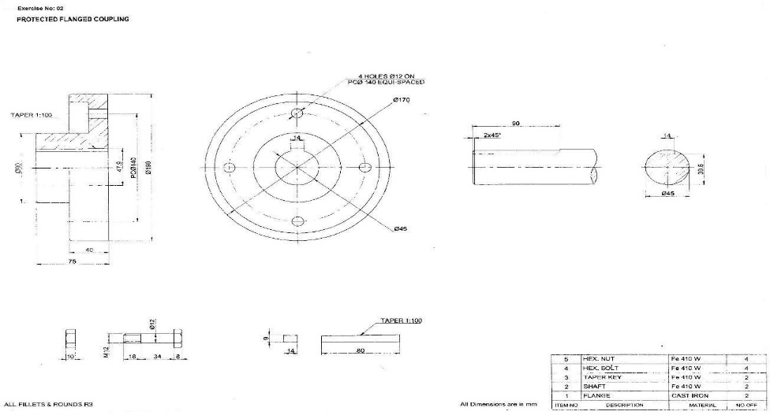

ALLOCATION OF MARKS

SNo | Descriptions |  | Max. Marks | Marks Awarded
1 | Creation of Sketch/Program writing |  | 15
2 | Modeling /Machining |  | 40
3 | Accuracy/Finishing |  | 05
4 | Written test(theory portions) |  | 30
5 | Viva voce |  | 10
TOTAL |  |  | 100
Internal Examiner |  | External Examiner

3 | Sketch the below 3D drawing with use of any CAD Packages. Bearing Block  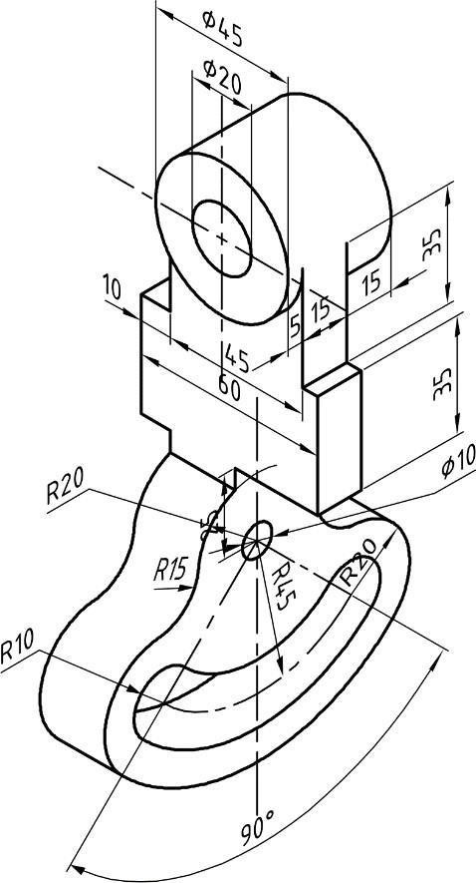

ALLOCATION OF MARKS

SNo | Descriptions |  | Max. Marks | Marks Awarded
1 | Creation of Sketch/Program writing |  | 15
2 | Modeling /Machining |  | 40
3 | Accuracy/Finishing |  | 05
4 | Written test(theory portions) |  | 30
5 | Viva voce |  | 10
TOTAL |  |  | 100
Internal Examiner |  | External Examiner

4 | Sketch the below 3D drawing with use of any CAD Packages. Screw Jack  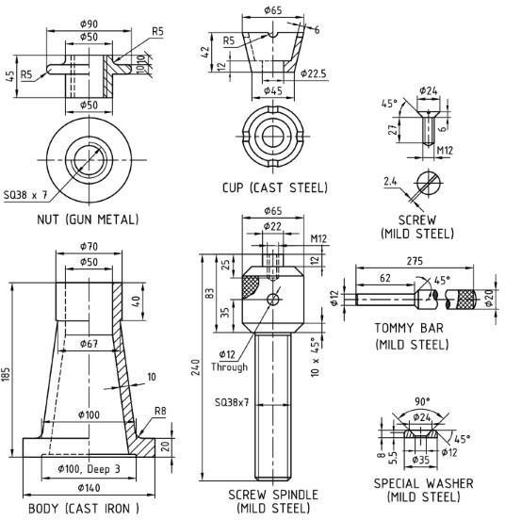

ALLOCATION OF MARKS

SNo | Descriptions |  | Max. Marks | Marks Awarded
1 | Creation of Sketch/Program writing |  | 15
2 | Modeling /Machining |  | 40
3 | Accuracy/Finishing |  | 05
4 | Written test(theory portions) |  | 30
5 | Viva voce |  | 10
TOTAL |  |  | 100
Internal Examiner |  | External Examiner

5 | Stimulate the program for CNC Turning Center  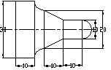

ALLOCATION OF MARKS

SNo | Descriptions |  | Max. Marks | Marks Awarded
1 | Creation of Sketch/Program writing |  | 15
2 | Modeling /Machining |  | 40
3 | Accuracy/Finishing |  | 05
4 | Written test(theory portions) |  | 30
5 | Viva voce |  | 10
TOTAL |  |  | 100
Internal Examiner |  | External Examiner

6 | Stimulate the program for CNC Milling Center  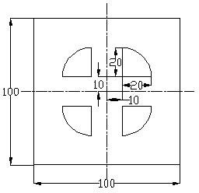

ALLOCATION OF MARKS

SNo |  | Descriptions |  | Max. Marks | Marks Awarded
1 |  | Creation of Sketch/Program writing |  | 15
2 |  | Modeling /Machining |  | 40
3 |  | Accuracy/Finishing |  | 05
4 |  | Written test(theory portions) |  | 30
5 |  | Viva voce |  | 10
TOTAL |  |  |  | 100
Internal Examiner |  |  | External Examiner
7 | Using Stock removal cycle–Create a part program for multiple turning operations and produce component in the Machine.  .  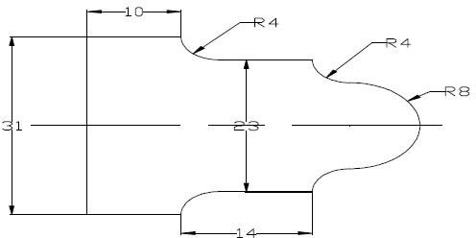

ALLOCATION OF MARKS

SNo | Descriptions |  | Max. Marks | Marks Awarded
1 | Creation of Sketch/Program writing |  | 15
2 | Modeling /Machining |  | 40
3 | Accuracy/Finishing |  | 05
4 | Written test(theory portions) |  | 30
5 | Viva voce |  | 10
TOTAL |  |  | 100
Internal Examiner |  | External Examiner

8 | Using canned cycle-Create a part program for thread cutting, grooving and produce component in the Machine.  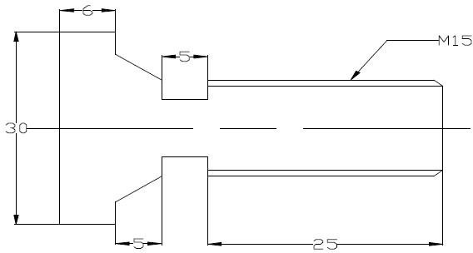

ALLOCATION OF MARKS

SNo | Descriptions |  | Max. Marks | Marks Awarded
1 | Creation of Sketch/Program writing |  | 15
2 | Modeling /Machining |  | 40
3 | Accuracy/Finishing |  | 05
4 | Written test(theory portions) |  | 30
5 | Viva voce |  | 10
TOTAL |  |  | 100
Internal Examiner |  | External Examiner

9 | Using canned cycle-Create a part program for drilling, tapping, counter sinking and produce component in the Machine.  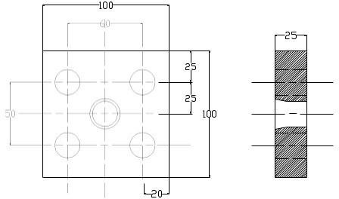

ALLOCATION OF MARKS

SNo | Descriptions |  | Max. Marks | Marks Awarded
1 | Creation of Sketch/Program writing |  | 15
2 | Modeling /Machining |  | 40
3 | Accuracy/Finishing |  | 05
4 | Written test(theory portions) |  | 30
5 | Viva voce |  | 10
TOTAL |  |  | 100
Internal Examiner |  | External Examiner

10 | Using sub program-Create a part program and produce component in the Machine.  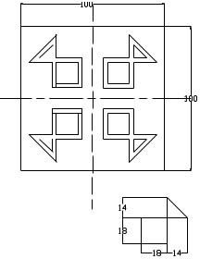

ALLOCATION OF MARKS

SNo | Descriptions |  | Max. Marks | Marks Awarded
1 | Creation of Sketch/Program writing |  | 15
2 | Modeling /Machining |  | 40
3 | Accuracy/Finishing |  | 05
4 | Written test(theory portions) |  | 30
5 | Viva voce |  | 10
TOTAL |  |  | 100
Internal Examiner |  | External Examiner

