1 | - Draw the front view of the assembled drawing of the components with dimensions  - Detailed drawings of the machine components will be given to students to create the solid modeling and assemble using any CAD software in the computer and take the printout.  SleeveandCotterJoint.  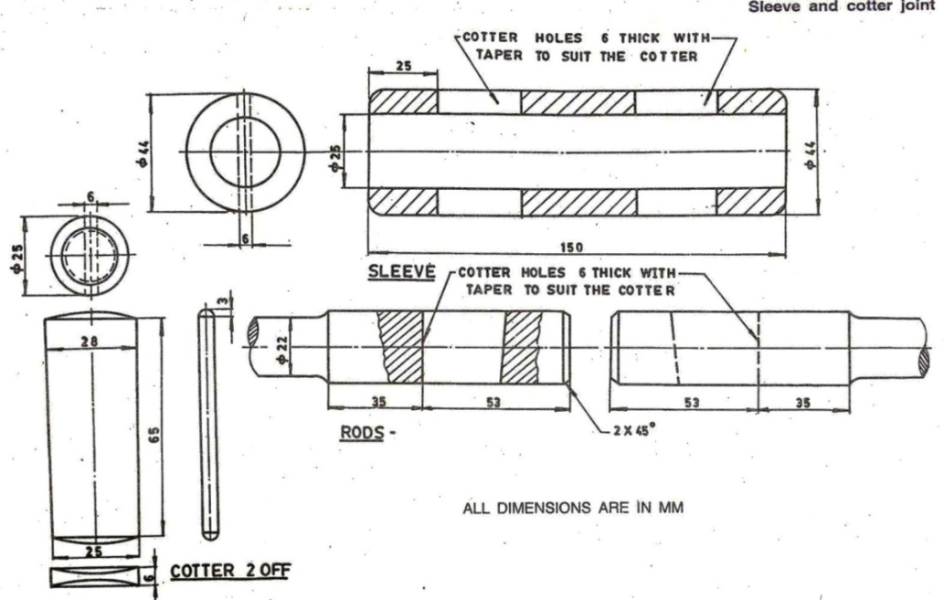

ALLOCATION OF MARKS

SNo |  | Descriptions |  | Max. Marks | Marks Awarded
1 |  | Command/Creation - Part A / CreationPartModelling -Part B |  | 20
2 |  | 2DViewwithDimensions - Part A / CADModelling(3D) -Part B |  | 30
3 |  | Assemblyoftheparts -Part B |  | 20
4 |  | Printout (Part A & Part B) |  | 10
5 |  | Writtentest |  | 10
6 |  | VivaVoce |  | 10
TOTAL |  |  |  | 100
Internal Examiner |  |  | External Examiner
2 | - Drawthefrontviewoftheassembleddrawingofthecomponentswithdimensions.  - DetaileddrawingsofthemachinecomponentswillbegiventostudentstocreatethesolidmodellingandassembleusinganyCADsoftwareinthecomputerandtakethe printout.  PlummerBlock  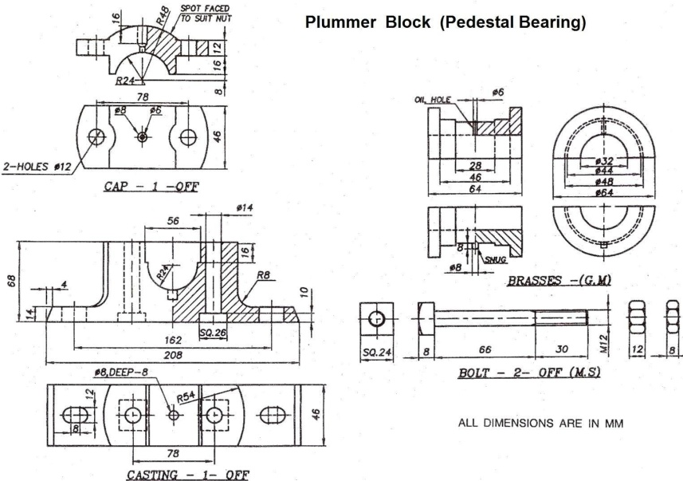

ALLOCATION OF MARKS

SNo | Descriptions |  | Max. Marks | Marks Awarded
1 | Command/Creation - Part A / CreationPartModelling -Part B |  | 20
2 | 2DViewwithDimensions - Part A / CADModelling(3D) -Part B |  | 30
3 | Assemblyoftheparts -Part B |  | 20
4 | Printout (Part A & Part B) |  | 10
5 | Writtentest |  | 10
6 | VivaVoce |  | 10
TOTAL |  |  | 100
Internal Examiner |  | External Examiner

3 | - Drawthefrontviewoftheassembleddrawingofthecomponentswithdimensions  - DetaileddrawingsofthemachinecomponentswillbegiventostudentstocreatethesolidmodellingandassembleusinganyCADsoftwareinthecomputerandtakethe printout.  FlangeCoupling.  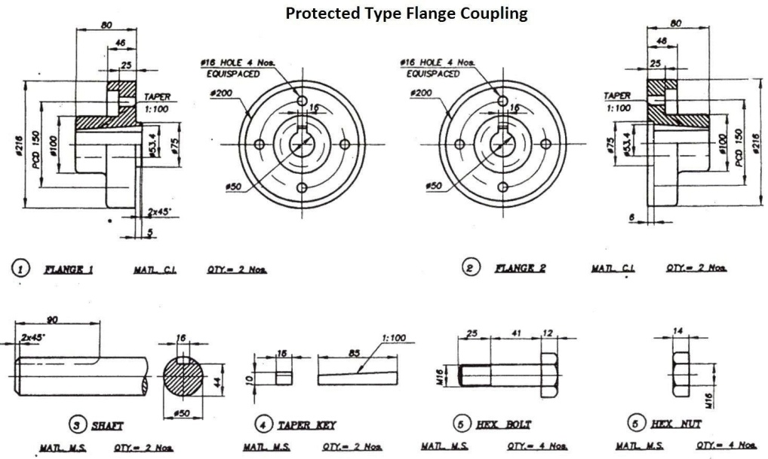

ALLOCATION OF MARKS

SNo | Descriptions |  | Max. Marks | Marks Awarded
1 | Command/Creation - Part A / CreationPartModelling -Part B |  | 20
2 | 2DViewwithDimensions - Part A / CADModelling(3D) -Part B |  | 30
3 | Assemblyoftheparts -Part B |  | 20
4 | Printout (Part A & Part B) |  | 10
5 | Writtentest |  | 10
6 | VivaVoce |  | 10
TOTAL |  |  | 100
Internal Examiner |  | External Examiner

4 | - Drawthefrontviewoftheassembleddrawingofthecomponentswithdimensions  - DetaileddrawingsofthemachinecomponentswillbegiventostudentstocreatethesolidmodellingandassembleusinganyCADsoftwareinthecomputerandtakethe printout.  BushedBearing.  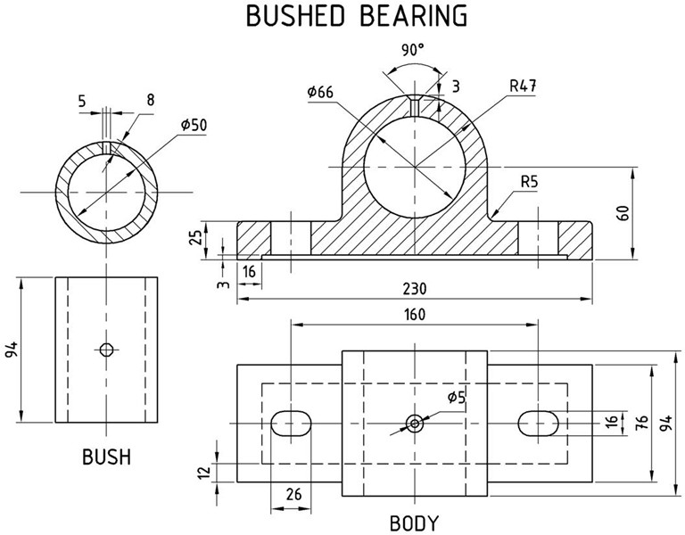

ALLOCATION OF MARKS

SNo | Descriptions |  | Max. Marks | Marks Awarded
1 | Command/Creation - Part A / CreationPartModelling -Part B |  | 20
2 | 2DViewwithDimensions - Part A / CADModelling(3D) -Part B |  | 30
3 | Assemblyoftheparts -Part B |  | 20
4 | Printout (Part A & Part B) |  | 10
5 | Writtentest |  | 10
6 | VivaVoce |  | 10
TOTAL |  |  | 100
Internal Examiner |  | External Examiner

