1 | M.S / Aluminium / Acrylic fibre / Plastic  Using Linear interpolation - Create a part program and produce component in the Machine  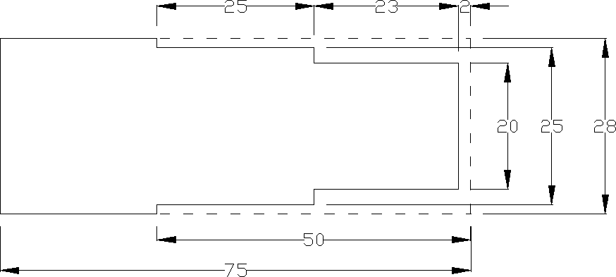

ALLOCATION OF MARKS

SNO | Descriptions |  | Max. Marks | Marks Awarded
1 | Aim / Procedure |  | 10
2 | Part Programming |  | 10
3 | Simulation/Machining |  | 30
4 | Finishing |  | 10
5 | Record of Work Done |  | 30
6 | Viva voce |  | 10
TOTAL |  |  | 100
Internal Examiner |  | External Examiner

2 | 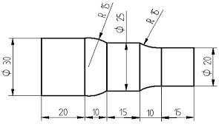  Using Linear and Circular interpolation - Create a part program and produce component in the Machine

ALLOCATION OF MARKS

SNO | Descriptions |  | Max. Marks | Marks Awarded
1 | Aim / Procedure |  | 10
2 | Part Programming |  | 10
3 | Simulation/Machining |  | 30
4 | Finishing |  | 10
5 | Record of Work Done |  | 30
6 | Viva voce |  | 10
TOTAL |  |  | 100
Internal Examiner |  | External Examiner

3 | Using Stock removal cycle – Create a part program for multiple turning operations and produce component in the Machine  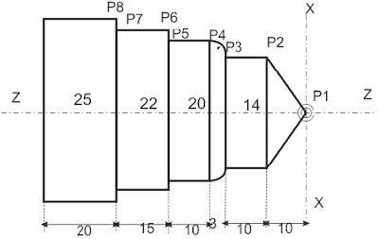

ALLOCATION OF MARKS

SNO | Descriptions |  | Max. Marks | Marks Awarded
1 | Aim / Procedure |  | 10
2 | Part Programming |  | 10
3 | Simulation/Machining |  | 30
4 | Finishing |  | 10
5 | Record of Work Done |  | 30
6 | Viva voce |  | 10
TOTAL |  |  | 100
Internal Examiner |  | External Examiner

4 | Using canned cycle - create part program for thread cutting, grooving and produce component.  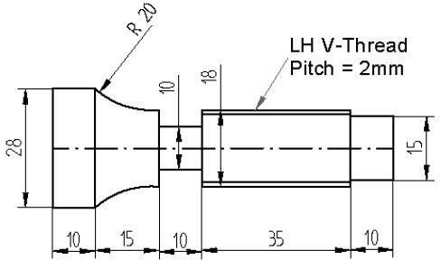

ALLOCATION OF MARKS

SNO | Descriptions |  | Max. Marks | Marks Awarded
1 | Aim / Procedure |  | 10
2 | Part Programming |  | 10
3 | Simulation/Machining |  | 30
4 | Finishing |  | 10
5 | Record of Work Done |  | 30
6 | Viva voce |  | 10
TOTAL |  |  | 100
Internal Examiner |  | External Examiner

5 | Using Linear interpolation and cutter radius compensation – Create a part program and produce component in the Machine.  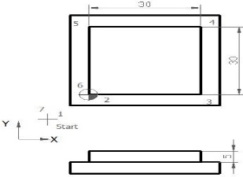  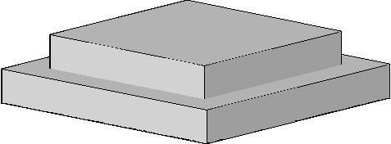

ALLOCATION OF MARKS

SNO | Descriptions |  | Max. Marks | Marks Awarded
1 | Aim / Procedure |  | 10
2 | Part Programming |  | 10
3 | Simulation/Machining |  | 30
4 | Finishing |  | 10
5 | Record of Work Done |  | 30
6 | Viva voce |  | 10
TOTAL |  |  | 100
Internal Examiner |  | External Examiner

6 | Using Linear interpolation and Circular interpolation and cutter radius compensation – Create a part program and produce component in the Machine.  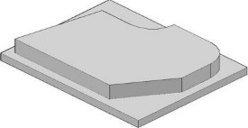  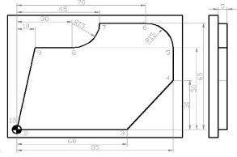

ALLOCATION OF MARKS

SNO | Descriptions |  | Max. Marks | Marks Awarded
1 | Aim / Procedure |  | 10
2 | Part Programming |  | 10
3 | Simulation/Machining |  | 30
4 | Finishing |  | 10
5 | Record of Work Done |  | 30
6 | Viva voce |  | 10
TOTAL |  |  | 100
Internal Examiner |  | External Examiner

7 | Using peck drilling cycle - Create a part program and produce component in the Machine  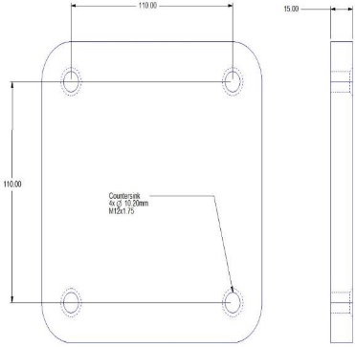

ALLOCATION OF MARKS

SNO | Descriptions |  | Max. Marks | Marks Awarded
1 | Aim / Procedure |  | 10
2 | Part Programming |  | 10
3 | Simulation/Machining |  | 30
4 | Finishing |  | 10
5 | Record of Work Done |  | 30
6 | Viva voce |  | 10
TOTAL |  |  | 100
Internal Examiner |  | External Examiner

8 | Using subprogram - Create a part program and produce component in the machine.  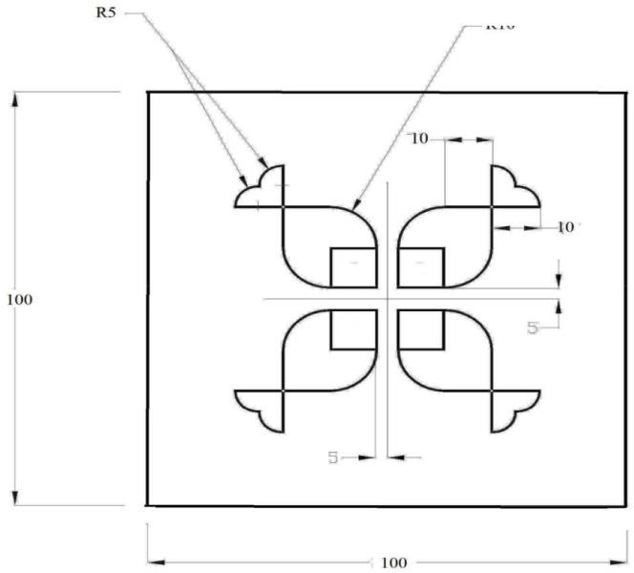

ALLOCATION OF MARKS

SNO | Descriptions |  | Max. Marks | Marks Awarded
1 | Aim / Procedure |  | 10
2 | Part Programming |  | 10
3 | Simulation/Machining |  | 30
4 | Finishing |  | 10
5 | Record of Work Done |  | 30
6 | Viva voce |  | 10
TOTAL |  |  | 100
Internal Examiner |  | External Examiner

