1 | Drilling and tapping  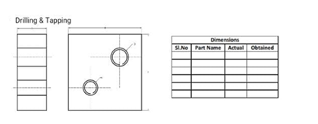

ALLOCATION OF MARKS

SNo | Descriptions |  | Max. Marks | Marks Awarded
1 | Aim & Tools required |  | 10
2 | Preparation / Procedure |  | 10
3 | Operation / Machining / Dimensions |  | 30
4 | Surface Finishing |  | 10
5 | Record of Work Done |  | 30
6 | Viva Voce |  | 10
TOTAL |  |  | 100
Internal Examiner |  | External Examiner

2 | Drilling and counter boring  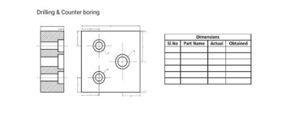

ALLOCATION OF MARKS

SNo | Descriptions |  | Max. Marks | Marks Awarded
1 | Aim & Tools required |  | 10
2 | Preparation / Procedure |  | 10
3 | Operation / Machining / Dimensions |  | 30
4 | Surface Finishing |  | 10
5 | Record of Work Done |  | 30
6 | Viva Voce |  | 10
TOTAL |  |  | 100
Internal Examiner |  | External Examiner

3 | Make Dove tail using Shaper  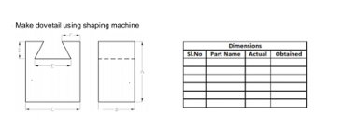

ALLOCATION OF MARKS

SNo | Descriptions |  | Max. Marks | Marks Awarded
1 | Aim & Tools required |  | 10
2 | Preparation / Procedure |  | 10
3 | Operation / Machining / Dimensions |  | 30
4 | Surface Finishing |  | 10
5 | Record of Work Done |  | 30
6 | Viva Voce |  | 10
TOTAL |  |  | 100
Internal Examiner |  | External Examiner

4 | Make Round to Square in Milling Machine  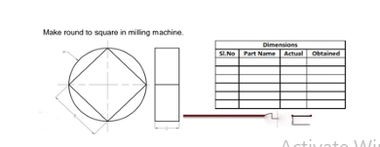

ALLOCATION OF MARKS

SNo | Descriptions |  | Max. Marks | Marks Awarded
1 | Aim & Tools required |  | 10
2 | Preparation / Procedure |  | 10
3 | Operation / Machining / Dimensions |  | 30
4 | Surface Finishing |  | 10
5 | Record of Work Done |  | 30
6 | Viva Voce |  | 10
TOTAL |  |  | 100
Internal Examiner |  | External Examiner

5 | Make Spur Gear using milling machine by simple Indexing  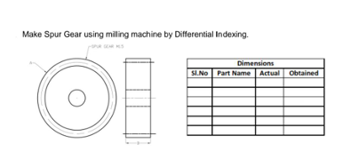

ALLOCATION OF MARKS

SNo | Descriptions |  | Max. Marks | Marks Awarded
1 | Aim & Tools required |  | 10
2 | Preparation / Procedure |  | 10
3 | Operation / Machining / Dimensions |  | 30
4 | Surface Finishing |  | 10
5 | Record of Work Done |  | 30
6 | Viva Voce |  | 10
TOTAL |  |  | 100
Internal Examiner |  | External Examiner

6 | Make helical gear using milling machine  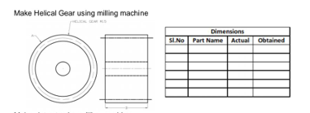

ALLOCATION OF MARKS

SNo | Descriptions |  | Max. Marks | Marks Awarded
1 | Aim & Tools required |  | 10
2 | Preparation / Procedure |  | 10
3 | Operation / Machining / Dimensions |  | 30
4 | Surface Finishing |  | 10
5 | Record of Work Done |  | 30
6 | Viva Voce |  | 10
TOTAL |  |  | 100
Internal Examiner |  | External Examiner

7 | Make a Slot  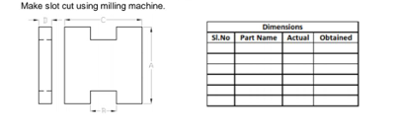

ALLOCATION OF MARKS

SNo | Descriptions |  | Max. Marks | Marks Awarded
1 | Aim & Tools required |  | 10
2 | Preparation / Procedure |  | 10
3 | Operation / Machining / Dimensions |  | 30
4 | Surface Finishing |  | 10
5 | Record of Work Done |  | 30
6 | Viva Voce |  | 10
TOTAL |  |  | 100
Internal Examiner |  | External Examiner

8 | Grind a plain surface using surface Grinder  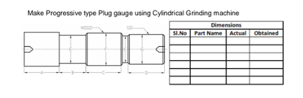

ALLOCATION OF MARKS

SNo | Descriptions |  | Max. Marks | Marks Awarded
1 | Aim & Tools required |  | 10
2 | Preparation / Procedure |  | 10
3 | Operation / Machining / Dimensions |  | 30
4 | Surface Finishing |  | 10
5 | Record of Work Done |  | 30
6 | Viva Voce |  | 10
TOTAL |  |  | 100
Internal Examiner |  | External Examiner

9 | Make progressive type plug gauge using cylindrical grinding machine  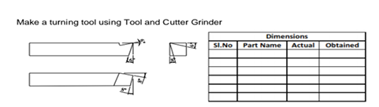

ALLOCATION OF MARKS

SNo | Descriptions |  | Max. Marks | Marks Awarded
1 | Aim & Tools required |  | 10
2 | Preparation / Procedure |  | 10
3 | Operation / Machining / Dimensions |  | 30
4 | Surface Finishing |  | 10
5 | Record of Work Done |  | 30
6 | Viva Voce |  | 10
TOTAL |  |  | 100
Internal Examiner |  | External Examiner

10 | Make a turning tool / milling cutter using tool and cutter grinder.  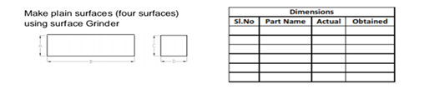

ALLOCATION OF MARKS

SNo | Descriptions |  | Max. Marks | Marks Awarded
1 | Aim & Tools required |  | 10
2 | Preparation / Procedure |  | 10
3 | Operation / Machining / Dimensions |  | 30
4 | Surface Finishing |  | 10
5 | Record of Work Done |  | 30
6 | Viva Voce |  | 10
TOTAL |  |  | 100
Internal Examiner |  | External Examiner

