1 | Solid pattern (Stepped pulley) / Split pattern (Bent Pipe with core print / T-pipes with core print/Tumbles)

ALLOCATION OF MARKS

SNo | Descriptions |  | Max. Marks | Marks Awarded
1 | Aim & Tools required |  | 10
2 | Preparation / Procedure |  | 30
3 | Moulding / Welding / Machining |  | 30
4 | Finish / Output |  | 20
5 | Viva Voce |  | 10
TOTAL |  |  | 100
Internal Examiner |  | External Examiner

2 | Loose Piece Pattern (Dovetail)/Core preparation (Bent pipe / T-pipe)

ALLOCATION OF MARKS

SNo | Descriptions |  | Max. Marks | Marks Awarded
1 | Aim & Tools required |  | 10
2 | Preparation / Procedure |  | 30
3 | Moulding / Welding / Machining |  | 30
4 | Finish / Output |  | 20
5 | Viva Voce |  | 10
TOTAL |  |  | 100
Internal Examiner |  | External Examiner

3 | Arc welding (Raw Material: 25 mm x 6mm MS flat)  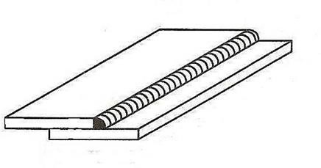  Lap joint

ALLOCATION OF MARKS

SNo | Descriptions |  | Max. Marks | Marks Awarded
1 | Aim & Tools required |  | 10
2 | Preparation / Procedure |  | 30
3 | Moulding / Welding / Machining |  | 30
4 | Finish / Output |  | 20
5 | Viva Voce |  | 10
TOTAL |  |  | 100
Internal Examiner |  | External Examiner

4 | T- joint  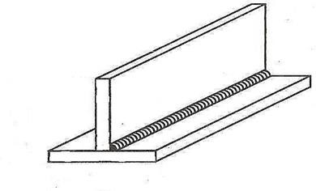

ALLOCATION OF MARKS

SNo | Descriptions |  | Max. Marks | Marks Awarded
1 | Aim & Tools required |  | 10
2 | Preparation / Procedure |  | 30
3 | Moulding / Welding / Machining |  | 30
4 | Finish / Output |  | 20
5 | Viva Voce |  | 10
TOTAL |  |  | 100
Internal Examiner |  | External Examiner

5 | Raw material 32 mm M.S. Rod  Facing, Step turning & Chamfering  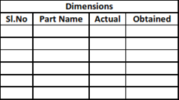  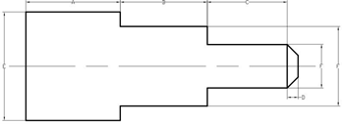

ALLOCATION OF MARKS

SNo | Descriptions |  | Max. Marks | Marks Awarded
1 | Aim & Tools required |  | 10
2 | Preparation / Procedure |  | 30
3 | Moulding / Welding / Machining |  | 30
4 | Finish / Output |  | 20
5 | Viva Voce |  | 10
TOTAL |  |  | 100
Internal Examiner |  | External Examiner

6 | Step turning & Groove cutting  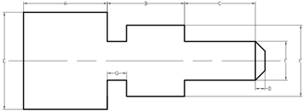  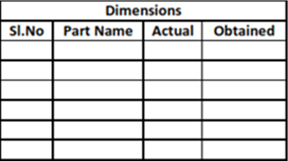

ALLOCATION OF MARKS

SNo | Descriptions |  | Max. Marks | Marks Awarded
1 | Aim & Tools required |  | 10
2 | Preparation / Procedure |  | 30
3 | Moulding / Welding / Machining |  | 30
4 | Finish / Output |  | 20
5 | Viva Voce |  | 10
TOTAL |  |  | 100
Internal Examiner |  | External Examiner

7 | Step turning & Taper turning  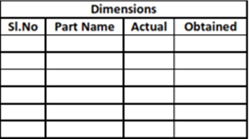  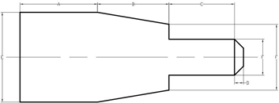

ALLOCATION OF MARKS

SNo | Descriptions |  | Max. Marks | Marks Awarded
1 | Aim & Tools required |  | 10
2 | Preparation / Procedure |  | 30
3 | Moulding / Welding / Machining |  | 30
4 | Finish / Output |  | 20
5 | Viva Voce |  | 10
TOTAL |  |  | 100
Internal Examiner |  | External Examiner

8 | Step turning & Knurling  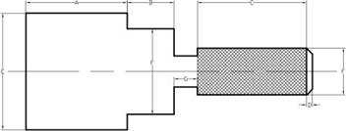  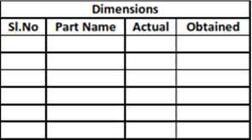

ALLOCATION OF MARKS

SNo | Descriptions |  | Max. Marks | Marks Awarded
1 | Aim & Tools required |  | 10
2 | Preparation / Procedure |  | 30
3 | Moulding / Welding / Machining |  | 30
4 | Finish / Output |  | 20
5 | Viva Voce |  | 10
TOTAL |  |  | 100
Internal Examiner |  | External Examiner

9 | Step turning & Thread cutting (L.H.)  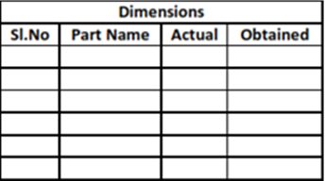  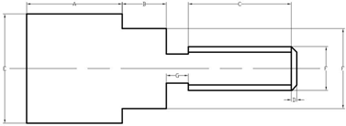

ALLOCATION OF MARKS

SNo | Descriptions |  | Max. Marks | Marks Awarded
1 | Aim & Tools required |  | 10
2 | Preparation / Procedure |  | 30
3 | Moulding / Welding / Machining |  | 30
4 | Finish / Output |  | 20
5 | Viva Voce |  | 10
TOTAL |  |  | 100
Internal Examiner |  | External Examiner

10 | Step turning & Thread cutting (R.H)  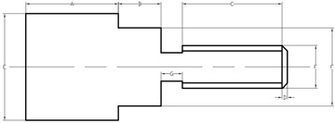  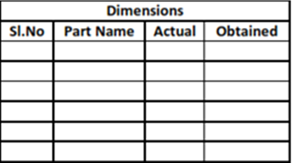

ALLOCATION OF MARKS

SNo | Descriptions |  | Max. Marks | Marks Awarded
1 | Aim & Tools required |  | 10
2 | Preparation / Procedure |  | 30
3 | Moulding / Welding / Machining |  | 30
4 | Finish / Output |  | 20
5 | Viva Voce |  | 10
TOTAL |  |  | 100
Internal Examiner |  | External Examiner

