1. | Draw the orthographic top view of any two robotic or mechanical links used in industrial manipulators.  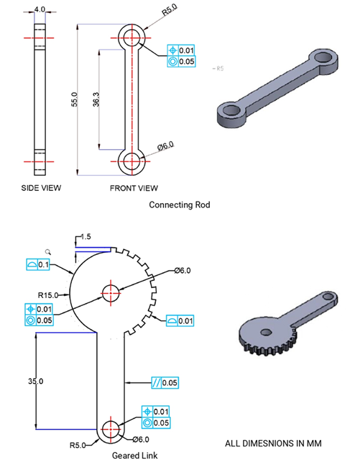

ALLOCATION OF MARKS

SNo | Descriptions |  | Max. Marks | Marks Awarded
1 | Drawing Component / Assembly / Layout / Circuit |  | 40
2 | Blocks, Layers, Annotations/ Symbols |  | 40
3 | Print out |  | 10
4 | Viva voce |  | 10
TOTAL |  |  | 100
Internal Examiner |  | External Examiner

2. | Illustrate the orthographic top view of any two robotic or mechanical joints commonly applied in automation systems.  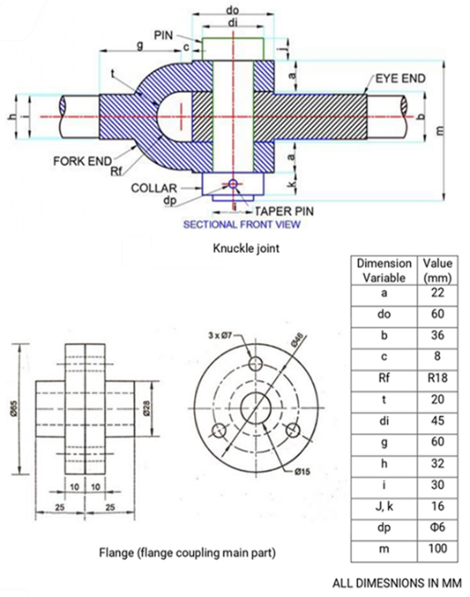

ALLOCATION OF MARKS

SNo | Descriptions |  | Max. Marks | Marks Awarded
1 | Drawing Component / Assembly / Layout / Circuit |  | 40
2 | Blocks, Layers, Annotations/ Symbols |  | 40
3 | Print out |  | 10
4 | Viva voce |  | 10
TOTAL |  |  | 100
Internal Examiner |  | External Examiner

3. | 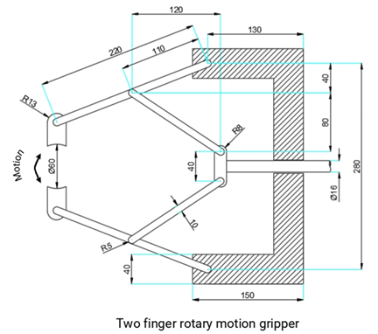  Sketch the orthographic top view of two finger rotary motion robotic/mechanical grippers employed for material handling

ALLOCATION OF MARKS

SNo | Descriptions |  | Max. Marks | Marks Awarded
1 | Drawing Component / Assembly / Layout / Circuit |  | 40
2 | Blocks, Layers, Annotations/ Symbols |  | 40
3 | Print out |  | 10
4 | Viva voce |  | 10
TOTAL |  |  | 100
Internal Examiner |  | External Examiner

4. | Sketch the orthographic top view of two finger rotary motion robotic/mechanical grippers employed for material handling.  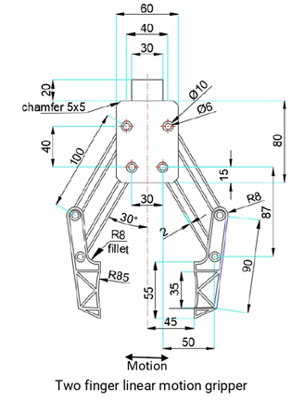

ALLOCATION OF MARKS

SNo | Descriptions |  | Max. Marks | Marks Awarded
1 | Drawing Component / Assembly / Layout / Circuit |  | 40
2 | Blocks, Layers, Annotations/ Symbols |  | 40
3 | Print out |  | 10
4 | Viva voce |  | 10
TOTAL |  |  | 100
Internal Examiner |  | External Examiner

5. | Draw the orthographic views of any two threaded fasteners used in machine assembly.  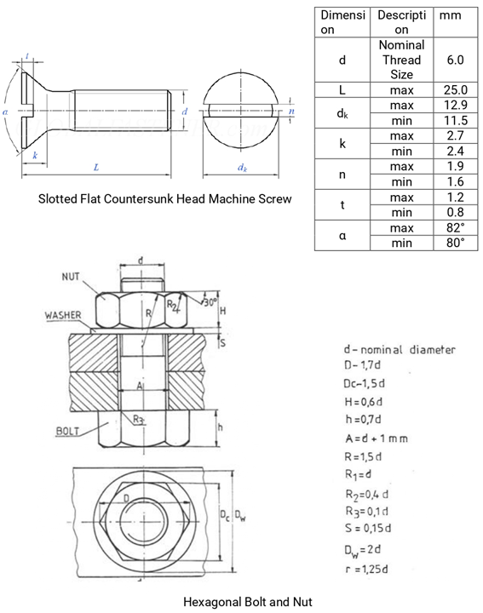

ALLOCATION OF MARKS

SNo | Descriptions |  | Max. Marks | Marks Awarded
1 | Drawing Component / Assembly / Layout / Circuit |  | 40
2 | Blocks, Layers, Annotations/ Symbols |  | 40
3 | Print out |  | 10
4 | Viva voce |  | 10
TOTAL |  |  | 100
Internal Examiner |  | External Examiner

6. | Develop a neat 2D model of a cam and follower mechanism applied in industrial automation.  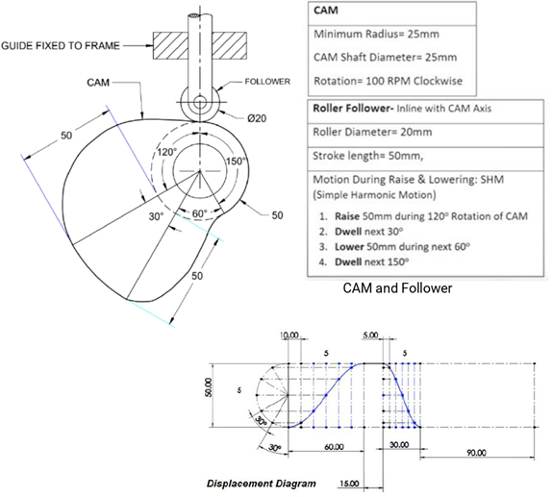

ALLOCATION OF MARKS

SNo | Descriptions |  | Max. Marks | Marks Awarded
1 | Drawing Component / Assembly / Layout / Circuit |  | 40
2 | Blocks, Layers, Annotations/ Symbols |  | 40
3 | Print out |  | 10
4 | Viva voce |  | 10
TOTAL |  |  | 100
Internal Examiner |  | External Examiner

7. | Draw the assembly view of an induction motor showing the end elevation with the top half in section.  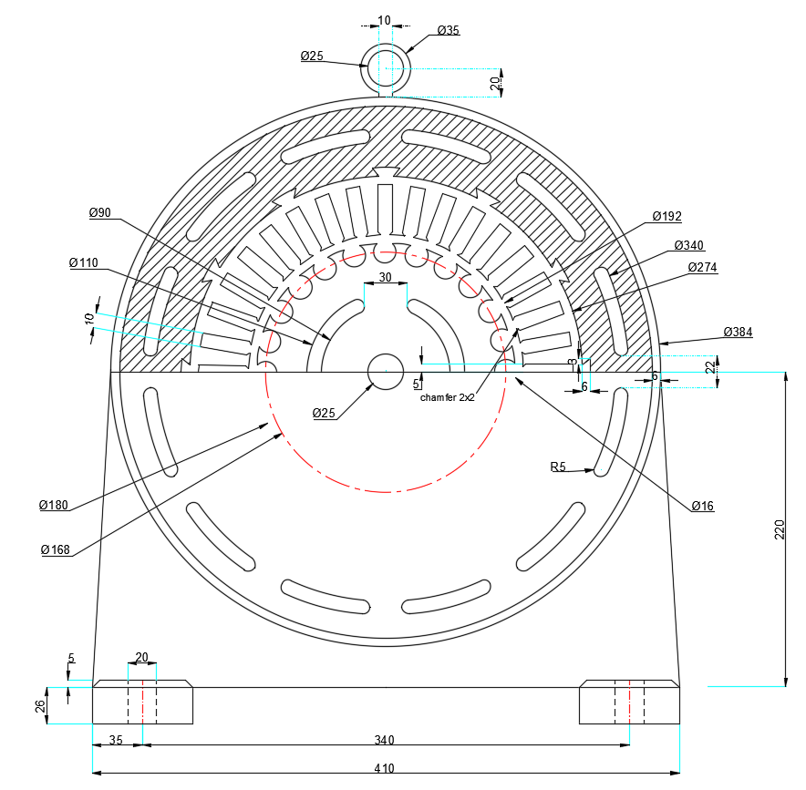

ALLOCATION OF MARKS

SNo | Descriptions |  | Max. Marks | Marks Awarded
1 | Drawing Component / Assembly / Layout / Circuit |  | 40
2 | Blocks, Layers, Annotations/ Symbols |  | 40
3 | Print out |  | 10
4 | Viva voce |  | 10
TOTAL |  |  | 100
Internal Examiner |  | External Examiner

8. | Create a standard single-line diagram of electrical symbols (switch, wire, contactor, motor, transformer) using CAD layers and block features.  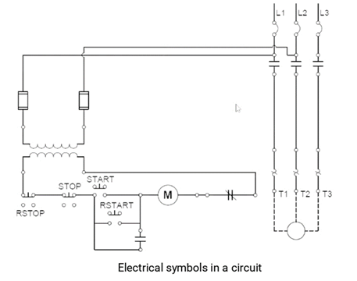

ALLOCATION OF MARKS

SNo | Descriptions |  | Max. Marks | Marks Awarded
1 | Drawing Component / Assembly / Layout / Circuit |  | 40
2 | Blocks, Layers, Annotations/ Symbols |  | 40
3 | Print out |  | 10
4 | Viva voce |  | 10
TOTAL |  |  | 100
Internal Examiner |  | External Examiner

9. | 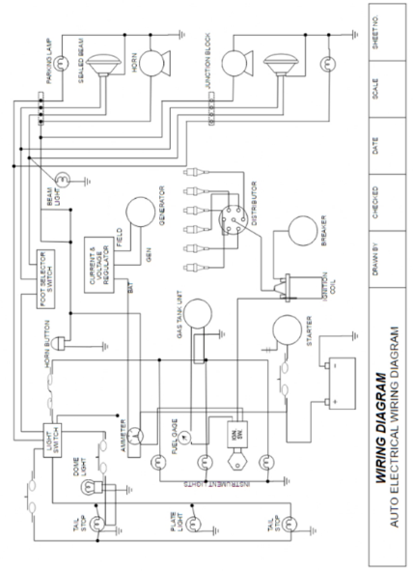  Prepare a neat single-line diagram of an electrical circuit using components available in the CAD library or external sources.

ALLOCATION OF MARKS

SNo | Descriptions |  | Max. Marks | Marks Awarded
1 | Drawing Component / Assembly / Layout / Circuit |  | 40
2 | Blocks, Layers, Annotations/ Symbols |  | 40
3 | Print out |  | 10
4 | Viva voce |  | 10
TOTAL |  |  | 100
Internal Examiner |  | External Examiner

10. | Design a layout/plan of a robotic work cell and represent it using a block diagram.  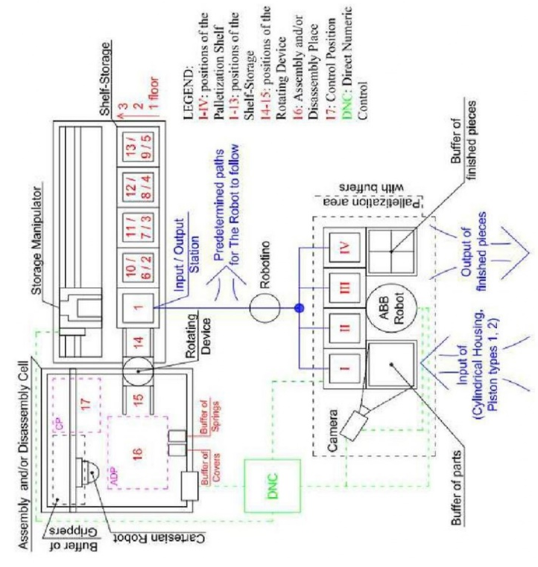

ALLOCATION OF MARKS

SNo |  | Descriptions |  | Max. Marks | Marks Awarded
1 |  | Drawing Component / Assembly / Layout / Circuit |  | 40
2 |  | Blocks, Layers, Annotations/ Symbols |  | 40
3 |  | Print out |  | 10
4 |  | Viva voce |  | 10
TOTAL |  |  |  | 100
Internal Examiner |  |  | External Examiner
11. | 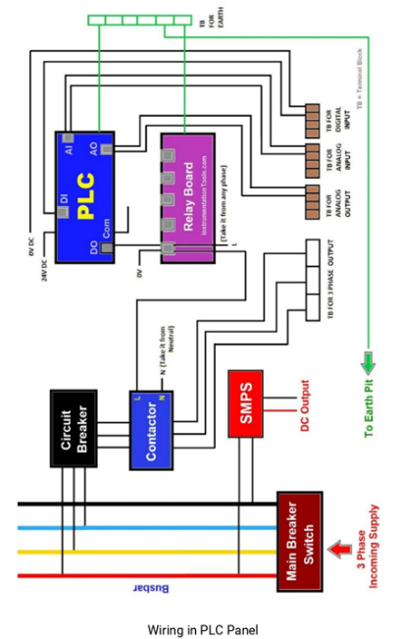  Draw a single-line diagram of a PLC panel wiring system consisting of the main breaker switch, bus bar, circuit breakers, relays, contactors, PLC, fuses, SMPS, terminal boards, utility sockets, and Earthing points.

ALLOCATION OF MARKS

SNo | Descriptions |  | Max. Marks | Marks Awarded
1 | Drawing Component / Assembly / Layout / Circuit |  | 40
2 | Blocks, Layers, Annotations/ Symbols |  | 40
3 | Print out |  | 10
4 | Viva voce |  | 10
TOTAL |  |  | 100
Internal Examiner |  | External Examiner

