Things To Do After The Installation💻

To Install the Linux Headers

Step 1 : sudo apt update && sudo apt upgrade

Step 2 :sudo apt install linux-headers-generic

Step 3 : sudo apt install linux-headers-$(uname-r)

Step 4 : 👍

To Install Virtual Box Guest addition
it Enable 3D Acceleration,more Functionalities..

Step 1 : Use the menu bar choose to Inser gust addition
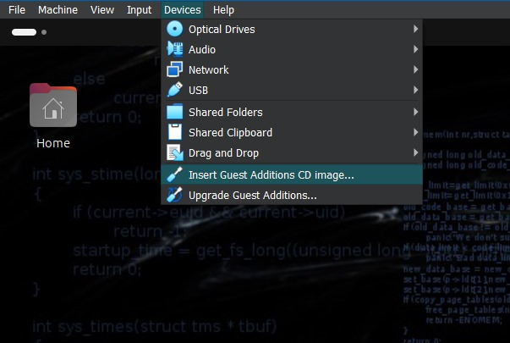

Step 2 : Onecs it mounted Open File manager see the CD Icon on side bar

Step 3 : open File in CD lcon Copy All Files , And Past in Documents Folder

Step 4 : Open Terminal are Press (CTRL+ALT+T) in Your KeyBoard

Step 5 : Navigate to Documents To Do that cd Dcouments

Step 6 : type ls,

Step 7 : Need to install VBoxLinuxAddition.run

Step 8 :sudo chmod 777 VBoxLinuxAddition.run press Enter

Step 9 : to execute Type sudo ./VboxLinuxAddition.run Press Enter

Step 10 : Restart the VM Type reboot

