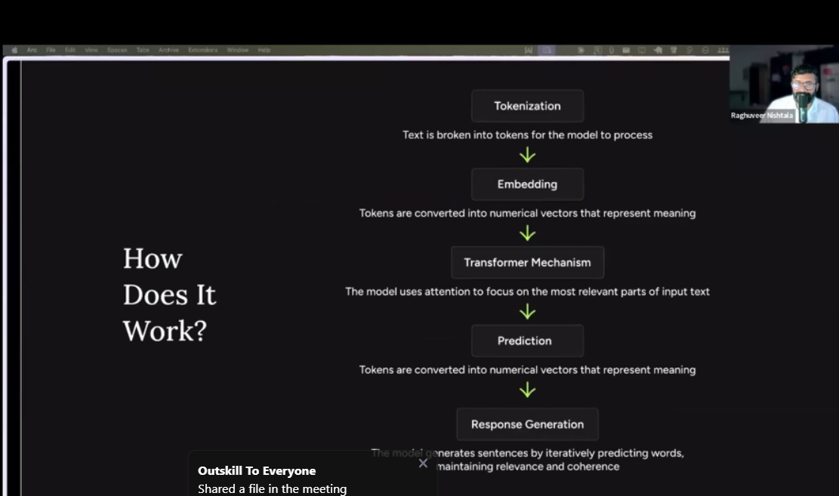

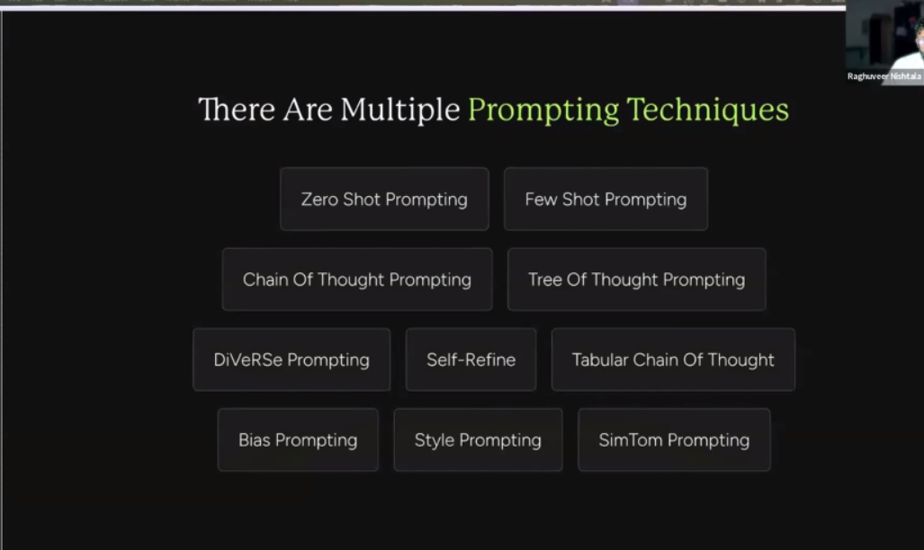

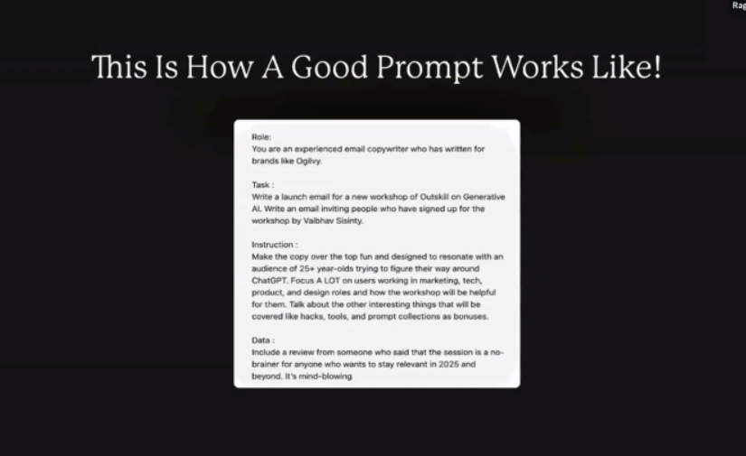

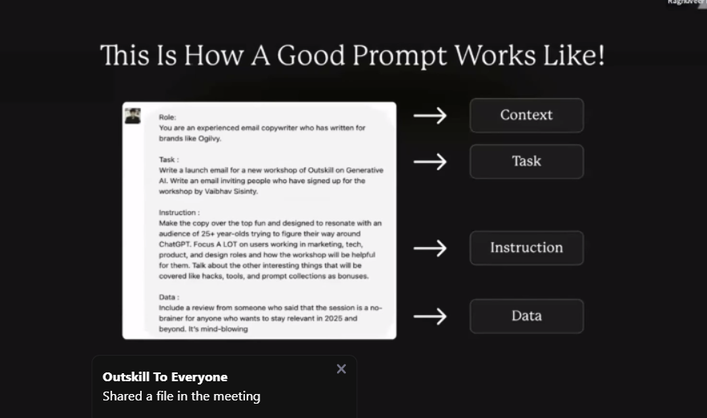

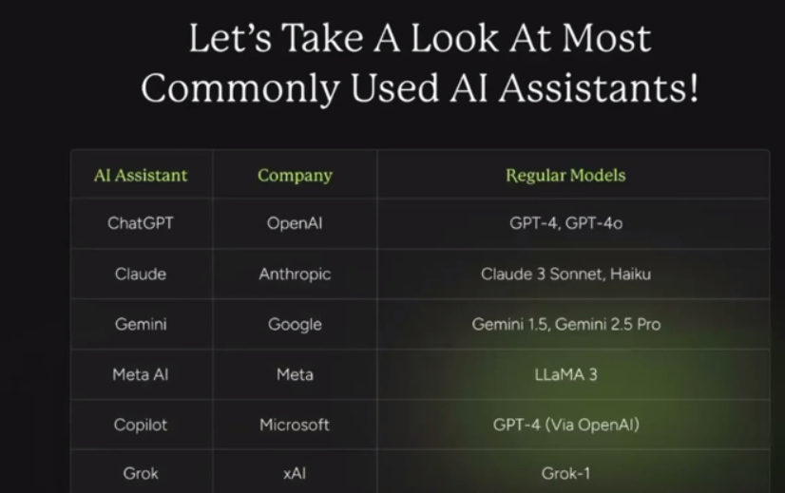

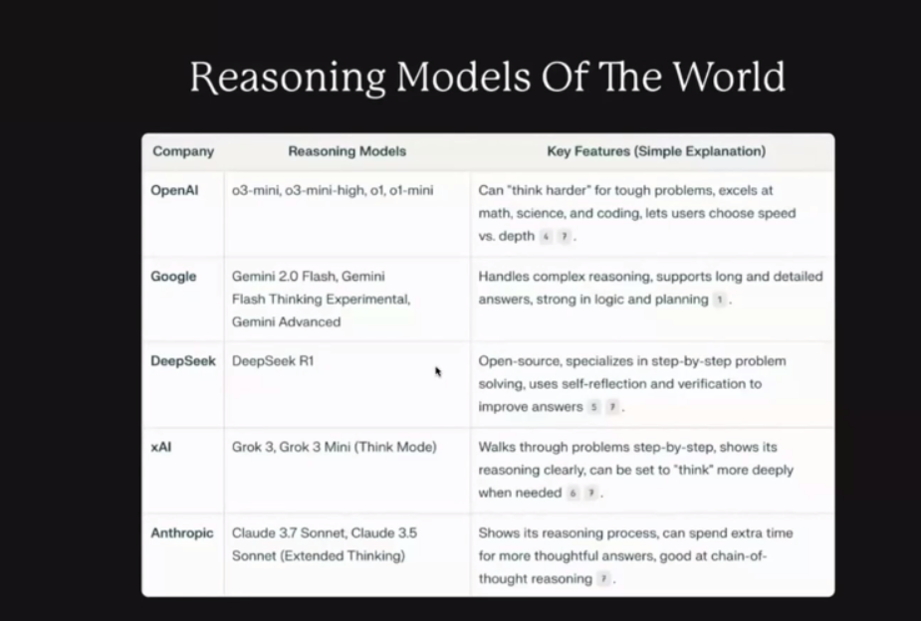

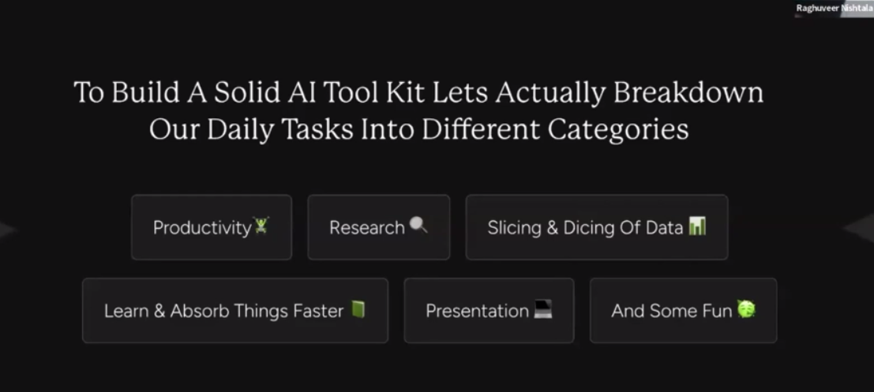

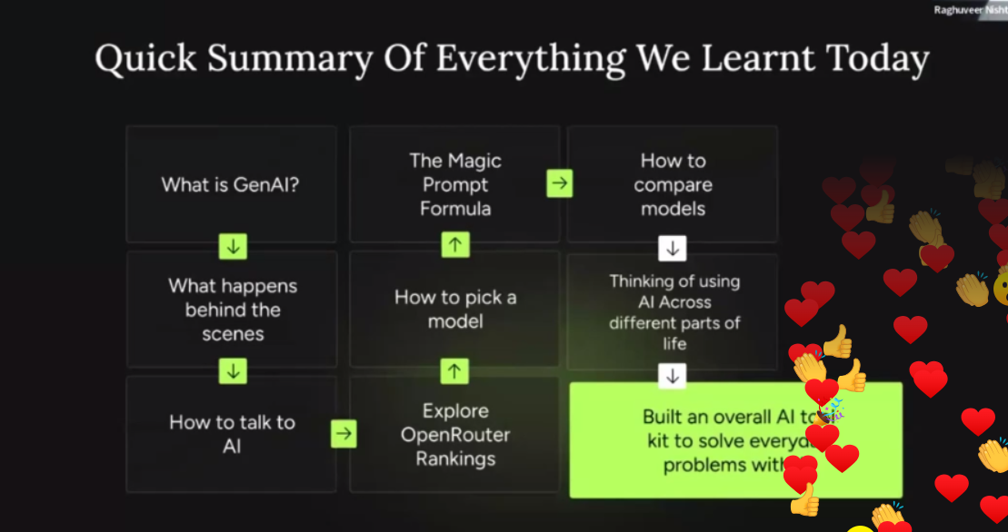

OutSkill's Generative AI Mastermind: Session 1 Resource Guide
Welcome, and congratulations on completing the first foundational session of the OutSkill Generative AI Mastermind!
What you've learned today is the critical launchpad for everything we will explore over the next sessions. This document is your personal guide to consolidate the core concepts, tools, and strategic insights we covered.
Think of today as building the ground floor of a skyscraper. We've laid the essential foundation understanding the AI revolution, defining your future role as an AI Generalist, and mastering the core mechanics of interacting with AI.
Review these materials, as they will be central to the advanced applications and hands-on building we will dive into next.

Part 1: The AI Revolution & The Future of Work
We are in the midst of a profound shift driven by two forms of artificial intelligence: Generative AI and Agentic AI.
- Generative AI: The creative engine. This is AI that focuses on generating new, original content—from text and code to complex data analysis. It's your co-creator and a powerful tool for brainstorming, drafting, and producing.
- Agentic AI: The executor. This is the next evolution, where AI systems can autonomously understand a goal, devise a plan, and execute a series of tasks to achieve it. Agentic AI is about doing and accomplishing, moving from a simple tool to a proactive collaborator.
This technological wave is fundamentally reshaping the job market. The narrative isn't about human replacement, but about human augmentation. The professionals who thrive will be those who learn to leverage AI as a powerful partner to amplify their intelligence, creativity, and efficiency.

Part 2: The Rise of the AI Generalist
In this new AI-first world, the most critical role is no longer the siloed specialist but the versatile AI Generalist.
An AI Generalist is a full-stack problem solver. They possess a broad and practical understanding of AI technologies and excel at applying the right tools to solve complex business challenges. They are the essential link between AI's technical potential and real-world value.
Key Traits of an AI Generalist:
- Broad AI Model Knowledge: A deep familiarity with the landscape of AI models and their unique capabilities.
- Strategic Application: The ability to discern which AI tool is best suited for a specific task to maximize efficiency and quality.
- Solution-Oriented Mindset: A relentless focus on building tangible solutions and driving measurable results with AI.
- Cross-Disciplinary Expertise: A solid understanding across key business domains, including Data, Technology, Product, Design, Marketing, and Management.

Part 3: Your Mastermind Roadmap to Becoming an AI Generalist
This two-day mastermind is structured to guide you through a transformative journey. Here are the five levels we are working to master:
- Level 1: The Foundations (Our Focus in Session 1)
  - Learn to communicate effectively with AI through expert prompting and begin building your personal toolkit of high-utility AI applications.
- Level 2: The Workflow Architect
  - Go beyond single commands. Learn to design sophisticated prompting systems and chain multiple tools into powerful, automated workflows to tackle complex, multi-step challenges.
- Level 3: The Creator's Playground
  - Dive deep into the world of multimodal generative AI. This is where you learn to apply AI to various creative and content-generation tasks across different media.
- Level 4: The Agent Builder
  - Make the leap from using AI to managing AI. Here, you'll learn to build, deploy, and oversee autonomous AI agents that can think, act, and amplify your efficiency by orders of magnitude.
- Level 5: The Vibe Coder
  - Bring it all together. You will learn to use no-code platforms fused with AI to architect and launch full-stack solutions for real-world business problems, innovating at speed without writing code.

Part 4: Core Skill - Mastering Prompt Engineering
The quality of your AI-generated output is a direct reflection of your input. A meticulously structured prompt is the key to unlocking high-quality, relevant results.
The Magic Prompt Formula
For consistent and superior results, use this four-part structure:
- Role: Define the AI's persona. (e.g., "You are a seasoned marketing strategist specializing in B2B SaaS.") This anchors its expertise and tone.
- Task: State your objective clearly and directly. (e.g., "Develop a three-month content marketing plan.")
- Instruction: Provide detailed constraints and guidelines. Specify the format, length, target audience, key points to cover, and anything to exclude.
- Data: Supply the necessary context. This could be competitor analysis, product descriptions, or customer feedback that the AI needs to perform the task.
Advanced Prompting Techniques
- Zero-Shot Prompting: A direct request without prior examples.
- Few-Shot Prompting: Providing a few input/output examples to guide the AI's response format.
- Chain-of-Thought (CoT) Prompting: Asking the model to "think step-by-step" to improve its reasoning on complex problems.
- Self-Refine: Instructing the model to review and improve its own generated response based on specific criteria.

Part 5: Core Skill - The AI Toolkit (Model & Tool Exploration)
A skilled AI Generalist knows their tools inside and out.
How Large Language Models (LLMs) Work: A Quick Recap
- Tokenization: Your prompt is broken down into smaller units (tokens).
- Embeddings: Each token is converted into a numerical representation of its meaning.
- Self-Attention (The "Transformer"): The model identifies and prioritizes the most important parts of your prompt to understand the core context.
- Prediction: Using its vast training, the model predicts the most probable next token in a sequence.
- Response Generation: It strings these predictions together, word by word, to form a complete and coherent response.
Common AI Assistants & Their Models
- ChatGPT (OpenAI): Models: GPT-5
- Gemini (Google): Models: Gemini 1.5 Pro, Gemini 2.5 Pro.
- Claude (Anthropic): Models: Claude 3 Sonnet, Claude 3 Haiku.
- Meta AI (Meta): Model: LLaMA 3.
- Copilot (Microsoft): Leverages OpenAI's GPT-4.
- Grok (xAI): Model: Grok-1.
Powerful Reasoning Models
For tasks requiring deep logic and problem-solving, these models are your go-to:
- OpenAI: o3-mini models for complex math, science, and coding challenges.
- Google: Gemini Advanced for intricate reasoning and strategic planning.
- DeepSeek: An open-source model skilled at step-by-step problem-solving.
- xAI: Grok 3 Mini, which can articulate its reasoning process.
- Anthropic: Claude 3.5 Sonnet (with Extended Thinking) excels at chain-of-thought reasoning.
Your Curated AI Tool Stack (From Session 1)
Productivity & Workflow Automation
- **Fireflies.ai:** Your AI meeting assistant for automated recording, transcription, and summarization.
- Gemini (in Google Workspace): A powerful co-pilot within your Google apps for summarizing emails, drafting documents, and more.
- Emily: A versatile AI assistant for streamlining a variety of productivity tasks.
Research & Information Synthesis
- Perplexity AI: An "answer engine" for direct, well-cited answers synthesized from web sources.
- Writesonic: A multifaceted AI assistant useful for both writing and conducting research, including SEO audits.
- NotebookLM (Google): A personal AI research tool that becomes an expert on your uploaded source documents.
Data Slicing & Analysis
- **Numerous.ai:** An AI add-on for spreadsheets that automates data analysis, cleaning, and manipulation.
- Claude (Anthropic): Exceptionally strong at analyzing and extracting insights from large documents and complex datasets.
Building Distribution & Marketing
- Supergrow: A specialized AI tool for optimizing and scaling your LinkedIn presence.

Session 1 Recap & Looking Ahead
Today, you've built the crucial first layer of your AI Generalist skill set. We've defined the future of work, established your role within it, and learned the fundamental language of AI through advanced prompting and tool exploration.
Get ready, because in our upcoming sessions, we will build directly on this foundation. We will move from understanding to doing—architecting complex workflows, building autonomous agents, and designing full-stack solutions.
👉 Here are all the prompts that have been used in the session :
- Magic Prompt Formulae & Email Crafting
Tools Used: ChatGPT 4o, Claude
Email to subscribers :
Write an email to 10k subscribers inviting them to the Generative AI 2-day Mastermind by Outskill.
—
You are an experienced email copywriter who has written for brands like Ogilvy.

Write a launch email for a new workshop of Outskill on Generative AI. Write an email inviting people who have signed up for the workshop by Vaibhav Sisinty.

Make the copy over the top fun and designed to resonate with an audience of 25+ year-olds trying to figure their way around ChatGPT. Focus A LOT on users working in marketing, tech, product, and design roles and how the workshop will be helpful for them. Talk about the other interesting things that will be covered like hacks, tools, and prompt collections as bonuses.

Include a review from someone who said that the session is a no-brainer for anyone who wants to stay relevant in 2025 and beyond. It’s mind-blowing

- Summarise a Youtube Video using AI
YT Video Summary
Link used: https://youtu.be/LPZh9BOjkQs?si=KIBO7BGvvxF1wJaB
Tools Used: Gemini
Summarize this YouTube video in bullet points, highlighting the key takeaways, main topics covered, and any actionable insights. Keep it concise and structured. Here's the video link: [<https://www.youtube.com/watch?v=LPZh9BOjkQs.](https://www.youtube.com/watch?v=LPZh9BOjkQs)>
- Generate Images Using AI
Tools Used: Grok
Image Gen Using AI Prompt:
Photorealisic image of elon musk looking super angry on sam atlman inside a cage both are bruised and are in middle of a cage fight
- Compose & Reply Emails Using AI
Tools Used: Gemini
Email Reply Using AI Prompt:
Compose & draft an email reply to a potential client following up on our discussion about AI-driven hiring solutions. Keep it professional but engaging, and highlight how our solution can improve their recruitment process. Mention that I'm available for a call next week.
- Brainstorming Using Deepseek R1
Tools Used: Deepseek R1/ ChatGPT
Brainstorming Prompt
"I have ₹10,000 to invest, along with a laptop and internet access for 30 days. I want to start a home-based business that operates entirely online, without requiring me to step outside. Please provide three business ideas, each with a detailed plan on how to grow my investment from ₹10,000 to ₹1,00,000 within 30 days. The business should not be service-based, and since I have no coding skills, it must be achievable without writing code or using no-code tools. Additionally, the plan should not rely on running ads, as I have no experience in ad management.."
- Job Hunting using AI
Tools Used: ChatGPT
Prompts 👇
Prompt :

[CV👩‍💼] Prompt 1A:
You are an expert in marketing. I would like you to review this CV and generate a summary that highlights the most impressive parts of the resume in bullet points

[CV👩‍💼 Prompt 1B:
Using this summary, generate a LinkedIn summary to improve my visibilty and help me get a job in Growth

Rewrite this using emojis and make it fun. Should be 600 characters long.

[CV👩‍💼] Prompt 1C:
As my career adviser, I would like you to re-word the CV I have just given you. Please tailor it to the following job advert to maximise the chances of getting an interview. Include any keywords mentioned in the job post. Organise the structure, summary, and experience in a method you deem best for the desired outcome. The job advert: [INSERT JOB ADVERT]

[CV👩‍💼] Prompt 1D:
I would like you to create a table with three columns. The first column (experience required), list any desired experiences in the job advert that my CV doesn't show. In the second column (improvement) write a suggestion as to how I will be able to acquire that particular skill with no previous knowledge. In the third column (priority), rank the particular experience from 1 - 10 in importance for getting the desired job where 10 is essential and 1 is not required at all.

I want the output to be a table.
After this, We’ll use Gemini Voice Chat / ChatGPT to act as an interviewer and practice a mock interview.
- Research Intern at Your Service
Tools Used: Perplexity
Prompts 👇
I am interested in gaining a comprehensive understanding of the growing coffee market in India. Could you provide an in-depth analysis of the current state of the coffee market in India? Specifically, I would like to know:

1. What is the overall size and growth rate of the coffee market in India right now? Are there any notable trends or projections for the future?
2. Who are the major players in the Indian coffee market? Please include both domestic and international companies, and highlight any key differences in their strategies or market shares.
3. Is there potential for new businesses to enter the Indian coffee market? What are the barriers to entry, and what opportunities exist for new entrants?
4. What are the various channels through which coffee is sold in India? For example, how significant are retail stores, online platforms, cafes, and other distribution methods?
5. What types of coffee products are most popular among Indian consumers? Are there specific preferences for certain varieties (e.g., instant coffee, ground coffee, specialty coffee)?
6. How do cultural and regional differences within India influence coffee consumption patterns?
7. Are there any recent innovations or emerging trends in the Indian coffee market that are worth noting?
8. What are the consumer demographics for coffee in India? How do factors such as age, income level, and urban vs. rural location impact coffee consumption?
9. How does the Indian coffee market compare to other major coffee markets globally in terms of growth, consumer preferences, and competitive landscape?
- Create SEO friendly Content Using AI
Tools Used: Writesonic Topic: Future of Work in the AII era
Reference Links to add👇
<https://www.kdnuggets.com/role-ai-shaping-future-work>
<https://www.forbes.com/sites/solrashidi/2025/01/30/the-future-of-work-ai-and-workforce-integration-for-scalable-success/>
<https://www.pwc.com/us/en/services/ai/ai-and-the-future-of-work.html>
<https://www.mckinsey.com/capabilities/mckinsey-digital/our-insights/superagency-in-the-workplace-empowering-people-to-unlock-ais-full-potential-at-work>
- Excel Pro Using AI
Prompts:
Analyze the overall customer review and classify its sentiment as Positive, Neutral, or Negative.
Database 👇
https://docs.google.com/spreadsheets/d/1CNksRrUjL9j-IljKAkSb1w8OKHZO8KLlRGeie4hOXFY/edit?usp=sharing
- Data Analysis Using AI
From a CSV file :
**Data file: https://www.kaggle.com/datasets**
**Used in the workshop: https://www.kaggle.com/datasets/arnavsmayan/netflix-userbase-dataset/**
Go through the data and give me 5 insights that I can present to my boss for my upcoming marketing meeting so that he gets impressed by me and promotes me in the coming appraisal cycle.
- Image Analysis Using AI
From the Dashboard Image :
Image used :

Give me the top 5 insights from this image.
- Music Gen Using AI
Prompt 👇 :
Create a calm lo-fi chill track with smooth beats, mellow piano, and relaxing background sounds. The theme should help people focus and unwind while studying.
Here are all the tool & Their Links :
Tool Name | Dub Link
Whispr Flow | https://outskill.link/wisprflow
Gemini | https://outskill.link/gemini
Emily | https://outskill.link/emily
Fireflies | https://outskill.link/fireflies
ChatGPT | https://outskill.link/chatgpt
Claude | https://outskill.link/claude
Phot AI | https://outskill.link/phot
Supergrow | https://outskill.link/supergrow
Numerous AI | https://outskill.link/numerous
Suno | https://outskill.link/suno
Notebook LM | https://outskill.link/notebook-lm
Social Sonic | https://outskill.link/socialsonic
Bolt | https://outskill.link/bolt
Vapi | https://outskill.link/vapi
Chronicle | https://outskill.link/chronicle
Humanic AI | https://outskill.link/humanic
Happenstance | https://outskill.link/happenstance
Perplexity Comet | https://outskill.link/perplexity-comet

Season 2

