GRC Application
User Manual — Auditor

Glimmora International
Generated: March 12, 2026
Version 1.0

Note: This document is auto-generated and confidential. Do not distribute without authorization.

Getting Started

Logging In
To access the application:
- Open your web browser and navigate to the application URL provided by your administrator.
- Enter your username and password on the login page.
- Click "Sign In" to access the application.
- Upon successful login, you will be redirected to your default dashboard.

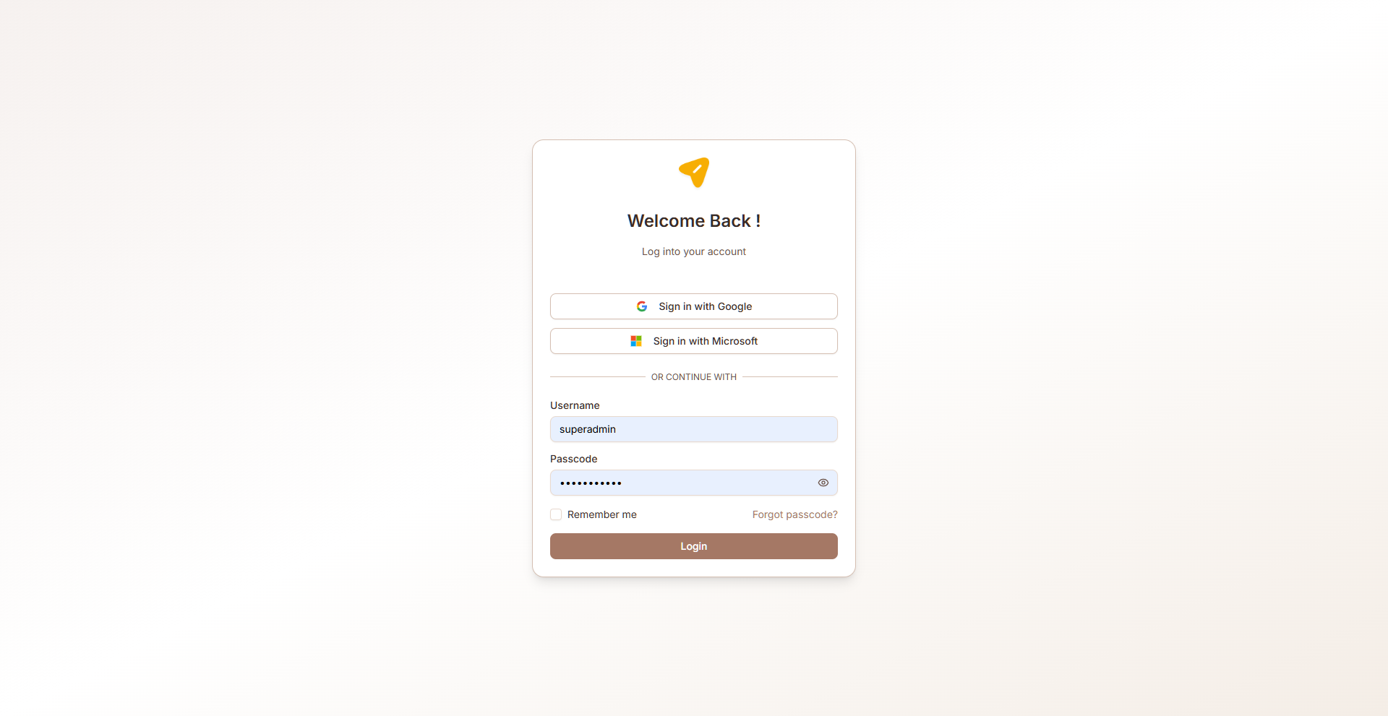
Figure: Login page

Navigation
The GRC module uses a sidebar navigation menu on the left side of the screen. Each menu item corresponds to a functional area. Your visible menu items depend on your assigned role and permissions.
Key navigation elements:
- Sidebar menu — Primary navigation to all accessible pages
- Breadcrumb trail — Shows your current location within the application
- Header bar — Contains user profile, notifications, and language switcher
- Language selector — Switch between English, Arabic (RTL), and Latvian

Multi-Language Support
The application supports three languages:
- English (default) — Left-to-right layout
- Arabic — Right-to-left (RTL) layout with full UI mirroring
- Latvian — Left-to-right layout
To change the language, use the language selector in the header. All labels, buttons, and system text will be translated. User-entered data (vendor names, risk descriptions, etc.) is also translated dynamically when records are created or edited.

Common UI Patterns
Throughout the application, you will encounter these common interface patterns:
- Data tables — Sortable, filterable lists with pagination and search
- Dialog forms — Modal forms for creating and editing records
- Accordion views — Expandable/collapsible sections for detailed information
- Status badges — Color-coded labels indicating record status
- Action buttons — Create, Edit, Delete, Export, and role-specific actions
- Toast notifications — Brief success/error messages after actions
- Charts — Bar charts, pie charts, and progress indicators on dashboards

Role: Auditor
Performs audit fieldwork, documents observations, creates findings, and gathers evidence during audit engagements.

Accessible Modules
- Internal Audit (fieldwork, findings)
- Compliance (view controls/evidence)

Key Capabilities
- Conduct assigned fieldwork tasks
- Create work papers and document observations
- Upload audit evidence and supporting files
- Create draft findings from fieldwork
- Record interview notes
- View compliance controls and evidence for testing
- View audit planning information for assigned engagements

Compliance
Manage compliance frameworks, controls, governance documents, evidence collection, exceptions, KPIs, risk matrices, and reporting. This module provides comprehensive compliance lifecycle management aligned with industry standards like ISO 27001, NIST, SOC 2, and GDPR.

Framework Selection
Browse and adopt compliance frameworks (ISO 27001, NIST, SOC 2, GDPR, etc.). Selected frameworks populate controls and requirements. Track compliance percentage, policy percentage, and evidence percentage per framework.
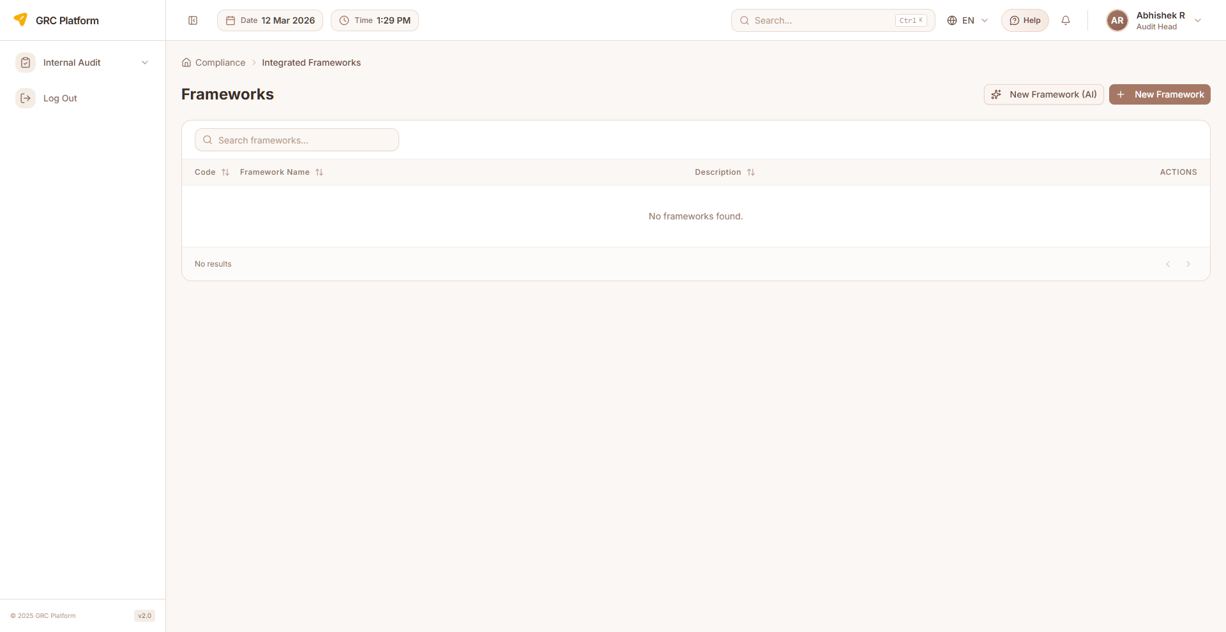
Figure: Framework Selection page view

Features & Capabilities
- Browse available compliance frameworks (cards/grid view)
- View framework details (code, name, description, type, status, country, industry)
- Select/adopt frameworks for your organization
- Track compliance percentage, policy percentage, evidence percentage
- Custom vs. standard framework differentiation
- Import framework templates from Excel
- Export framework data
- Download framework template
- Framework subscription/access management
- Pagination support

Navigation Path
Sidebar → Compliance → Frameworks

Control Assessment
Manage and assess compliance controls derived from adopted frameworks. Each control maps to framework requirements and can be linked to evidence and risks.
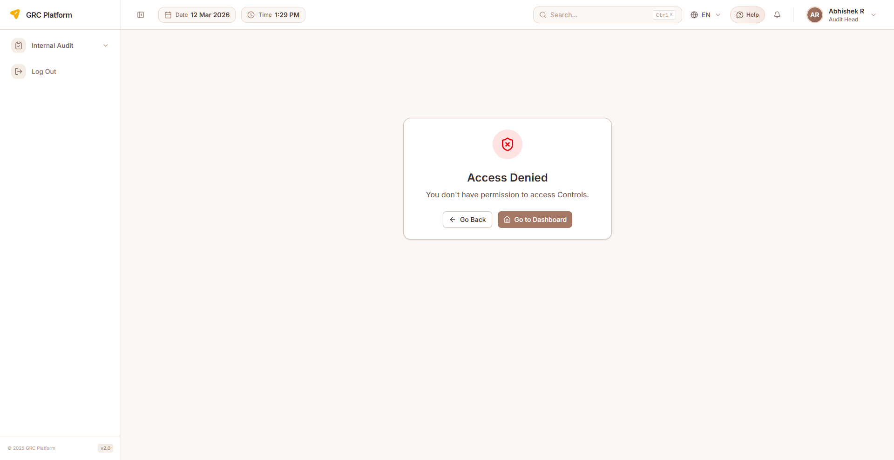
Figure: Control Assessment page view

Features & Capabilities
- List all controls with status indicators (Compliant, Partially Compliant, Non-Compliant, Not Assessed)
- View control details (code, name, description, domain, category, status)
- Assess control effectiveness
- Link controls to evidence items
- Map controls to risks
- Multi-select column filtering
- Filter by framework, domain, status
- Bulk assessment capabilities
- Create, edit, delete controls
- Pagination support

Navigation Path
Sidebar → Compliance → Controls

Governance Documents
Manage policies, procedures, standards, and guidelines. Track document lifecycle including creation, review, approval, and version history. Documents link to frameworks and controls.
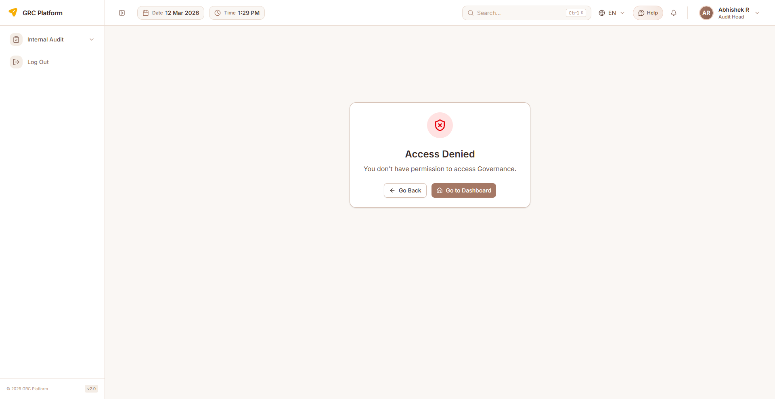
Figure: Governance Documents page view

Features & Capabilities
- List all governance documents with version and status
- Create new documents (policy, procedure, standard, guideline)
- Document properties: code, name, version, document type
- Edit document content and metadata
- Document review and approval workflow
- Version history tracking
- Set review schedules and due dates (policy recurrence)
- Assign document owners and reviewers
- Upload supporting files/attachments
- Link documents to frameworks and controls
- Evidence attachment support
- Delete documents
- Download documents

Navigation Path
Sidebar → Compliance → Governance

Evidence Management
Collect, manage, and track evidence demonstrating compliance with controls. Evidence items can be linked to specific controls, uploaded as files, and go through review workflows.
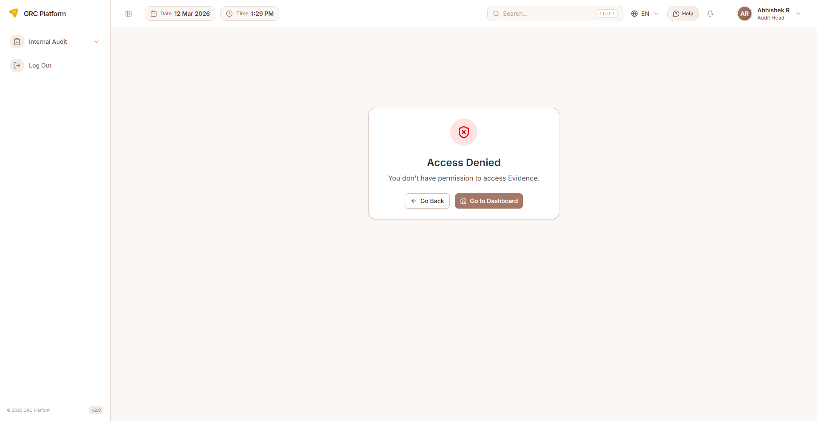
Figure: Evidence Management page view

Features & Capabilities
- List evidence items with status and due dates
- Create evidence requests and assign to contributors
- Upload evidence files (documents, screenshots, exports)
- Link evidence to specific controls and frameworks
- Track status (Pending, Submitted, Approved, Rejected)
- Set evidence collection due dates
- Review and approve/reject submitted evidence
- AI-powered evidence suggestions
- Evidence versioning
- Filter by status, assignee, control
- Delete evidence records

Navigation Path
Sidebar → Compliance → Evidence

Exceptions
Document and track compliance exceptions — situations where a control cannot be fully implemented and a risk acceptance or compensating control is applied.
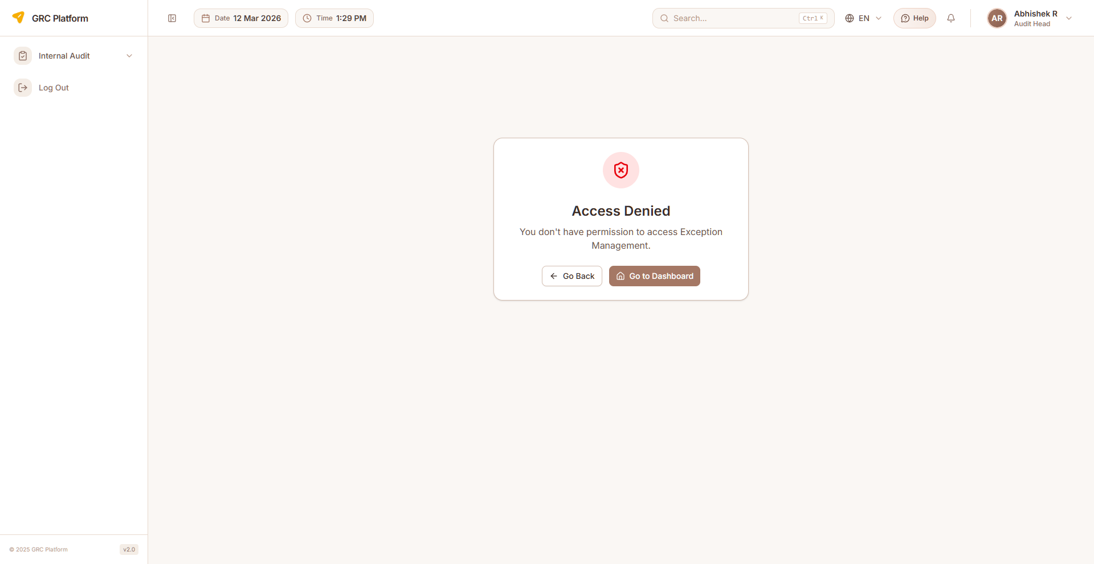
Figure: Exceptions page view

Features & Capabilities
- List all compliance exceptions with status indicators
- Create exception requests with justification
- Exception properties: code, description, severity, status
- Specify compensating controls
- Set exception expiry/target remediation dates
- Department and owner assignment
- Track exception approval status (open, in-progress, closed)
- Visual status indicators (pie chart, status timeline)
- Edit and delete exceptions
- Link exceptions to controls
- Pagination support

Navigation Path
Sidebar → Compliance → Exceptions

KPIs
Define and track Key Performance Indicators for compliance programs. Monitor compliance health through measurable metrics with targets and thresholds.
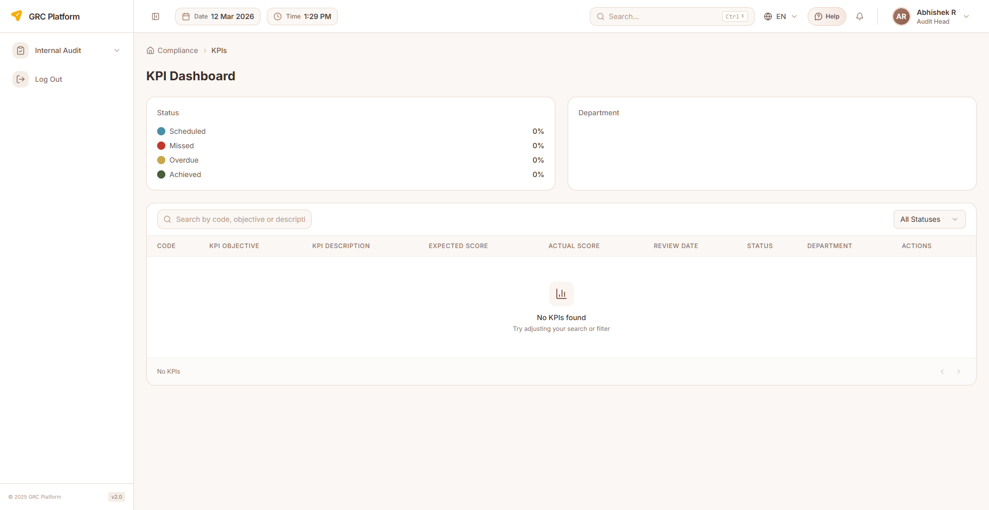
Figure: KPIs page view

Features & Capabilities
- List compliance KPIs with current values and targets
- KPI properties: code, objective, description, expected score, actual score
- Department association for each KPI
- Evidence linkage to KPIs
- Review date tracking
- Status tracking: Scheduled, Missed, Overdue, Achieved
- Visual indicators for KPI health
- Filter by status and department
- Search KPIs

Navigation Path
Sidebar → Compliance → KPIs

Risk Matrix
Map relationships between risks and controls. Visualize which controls mitigate which risks and identify gaps in coverage.
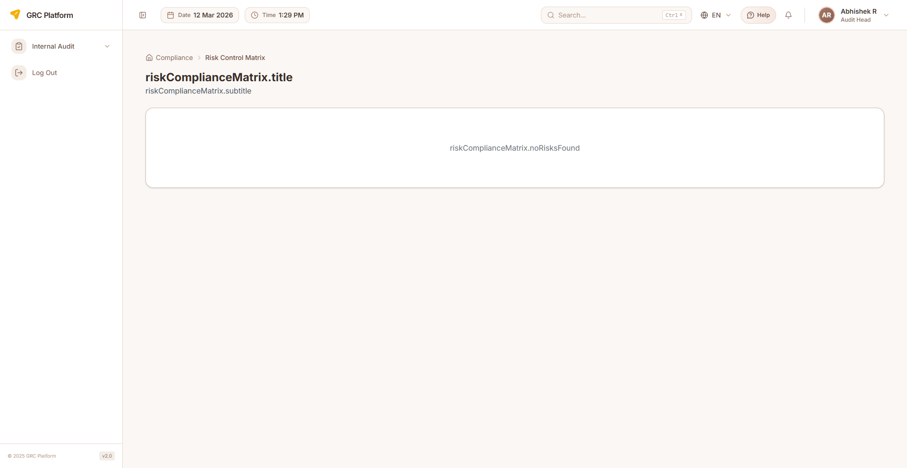
Figure: Risk Matrix page view

Features & Capabilities
- Matrix view of risks vs controls
- Link/unlink controls to risks
- Identify unmitigated risks (gaps)
- View control effectiveness per risk
- Status indicators (compliant, non-compliant, partial compliant, not applicable)
- Collapsible risk groups
- Residual risk assessment view
- Search and filter

Navigation Path
Sidebar → Compliance → Risk Matrix

Compliance Reports
Generate compliance reports and analytics. View compliance dashboard with framework coverage metrics.

Features & Capabilities
- Compliance reporting and analytics
- Compliance dashboard view
- Framework coverage metrics
- Export and download capabilities

Navigation Path
Sidebar → Compliance → Reports

Compliance Master Data
Centralized configuration for compliance definitions including framework definitions, control templates, domain/category definitions, evidence templates, and governance templates.

Features & Capabilities
- Framework definitions and templates
- Control templates
- Domain and category definitions
- Evidence templates
- Governance document templates

Navigation Path
Sidebar → Compliance → Master Data

Internal Audit
Plan, execute, and report on internal audits. Manage the complete audit lifecycle from universe definition through risk identification, audit planning, fieldwork, findings, corrective actions, and final reporting.

Audit Dashboard
Overview of audit function with risk statistics, audit statistics, CAPA status by department, annual audit plan calendar, and auditor schedule visualization.
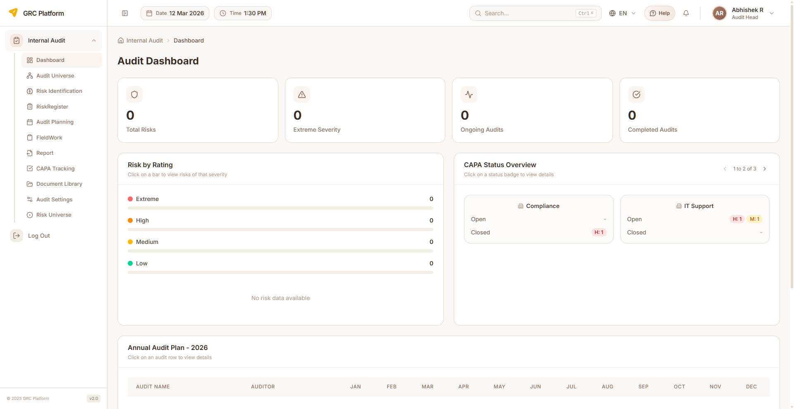
Figure: Audit Dashboard page view

Features & Capabilities
- Risk statistics: total, extreme, high, medium, low
- Audit statistics: ongoing, completed, planned
- CAPA status by department (open/closed breakdown)
- Annual audit plan calendar
- Auditor schedule visualization
- Department-wise audit metrics

Navigation Path
Sidebar → Internal Audit → Dashboard

Audit Universe
Define the complete set of auditable entities, processes, and functions. This forms the basis for risk-based audit planning.
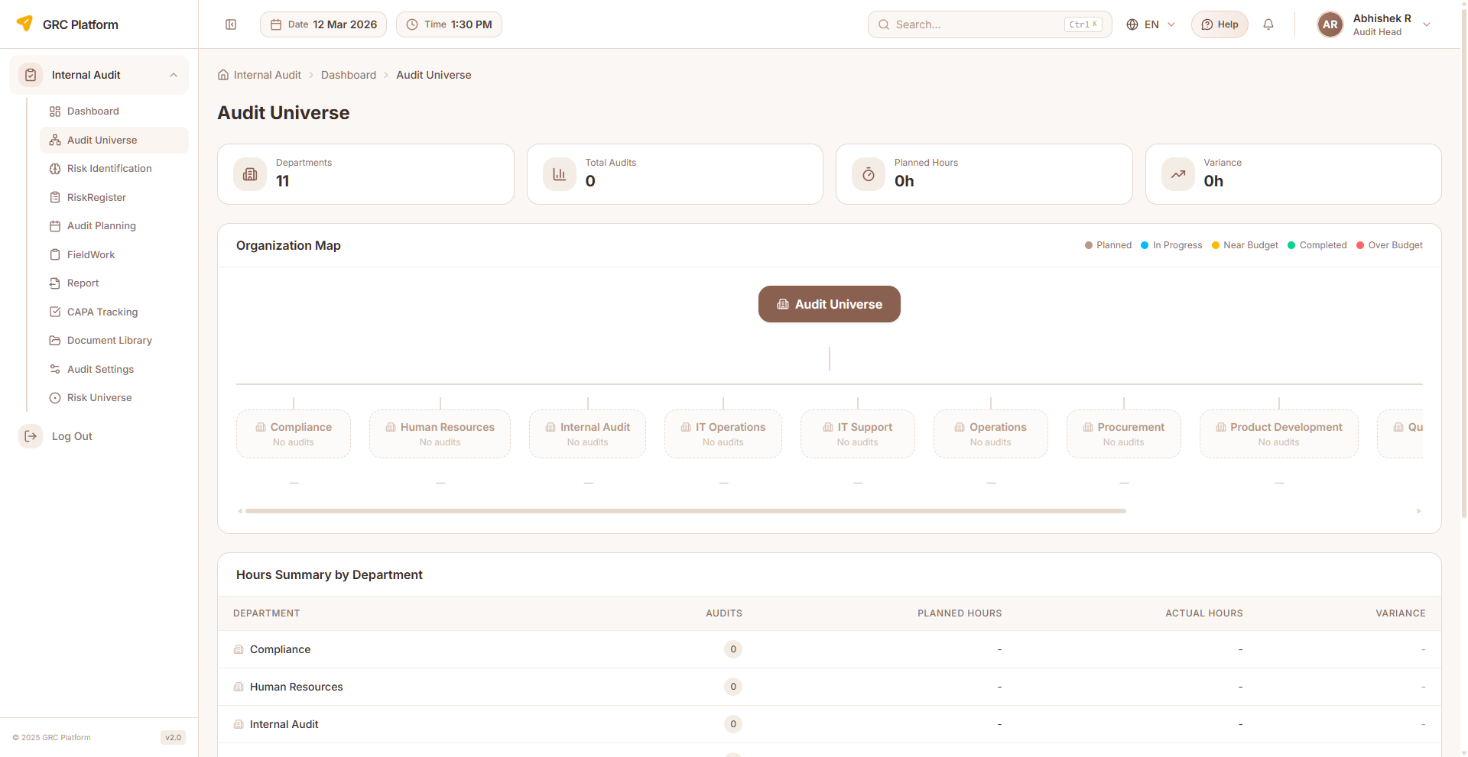
Figure: Audit Universe page view

Features & Capabilities
- Department-based audit scope view
- Display departments with associated audits
- Audit metrics: planned hours vs actual hours
- Status tracking per audit
- Timeline view (start/end dates)
- Search and navigate to audit details

Navigation Path
Sidebar → Internal Audit → Audit Universe

Risk Identification
Identify and document risks for audit planning purposes using structured risk entry and assessment methodology.

Features & Capabilities
- Structured risk entry forms
- Assessment methodology configuration
- Create, edit, view risk entries
- Link risks to audit planning

Navigation Path
Sidebar → Internal Audit → Risk Identification

Audit Risk Register
Risk inventory specific to the audit function. Create risks manually or use AI-recommended risks feature.

Features & Capabilities
- List audit risks with risk ID, name, likelihood, impact
- Create risks manually or via AI recommendations
- Probability and impact assessment
- Audit category and type assignment
- Edit and delete risks
- Search and pagination

Navigation Path
Sidebar → Internal Audit → Risk Register

Audit Planning
Create and manage audit engagements. Define scope, objectives, timeline, assign audit team members, and link risks to audit plans.
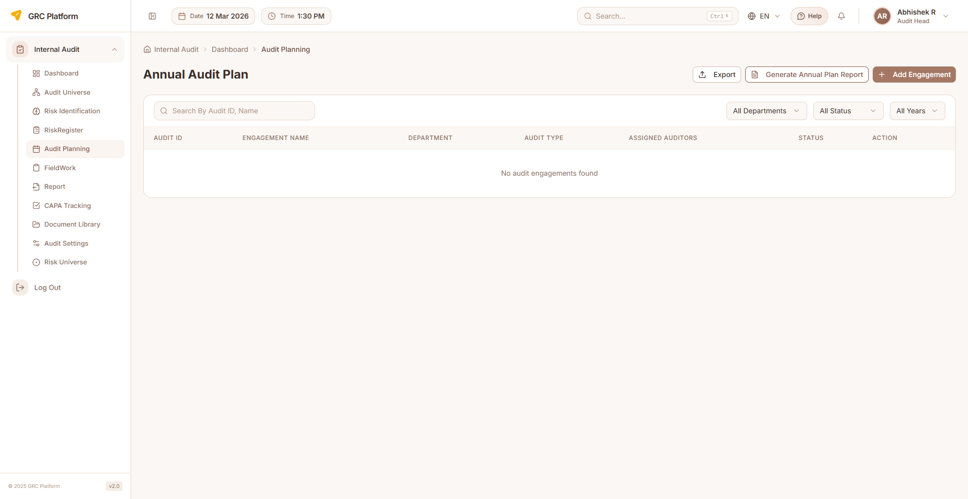
Figure: Audit Planning page view

Features & Capabilities
- Annual audit plan creation and management
- Create audit engagements (title, department, start/end dates)
- Assign auditors (single or multiple)
- Risk linkage to audit plan
- Planned hours tracking
- Track engagement status (Planned, In Progress, Completed, Cancelled)
- Edit and delete engagements
- Download and upload engagement documents
- Search and pagination

Navigation Path
Sidebar → Internal Audit → Audit Planning

Fieldwork
Execute audit fieldwork — conduct testing, gather evidence, document observations, and link findings to engagements.
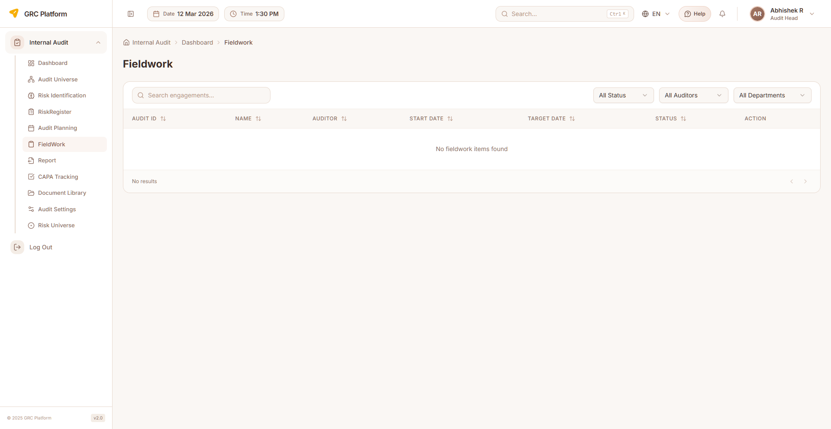
Figure: Fieldwork page view

Features & Capabilities
- List engagements with title, department, status, dates, auditor
- View assigned fieldwork tasks
- Create work papers and document observations
- Upload audit evidence and supporting files
- Record interview notes
- Track fieldwork completion status
- Add findings from fieldwork
- Filter by department, status, auditor
- Pagination support

Navigation Path
Sidebar → Internal Audit → Fieldwork

Findings
Document and manage audit findings identified during fieldwork. Classify by severity, assign owners, and track remediation progress.

Features & Capabilities
- List all audit findings with severity and status
- Create findings (finding ID, title, description, severity, recommendation)
- Classify severity: Critical, High, Medium, Low, Informational
- Assign finding owners for remediation
- Set remediation due dates
- Track status: Open, In Progress, Closed, Overdue
- Link findings to controls and risks
- Edit and delete findings

Navigation Path
Sidebar → Internal Audit → Findings (via Fieldwork)

CAPA Tracking
Track Corrective and Preventive Actions (CAPA) arising from audit findings. Monitor implementation, verify effectiveness, and manage escalations.
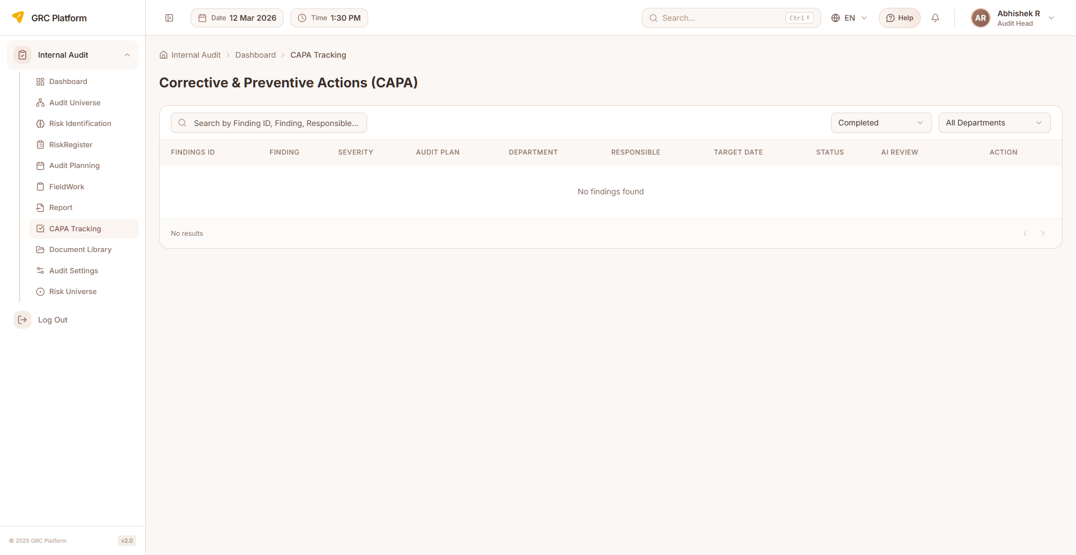
Figure: CAPA Tracking page view

Features & Capabilities
- List all CAPA items with status, severity, and due dates
- Create CAPA entries linked to findings
- Define corrective and preventive actions
- Action tracking: type, description, completion percentage, status
- Assign responsible persons and target completion dates
- Track implementation progress
- Comments and discussion support
- File attachments for evidence
- Verify action effectiveness
- Escalate overdue CAPAs
- Filter by status
- Search and pagination

Navigation Path
Sidebar → Internal Audit → CAPA Tracking

Audit Reports
Generate and manage audit reports. Compile findings, recommendations, management responses, and conclusions into formal audit reports.
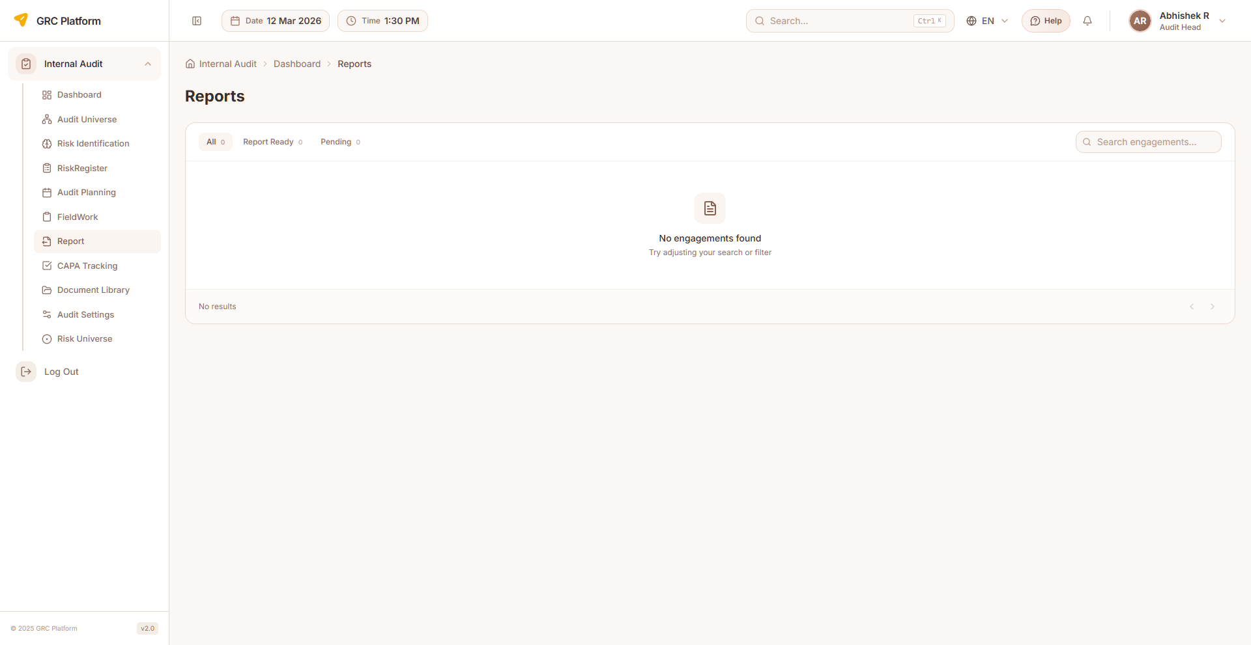
Figure: Audit Reports page view

Features & Capabilities
- List all audit reports with status
- Generate reports from engagement data
- Report properties: report code, title, executive summary, scope, objectives, methodology
- Include observations, recommendations, management response
- Conclusion and overall result
- Auditee comments and response
- Status: Draft, Submitted, Approved
- Report preview and PDF generation
- Download reports
- Search and pagination

Navigation Path
Sidebar → Internal Audit → Report

Document Library
Centralized audit document repository for uploading, organizing, and managing audit-related documents.

Features & Capabilities
- Document upload and organization
- File management
- Centralized document repository

Navigation Path
Sidebar → Internal Audit → Document Library

Audit Settings
Configure the audit function including audit types, departments, periodicity, processes, risk assessment matrices, categories, control nature, user management, and escalation policies.

Features & Capabilities
- Audit Types — define types (internal, external, compliance, operational)
- Departments — department management
- Periodicity — audit frequency/cycle configuration
- Process — process and sub-process definitions for audit scope
- Risk Assessment — probability and impact matrices
- Categories — audit categories
- Nature of Controls — control types and characteristics
- User Management — audit team member assignment and roles
- Escalation — escalation policies for audit findings

Navigation Path
Sidebar → Internal Audit → Settings

Permissions Reference
Each role has specific permissions that determine what actions they can perform. The permission system uses a resource:action pattern.

Actions
- view — Read-only access to see data
- create — Ability to create new records
- edit — Ability to modify existing records
- delete — Ability to remove records
- approve — Ability to approve/reject submissions

Permission Scopes
- Global — Access to all records across the organization
- Department — Access limited to records within the user's department
- Own — Access limited to records owned by or assigned to the user

How Permissions Work
When you log in, your assigned role determines which sidebar menu items are visible and which actions you can perform on each page. If a menu item or button is not visible, it means your role does not have the required permission.
Permissions are enforced at both the UI level (hiding unavailable options) and the API level (blocking unauthorized requests). This ensures data security regardless of how the application is accessed.

Glossary

GRC
Governance, Risk, and Compliance — integrated approach to managing governance, risk management, and compliance activities across the organization.

BIA
Business Impact Analysis — process of determining critical business processes and the potential impact of disruption.

RTO
Recovery Time Objective — maximum acceptable time to restore a process after disruption.

RPO
Recovery Point Objective — maximum acceptable data loss measured in time.

BCP
Business Continuity Plan — documented procedures for maintaining business operations during and after a disaster.

CAPA
Corrective and Preventive Action — actions taken to eliminate the causes of non-conformities and prevent recurrence.

CIA
Confidentiality, Integrity, Availability — three pillars of information security used for asset classification.

Control
Measure that modifies risk — can be a policy, procedure, guideline, practice, or organizational structure.

Finding
Result of an audit that identifies a gap between the current state and the expected criteria.

Risk Register
Centralized record of identified risks with their analysis, treatment plans, and current status.

Risk Matrix
Visual tool mapping risks against controls to identify coverage and gaps.

Framework
Structured set of guidelines and best practices for managing compliance (e.g., ISO 27001, NIST, SOC 2, GDPR).

Audit Universe
Complete set of auditable entities, processes, and functions within the organization.

Audit Engagement
A planned and executed audit activity with defined scope, objectives, and team.

Evidence
Documentation, records, or artifacts that demonstrate compliance with controls and requirements.

Exception
Documented deviation from a control requirement, with justification and compensating controls.

KPI
Key Performance Indicator — measurable metric for tracking compliance program health.

