GRC Application
Complete User Manual — All Roles

Glimmora International
Generated: March 12, 2026
Version 1.0

Note: This document is auto-generated and confidential. Do not distribute without authorization.

Getting Started

Logging In
To access the application:
- Open your web browser and navigate to the application URL provided by your administrator.
- Enter your username and password on the login page.
- Click "Sign In" to access the application.
- Upon successful login, you will be redirected to your default dashboard.

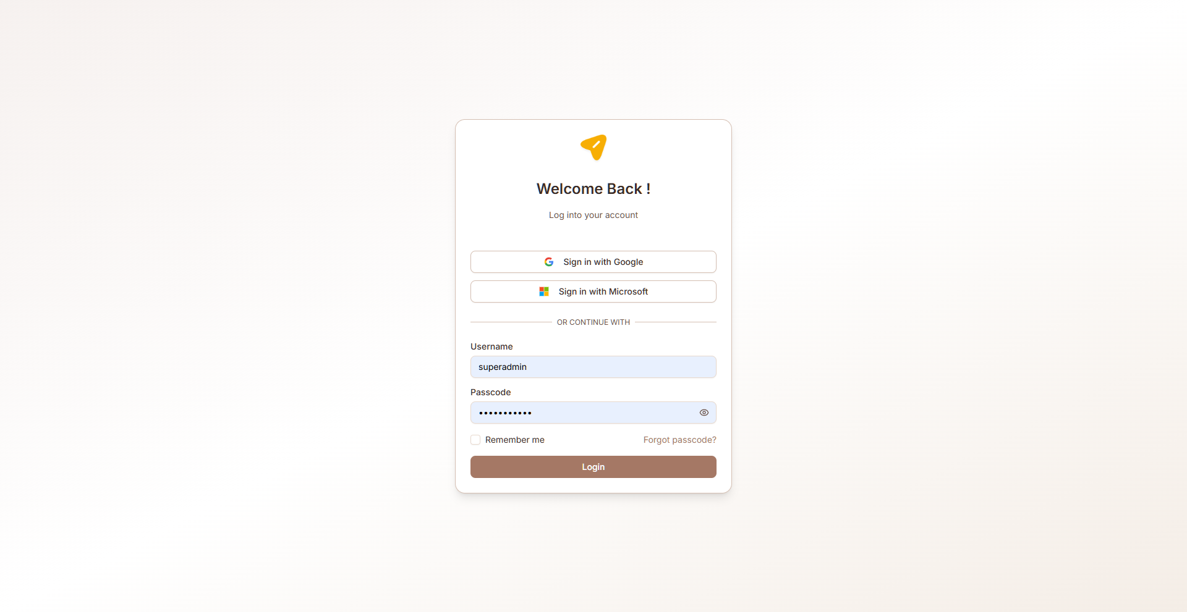
Figure: Login page

Navigation
The GRC module uses a sidebar navigation menu on the left side of the screen. Each menu item corresponds to a functional area. Your visible menu items depend on your assigned role and permissions.
Key navigation elements:
- Sidebar menu — Primary navigation to all accessible pages
- Breadcrumb trail — Shows your current location within the application
- Header bar — Contains user profile, notifications, and language switcher
- Language selector — Switch between English, Arabic (RTL), and Latvian

Multi-Language Support
The application supports three languages:
- English (default) — Left-to-right layout
- Arabic — Right-to-left (RTL) layout with full UI mirroring
- Latvian — Left-to-right layout
To change the language, use the language selector in the header. All labels, buttons, and system text will be translated. User-entered data (vendor names, risk descriptions, etc.) is also translated dynamically when records are created or edited.

Common UI Patterns
Throughout the application, you will encounter these common interface patterns:
- Data tables — Sortable, filterable lists with pagination and search
- Dialog forms — Modal forms for creating and editing records
- Accordion views — Expandable/collapsible sections for detailed information
- Status badges — Color-coded labels indicating record status
- Action buttons — Create, Edit, Delete, Export, and role-specific actions
- Toast notifications — Brief success/error messages after actions
- Charts — Bar charts, pie charts, and progress indicators on dashboards

Roles Overview
The following table summarizes all available roles and their primary responsibilities:

Role | Description | Key Access Areas
GRC Administrator | System-level administrator with full access to all GRC modules and system configuration. Manages cus... | GRC Administration, Organization, Compliance, Risk Management
Customer Administrator | Organization-level administrator who manages users, settings, and has full access to all GRC modules... | Organization, Compliance, Risk Management, Asset Management
Audit Head | Head of the internal audit function with full access to all audit activities. Oversees audit plannin... | Internal Audit (full access), Risk Management (view), Compliance (view), Organization (view)
Audit Manager | Manages audit engagements, assigns work to auditors, reviews fieldwork, oversees finding resolution,... | Internal Audit (planning, fieldwork, findings, CAPA, reports), Risk Management (view), Compliance (view)
Auditor | Performs audit fieldwork, documents observations, creates findings, and gathers evidence during audi... | Internal Audit (fieldwork, findings), Compliance (view controls/evidence)
Auditee | Subject of an audit who provides information, responds to findings, and implements corrective action... | Internal Audit (view own findings, CAPA response)
Reviewer | Cross-module reviewer who can view and review content across all GRC modules organization-wide. Limi... | Organization (view), Compliance (view/review), Risk Management (view), Asset Management (view)
Department Reviewer | Reviewer scoped to their assigned department. Can view and review data only within their department'... | Organization (dept view), Compliance (dept view), Risk Management (dept view), Asset Management (dept view)
Department Contributor | Contributor scoped to their assigned department. Can create and edit certain records within their de... | Compliance (dept contribute), Risk Management (dept contribute), Asset Management (dept contribute)

GRC Administrator
System-level administrator with full access to all GRC modules and system configuration. Manages customer accounts, system settings, and has unrestricted access to all functionality across all tenants.

Accessible Modules
- GRC Administration
- Organization
- Compliance
- Risk Management
- Asset Management
- Internal Audit

Key Capabilities
- Full CRUD access to all modules across all tenants
- Manage customer accounts (create, edit, delete, activate, block)
- Configure system-wide settings (SSO, email, imports/exports)
- Manage compliance master data (frameworks, controls, governance templates)
- Access all dashboards and reports system-wide
- Framework management (add/remove compliance frameworks)
- System-wide data visibility across all departments and tenants
- Email settings and notification configuration

Customer Administrator
Organization-level administrator who manages users, settings, and has full access to all GRC modules within their customer account (tenant). Cannot access GRC Administration or other tenants.

Accessible Modules
- Organization
- Compliance
- Risk Management
- Asset Management
- Internal Audit

Key Capabilities
- Full CRUD access to all modules within their tenant
- Manage users and assign roles within the organization
- Configure organization settings (profile, context, BIA)
- View all dashboards and reports within tenant
- Full access to all department data within tenant
- Manage compliance frameworks for the organization
- Organization profile and branding configuration

Audit Head
Head of the internal audit function with full access to all audit activities. Oversees audit planning, execution, reporting, and CAPA management. Has read access to Risk and Compliance for audit planning context.

Accessible Modules
- Internal Audit (full access)
- Risk Management (view)
- Compliance (view)
- Organization (view)

Key Capabilities
- Full CRUD on all Internal Audit pages (Universe, Planning, Fieldwork, Findings, CAPA, Reports)
- Approve and finalize audit reports
- Oversee audit team assignments and schedules
- Configure all audit settings (types, periodicity, escalation, etc.)
- View risk register and compliance status for audit planning context
- Dashboard access for audit metrics and analytics
- Manage audit document library
- Risk identification and audit risk register management

Audit Manager
Manages audit engagements, assigns work to auditors, reviews fieldwork, oversees finding resolution, and generates audit reports.

Accessible Modules
- Internal Audit (planning, fieldwork, findings, CAPA, reports)
- Risk Management (view)
- Compliance (view)

Key Capabilities
- Create and manage audit engagements
- Assign fieldwork to auditors
- Review and approve work papers
- Create and manage findings
- Track CAPA progress and escalate overdue items
- Generate and review audit reports
- View risk and compliance data for audit context
- Manage auditor schedules

Auditor
Performs audit fieldwork, documents observations, creates findings, and gathers evidence during audit engagements.

Accessible Modules
- Internal Audit (fieldwork, findings)
- Compliance (view controls/evidence)

Key Capabilities
- Conduct assigned fieldwork tasks
- Create work papers and document observations
- Upload audit evidence and supporting files
- Create draft findings from fieldwork
- Record interview notes
- View compliance controls and evidence for testing
- View audit planning information for assigned engagements

Auditee
Subject of an audit who provides information, responds to findings, and implements corrective actions. Has limited access to view findings and update CAPA items assigned to them.

Accessible Modules
- Internal Audit (view own findings, CAPA response)

Key Capabilities
- View audit findings assigned to them
- Provide management responses to findings
- View and update CAPA items assigned to them
- Upload corrective action evidence
- View audit engagement details relevant to them
- Add comments to CAPA discussions

Reviewer
Cross-module reviewer who can view and review content across all GRC modules organization-wide. Limited editing — primarily view and approval capabilities.

Accessible Modules
- Organization (view)
- Compliance (view/review)
- Risk Management (view)
- Asset Management (view)
- Internal Audit (view)

Key Capabilities
- View all module data across the organization
- Review and comment on risks, controls, and findings
- Approve/reject evidence submissions
- Review governance documents for approval
- Access all dashboards and reports
- Cross-department visibility

Department Reviewer
Reviewer scoped to their assigned department. Can view and review data only within their department's scope.

Accessible Modules
- Organization (dept view)
- Compliance (dept view)
- Risk Management (dept view)
- Asset Management (dept view)

Key Capabilities
- View module data scoped to their department
- Review risks and controls within department
- Review evidence for department-owned controls
- Access department-level dashboards
- Approve/reject department-scoped items

Department Contributor
Contributor scoped to their assigned department. Can create and edit certain records within their department's scope.

Accessible Modules
- Compliance (dept contribute)
- Risk Management (dept contribute)
- Asset Management (dept contribute)

Key Capabilities
- Create and edit risks within their department
- Submit evidence for department controls
- Update asset information for department assets
- View department-scoped data
- Create compliance exception requests

Organization
Manage your organization's profile, context, stakeholders, business processes, users, and business impact analysis. This module establishes the foundational information that other GRC modules reference.

Organization Profile
View and manage the organization's identity record including name, email, phone, logo, established date, employee count, branch count, head office location, website, vision, mission, values, CEO message, social media links, and brochure.
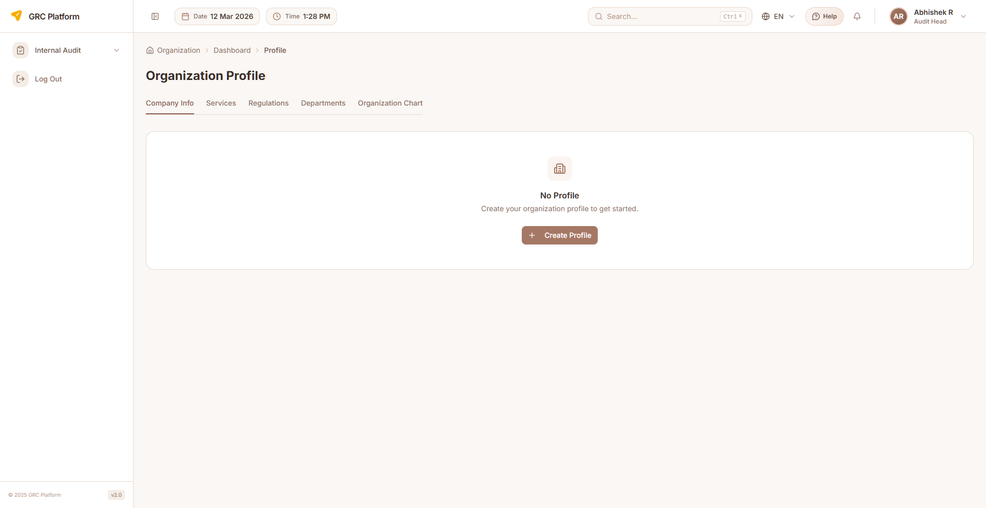
Figure: Organization Profile page view

Features & Capabilities
- View organization details (name, industry, size, location, contact)
- Edit organization profile information
- Upload organization logo and brochure
- Set regulatory jurisdiction and compliance requirements
- Manage branches (location, address per branch)
- Manage data centers (location type, address, vendor)
- Manage cloud providers (name, service type)
- Social media links (Facebook, YouTube, Twitter, LinkedIn)

Navigation Path
Sidebar → Organization → Profile

Organization Context
Define internal and external context factors that affect the organization's risk and compliance posture. Manage stakeholders, interested parties, and context issues with preventive/corrective actions.
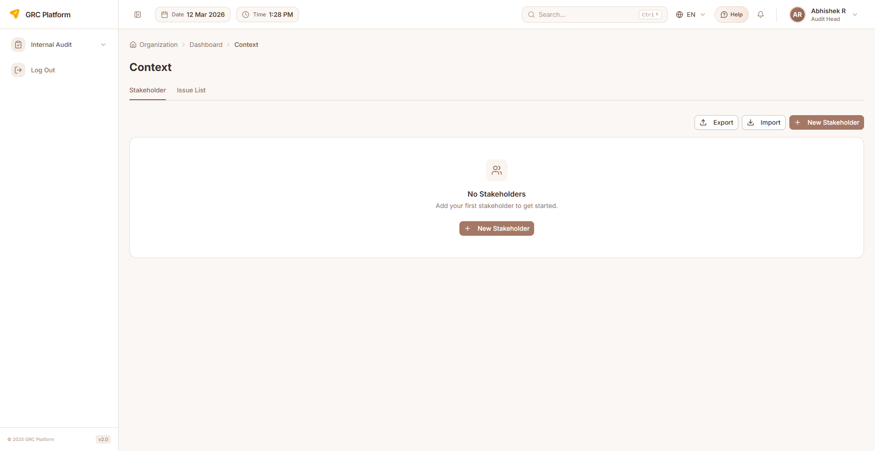
Figure: Organization Context page view

Features & Capabilities
- Define internal context factors (culture, governance, capabilities)
- Define external context factors (regulatory, market, technology)
- Manage stakeholders (add, edit, delete) with type and status
- Assign departments to stakeholders
- Email and contact management per stakeholder
- Document and file attachments for context records
- Issue actions tracking (preventive and corrective actions)
- Search and download context data

Navigation Path
Sidebar → Organization → Context

Users
Manage user accounts within your organization. Create users, assign roles, set departments, configure language preferences, and track login activity.
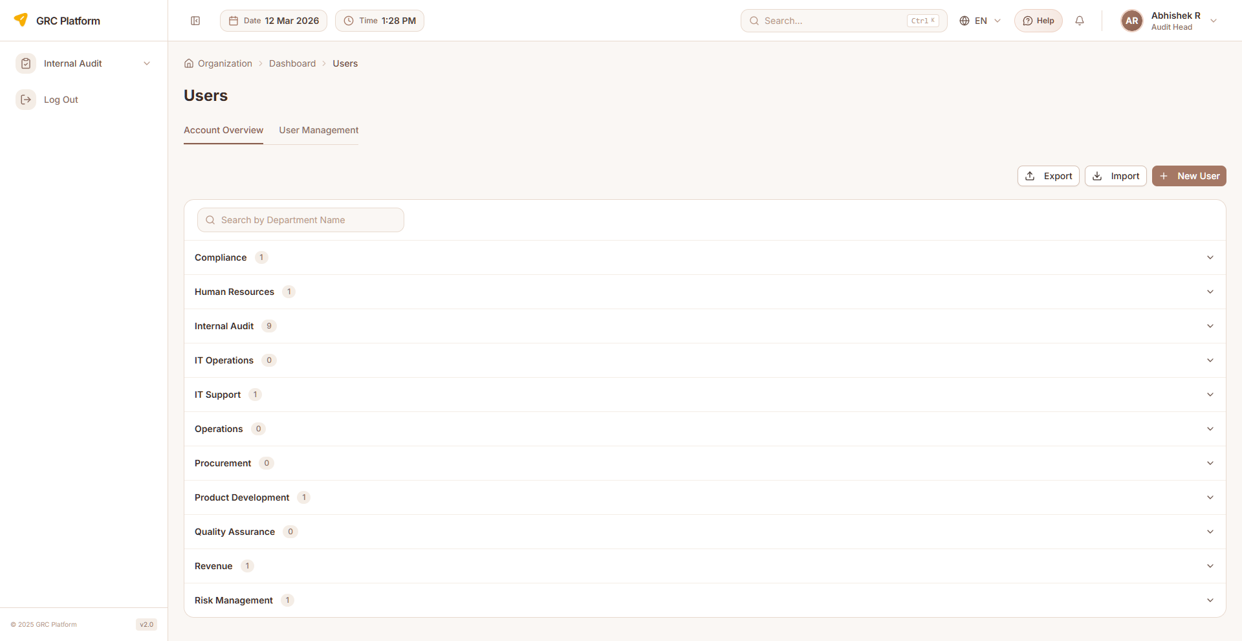
Figure: Users page view

Features & Capabilities
- List all users with role, department, and status
- Create new users (username, email, first name, last name, designation, function)
- Assign roles by function (Business, Security, Audit)
- Department assignment and reporting manager
- Language preferences and timezone configuration
- Last login tracking
- User activation and blocking
- Bulk import/export of user lists
- Search and filter users

Navigation Path
Sidebar → Organization → Users

Business Processes
Document and manage business processes. Processes can be linked to risks, controls, and assets for comprehensive traceability. Each process supports KPI tracking and BIA assessment.
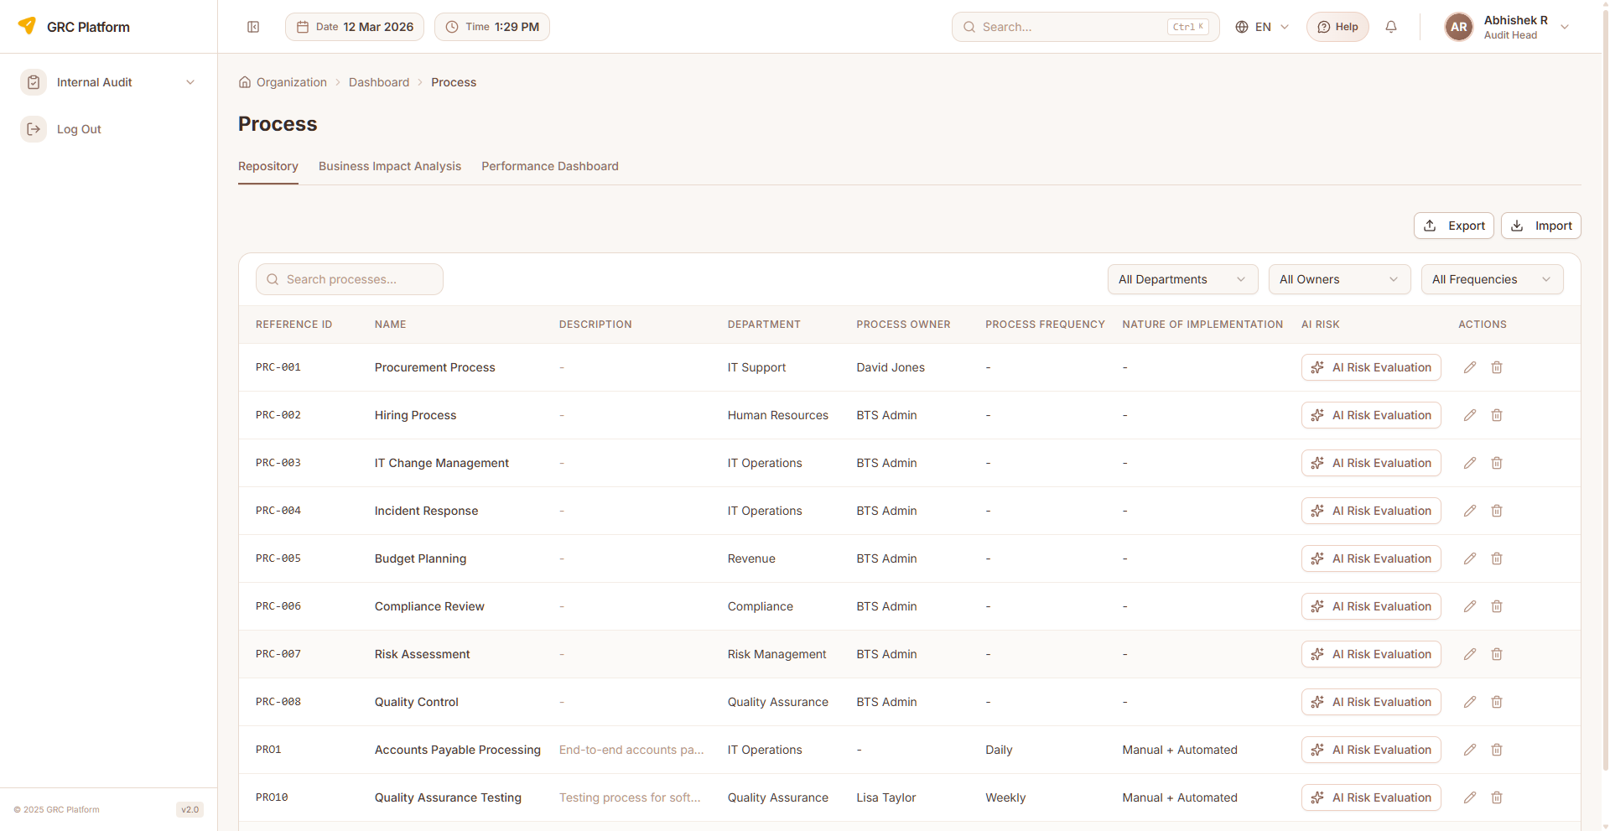
Figure: Business Processes page view

Features & Capabilities
- List all business processes with filtering and search
- Create new processes (name, code, owner, department, description)
- Edit existing process information
- Delete processes
- Process KPI tracking per process
- BIA (Business Impact Analysis) per process
- Link processes to risks and controls
- Classify process criticality
- Process hierarchy support
- Export process data

Navigation Path
Sidebar → Organization → Process

Business Impact Analysis (BIA)
Conduct business impact analysis to identify critical processes, determine recovery priorities, and establish RTO/RPO targets. Configure BIA categories and methodology.

Features & Capabilities
- List BIA records with impact ratings
- Create BIA entries for business processes
- Define RTO (Recovery Time Objective) and RPO (Recovery Point Objective)
- Set impact ratings (financial, operational, reputational, legal)
- Determine process criticality based on impact analysis
- Configure BIA categories with sort order and active status
- Configure BIA methodology and approach
- Business Continuity Planning (BCP) labels configuration
- Edit and delete BIA records

Navigation Path
Sidebar → Organization → Settings → BIA

Organization Settings
Configure organization-level settings including BIA categories, BIA methodology, BCP labels, and translations.
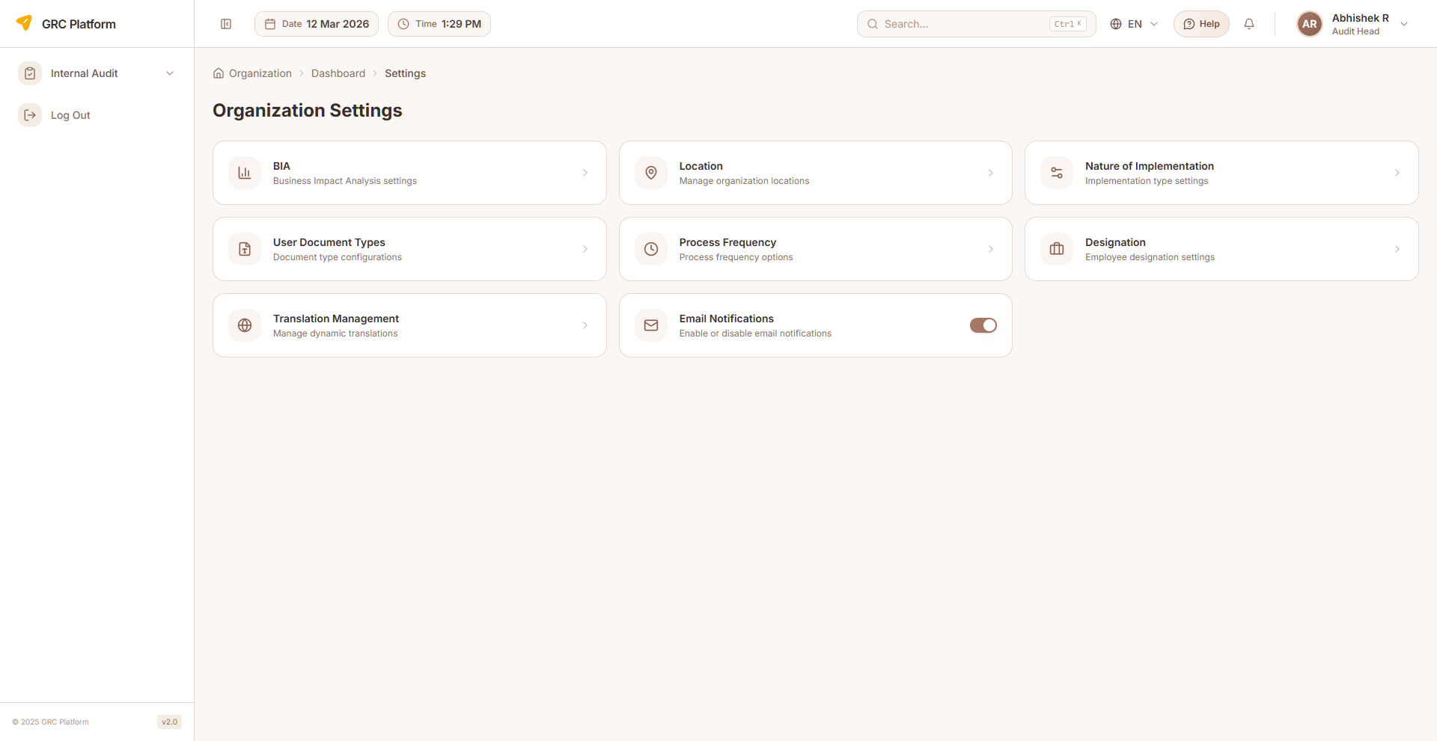
Figure: Organization Settings page view

Features & Capabilities
- BIA Categories — define assessment categories with sort order and active status
- BIA Methodology — configure BIA assessment approach
- BCP Labels — business continuity planning labels
- Translations — manage organization-level translations

Navigation Path
Sidebar → Organization → Settings

Compliance
Manage compliance frameworks, controls, governance documents, evidence collection, exceptions, KPIs, risk matrices, and reporting. This module provides comprehensive compliance lifecycle management aligned with industry standards like ISO 27001, NIST, SOC 2, and GDPR.

Framework Selection
Browse and adopt compliance frameworks (ISO 27001, NIST, SOC 2, GDPR, etc.). Selected frameworks populate controls and requirements. Track compliance percentage, policy percentage, and evidence percentage per framework.
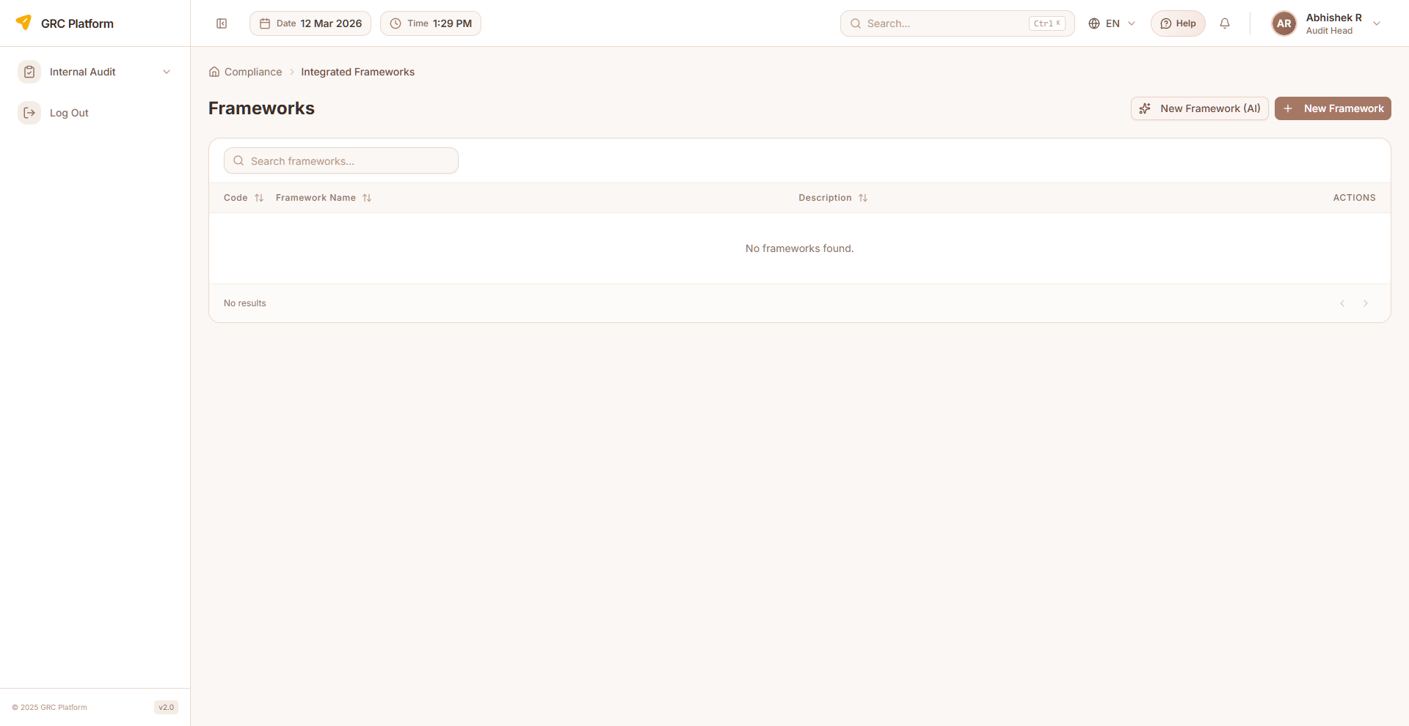
Figure: Framework Selection page view

Features & Capabilities
- Browse available compliance frameworks (cards/grid view)
- View framework details (code, name, description, type, status, country, industry)
- Select/adopt frameworks for your organization
- Track compliance percentage, policy percentage, evidence percentage
- Custom vs. standard framework differentiation
- Import framework templates from Excel
- Export framework data
- Download framework template
- Framework subscription/access management
- Pagination support

Navigation Path
Sidebar → Compliance → Frameworks

Control Assessment
Manage and assess compliance controls derived from adopted frameworks. Each control maps to framework requirements and can be linked to evidence and risks.
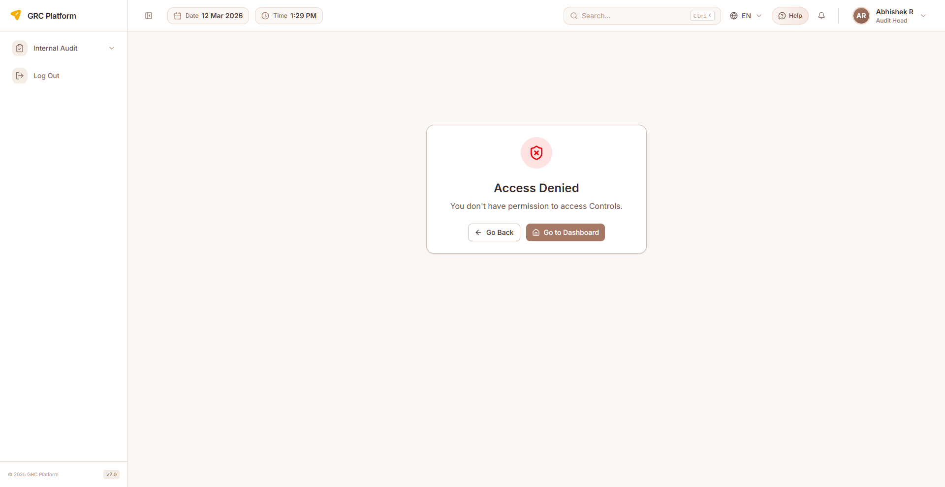
Figure: Control Assessment page view

Features & Capabilities
- List all controls with status indicators (Compliant, Partially Compliant, Non-Compliant, Not Assessed)
- View control details (code, name, description, domain, category, status)
- Assess control effectiveness
- Link controls to evidence items
- Map controls to risks
- Multi-select column filtering
- Filter by framework, domain, status
- Bulk assessment capabilities
- Create, edit, delete controls
- Pagination support

Navigation Path
Sidebar → Compliance → Controls

Governance Documents
Manage policies, procedures, standards, and guidelines. Track document lifecycle including creation, review, approval, and version history. Documents link to frameworks and controls.
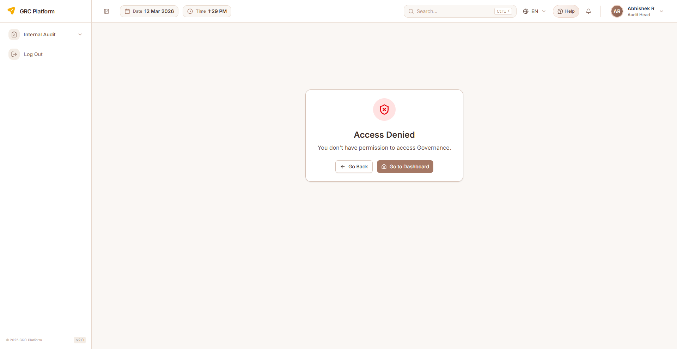
Figure: Governance Documents page view

Features & Capabilities
- List all governance documents with version and status
- Create new documents (policy, procedure, standard, guideline)
- Document properties: code, name, version, document type
- Edit document content and metadata
- Document review and approval workflow
- Version history tracking
- Set review schedules and due dates (policy recurrence)
- Assign document owners and reviewers
- Upload supporting files/attachments
- Link documents to frameworks and controls
- Evidence attachment support
- Delete documents
- Download documents

Navigation Path
Sidebar → Compliance → Governance

Evidence Management
Collect, manage, and track evidence demonstrating compliance with controls. Evidence items can be linked to specific controls, uploaded as files, and go through review workflows.
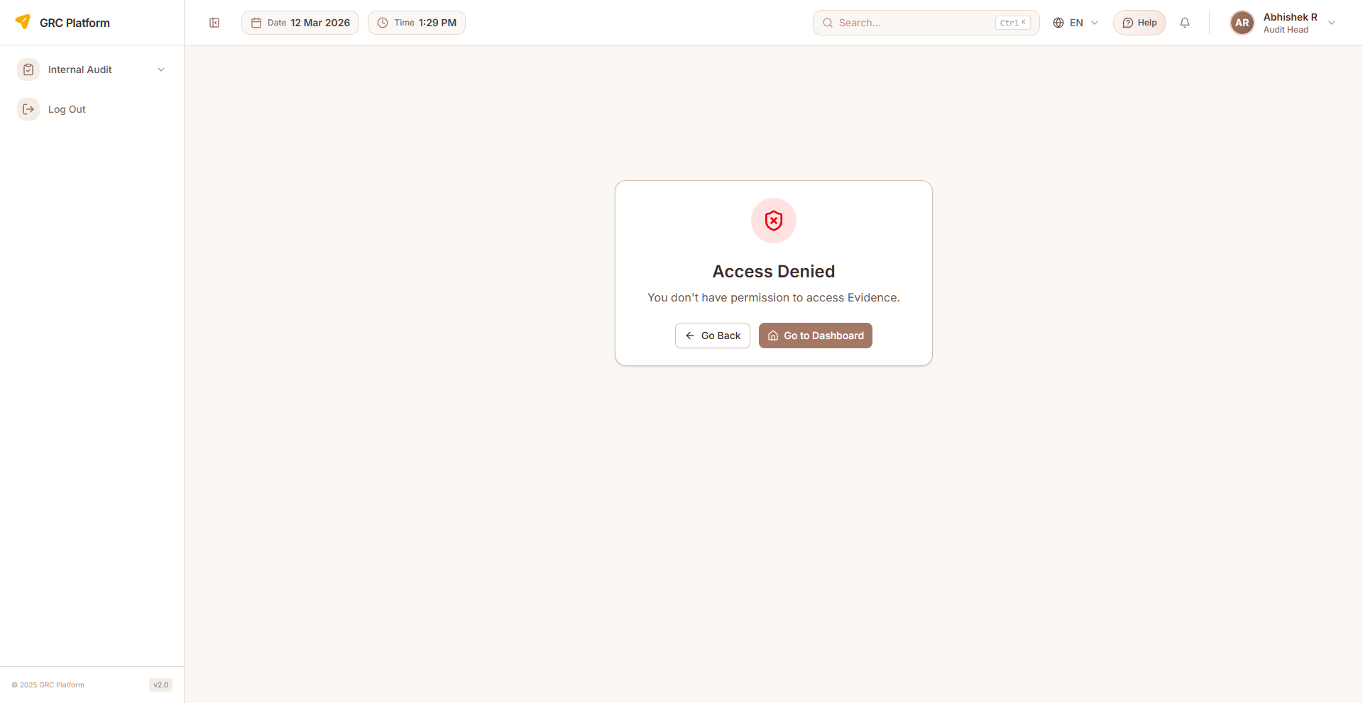
Figure: Evidence Management page view

Features & Capabilities
- List evidence items with status and due dates
- Create evidence requests and assign to contributors
- Upload evidence files (documents, screenshots, exports)
- Link evidence to specific controls and frameworks
- Track status (Pending, Submitted, Approved, Rejected)
- Set evidence collection due dates
- Review and approve/reject submitted evidence
- AI-powered evidence suggestions
- Evidence versioning
- Filter by status, assignee, control
- Delete evidence records

Navigation Path
Sidebar → Compliance → Evidence

Exceptions
Document and track compliance exceptions — situations where a control cannot be fully implemented and a risk acceptance or compensating control is applied.
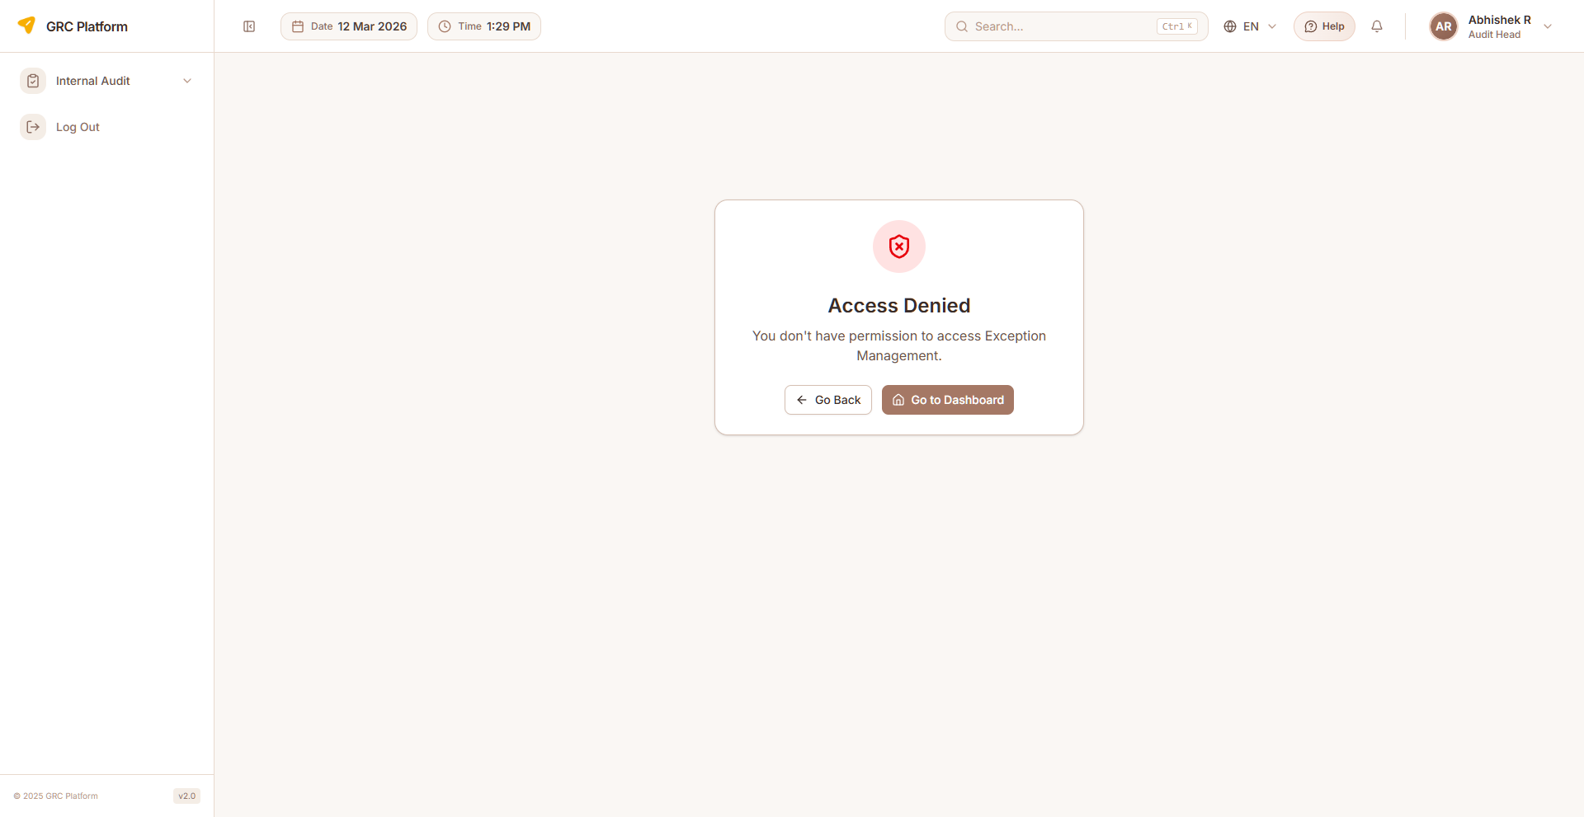
Figure: Exceptions page view

Features & Capabilities
- List all compliance exceptions with status indicators
- Create exception requests with justification
- Exception properties: code, description, severity, status
- Specify compensating controls
- Set exception expiry/target remediation dates
- Department and owner assignment
- Track exception approval status (open, in-progress, closed)
- Visual status indicators (pie chart, status timeline)
- Edit and delete exceptions
- Link exceptions to controls
- Pagination support

Navigation Path
Sidebar → Compliance → Exceptions

KPIs
Define and track Key Performance Indicators for compliance programs. Monitor compliance health through measurable metrics with targets and thresholds.
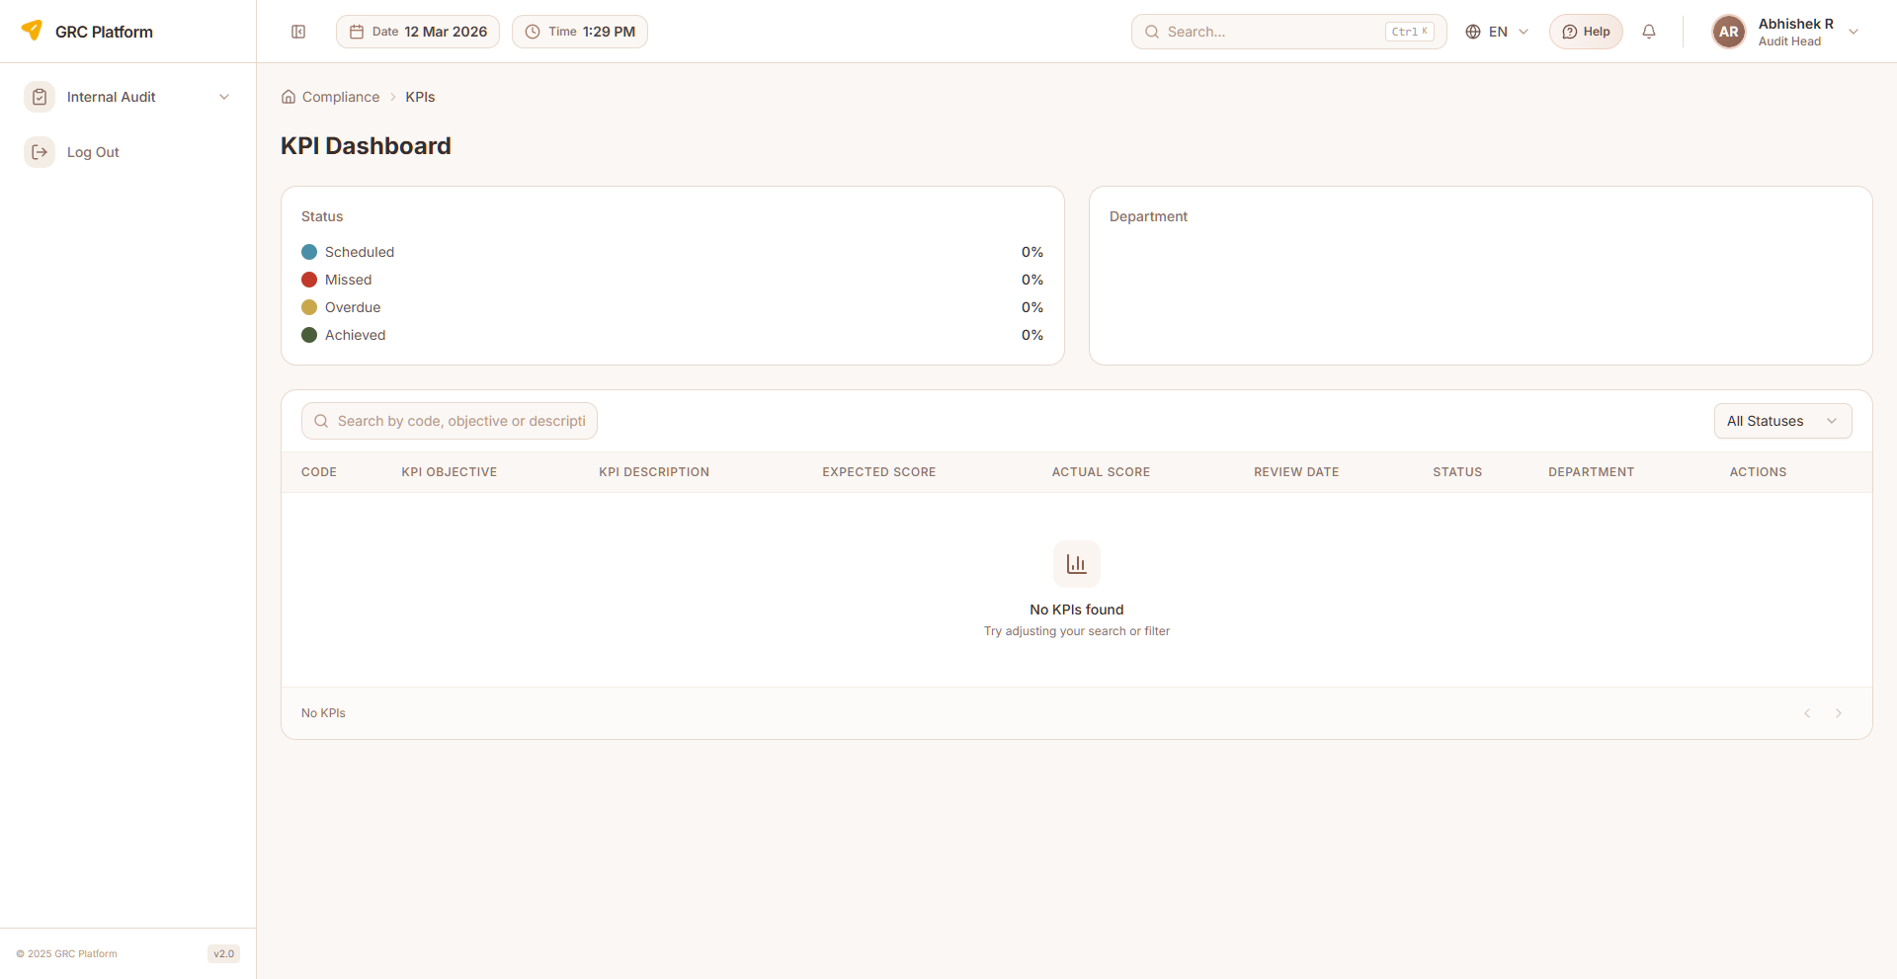
Figure: KPIs page view

Features & Capabilities
- List compliance KPIs with current values and targets
- KPI properties: code, objective, description, expected score, actual score
- Department association for each KPI
- Evidence linkage to KPIs
- Review date tracking
- Status tracking: Scheduled, Missed, Overdue, Achieved
- Visual indicators for KPI health
- Filter by status and department
- Search KPIs

Navigation Path
Sidebar → Compliance → KPIs

Risk Matrix
Map relationships between risks and controls. Visualize which controls mitigate which risks and identify gaps in coverage.
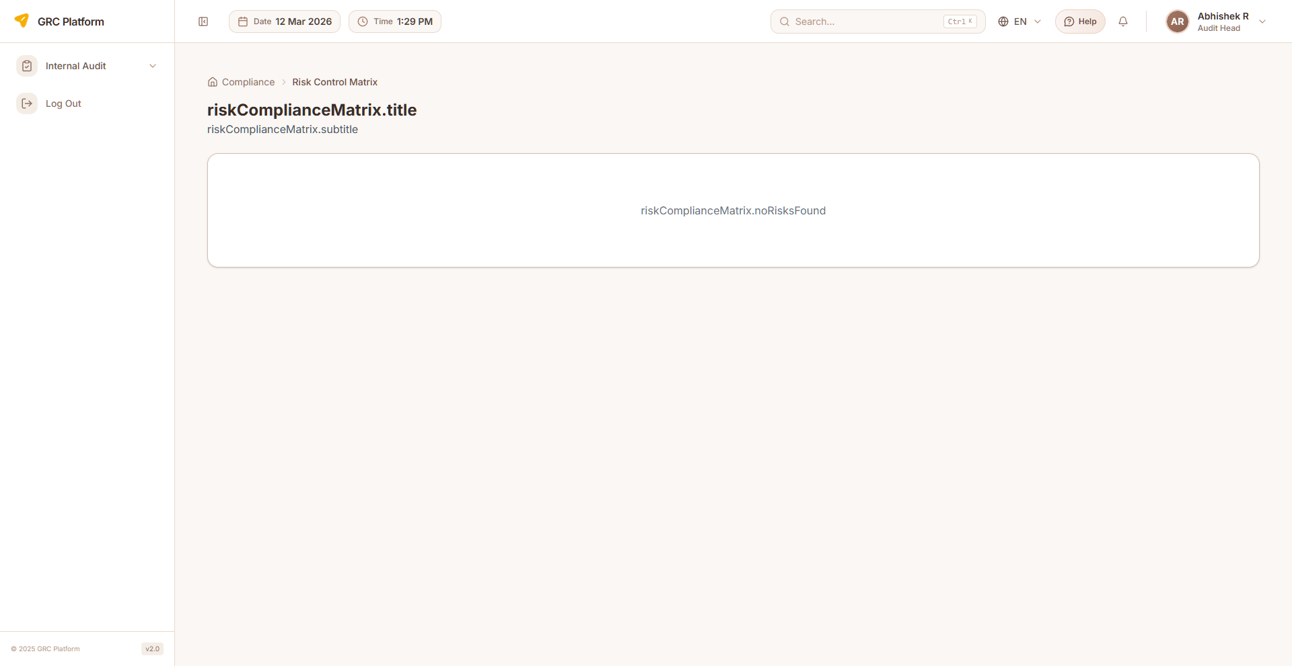
Figure: Risk Matrix page view

Features & Capabilities
- Matrix view of risks vs controls
- Link/unlink controls to risks
- Identify unmitigated risks (gaps)
- View control effectiveness per risk
- Status indicators (compliant, non-compliant, partial compliant, not applicable)
- Collapsible risk groups
- Residual risk assessment view
- Search and filter

Navigation Path
Sidebar → Compliance → Risk Matrix

Compliance Reports
Generate compliance reports and analytics. View compliance dashboard with framework coverage metrics.

Features & Capabilities
- Compliance reporting and analytics
- Compliance dashboard view
- Framework coverage metrics
- Export and download capabilities

Navigation Path
Sidebar → Compliance → Reports

Compliance Master Data
Centralized configuration for compliance definitions including framework definitions, control templates, domain/category definitions, evidence templates, and governance templates.

Features & Capabilities
- Framework definitions and templates
- Control templates
- Domain and category definitions
- Evidence templates
- Governance document templates

Navigation Path
Sidebar → Compliance → Master Data

Risk Management
Identify, assess, respond to, and monitor risks across the organization. This module supports the complete risk management lifecycle from identification through treatment, monitoring, and reporting.

Risk Dashboard
Summary dashboard with risk statistics and analytics. View total risks, status breakdown, risk by strategy, risk by rating, and risk by category through interactive charts.
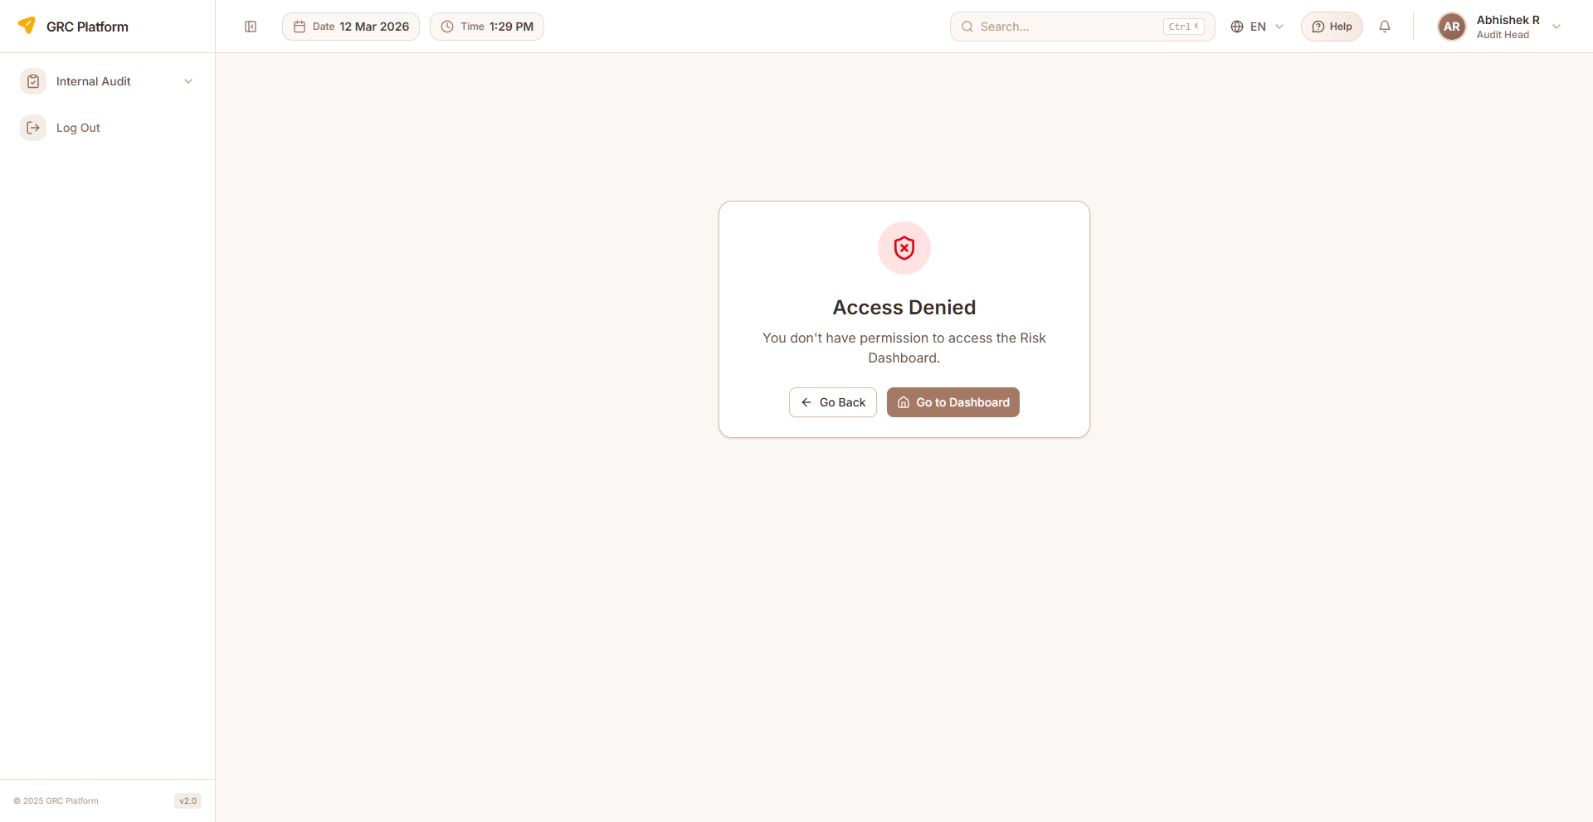
Figure: Risk Dashboard page view

Features & Capabilities
- Summary metrics: total risks, status breakdown
- Risk by status chart
- Risk by strategy chart (Mitigate, Accept, Transfer, Avoid)
- Risk by rating chart
- Risk by category chart
- Real-time statistics
- Translated category names

Navigation Path
Sidebar → Risk Management → Dashboard

Risk Register
Central repository of all identified risks. Create, manage, and track risks with their inherent and residual ratings, owners, treatment status, and linkages to controls and processes.
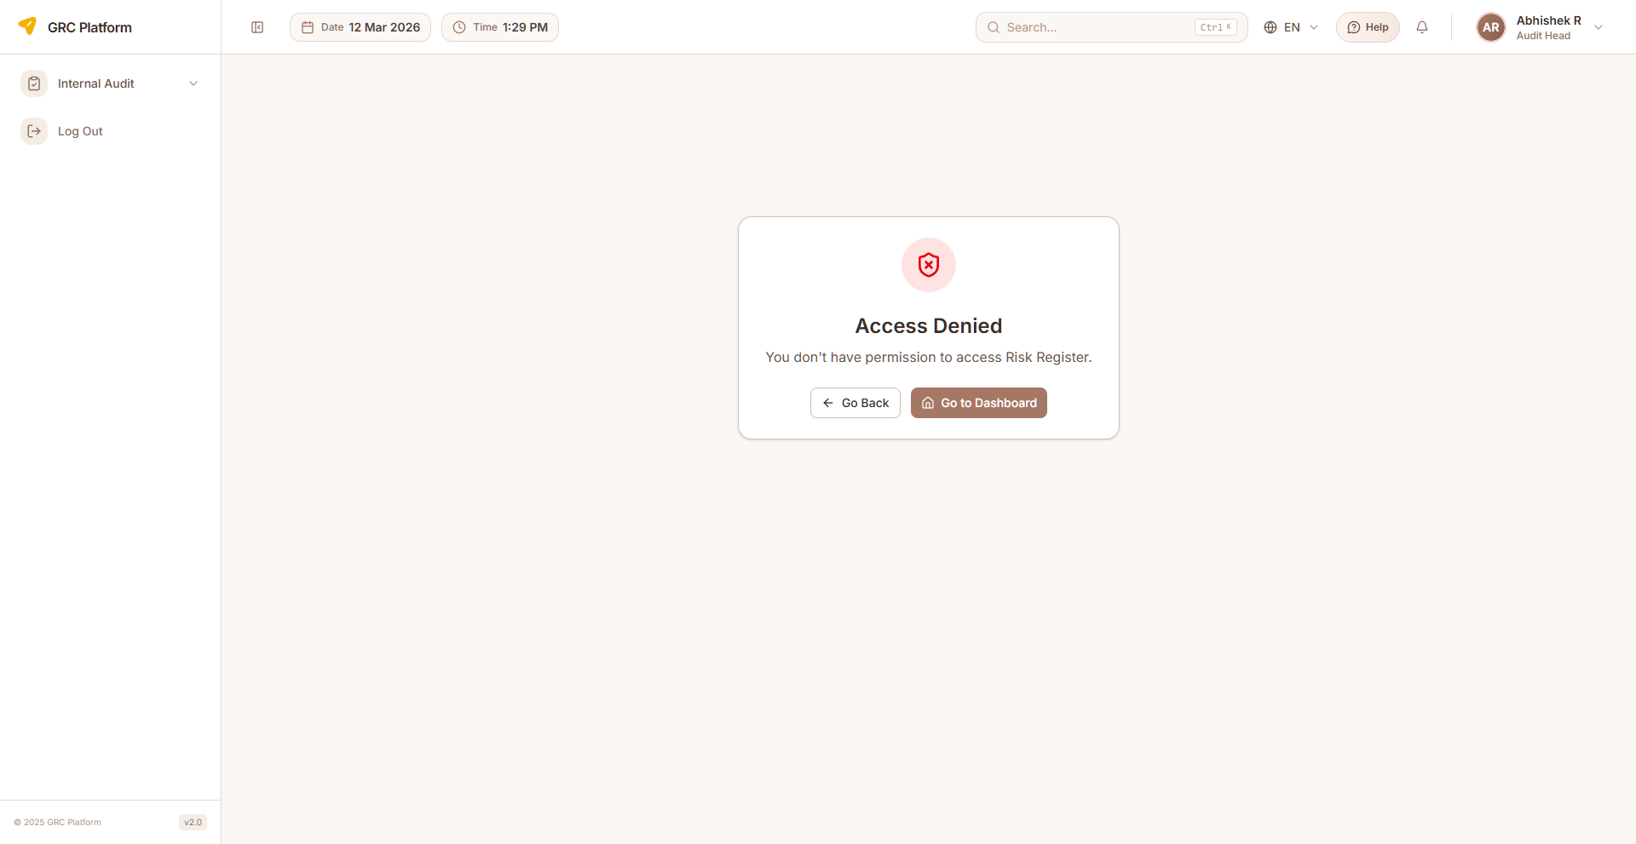
Figure: Risk Register page view

Features & Capabilities
- List all risks with severity indicators and status
- Create new risks (name, description, risk sources, category, type)
- Risk scoring: likelihood (1-5) × impact (1-5) = risk score
- Set inherent risk rating and residual risk rating
- Assign risk owners with contact info and department
- Categorize: Strategic, Operational, Financial, Compliance, Technology
- Status tracking: open, in-progress, completed, mitigate, accept, transfer, avoid
- Rating badges with color coding
- Bulk import/export (Excel)
- AI-powered risk suggestions
- Link risks to controls and processes
- View risk details with full history
- Search, filter, pagination
- Delete risks

Navigation Path
Sidebar → Risk Management → Risk Register

Risk Assessment
Perform detailed risk assessments using likelihood and impact matrices. Evaluate risks quantitatively and qualitatively with structured assessment workflows.
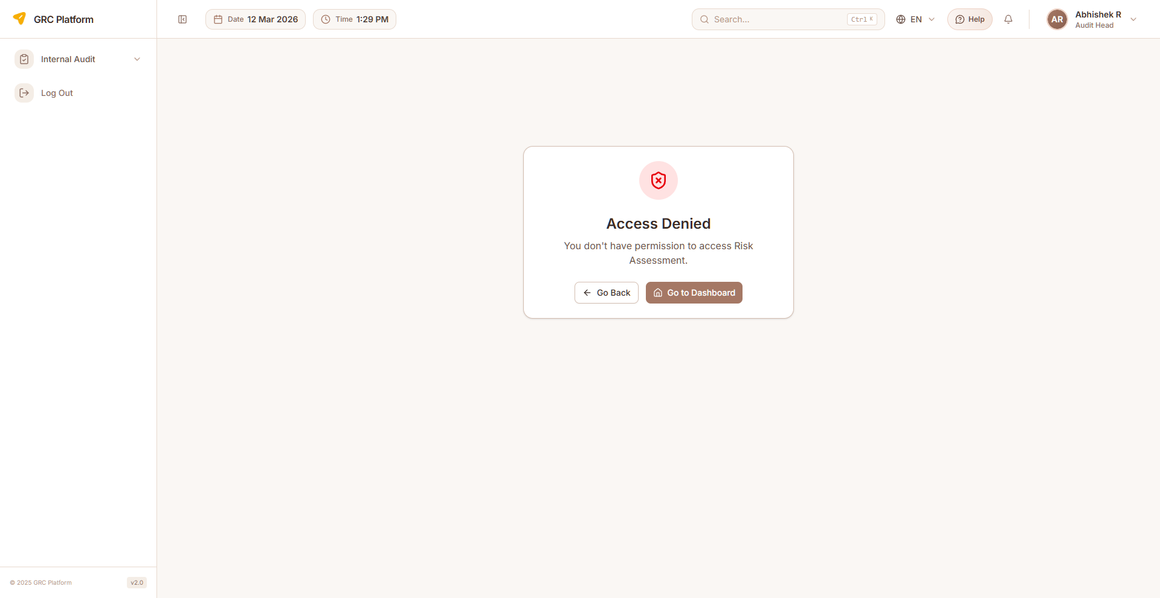
Figure: Risk Assessment page view

Features & Capabilities
- Risk assessment matrix (5×5 likelihood vs impact)
- Define assessment criteria and scales
- Perform inherent risk assessment
- Perform residual risk assessment (after controls)
- Document assessment rationale
- Compare inherent vs residual risk levels
- Risk heatmap visualization
- Assessment status tracking (draft, submitted, approved, rejected, in-progress)
- Threat and vulnerability mapping
- Assessment wizard for structured input
- Department-scoped assessment

Navigation Path
Sidebar → Risk Management → Risk Assessment

Risk Response
Plan and track risk treatment actions. Define mitigation strategies, assign responsibilities, and monitor implementation.
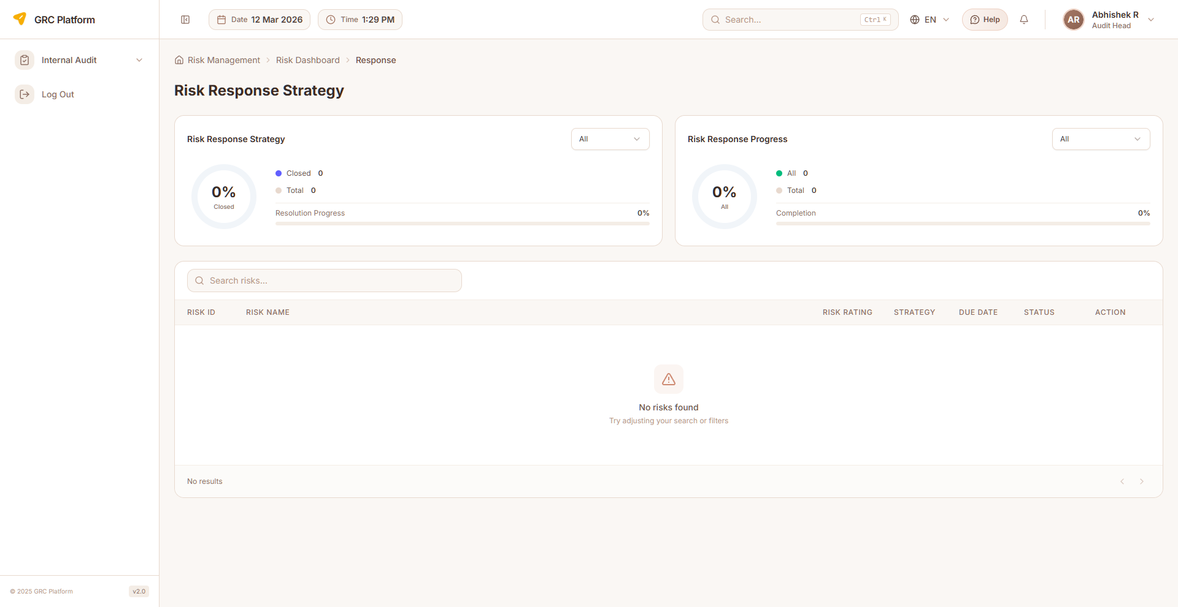
Figure: Risk Response page view

Features & Capabilities
- View risks requiring response/treatment
- Define response strategy (Mitigate, Accept, Transfer, Avoid)
- Create treatment action plans with due dates
- Assign action owners and due dates
- Track action implementation status (open, in-progress, completed)
- Response progress tracking
- Document response effectiveness
- Department-scoped access

Navigation Path
Sidebar → Risk Management → Risk Response

Risk Control Matrix
Map relationships between risks and controls. Visualize which controls mitigate which risks and identify coverage gaps.
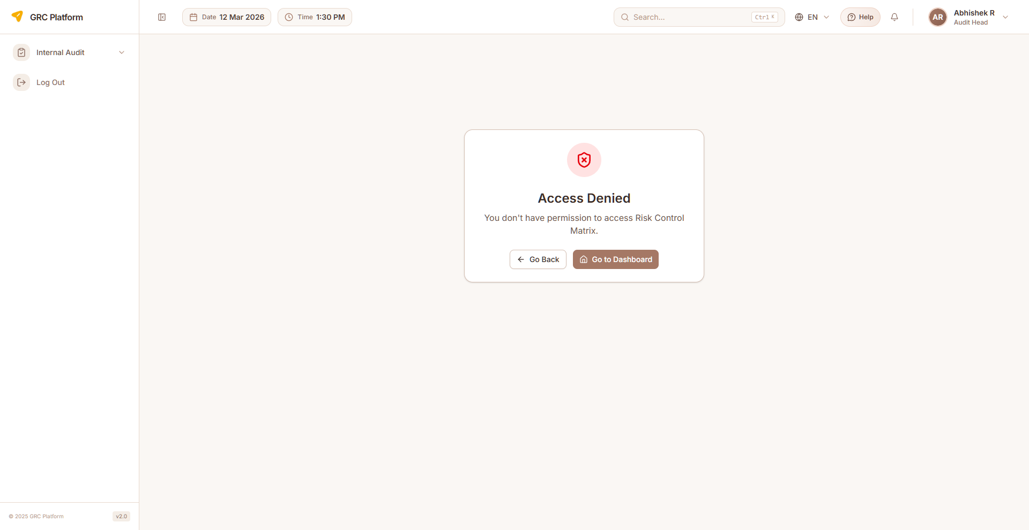
Figure: Risk Control Matrix page view

Features & Capabilities
- Matrix view of risks vs controls
- Link/unlink controls to risks
- Identify unmitigated risks (gaps)
- View control effectiveness per risk
- Residual risk calculation
- Status indicators for each control-risk link
- Collapsible risk groups
- Search and filter

Navigation Path
Sidebar → Risk Management → Risk Control Matrix

Risk Settings
Configure risk categories, types, thresholds, and rating matrix.

Features & Capabilities
- Risk category management
- Risk type definitions
- Risk rating matrix customization
- Threshold configuration

Navigation Path
Sidebar → Risk Management → Settings

Risk Reports
Generate risk reporting and analytics for management review.

Features & Capabilities
- Risk metrics and trends
- Risk summary reports
- Export capabilities

Navigation Path
Sidebar → Risk Management → Reports

Asset Management
Maintain an inventory of organizational assets and classify them according to their criticality and sensitivity (CIA). Assets can be linked to risks, controls, and processes.

Asset Inventory
Comprehensive inventory of all organizational assets including hardware, software, data, networks, personnel, and facilities.
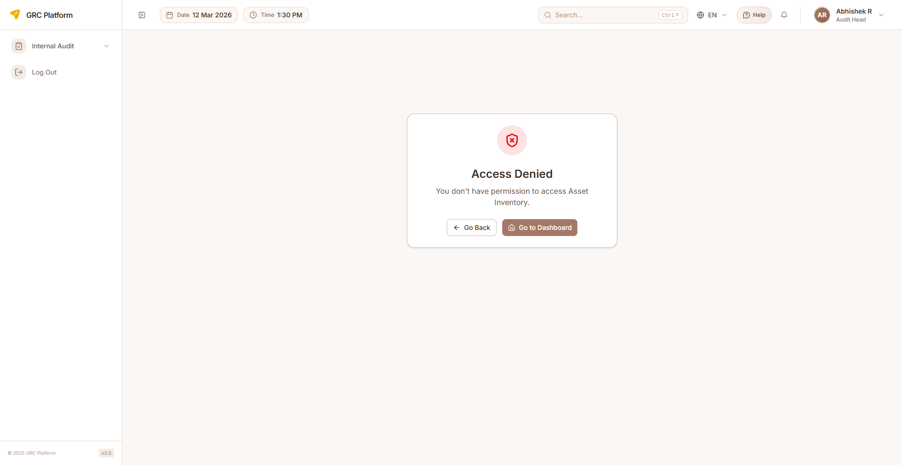
Figure: Asset Inventory page view

Features & Capabilities
- List all assets with type, owner, classification, and status
- Create new assets (name, type, category, sub-category, group, owner, location)
- Asset types: Package, Server, Monitor, Database, Users, Building, Wrench
- Department and owner assignment
- Acquisition date tracking
- Status management
- Edit and delete assets
- Bulk import/export (Excel)
- Search, filter, pagination
- Link assets to risks and processes

Navigation Path
Sidebar → Asset Management → Inventory

Asset Classification
Classify assets based on confidentiality, integrity, and availability (CIA) requirements using a hierarchical classification system.
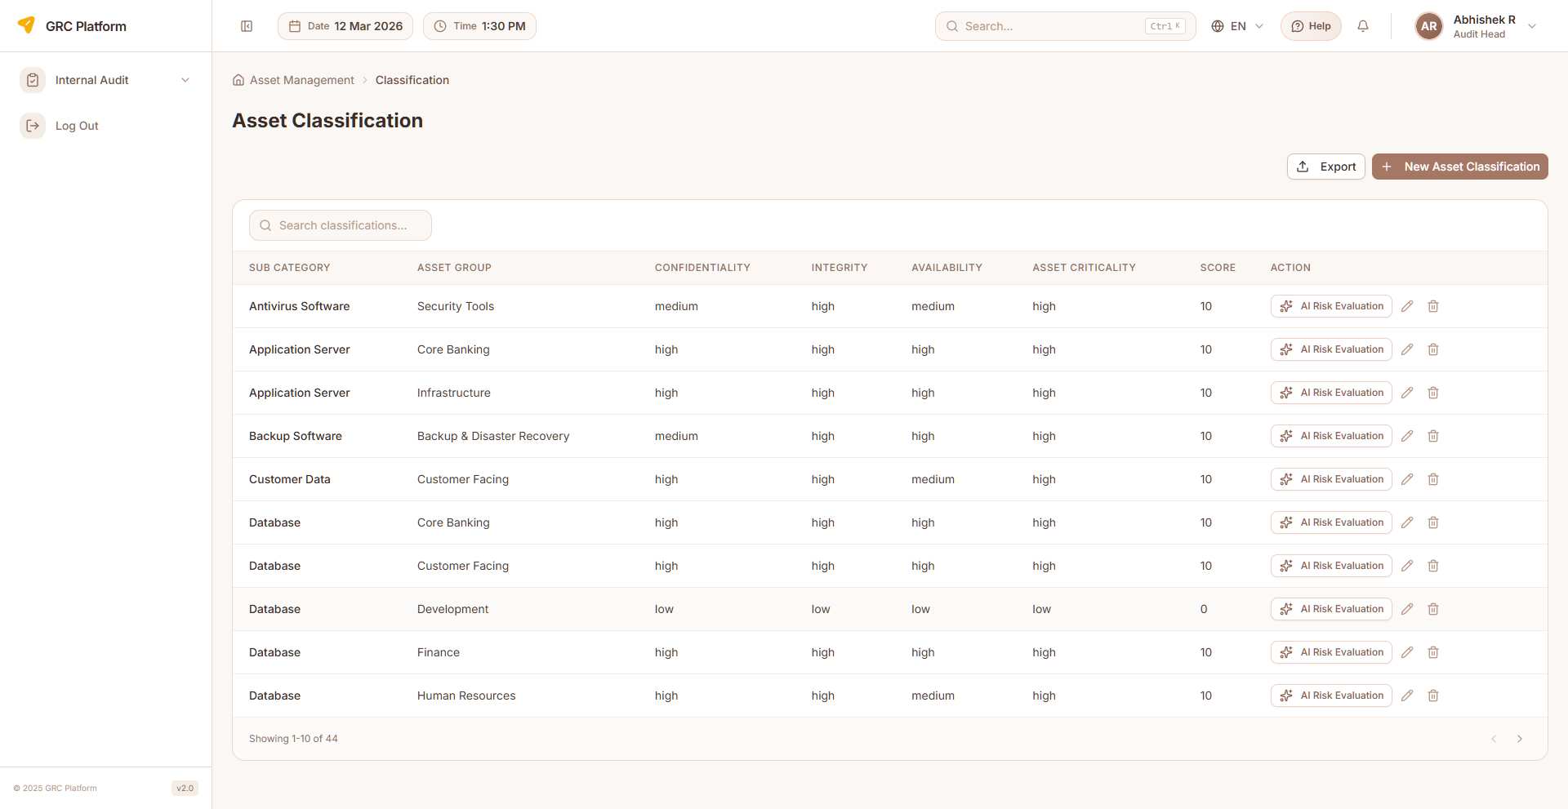
Figure: Asset Classification page view

Features & Capabilities
- Classification hierarchy: Category → Sub-Category → Group
- Define classification levels (Public, Internal, Confidential, Restricted)
- Classify assets by CIA impact (Confidentiality, Integrity, Availability)
- Set handling and protection requirements per classification
- Asset grouping and organization
- Create, edit, delete classifications
- View hierarchy

Navigation Path
Sidebar → Asset Management → Classification

Asset Settings
Configure asset types, classifications, and master data setup.

Features & Capabilities
- Asset type configuration
- Classification level definitions
- Master data setup

Navigation Path
Sidebar → Asset Management → Settings

Asset Reports
Asset analytics and reporting including distribution by type and classification.

Features & Capabilities
- Asset distribution by type/classification
- Asset analytics and reporting
- Export capabilities

Navigation Path
Sidebar → Asset Management → Reports

Internal Audit
Plan, execute, and report on internal audits. Manage the complete audit lifecycle from universe definition through risk identification, audit planning, fieldwork, findings, corrective actions, and final reporting.

Audit Dashboard
Overview of audit function with risk statistics, audit statistics, CAPA status by department, annual audit plan calendar, and auditor schedule visualization.
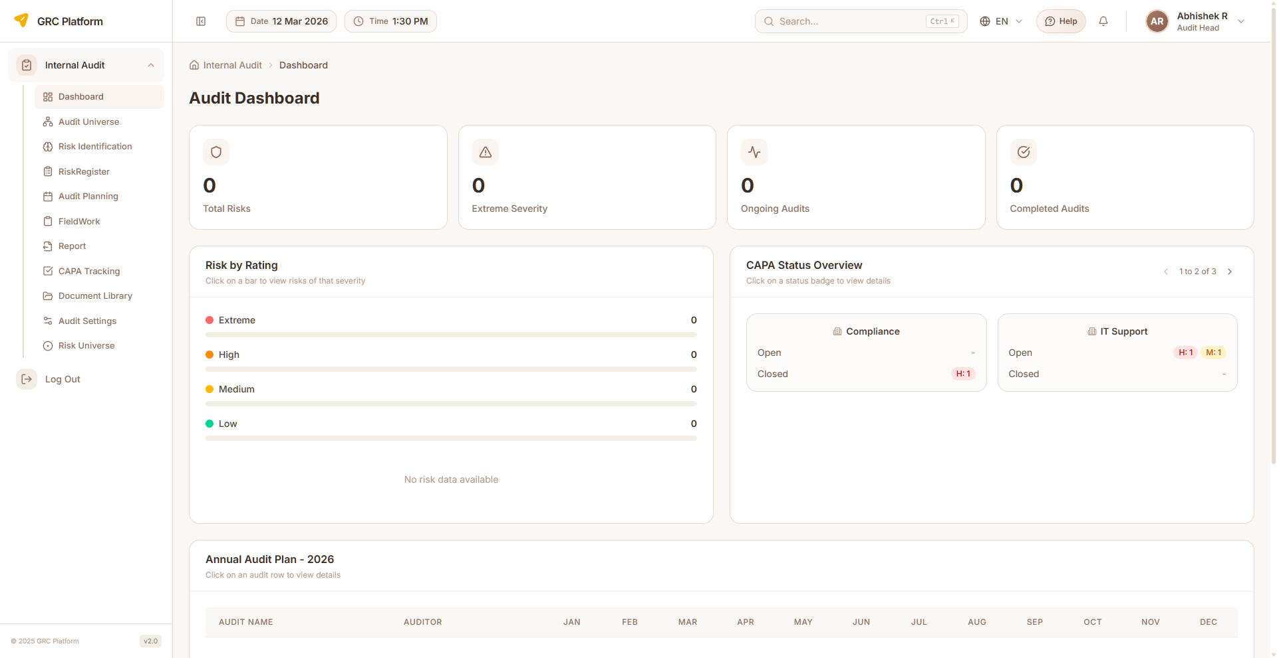
Figure: Audit Dashboard page view

Features & Capabilities
- Risk statistics: total, extreme, high, medium, low
- Audit statistics: ongoing, completed, planned
- CAPA status by department (open/closed breakdown)
- Annual audit plan calendar
- Auditor schedule visualization
- Department-wise audit metrics

Navigation Path
Sidebar → Internal Audit → Dashboard

Audit Universe
Define the complete set of auditable entities, processes, and functions. This forms the basis for risk-based audit planning.
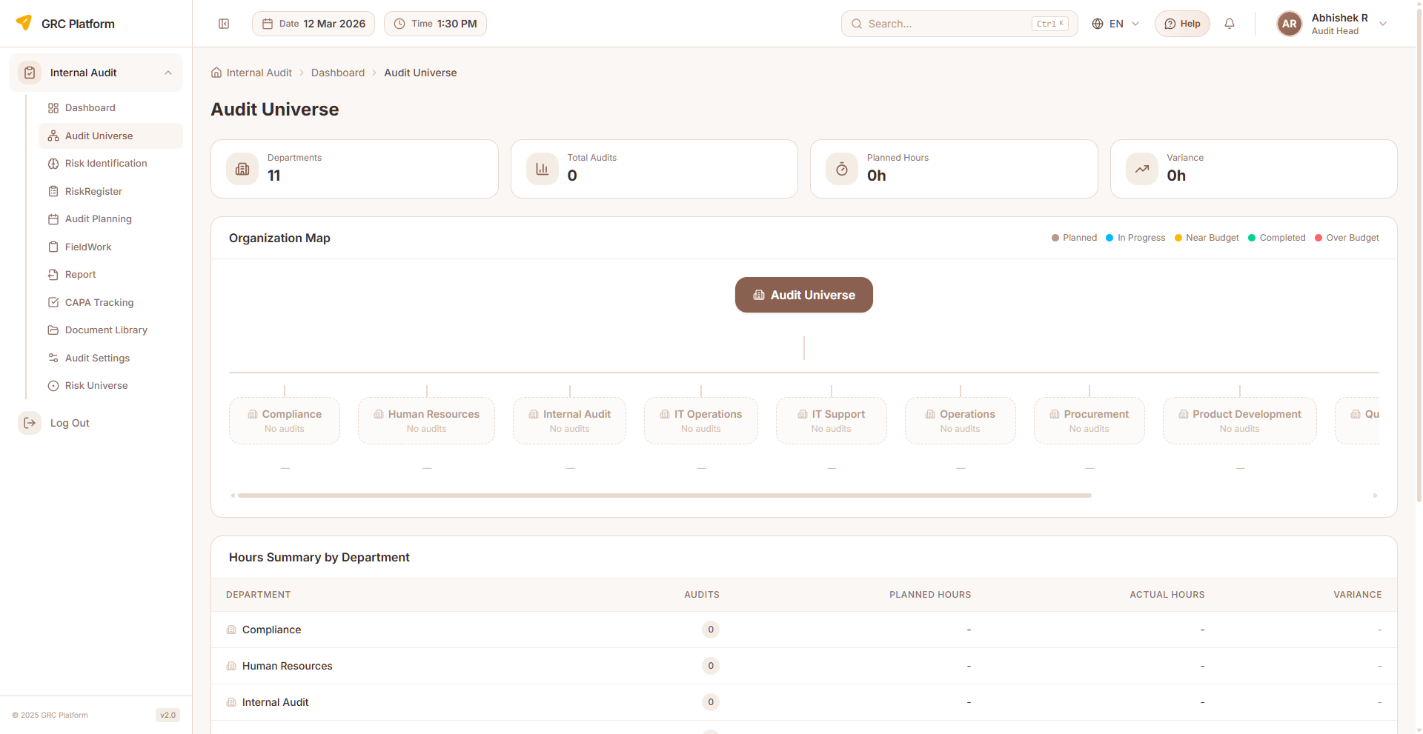
Figure: Audit Universe page view

Features & Capabilities
- Department-based audit scope view
- Display departments with associated audits
- Audit metrics: planned hours vs actual hours
- Status tracking per audit
- Timeline view (start/end dates)
- Search and navigate to audit details

Navigation Path
Sidebar → Internal Audit → Audit Universe

Risk Identification
Identify and document risks for audit planning purposes using structured risk entry and assessment methodology.

Features & Capabilities
- Structured risk entry forms
- Assessment methodology configuration
- Create, edit, view risk entries
- Link risks to audit planning

Navigation Path
Sidebar → Internal Audit → Risk Identification

Audit Risk Register
Risk inventory specific to the audit function. Create risks manually or use AI-recommended risks feature.

Features & Capabilities
- List audit risks with risk ID, name, likelihood, impact
- Create risks manually or via AI recommendations
- Probability and impact assessment
- Audit category and type assignment
- Edit and delete risks
- Search and pagination

Navigation Path
Sidebar → Internal Audit → Risk Register

Audit Planning
Create and manage audit engagements. Define scope, objectives, timeline, assign audit team members, and link risks to audit plans.
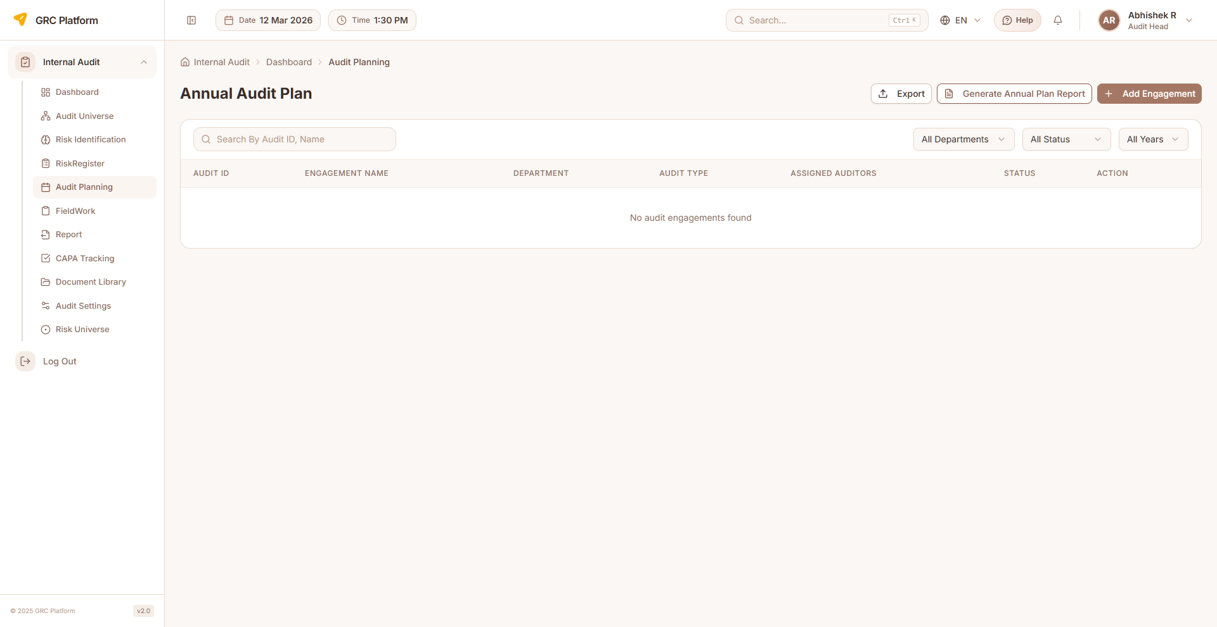
Figure: Audit Planning page view

Features & Capabilities
- Annual audit plan creation and management
- Create audit engagements (title, department, start/end dates)
- Assign auditors (single or multiple)
- Risk linkage to audit plan
- Planned hours tracking
- Track engagement status (Planned, In Progress, Completed, Cancelled)
- Edit and delete engagements
- Download and upload engagement documents
- Search and pagination

Navigation Path
Sidebar → Internal Audit → Audit Planning

Fieldwork
Execute audit fieldwork — conduct testing, gather evidence, document observations, and link findings to engagements.
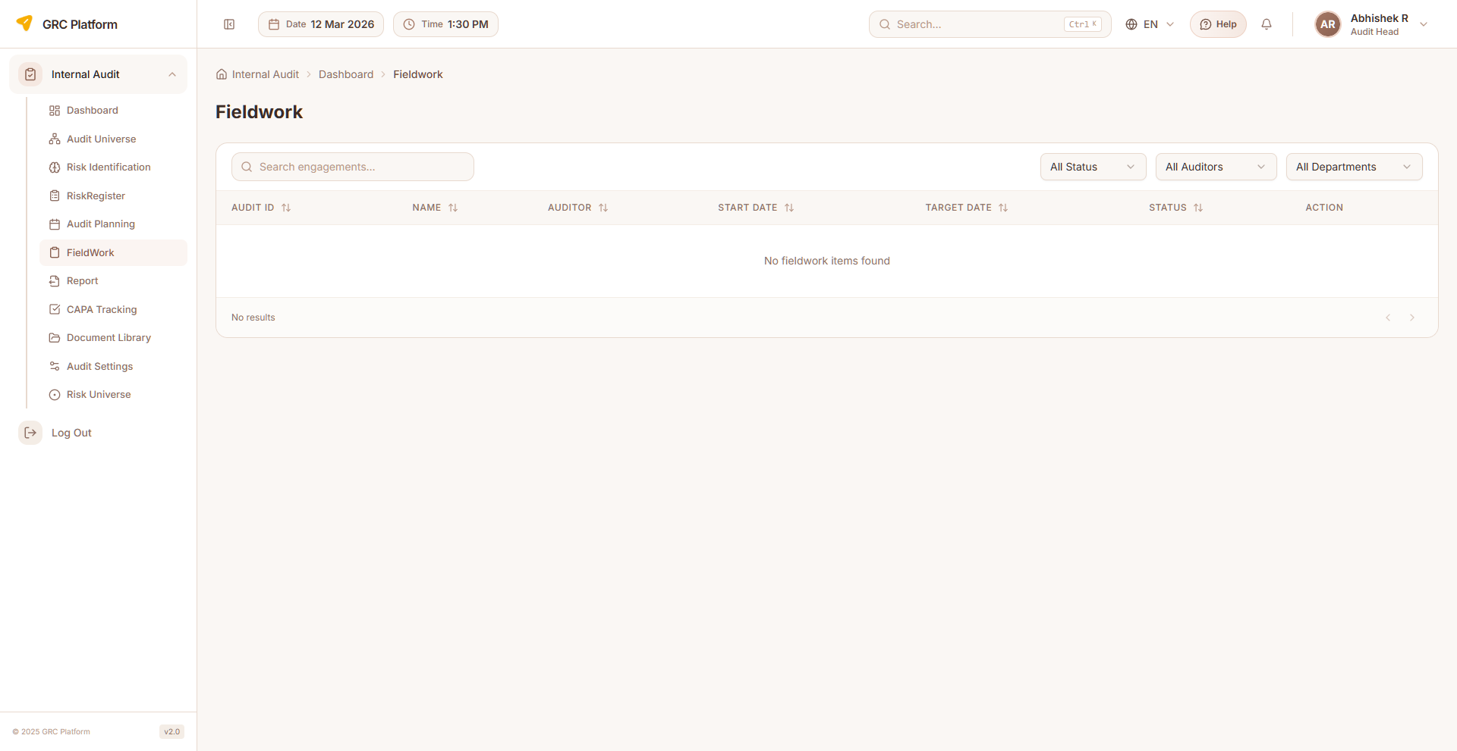
Figure: Fieldwork page view

Features & Capabilities
- List engagements with title, department, status, dates, auditor
- View assigned fieldwork tasks
- Create work papers and document observations
- Upload audit evidence and supporting files
- Record interview notes
- Track fieldwork completion status
- Add findings from fieldwork
- Filter by department, status, auditor
- Pagination support

Navigation Path
Sidebar → Internal Audit → Fieldwork

Findings
Document and manage audit findings identified during fieldwork. Classify by severity, assign owners, and track remediation progress.

Features & Capabilities
- List all audit findings with severity and status
- Create findings (finding ID, title, description, severity, recommendation)
- Classify severity: Critical, High, Medium, Low, Informational
- Assign finding owners for remediation
- Set remediation due dates
- Track status: Open, In Progress, Closed, Overdue
- Link findings to controls and risks
- Edit and delete findings

Navigation Path
Sidebar → Internal Audit → Findings (via Fieldwork)

CAPA Tracking
Track Corrective and Preventive Actions (CAPA) arising from audit findings. Monitor implementation, verify effectiveness, and manage escalations.
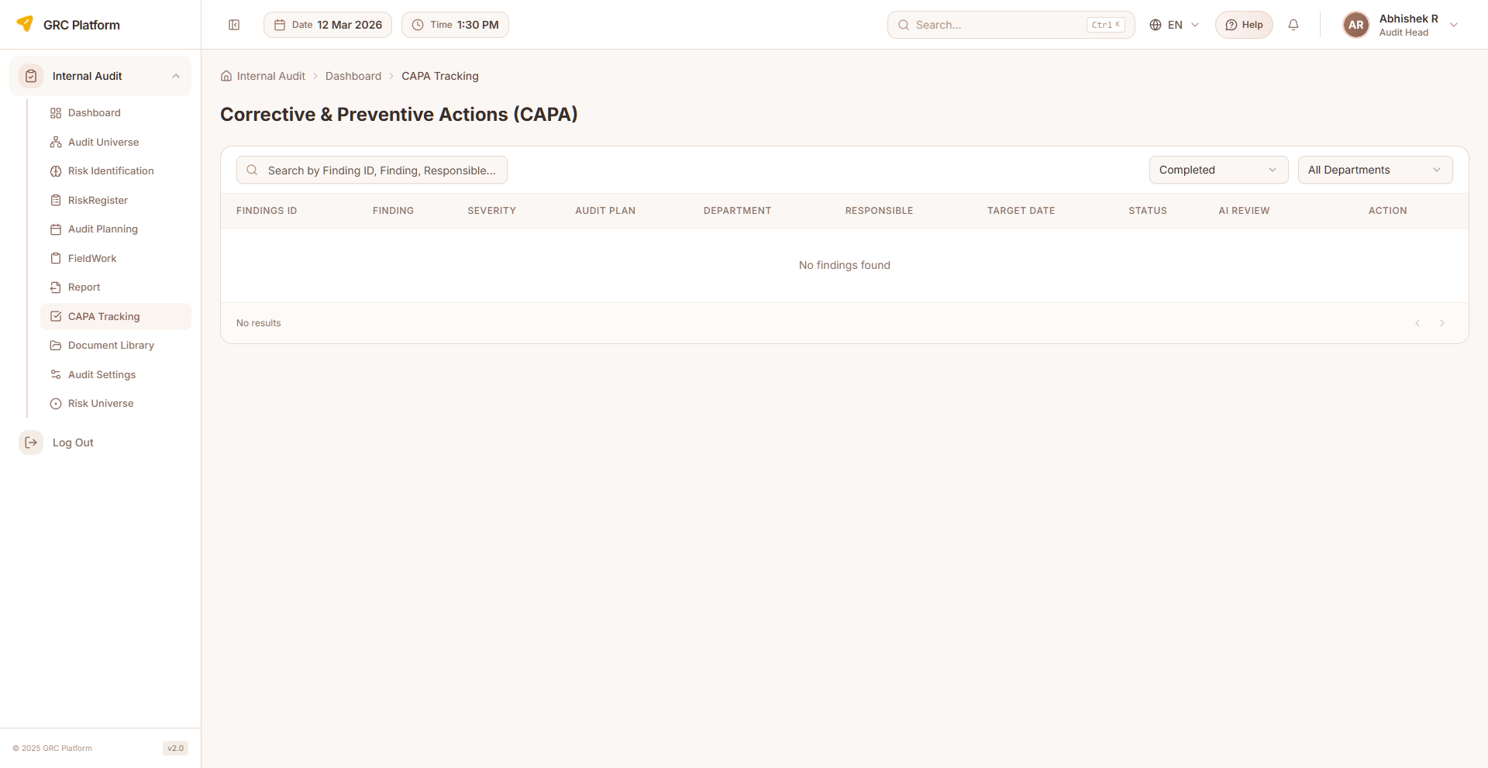
Figure: CAPA Tracking page view

Features & Capabilities
- List all CAPA items with status, severity, and due dates
- Create CAPA entries linked to findings
- Define corrective and preventive actions
- Action tracking: type, description, completion percentage, status
- Assign responsible persons and target completion dates
- Track implementation progress
- Comments and discussion support
- File attachments for evidence
- Verify action effectiveness
- Escalate overdue CAPAs
- Filter by status
- Search and pagination

Navigation Path
Sidebar → Internal Audit → CAPA Tracking

Audit Reports
Generate and manage audit reports. Compile findings, recommendations, management responses, and conclusions into formal audit reports.
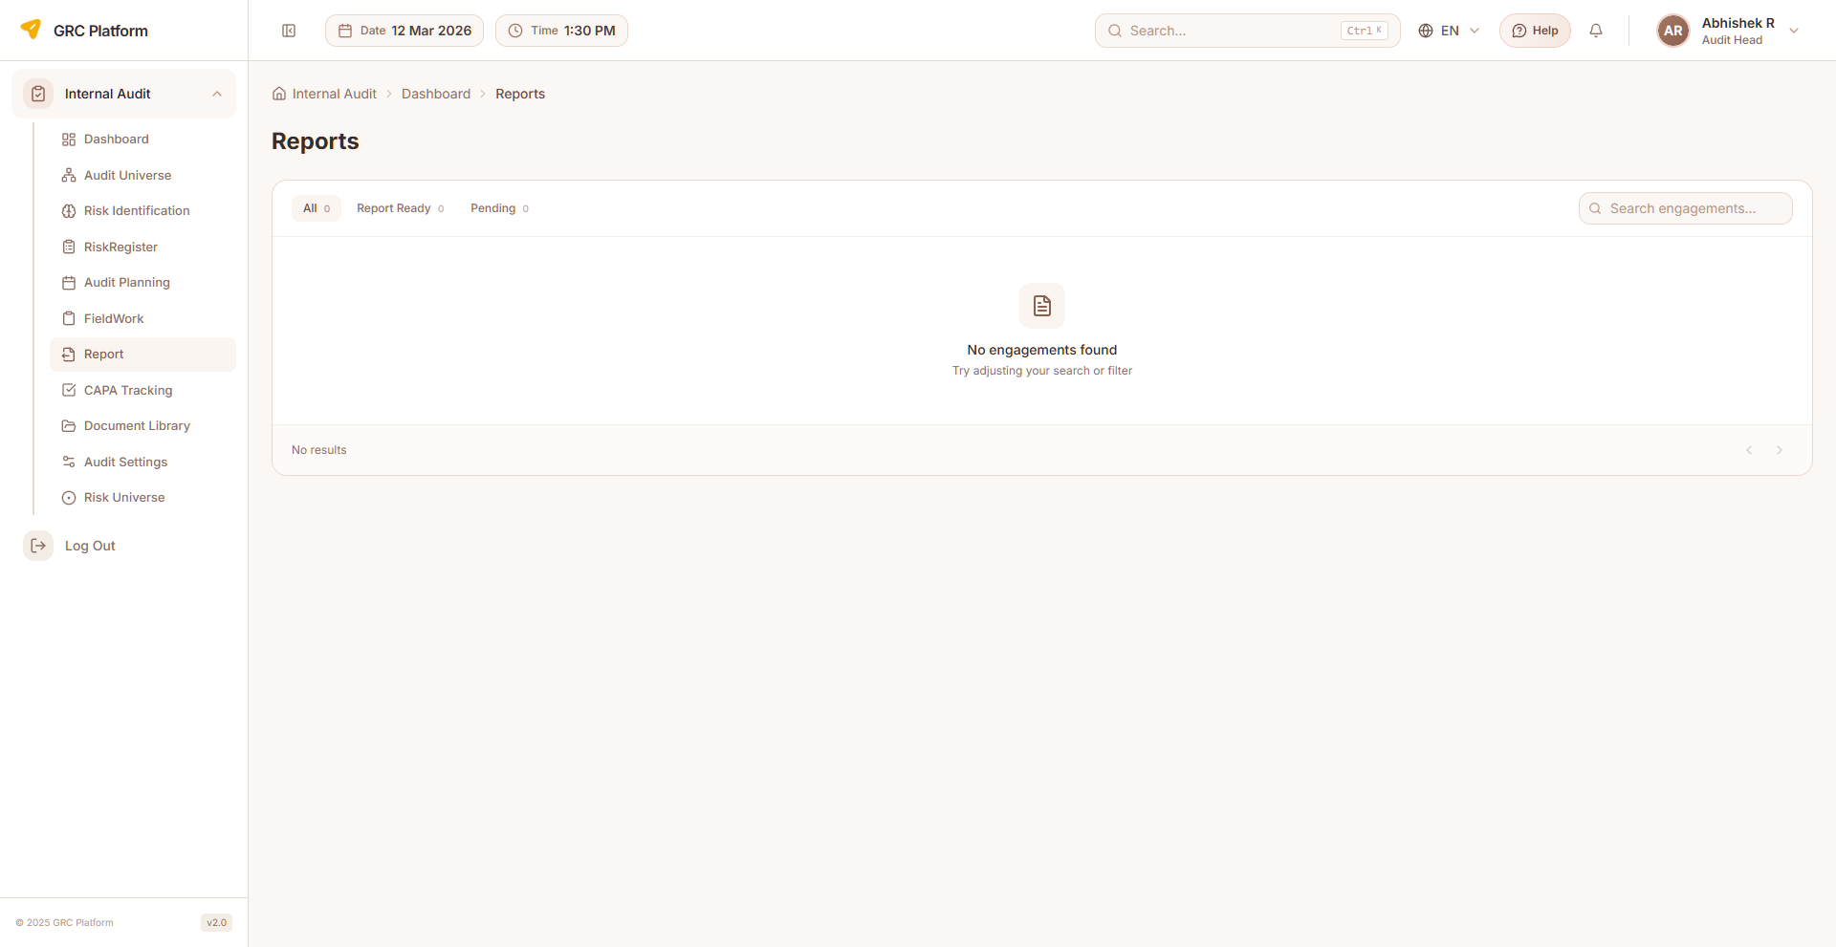
Figure: Audit Reports page view

Features & Capabilities
- List all audit reports with status
- Generate reports from engagement data
- Report properties: report code, title, executive summary, scope, objectives, methodology
- Include observations, recommendations, management response
- Conclusion and overall result
- Auditee comments and response
- Status: Draft, Submitted, Approved
- Report preview and PDF generation
- Download reports
- Search and pagination

Navigation Path
Sidebar → Internal Audit → Report

Document Library
Centralized audit document repository for uploading, organizing, and managing audit-related documents.

Features & Capabilities
- Document upload and organization
- File management
- Centralized document repository

Navigation Path
Sidebar → Internal Audit → Document Library

Audit Settings
Configure the audit function including audit types, departments, periodicity, processes, risk assessment matrices, categories, control nature, user management, and escalation policies.

Features & Capabilities
- Audit Types — define types (internal, external, compliance, operational)
- Departments — department management
- Periodicity — audit frequency/cycle configuration
- Process — process and sub-process definitions for audit scope
- Risk Assessment — probability and impact matrices
- Categories — audit categories
- Nature of Controls — control types and characteristics
- User Management — audit team member assignment and roles
- Escalation — escalation policies for audit findings

Navigation Path
Sidebar → Internal Audit → Settings

GRC Administration
System-level administration for managing customer accounts, compliance master data, email settings, and system configuration. This module is only accessible to GRC Administrators.

Customer Accounts
Multi-tenant customer account management. Create, edit, and manage customer organizations with subscription module flags and configuration.
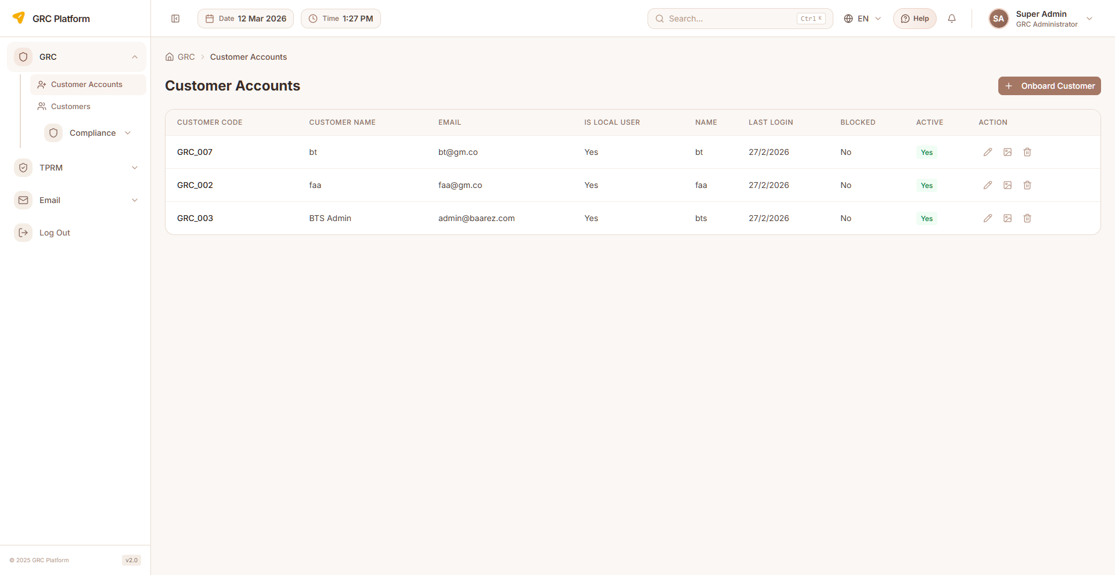
Figure: Customer Accounts page view

Features & Capabilities
- List all customer accounts
- Create new customer accounts
- Edit customer details
- Delete customer accounts
- Account activation/blocking
- Subscription module flags (isGrcAdded, isTprmAdded, isQpostComplianceEnabled)
- Email and contact assignment
- Logo upload and management
- Language and timezone configuration

Navigation Path
Sidebar → GRC → Customer Accounts

Compliance Master Data
System-wide compliance definitions including frameworks, controls, governance templates, evidence templates, and domain/category definitions.

Features & Capabilities
- System-wide framework management
- Control definitions
- Governance document templates
- Evidence templates
- Domain and category definitions

Navigation Path
Sidebar → GRC → Compliance Master Data

Email Settings
Configure system email settings for notifications and alerts.
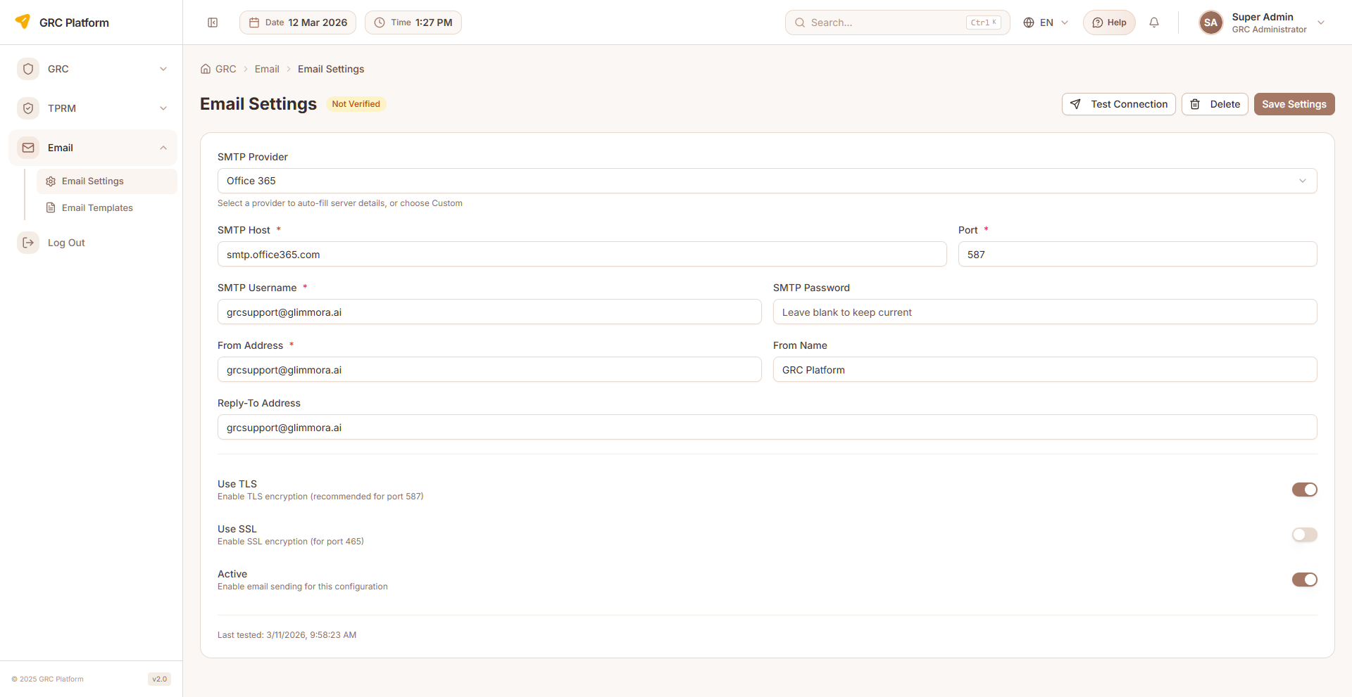
Figure: Email Settings page view

Features & Capabilities
- SMTP settings configuration
- Email template management
- Notification email configuration

Navigation Path
Sidebar → GRC → Email Settings

System Configuration
System-wide configuration settings including SSO, Excel import/export, PDF report settings, and system reflection.

Features & Capabilities
- Reflection — system reflection/analysis settings
- Excel Import — import configuration
- Excel Export — export templates
- PDF Report — report generation settings
- SSO — Single Sign-On configuration

Navigation Path
Sidebar → GRC → Configuration

Permissions Reference
Each role has specific permissions that determine what actions they can perform. The permission system uses a resource:action pattern.

Actions
- view — Read-only access to see data
- create — Ability to create new records
- edit — Ability to modify existing records
- delete — Ability to remove records
- approve — Ability to approve/reject submissions

Permission Scopes
- Global — Access to all records across the organization
- Department — Access limited to records within the user's department
- Own — Access limited to records owned by or assigned to the user

How Permissions Work
When you log in, your assigned role determines which sidebar menu items are visible and which actions you can perform on each page. If a menu item or button is not visible, it means your role does not have the required permission.
Permissions are enforced at both the UI level (hiding unavailable options) and the API level (blocking unauthorized requests). This ensures data security regardless of how the application is accessed.

Glossary

GRC
Governance, Risk, and Compliance — integrated approach to managing governance, risk management, and compliance activities across the organization.

BIA
Business Impact Analysis — process of determining critical business processes and the potential impact of disruption.

RTO
Recovery Time Objective — maximum acceptable time to restore a process after disruption.

RPO
Recovery Point Objective — maximum acceptable data loss measured in time.

BCP
Business Continuity Plan — documented procedures for maintaining business operations during and after a disaster.

CAPA
Corrective and Preventive Action — actions taken to eliminate the causes of non-conformities and prevent recurrence.

CIA
Confidentiality, Integrity, Availability — three pillars of information security used for asset classification.

Control
Measure that modifies risk — can be a policy, procedure, guideline, practice, or organizational structure.

Finding
Result of an audit that identifies a gap between the current state and the expected criteria.

Risk Register
Centralized record of identified risks with their analysis, treatment plans, and current status.

Risk Matrix
Visual tool mapping risks against controls to identify coverage and gaps.

Framework
Structured set of guidelines and best practices for managing compliance (e.g., ISO 27001, NIST, SOC 2, GDPR).

Audit Universe
Complete set of auditable entities, processes, and functions within the organization.

Audit Engagement
A planned and executed audit activity with defined scope, objectives, and team.

Evidence
Documentation, records, or artifacts that demonstrate compliance with controls and requirements.

Exception
Documented deviation from a control requirement, with justification and compensating controls.

KPI
Key Performance Indicator — measurable metric for tracking compliance program health.

