TPRM Module
User Manual — Internal IT Team

Glimmora International
Generated: March 12, 2026
Version 1.0

Note: This document is auto-generated and confidential. Do not distribute without authorization.

Getting Started

Logging In
To access the application:
- Open your web browser and navigate to the application URL provided by your administrator.
- Enter your username and password on the login page.
- Click "Sign In" to access the application.
- Upon successful login, you will be redirected to your default dashboard.

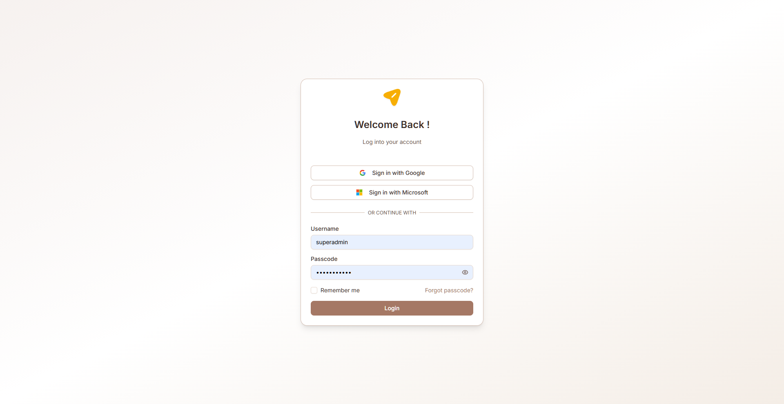
Figure: Login page

Navigation
The TPRM module uses a sidebar navigation menu on the left side of the screen. Each menu item corresponds to a functional area. Your visible menu items depend on your assigned role and permissions.
Key navigation elements:
- Sidebar menu — Primary navigation to all accessible pages
- Breadcrumb trail — Shows your current location within the application
- Header bar — Contains user profile, notifications, and language switcher
- Language selector — Switch between English, Arabic (RTL), and Latvian

Multi-Language Support
The application supports three languages:
- English (default) — Left-to-right layout
- Arabic — Right-to-left (RTL) layout with full UI mirroring
- Latvian — Left-to-right layout
To change the language, use the language selector in the header. All labels, buttons, and system text will be translated. User-entered data (vendor names, risk descriptions, etc.) is also translated dynamically when records are created or edited.

Common UI Patterns
Throughout the application, you will encounter these common interface patterns:
- Data tables — Sortable, filterable lists with pagination and search
- Dialog forms — Modal forms for creating and editing records
- Accordion views — Expandable/collapsible sections for detailed information
- Status badges — Color-coded labels indicating record status
- Action buttons — Create, Edit, Delete, Export, and role-specific actions
- Toast notifications — Brief success/error messages after actions
- Charts — Bar charts, pie charts, and progress indicators on dashboards

Role: Internal IT Team
Provides technical input for vendor assessments, particularly around IT security, infrastructure, and technology risks. Manages IT-related vendor issues.

Accessible Modules
- IT Issue Management

Key Capabilities
- View and manage IT-related vendor issues
- Technical issue tracking and remediation
- IT security input for vendor assessments
- Assess IT-related vendor risks

Issue & Remediation
Track and manage issues identified during assessments, assign remediation actions, monitor resolution progress, and manage issue comments.

Assessor Issue Register
Assessor's view of the issue register. View issues grouped by vendor with severity breakdowns (High/Medium/Low). Drill into vendor-specific issues for detailed information.
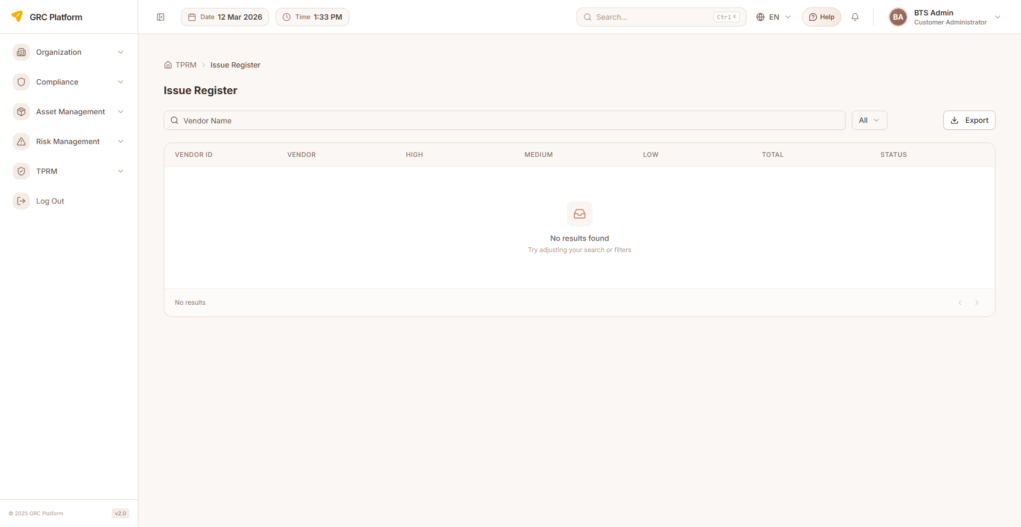
Figure: Assessor Issue Register page view

Features & Capabilities
- Issue register tab: vendors grouped with High/Medium/Low severity counts and totals
- Click vendor to see detailed issues list
- Issue details: domain, severity, issue description, risk, recommendation
- Issue codes and status tracking (Open, Overdue, Closed)
- Assessment code linkage
- Due date tracking
- Question number reference
- Remediation comments support

Navigation Path
Sidebar → TPRM → Assessor → Issue Register

RM Issue Register
Relationship Manager's issue register with full remediation tracking capabilities.
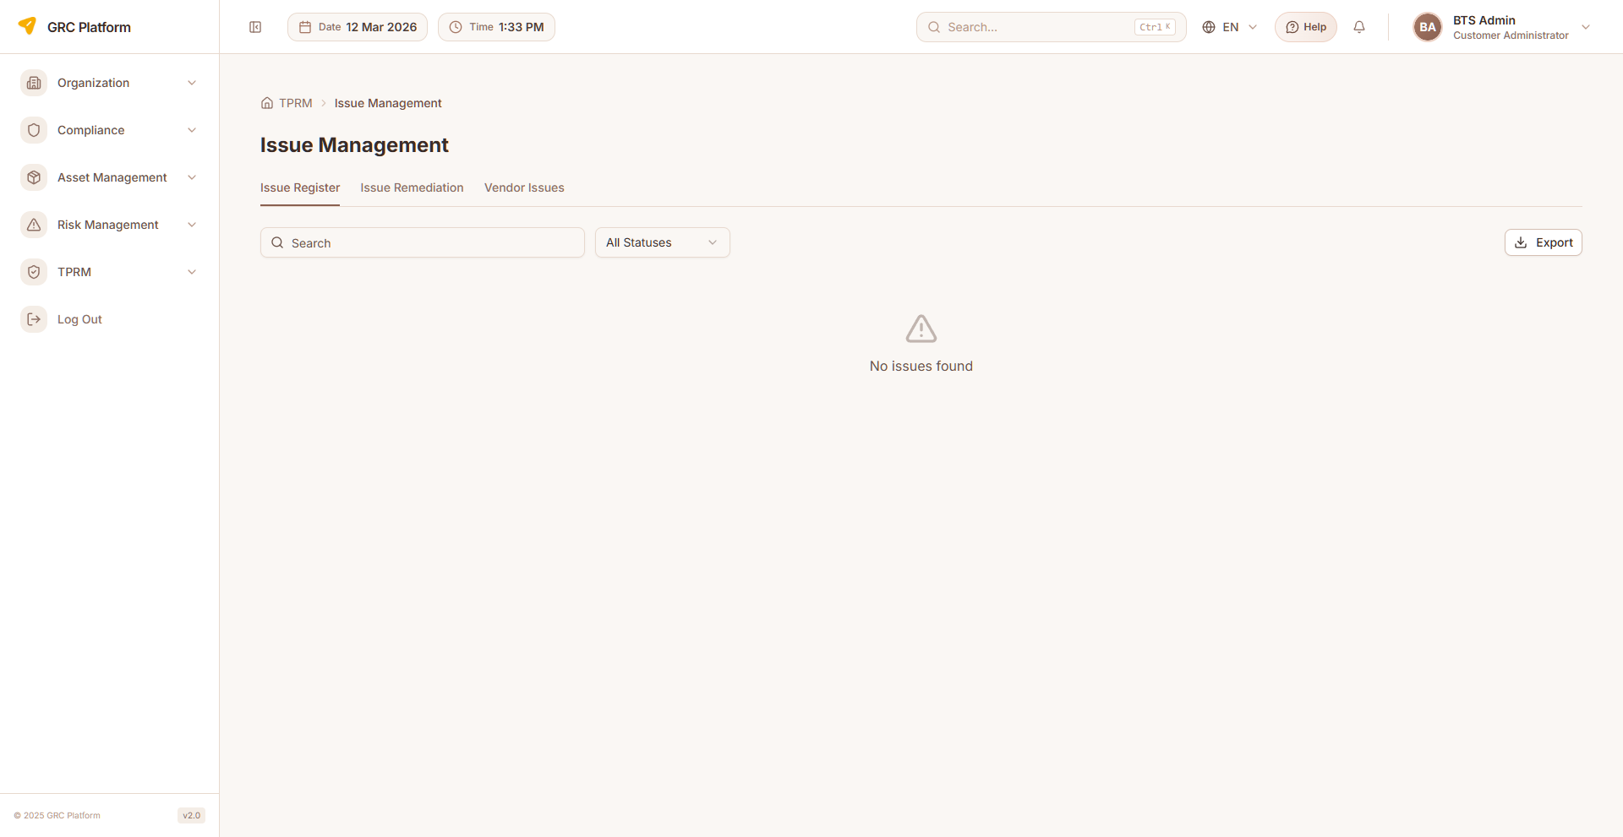
Figure: RM Issue Register page view

Features & Capabilities
- List issues with severity, status, and due dates
- View issue details and remediation plans
- Assign remediation owners
- Set due dates for remediation
- Track remediation status
- Add comments to issues
- Export issue register

Navigation Path
Sidebar → TPRM → RM → Issue Management

BO Issues
Business Owner's issue management view.
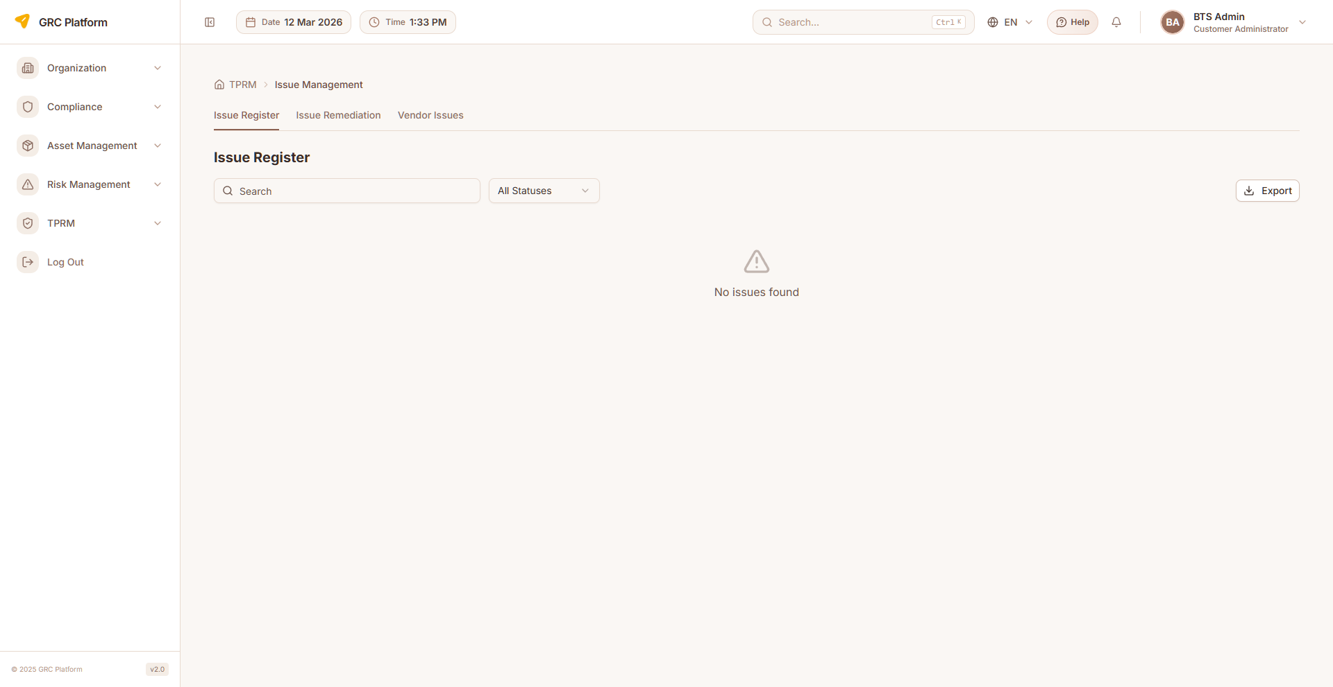
Figure: BO Issues page view

Features & Capabilities
- View issues related to business unit vendors
- Track issue severity and status
- Monitor remediation progress

Navigation Path
Sidebar → TPRM → BO → Issue Management

IT Issues
Internal IT Team's issue management for IT-related vendor issues.

Features & Capabilities
- View IT-related vendor issues
- Technical issue tracking and management
- IT remediation workflows

Navigation Path
Sidebar → TPRM → Internal IT → Issue Management

Permissions Reference
Each role has specific permissions that determine what actions they can perform. The permission system uses a resource:action pattern.

Actions
- view — Read-only access to see data
- create — Ability to create new records
- edit — Ability to modify existing records
- delete — Ability to remove records
- approve — Ability to approve/reject submissions

Permission Scopes
- Global — Access to all records across the organization
- Department — Access limited to records within the user's department
- Own — Access limited to records owned by or assigned to the user

How Permissions Work
When you log in, your assigned role determines which sidebar menu items are visible and which actions you can perform on each page. If a menu item or button is not visible, it means your role does not have the required permission.
Permissions are enforced at both the UI level (hiding unavailable options) and the API level (blocking unauthorized requests). This ensures data security regardless of how the application is accessed.

Glossary

TPRM
Third Party Risk Management — systematic process of analyzing and managing risks associated with outsourcing to third-party vendors.

VRR
Vendor Risk Rating — overall risk classification of a vendor, rated as Nominal, Low, Moderate, High, or Critical.

CAIQ
Consensus Assessments Initiative Questionnaire — standardized questionnaire for assessing cloud service provider security, organized by domains.

Assessment
Formal evaluation of a vendor's security and compliance posture through structured questionnaire-based review.

Remediation
Corrective action taken to address identified issues or vulnerabilities found during vendor assessments.

Monitoring Scan
Automated security assessment of a vendor using AI-powered web intelligence gathering across 17+ targeted searches.

KPI (Monitoring)
Key Performance Indicator in vendor monitoring — measures like Network Security, DNS Health, SSL/TLS Config, etc., scored 0-100.

Inherent Risk
Risk level before any controls or mitigations are applied.

Residual Risk
Risk level remaining after controls and mitigations are applied.

Domain
Specific area of assessment (e.g., Data Security, Access Control, Business Continuity).

Offboarding
Process of terminating a vendor relationship, including contract closure and final assessment.

Due Diligence
Systematic investigation of a vendor before and during the engagement to assess risk.

Scorecard
Quantitative summary of a vendor's security posture across multiple KPIs.

Assessment Factory
Batch mechanism for creating multiple vendor assessments simultaneously.

SME
Subject Matter Expert — specialist who provides domain-specific expertise during vendor assessments.

