TPRM Module
User Manual — Relationship Manager

Glimmora International
Generated: March 12, 2026
Version 1.0

Note: This document is auto-generated and confidential. Do not distribute without authorization.

Getting Started

Logging In
To access the application:
- Open your web browser and navigate to the application URL provided by your administrator.
- Enter your username and password on the login page.
- Click "Sign In" to access the application.
- Upon successful login, you will be redirected to your default dashboard.

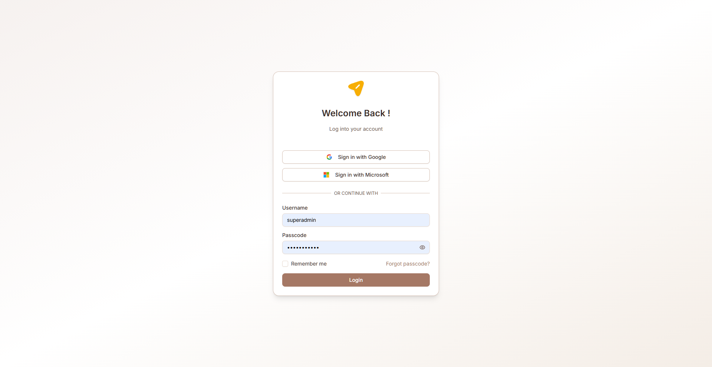
Figure: Login page

Navigation
The TPRM module uses a sidebar navigation menu on the left side of the screen. Each menu item corresponds to a functional area. Your visible menu items depend on your assigned role and permissions.
Key navigation elements:
- Sidebar menu — Primary navigation to all accessible pages
- Breadcrumb trail — Shows your current location within the application
- Header bar — Contains user profile, notifications, and language switcher
- Language selector — Switch between English, Arabic (RTL), and Latvian

Multi-Language Support
The application supports three languages:
- English (default) — Left-to-right layout
- Arabic — Right-to-left (RTL) layout with full UI mirroring
- Latvian — Left-to-right layout
To change the language, use the language selector in the header. All labels, buttons, and system text will be translated. User-entered data (vendor names, risk descriptions, etc.) is also translated dynamically when records are created or edited.

Common UI Patterns
Throughout the application, you will encounter these common interface patterns:
- Data tables — Sortable, filterable lists with pagination and search
- Dialog forms — Modal forms for creating and editing records
- Accordion views — Expandable/collapsible sections for detailed information
- Status badges — Color-coded labels indicating record status
- Action buttons — Create, Edit, Delete, Export, and role-specific actions
- Toast notifications — Brief success/error messages after actions
- Charts — Bar charts, pie charts, and progress indicators on dashboards

Role: Relationship Manager
Manages the vendor relationship lifecycle end-to-end. Creates vendors, initiates assessments, assigns assessors, tracks issues, manages contracts, and ensures vendor compliance throughout the engagement.

Accessible Modules
- RM Dashboard
- RM Vendor Inventory
- RM Assessments
- RM Issue Register
- RM Contracts
- RM Monitoring
- Reports
- RM Support

Key Capabilities
- Create and manage vendor records in RM Inventory
- Initiate vendor assessments and assign assessors
- Track assessment progress through full lifecycle (Draft → Completed)
- Manage issue register with remediation tracking
- Assign remediation owners and set due dates
- Manage vendor contracts and monitor expiration
- View RM dashboard for portfolio overview (2 charts)
- View monitoring scorecard for vendor security posture
- Generate TPRM reports
- Add comments to issues

Dashboard
Role-specific dashboards providing at-a-glance views of vendor risk posture, assessment progress, and issue status through interactive charts and analytics.

RM Dashboard
Relationship Manager dashboard showing vendor criticality distribution and assessment status across all managed vendors.
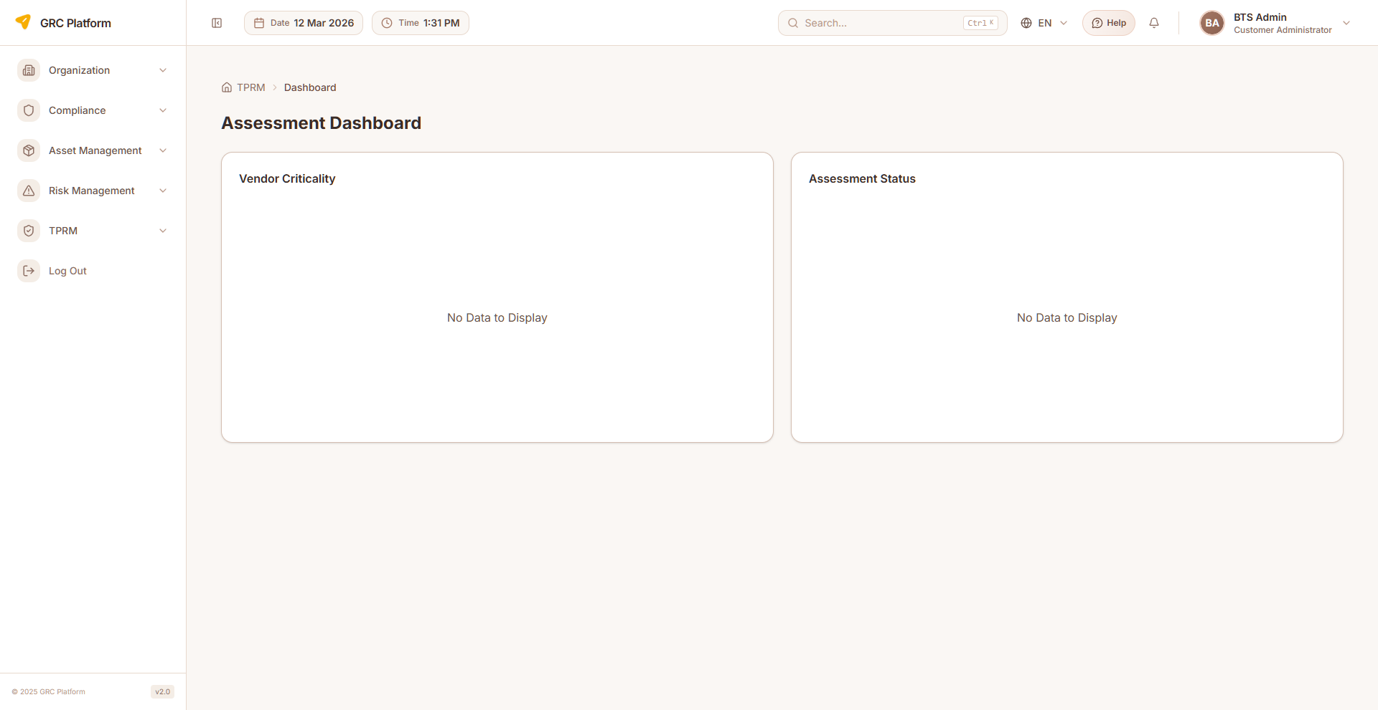
Figure: RM Dashboard page view

Features & Capabilities
- Vendor Criticality bar chart (Nominal, Low, Moderate, High, Critical) with color coding
- Assessment Status bar chart (Initiated, In Progress, Completed)
- Interactive tooltips with vendor/assessment counts
- Auto-refresh on page load
- "No Data to Display" message when no vendors exist

Navigation Path
Sidebar → TPRM → RM → Dashboard

BO Dashboard
Business Owner dashboard showing vendor criticality and assessment status for vendors in the business unit.

Figure: BO Dashboard page view

Features & Capabilities
- Vendor Criticality bar chart (Nominal, Low, Moderate, High, Critical) with color coding
- Assessment Status bar chart (Initiated, In Progress, Completed)
- Interactive tooltips with counts
- Auto-refresh on page load

Navigation Path
Sidebar → TPRM → BO → Dashboard

Assessor Dashboard
Comprehensive assessor dashboard with 6 analytical charts covering issues, assessments, risks, results, top vendors, and domain distribution.
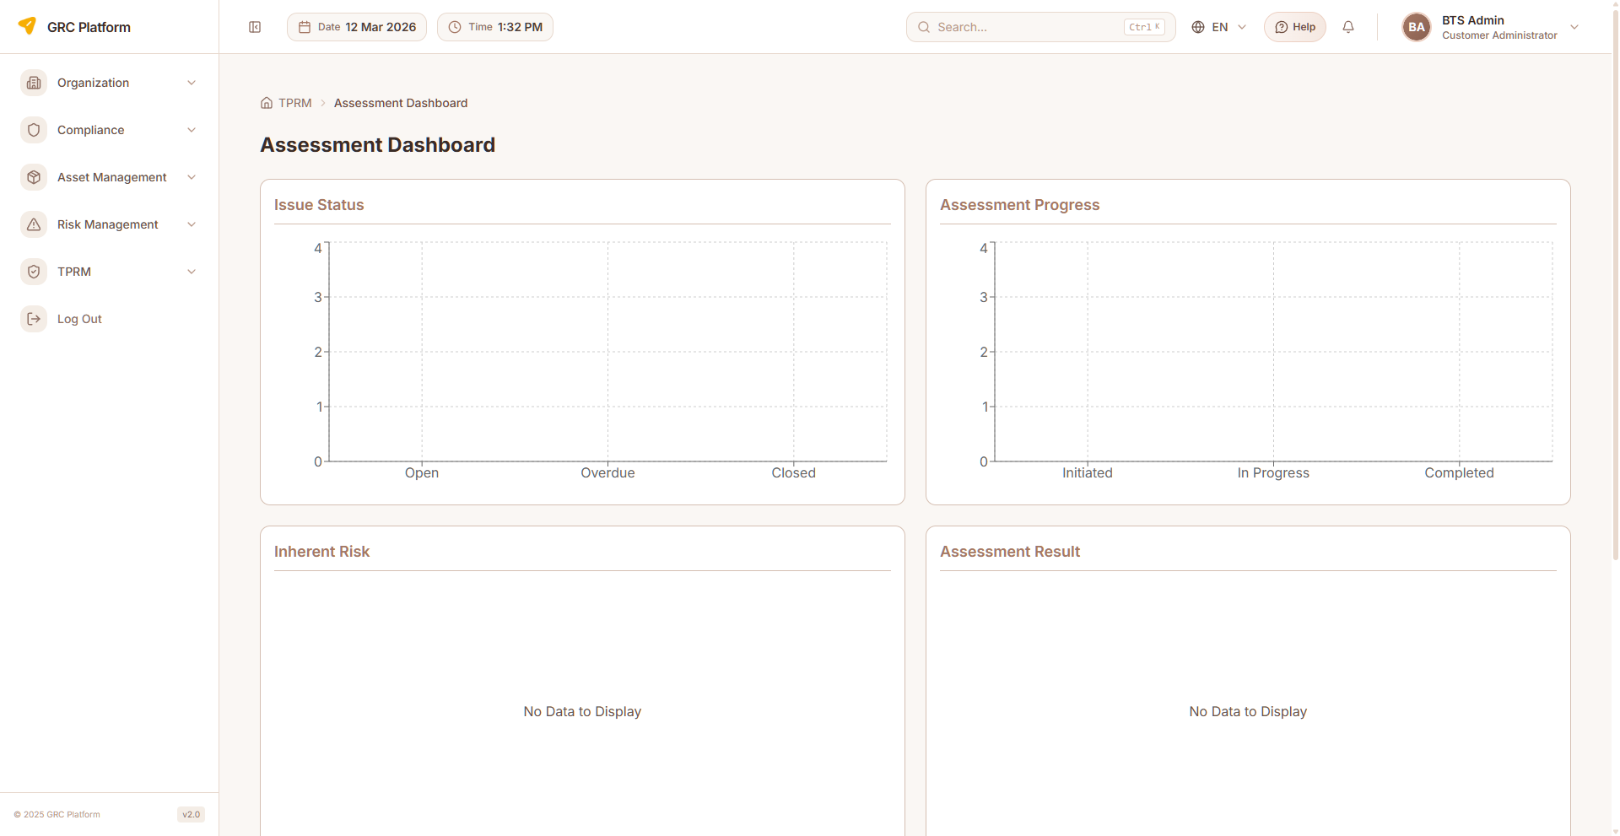
Figure: Assessor Dashboard page view

Features & Capabilities
- Issue Status bar chart (Open, Overdue, Closed) — maps DB statuses to 3 buckets
- Assessment Progress bar chart (Initiated, In Progress, Completed)
- Inherent Risk pie chart (High, Medium, Low) — mapped from VRR levels
- Assessment Result pie chart (Satisfactory, Unsatisfactory, Deficient)
- Top 5 Vendors stacked bar chart by severity (High, Medium, Low)
- Domain distribution horizontal bar chart (top 10 domains by issue count, strips CUST. prefix)
- Empty state handling for each chart

Navigation Path
Sidebar → TPRM → Assessor → Dashboard

Vendor Management
Core vendor lifecycle management including creation, inventory management, risk profiling, contract management, and vendor offboarding across different role perspectives.

Vendor Management (Admin)
Full vendor management with accordion-based UI showing vendor details, risk profiles, security monitoring scores, and contract information.
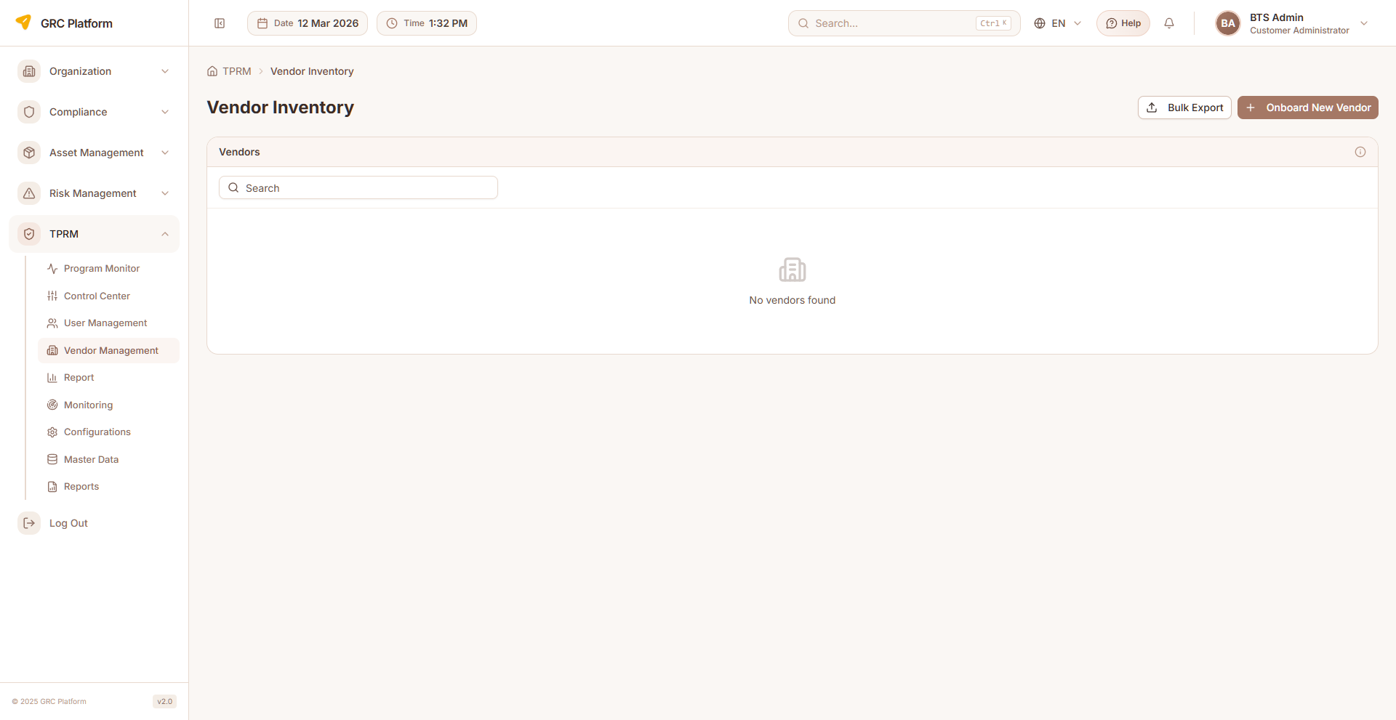
Figure: Vendor Management (Admin) page view

Features & Capabilities
- Accordion vendor list with expandable details
- Create vendor form with 6 sections and 25+ fields
- Vendor sections: Info, Contact, Service Category, Department, Risk Profile, Contract Dates, Certifications
- Vendor Risk Profile toggles: Access to Network, Cloud, Access to Data, PII
- Security Monitoring display: Overall Score, Security Posture, Threat Exposure
- Export individual vendor or bulk CSV export
- Edit and delete vendors
- Option to trigger monitoring scan on vendor creation
- Dynamic translation support

Navigation Path
Sidebar → TPRM → Vendor Management

RM Vendor Inventory
Relationship Manager's view of all vendors with risk ratings, status, and assessment information. Create, edit, and manage vendor records.
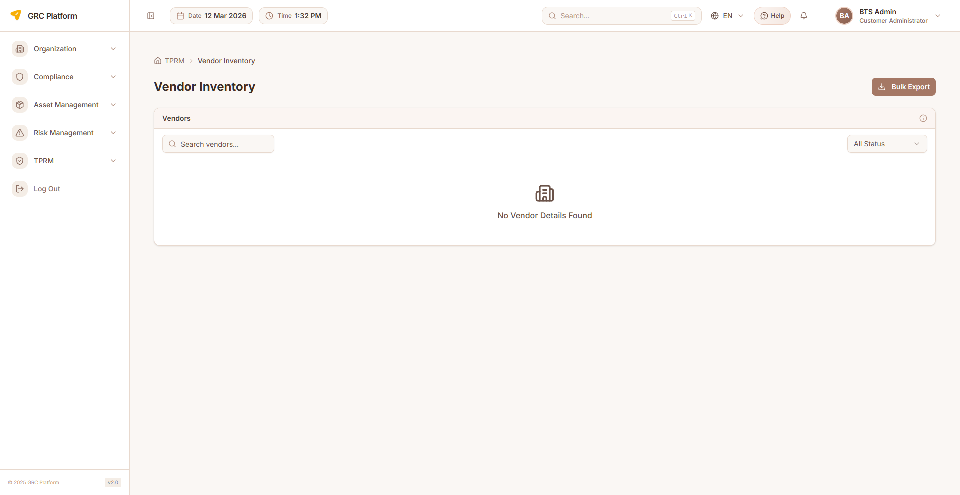
Figure: RM Vendor Inventory page view

Features & Capabilities
- List all vendors with risk rating (VRR), status, and assessment info
- Create new vendor (name, domain, vendor code, description)
- Edit vendor details
- Delete vendors
- View vendor risk rating: Nominal, Low, Moderate, High, Critical
- Initiate vendor assessments
- View assessment history per vendor
- Filter and search vendors

Navigation Path
Sidebar → TPRM → RM → Vendor Inventory

BO Vendor Inventory
Business Owner's view of vendors within their business unit. Complex UI with nested accordion, create/edit forms, and contract management.

Figure: BO Vendor Inventory page view

Features & Capabilities
- Nested accordion with vendor details
- Create/edit dialog with multi-section form
- Contract management: download/upload documents
- CSV bulk export capability
- Vendor Risk Profile toggles
- View vendor details and risk ratings
- View assessment status and history
- Filter and search

Navigation Path
Sidebar → TPRM → BO → Vendor Inventory

Assessor Vendor Inventory
Assessor's read-only view of vendors assigned for assessment, focusing on assessment workload and status.
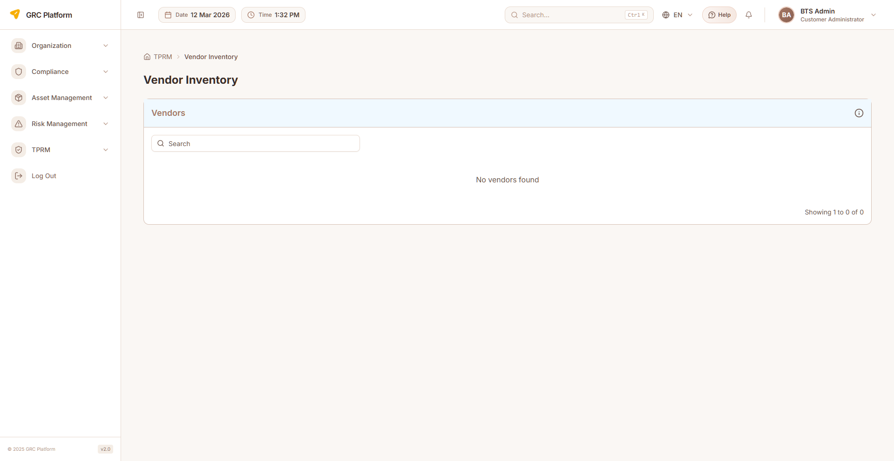
Figure: Assessor Vendor Inventory page view

Features & Capabilities
- List vendors assigned for assessment
- View vendor details and current risk rating
- Access assessment forms for assigned vendors
- Track assessment completion status

Navigation Path
Sidebar → TPRM → Assessor → Inventory

Contract Management
Manage vendor contracts, track expiration dates, initiate renewals, and handle offboarding workflows.

BO Contracts
Business Owner contract management with tabs for expiring contracts and all vendor contracts. Supports offboarding initiation and contract renewal.
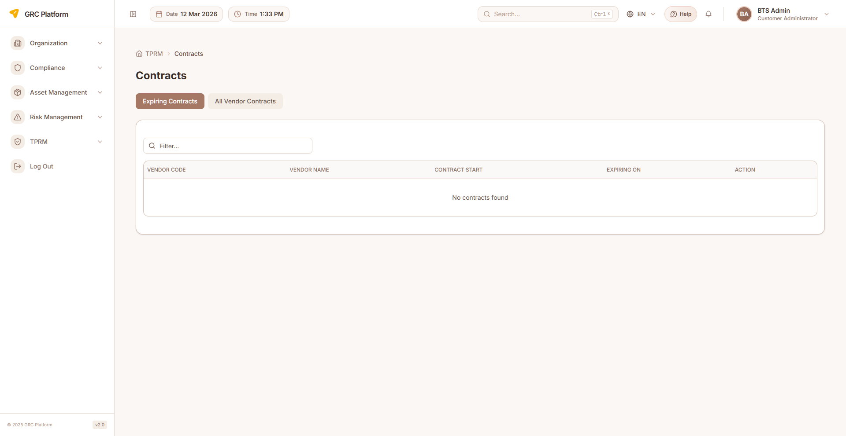
Figure: BO Contracts page view

Features & Capabilities
- Expiring Contracts tab with action buttons
- All Vendor Contracts tab
- Start Offboarding action (conditional on assessment status)
- Renew Contract dialog with new start/end date inputs
- Contract file upload (PDF/Word/Excel)
- Status badges: "Offboard Request Submitted" for offboarding vendors
- Date highlighting: red for expired, amber for expiring soon
- Download contract documents

Navigation Path
Sidebar → TPRM → BO → Contracts

RM Contracts
Relationship Manager contract management view for tracking and managing vendor contracts.

Figure: RM Contracts page view

Features & Capabilities
- Contract listing and management
- Contract renewal tracking
- Expiration date monitoring
- Download contract documents

Navigation Path
Sidebar → TPRM → RM → Contracts

Assessment Management
Create, conduct, and manage vendor risk assessments using questionnaire-based approaches (CAIQ). Supports assessment lifecycle from creation through completion and approval.

RM Assessments
Relationship Manager assessment management. Create assessments, assign assessors, and track the full assessment lifecycle.
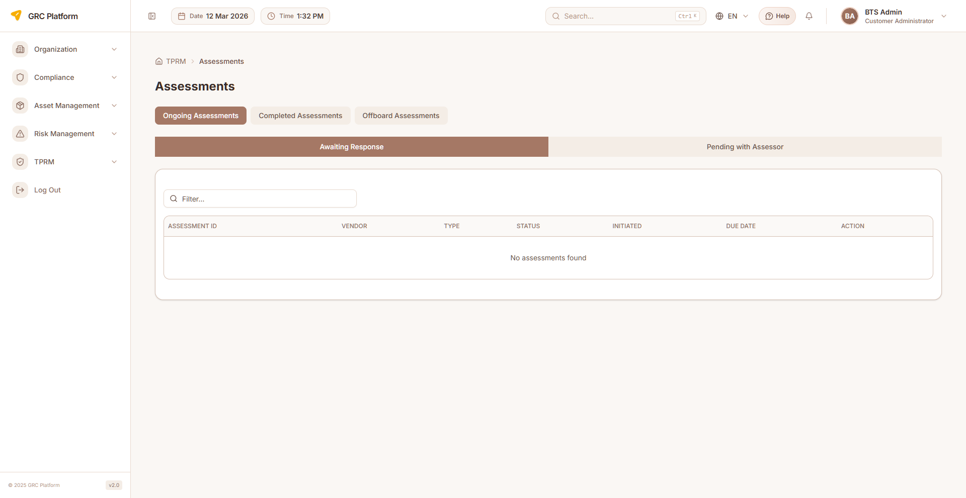
Figure: RM Assessments page view

Features & Capabilities
- List all assessments with status and assignee
- Create new assessment (select vendor, type, assign assessor)
- View assessment details and results
- Track status: Draft → In Progress → Submitted → Under Review → Approved/Completed
- Filter by status, vendor, assessor

Navigation Path
Sidebar → TPRM → RM → Assessments

BO Assessments
Business Owner assessment view with tabbed interface for Ongoing, Completed, and Offboard assessments with sub-tab navigation.

Figure: BO Assessments page view

Features & Capabilities
- Top tabs: Ongoing Assessments, Completed Assessments, Offboard Assessments
- Ongoing sub-tabs: Awaiting Response, Pending with Assessor
- Offboard sub-tabs: Offboard Approval, Terminated Vendors
- Table columns: Assessment ID, Vendor, Type, Status, Initiated, Due Date, Action
- Status color coding: Initiated (outline), In-Progress (secondary), Completed (default)
- Route to offboard review page for offboarding assessments

Navigation Path
Sidebar → TPRM → BO → Assessments

AM Assessments
Account Manager assessment view with tabs for Active, Submitted, Past, and Offboard assessments. Start or resume assessments from this page.
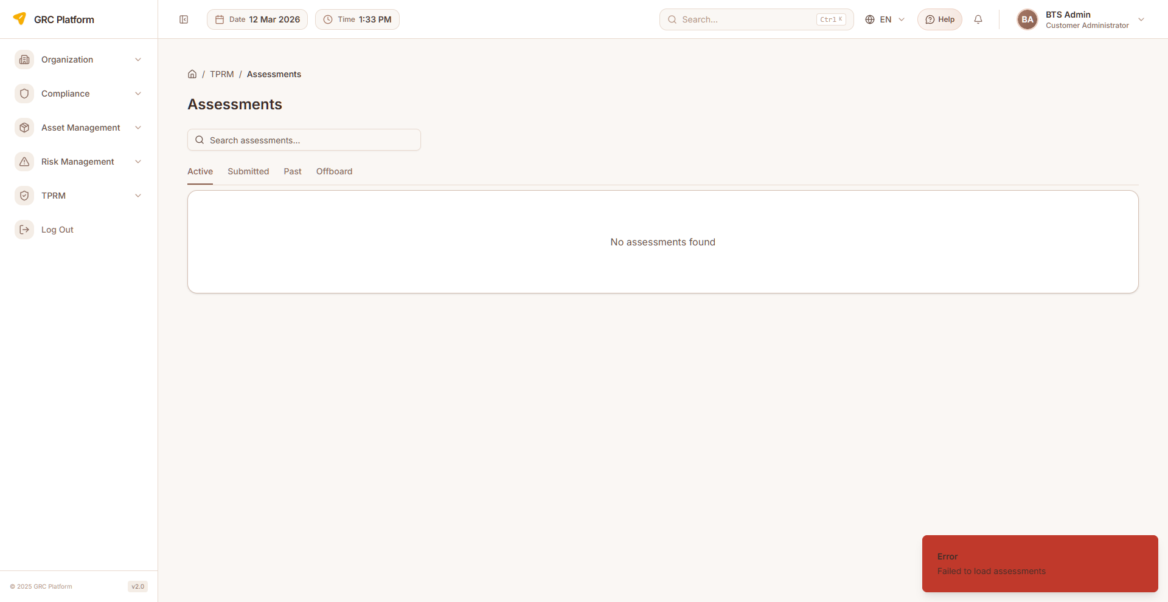
Figure: AM Assessments page view

Features & Capabilities
- Tabs: Active, Submitted, Past, Offboard assessments
- Search: filter by assessment code/vendor
- Start (Draft) or Resume assessments
- Offboard routing to dedicated offboard questionnaire page
- Status color coding: Gray (Draft), Blue (In Progress), Orange (Returned), Purple (Submitted), Indigo (Under Review), Green (Completed)

Navigation Path
Sidebar → TPRM → AM → Assessments

Assessor Assessments
Assessor's workqueue of assigned assessments. Conduct assessments by answering CAIQ questionnaire questions with AI assistance.
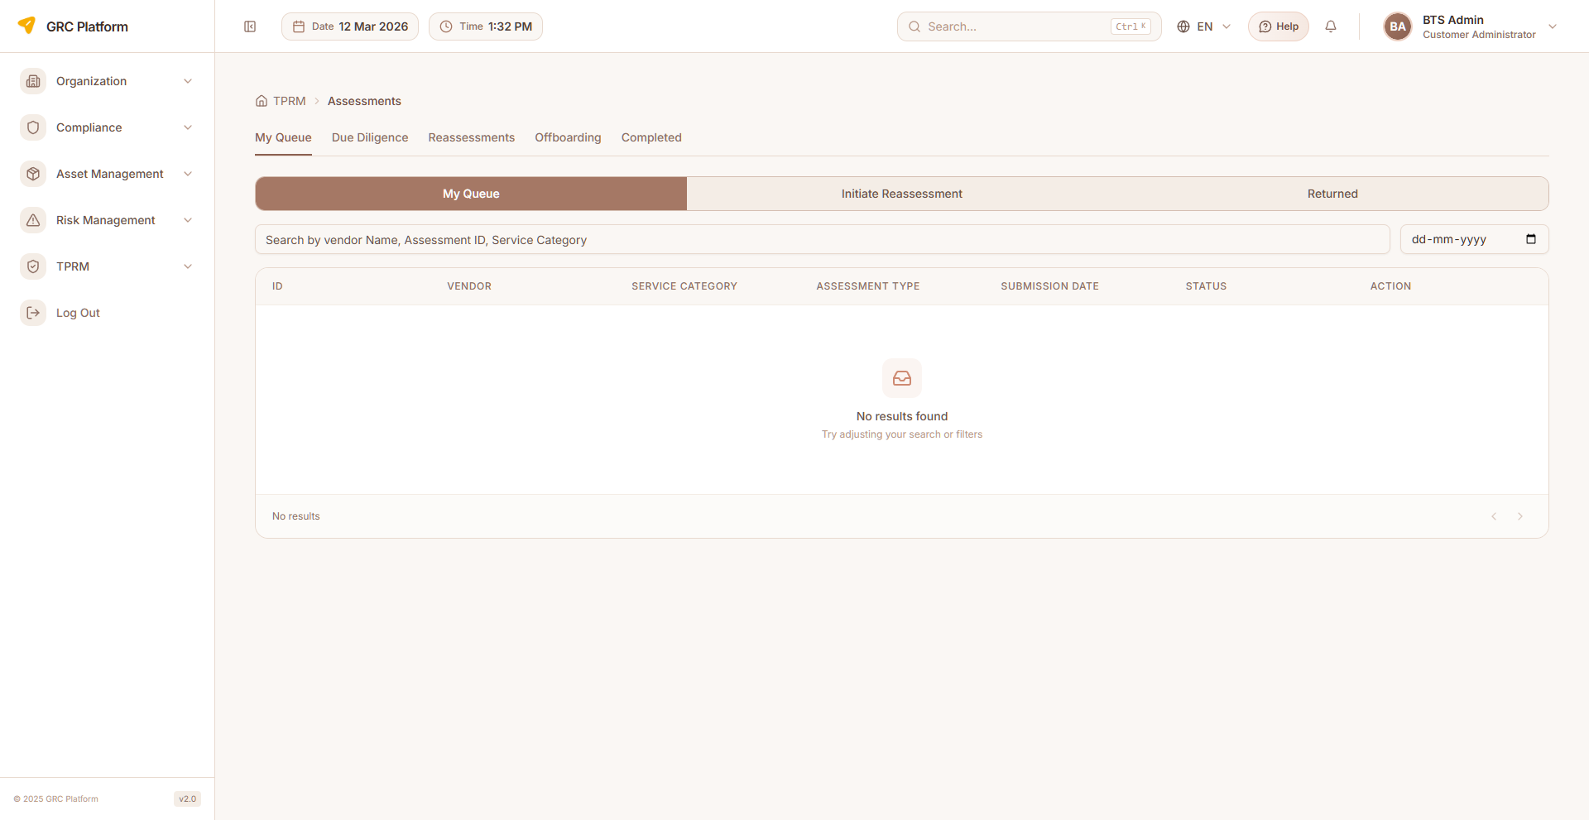
Figure: Assessor Assessments page view

Features & Capabilities
- List assessments assigned for completion
- Open assessment questionnaire (CAIQ questions by domain)
- Answer questions with compliance ratings
- Add evidence and notes to individual questions
- Submit completed assessments for review
- Save draft progress at any time
- AI-assisted question answering (Enable AI button)
- View vendor details within assessment context

Navigation Path
Sidebar → TPRM → Assessor → Assessments

Approver Assessments
Approver's view of submitted assessments awaiting review. Review responses, approve or reject with comments.

Figure: Approver Assessments page view

Features & Capabilities
- List assessments submitted for approval
- Review assessment responses and evidence per question
- Approve or reject assessments with review comments
- View assessment result summary and overall score

Navigation Path
Sidebar → TPRM → Approver → Assessments

CAIQ Questions
View the CAIQ questionnaire library organized by domains. Search and filter assessment questions.

Figure: CAIQ Questions page view

Features & Capabilities
- List all CAIQ questions organized by domain
- View question details (ID, question text, domain)
- Search questions by keyword
- Filter by domain

Navigation Path
Sidebar → TPRM → Assessor → CAIQ Questions

Assessment Factory
Batch create and schedule assessments for multiple vendors. Generate assessments at scale.

Features & Capabilities
- Batch assessment generation
- Scheduled assessment creation
- Multi-vendor assessment initiation
- Template-based assessment creation

Navigation Path
Sidebar → TPRM → Assessor → Assessment Factory

Assessment Templates
Manage assessment templates that define the structure and questions for vendor assessments.

Features & Capabilities
- Template creation and management
- Define assessment structure and questions
- Assign templates to assessment types

Navigation Path
Sidebar → TPRM → Assessor → Template

Issue & Remediation
Track and manage issues identified during assessments, assign remediation actions, monitor resolution progress, and manage issue comments.

Assessor Issue Register
Assessor's view of the issue register. View issues grouped by vendor with severity breakdowns (High/Medium/Low). Drill into vendor-specific issues for detailed information.
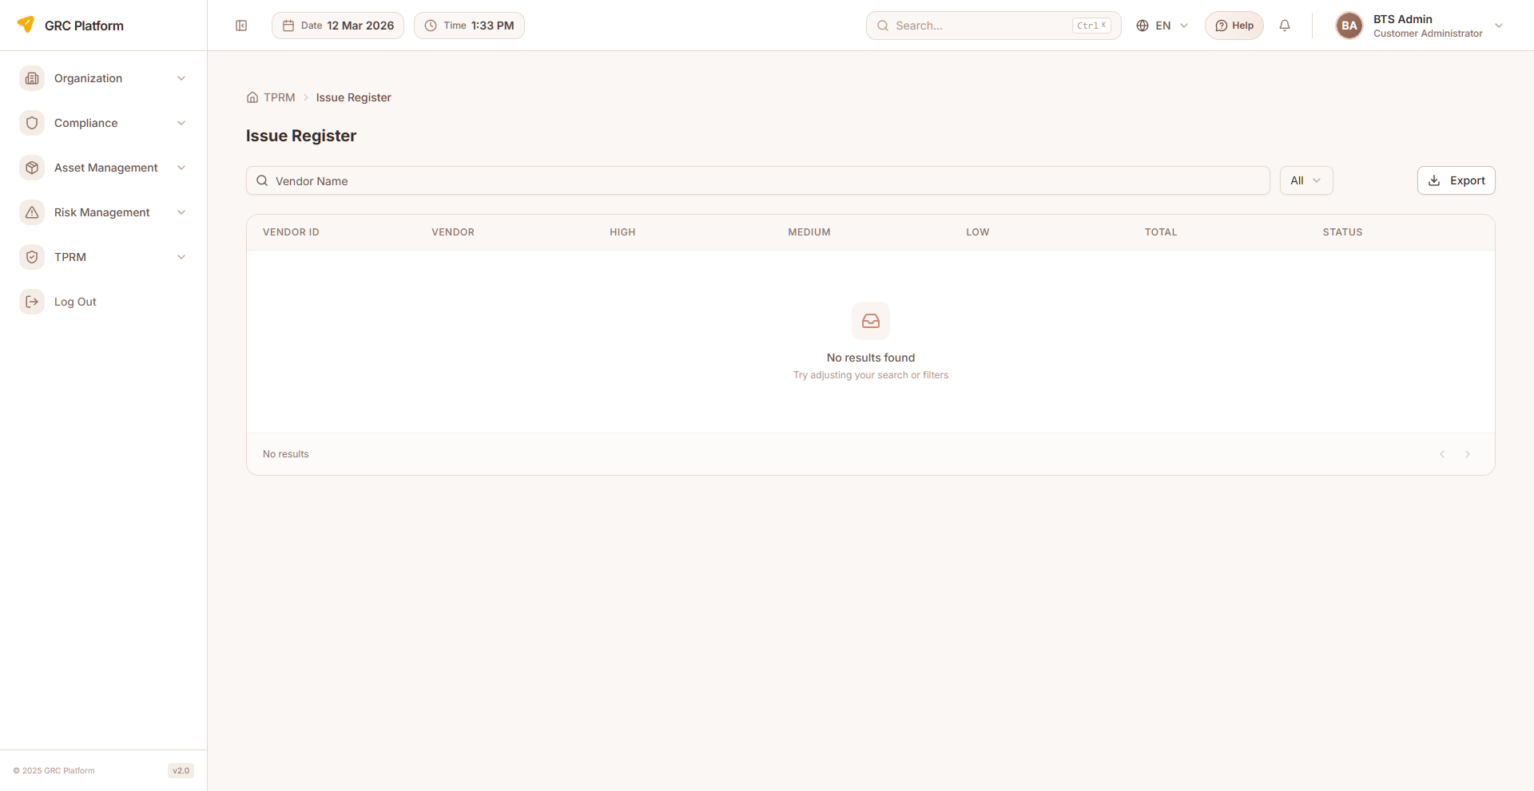
Figure: Assessor Issue Register page view

Features & Capabilities
- Issue register tab: vendors grouped with High/Medium/Low severity counts and totals
- Click vendor to see detailed issues list
- Issue details: domain, severity, issue description, risk, recommendation
- Issue codes and status tracking (Open, Overdue, Closed)
- Assessment code linkage
- Due date tracking
- Question number reference
- Remediation comments support

Navigation Path
Sidebar → TPRM → Assessor → Issue Register

RM Issue Register
Relationship Manager's issue register with full remediation tracking capabilities.
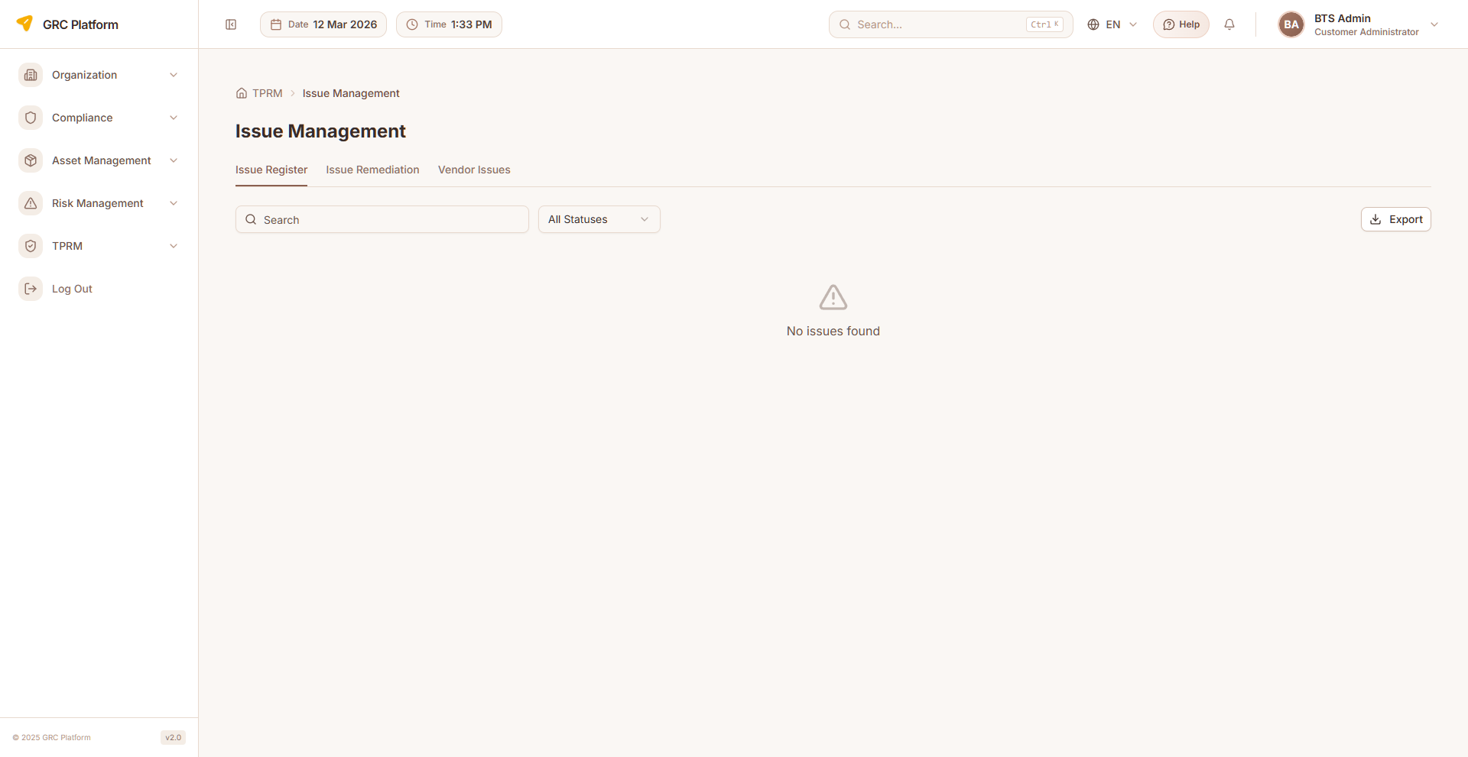
Figure: RM Issue Register page view

Features & Capabilities
- List issues with severity, status, and due dates
- View issue details and remediation plans
- Assign remediation owners
- Set due dates for remediation
- Track remediation status
- Add comments to issues
- Export issue register

Navigation Path
Sidebar → TPRM → RM → Issue Management

BO Issues
Business Owner's issue management view.
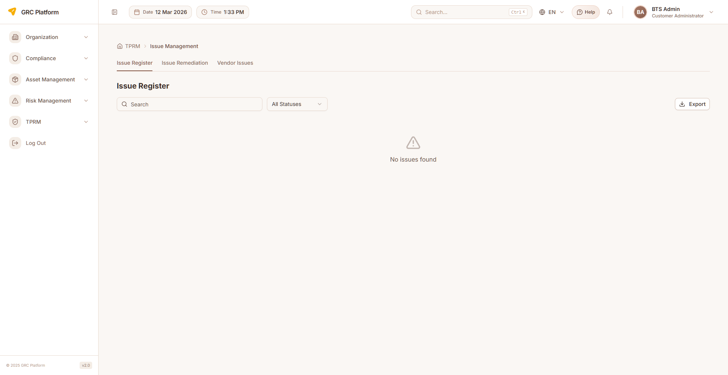
Figure: BO Issues page view

Features & Capabilities
- View issues related to business unit vendors
- Track issue severity and status
- Monitor remediation progress

Navigation Path
Sidebar → TPRM → BO → Issue Management

IT Issues
Internal IT Team's issue management for IT-related vendor issues.

Features & Capabilities
- View IT-related vendor issues
- Technical issue tracking and management
- IT remediation workflows

Navigation Path
Sidebar → TPRM → Internal IT → Issue Management

Monitoring & Scanning
Continuous vendor monitoring through automated security scanning, web intelligence gathering, and ongoing risk assessment with a 14-KPI scorecard.

Vendor Monitoring
Automated vendor security scanning and continuous monitoring dashboard. Trigger on-demand scans that analyze vendor security posture using AI-powered web intelligence gathering with 17+ targeted searches per vendor.
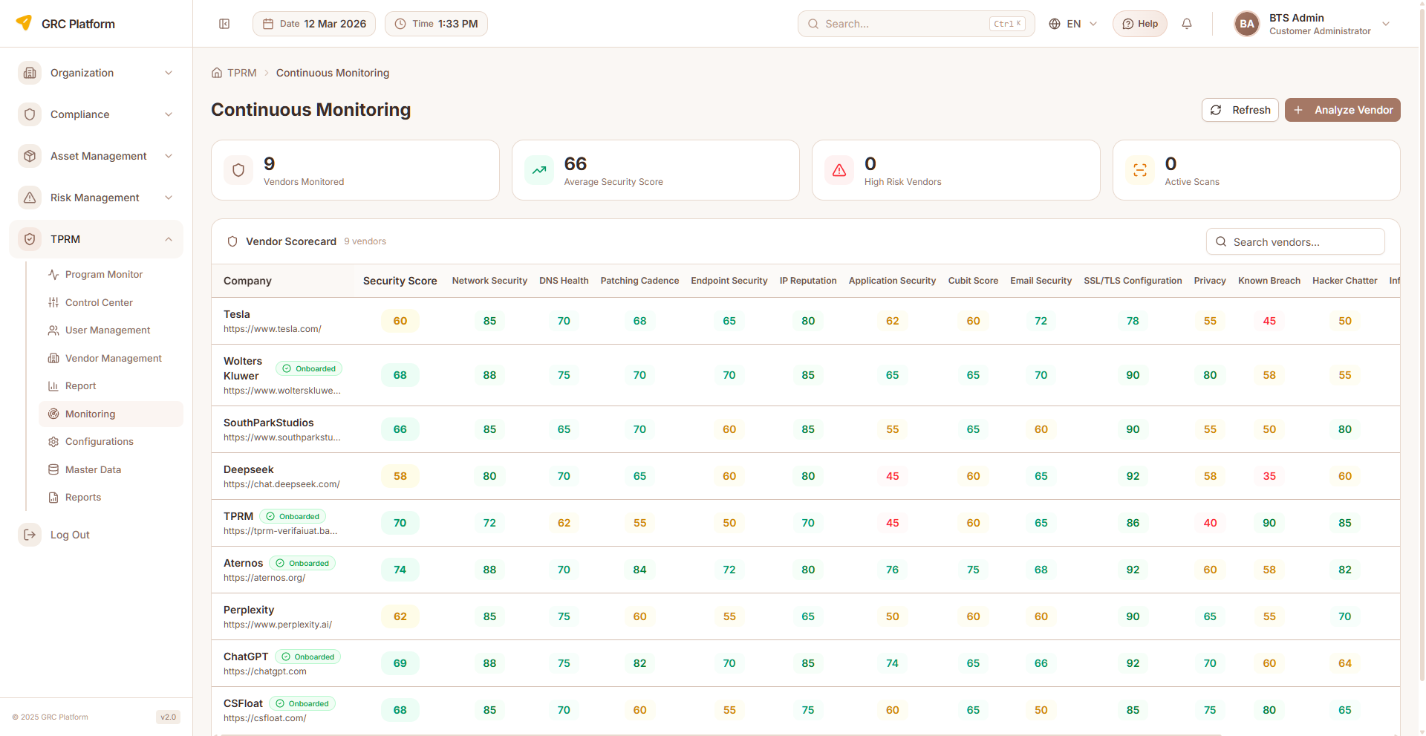
Figure: Vendor Monitoring page view

Features & Capabilities
- Stat cards: Vendors Monitored, Avg Security Score, High Risk Vendors, Active Scans
- Vendor Scorecard table with sticky vendor name column
- 14 KPI columns: Network Security, DNS Health, Patching Cadence, Endpoint Security, IP Reputation, Application Security, Cubit Score, Email Security, SSL/TLS Config, Privacy, Known Breach, Hacker Chatter, Information Leak, Social Engineering
- Security Score badge per vendor with color coding
- KPI cell colors: Green (≥80), Emerald (≥65), Yellow (≥50), Red (<50)
- Trigger new vendor scan dialog (enter vendor name and domain URL)
- Two-phase intelligence: HTTP header scan + 17 web searches + GPT-4o assessment
- Domain scores breakdown: Data Breaches, Vulnerabilities, Security Posture, Certifications, DNS/Email, SSL/TLS, IP Reputation, Privacy, Dark Web, News
- Queued/Processing scan status indicators with background polling (10s interval)
- Automatic stale scan cleanup (10 min timeout)
- View scan history per vendor
- Delete vendor monitoring records
- Only completed assessments shown in scorecard

Navigation Path
Sidebar → TPRM → Monitoring

Monitoring Detail
Detailed KPI analysis for a specific vendor's monitoring scan results.

Features & Capabilities
- Full KPI breakdown for individual vendor
- Historical scan comparison
- Detailed security score analysis

Navigation Path
Click vendor in Monitoring → Detail View

Reports
Generate comprehensive TPRM reports for management review, audit purposes, and regulatory compliance.

TPRM Reports
Generate and view TPRM reports including vendor risk summaries, assessment completion reports, issue resolution tracking, and historical trends.
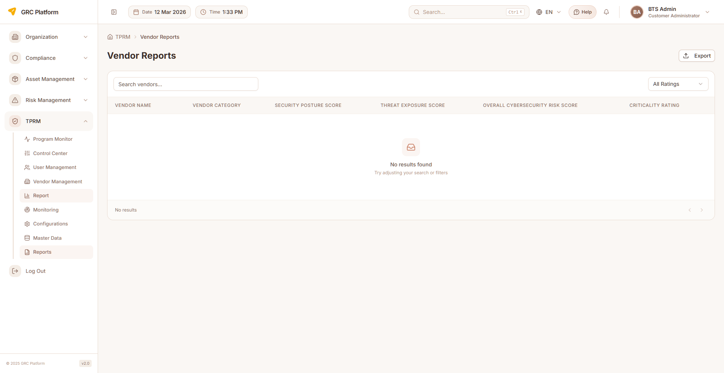
Figure: TPRM Reports page view

Features & Capabilities
- Vendor risk assessment reports
- Assessment completion summary reports
- Issue and remediation status reports
- Export reports for stakeholder distribution
- Historical trend analysis

Navigation Path
Sidebar → TPRM → Reports

Assessment Factory Reports
Reports on assessment factory history and batch assessment results.

Features & Capabilities
- Assessment factory batch history
- Batch assessment completion status
- Factory assessment analytics

Navigation Path
Sidebar → TPRM → Assessor → Assessment History

Notifications & Support
Role-specific notifications and support resources for all TPRM users.

Notifications
Role-specific notification center showing relevant alerts and updates for TPRM activities. Each role has its own notification page.

Features & Capabilities
- View unread notifications with badge count in header
- Assessment assignment notifications
- Status change alerts (assessment status, vendor status)
- Due date reminders for assessments and remediations
- Mark notifications as read
- Notification dropdown in header for quick access

Navigation Path
Header notification bell or Sidebar → TPRM → [Role] → Notifications

Contact Us / Support
Submit support requests and access help resources. Each role has its own support page.

Features & Capabilities
- Submit support/contact form
- View support team contact details
- FAQ and help resources

Navigation Path
Sidebar → TPRM → [Role] → Support

Permissions Reference
Each role has specific permissions that determine what actions they can perform. The permission system uses a resource:action pattern.

Actions
- view — Read-only access to see data
- create — Ability to create new records
- edit — Ability to modify existing records
- delete — Ability to remove records
- approve — Ability to approve/reject submissions

Permission Scopes
- Global — Access to all records across the organization
- Department — Access limited to records within the user's department
- Own — Access limited to records owned by or assigned to the user

How Permissions Work
When you log in, your assigned role determines which sidebar menu items are visible and which actions you can perform on each page. If a menu item or button is not visible, it means your role does not have the required permission.
Permissions are enforced at both the UI level (hiding unavailable options) and the API level (blocking unauthorized requests). This ensures data security regardless of how the application is accessed.

Glossary

TPRM
Third Party Risk Management — systematic process of analyzing and managing risks associated with outsourcing to third-party vendors.

VRR
Vendor Risk Rating — overall risk classification of a vendor, rated as Nominal, Low, Moderate, High, or Critical.

CAIQ
Consensus Assessments Initiative Questionnaire — standardized questionnaire for assessing cloud service provider security, organized by domains.

Assessment
Formal evaluation of a vendor's security and compliance posture through structured questionnaire-based review.

Remediation
Corrective action taken to address identified issues or vulnerabilities found during vendor assessments.

Monitoring Scan
Automated security assessment of a vendor using AI-powered web intelligence gathering across 17+ targeted searches.

KPI (Monitoring)
Key Performance Indicator in vendor monitoring — measures like Network Security, DNS Health, SSL/TLS Config, etc., scored 0-100.

Inherent Risk
Risk level before any controls or mitigations are applied.

Residual Risk
Risk level remaining after controls and mitigations are applied.

Domain
Specific area of assessment (e.g., Data Security, Access Control, Business Continuity).

Offboarding
Process of terminating a vendor relationship, including contract closure and final assessment.

Due Diligence
Systematic investigation of a vendor before and during the engagement to assess risk.

Scorecard
Quantitative summary of a vendor's security posture across multiple KPIs.

Assessment Factory
Batch mechanism for creating multiple vendor assessments simultaneously.

SME
Subject Matter Expert — specialist who provides domain-specific expertise during vendor assessments.

