TPRM Module
User Manual — TPRM Approver

Glimmora International
Generated: March 12, 2026
Version 1.0

Note: This document is auto-generated and confidential. Do not distribute without authorization.

Getting Started

Logging In
To access the application:
- Open your web browser and navigate to the application URL provided by your administrator.
- Enter your username and password on the login page.
- Click "Sign In" to access the application.
- Upon successful login, you will be redirected to your default dashboard.

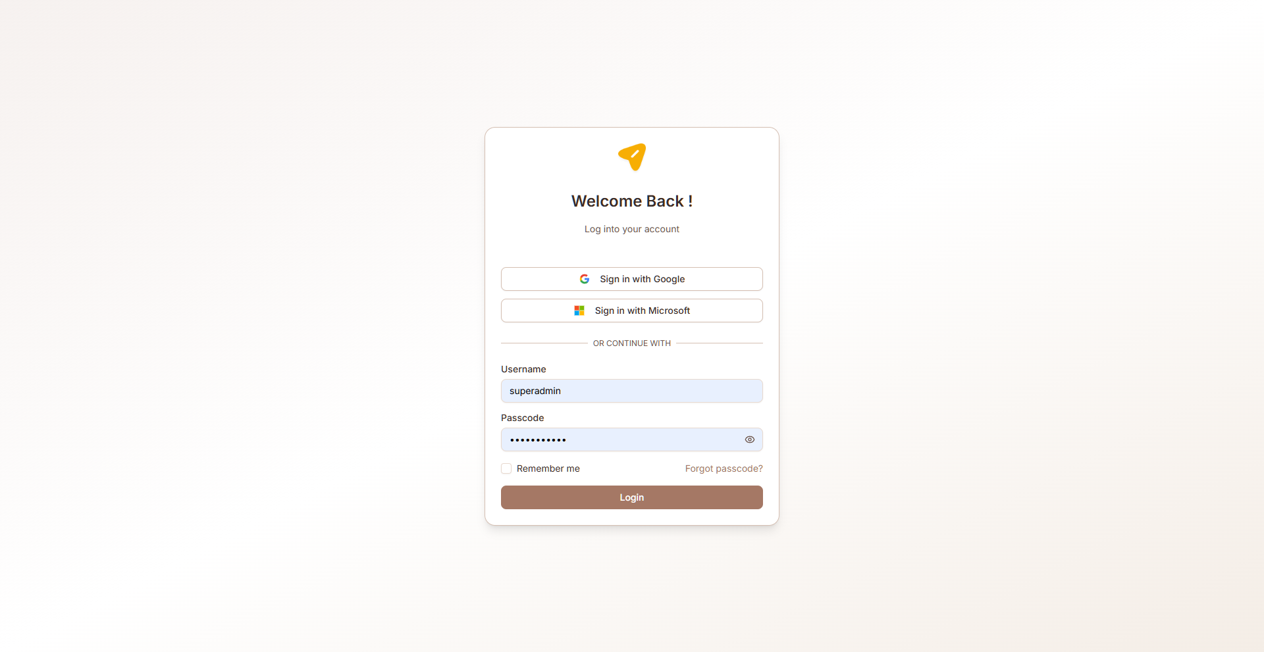
Figure: Login page

Navigation
The TPRM module uses a sidebar navigation menu on the left side of the screen. Each menu item corresponds to a functional area. Your visible menu items depend on your assigned role and permissions.
Key navigation elements:
- Sidebar menu — Primary navigation to all accessible pages
- Breadcrumb trail — Shows your current location within the application
- Header bar — Contains user profile, notifications, and language switcher
- Language selector — Switch between English, Arabic (RTL), and Latvian

Multi-Language Support
The application supports three languages:
- English (default) — Left-to-right layout
- Arabic — Right-to-left (RTL) layout with full UI mirroring
- Latvian — Left-to-right layout
To change the language, use the language selector in the header. All labels, buttons, and system text will be translated. User-entered data (vendor names, risk descriptions, etc.) is also translated dynamically when records are created or edited.

Common UI Patterns
Throughout the application, you will encounter these common interface patterns:
- Data tables — Sortable, filterable lists with pagination and search
- Dialog forms — Modal forms for creating and editing records
- Accordion views — Expandable/collapsible sections for detailed information
- Status badges — Color-coded labels indicating record status
- Action buttons — Create, Edit, Delete, Export, and role-specific actions
- Toast notifications — Brief success/error messages after actions
- Charts — Bar charts, pie charts, and progress indicators on dashboards

Role: TPRM Approver
Reviews and approves submitted vendor assessments. Ensures assessment quality, accuracy, and completeness before finalization. Can approve or reject with detailed review comments.

Accessible Modules
- Approver Dashboard
- Approver Assessments
- Reports
- Notifications

Key Capabilities
- Review submitted assessments — view all responses and evidence
- Approve or reject assessments with detailed review comments
- View assessment result summary and overall score
- Access approver dashboard (same as assessor dashboard)
- Generate assessment reports
- Receive notifications for assessments awaiting approval

Dashboard
Role-specific dashboards providing at-a-glance views of vendor risk posture, assessment progress, and issue status through interactive charts and analytics.

RM Dashboard
Relationship Manager dashboard showing vendor criticality distribution and assessment status across all managed vendors.
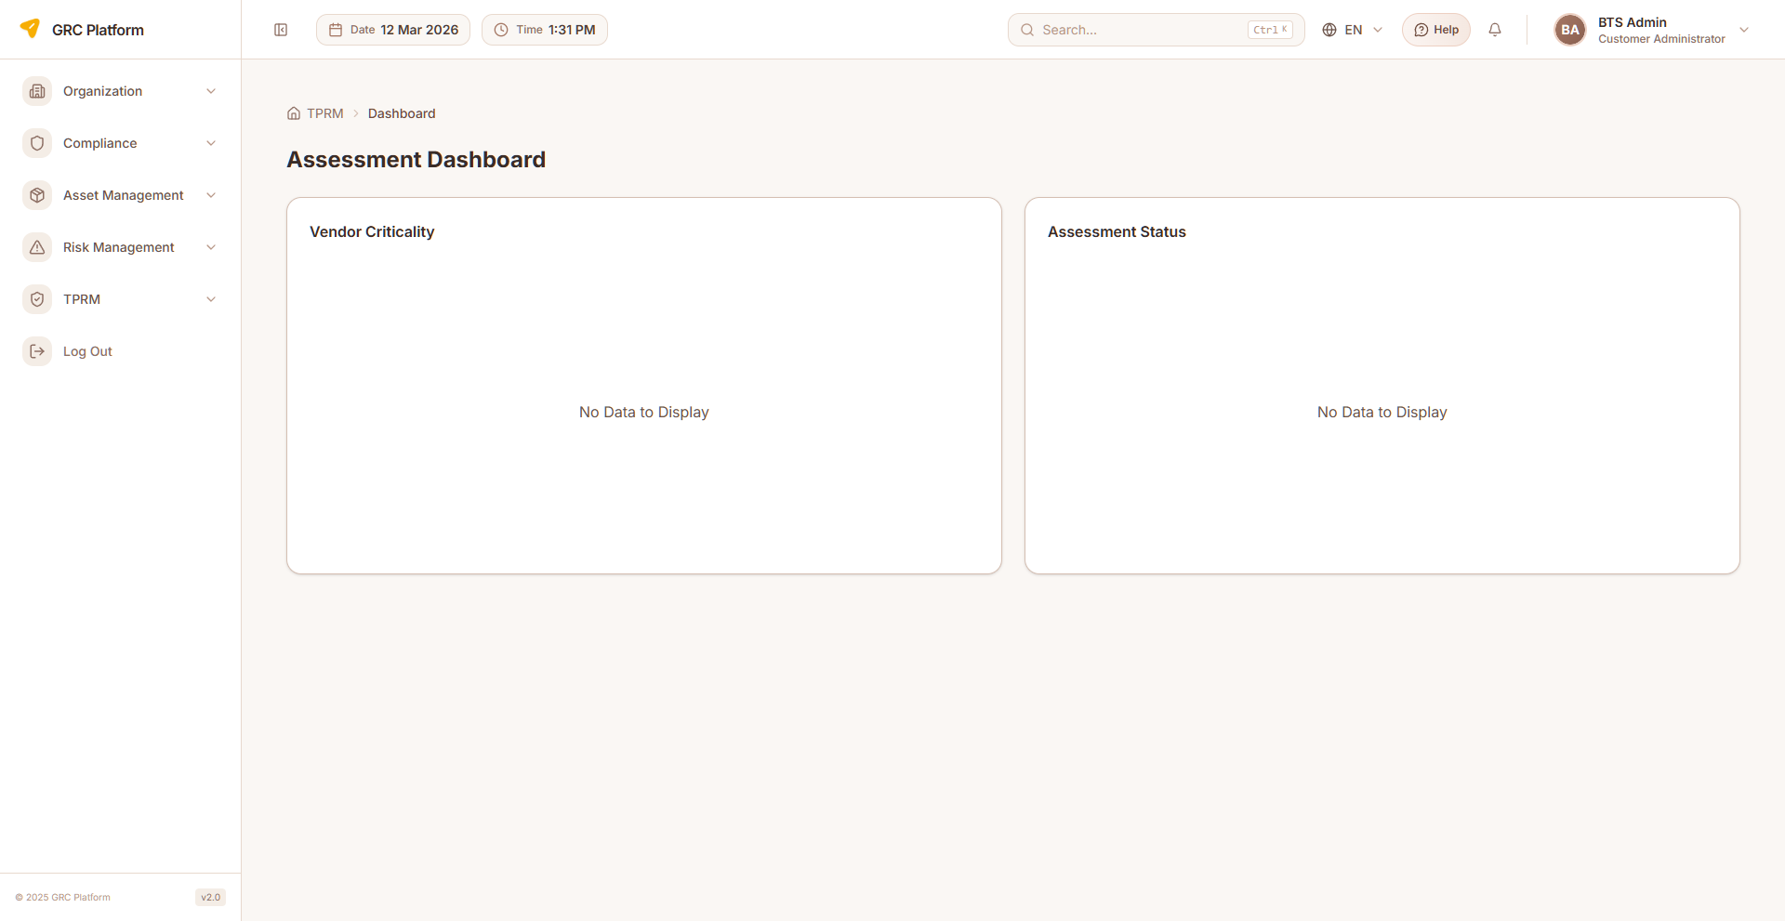
Figure: RM Dashboard page view

Features & Capabilities
- Vendor Criticality bar chart (Nominal, Low, Moderate, High, Critical) with color coding
- Assessment Status bar chart (Initiated, In Progress, Completed)
- Interactive tooltips with vendor/assessment counts
- Auto-refresh on page load
- "No Data to Display" message when no vendors exist

Navigation Path
Sidebar → TPRM → RM → Dashboard

BO Dashboard
Business Owner dashboard showing vendor criticality and assessment status for vendors in the business unit.

Figure: BO Dashboard page view

Features & Capabilities
- Vendor Criticality bar chart (Nominal, Low, Moderate, High, Critical) with color coding
- Assessment Status bar chart (Initiated, In Progress, Completed)
- Interactive tooltips with counts
- Auto-refresh on page load

Navigation Path
Sidebar → TPRM → BO → Dashboard

Assessor Dashboard
Comprehensive assessor dashboard with 6 analytical charts covering issues, assessments, risks, results, top vendors, and domain distribution.
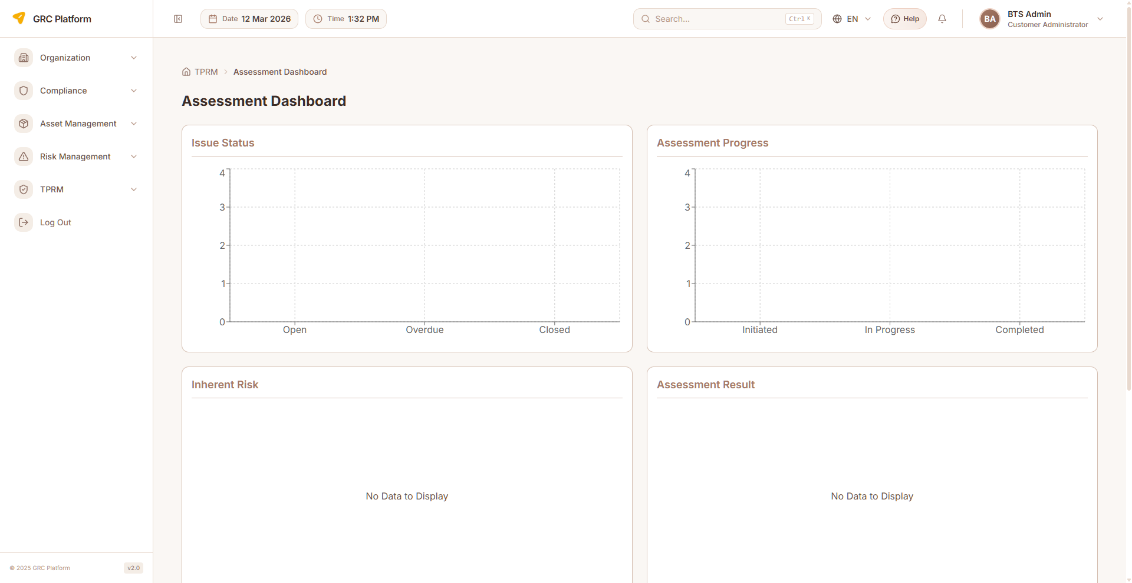
Figure: Assessor Dashboard page view

Features & Capabilities
- Issue Status bar chart (Open, Overdue, Closed) — maps DB statuses to 3 buckets
- Assessment Progress bar chart (Initiated, In Progress, Completed)
- Inherent Risk pie chart (High, Medium, Low) — mapped from VRR levels
- Assessment Result pie chart (Satisfactory, Unsatisfactory, Deficient)
- Top 5 Vendors stacked bar chart by severity (High, Medium, Low)
- Domain distribution horizontal bar chart (top 10 domains by issue count, strips CUST. prefix)
- Empty state handling for each chart

Navigation Path
Sidebar → TPRM → Assessor → Dashboard

Assessment Management
Create, conduct, and manage vendor risk assessments using questionnaire-based approaches (CAIQ). Supports assessment lifecycle from creation through completion and approval.

RM Assessments
Relationship Manager assessment management. Create assessments, assign assessors, and track the full assessment lifecycle.
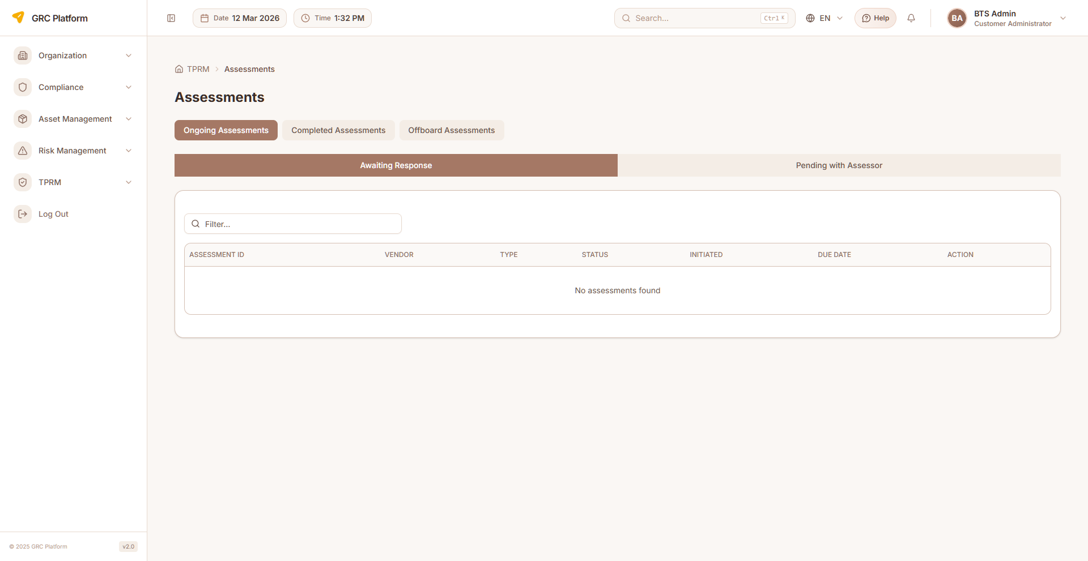
Figure: RM Assessments page view

Features & Capabilities
- List all assessments with status and assignee
- Create new assessment (select vendor, type, assign assessor)
- View assessment details and results
- Track status: Draft → In Progress → Submitted → Under Review → Approved/Completed
- Filter by status, vendor, assessor

Navigation Path
Sidebar → TPRM → RM → Assessments

BO Assessments
Business Owner assessment view with tabbed interface for Ongoing, Completed, and Offboard assessments with sub-tab navigation.

Figure: BO Assessments page view

Features & Capabilities
- Top tabs: Ongoing Assessments, Completed Assessments, Offboard Assessments
- Ongoing sub-tabs: Awaiting Response, Pending with Assessor
- Offboard sub-tabs: Offboard Approval, Terminated Vendors
- Table columns: Assessment ID, Vendor, Type, Status, Initiated, Due Date, Action
- Status color coding: Initiated (outline), In-Progress (secondary), Completed (default)
- Route to offboard review page for offboarding assessments

Navigation Path
Sidebar → TPRM → BO → Assessments

AM Assessments
Account Manager assessment view with tabs for Active, Submitted, Past, and Offboard assessments. Start or resume assessments from this page.
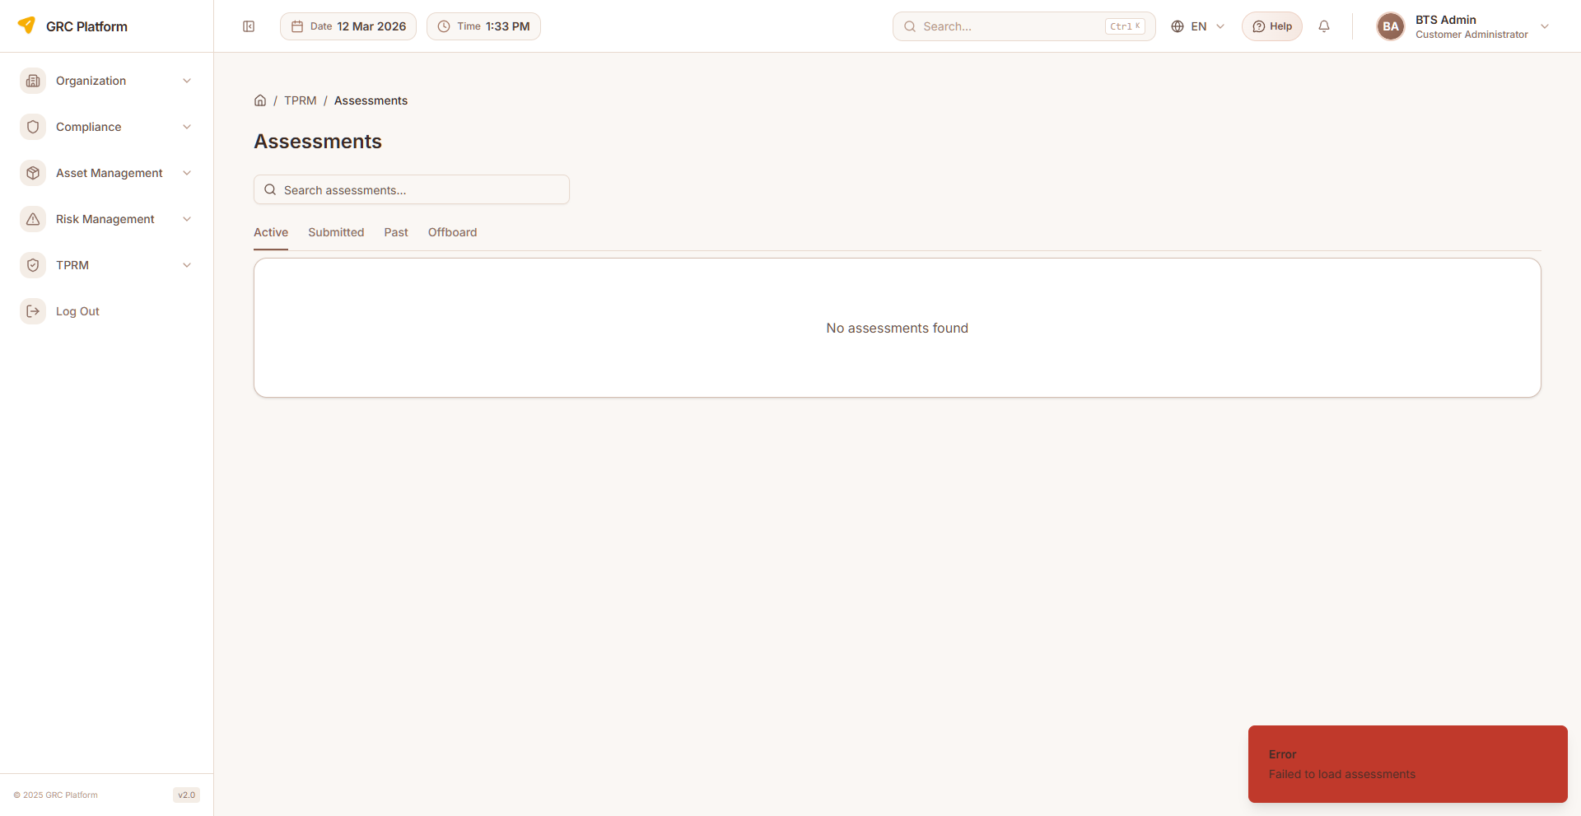
Figure: AM Assessments page view

Features & Capabilities
- Tabs: Active, Submitted, Past, Offboard assessments
- Search: filter by assessment code/vendor
- Start (Draft) or Resume assessments
- Offboard routing to dedicated offboard questionnaire page
- Status color coding: Gray (Draft), Blue (In Progress), Orange (Returned), Purple (Submitted), Indigo (Under Review), Green (Completed)

Navigation Path
Sidebar → TPRM → AM → Assessments

Assessor Assessments
Assessor's workqueue of assigned assessments. Conduct assessments by answering CAIQ questionnaire questions with AI assistance.
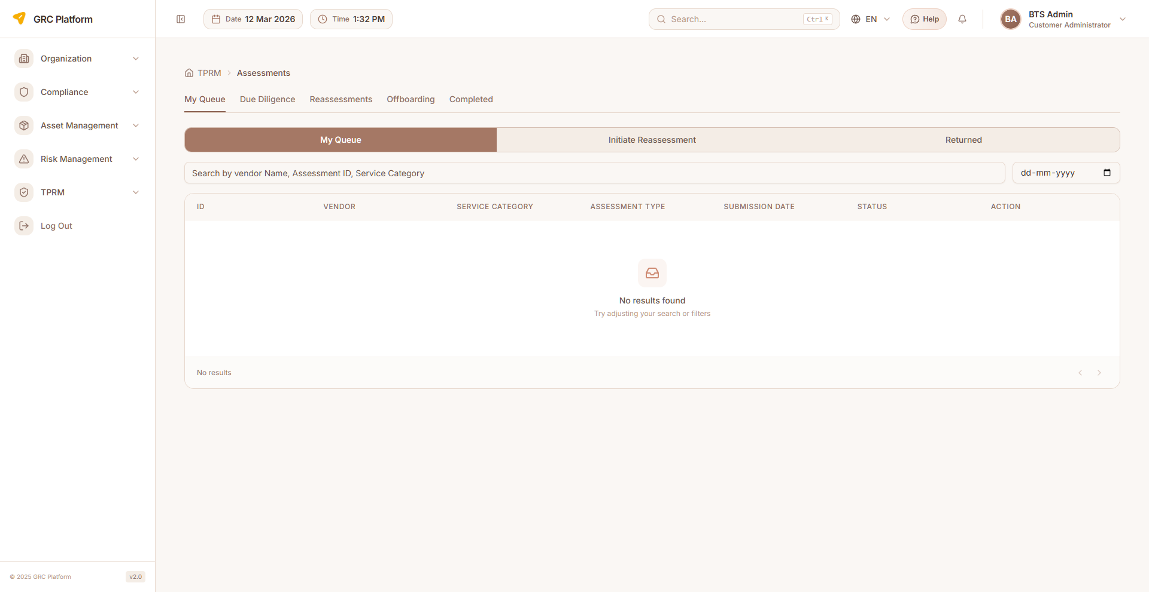
Figure: Assessor Assessments page view

Features & Capabilities
- List assessments assigned for completion
- Open assessment questionnaire (CAIQ questions by domain)
- Answer questions with compliance ratings
- Add evidence and notes to individual questions
- Submit completed assessments for review
- Save draft progress at any time
- AI-assisted question answering (Enable AI button)
- View vendor details within assessment context

Navigation Path
Sidebar → TPRM → Assessor → Assessments

Approver Assessments
Approver's view of submitted assessments awaiting review. Review responses, approve or reject with comments.

Figure: Approver Assessments page view

Features & Capabilities
- List assessments submitted for approval
- Review assessment responses and evidence per question
- Approve or reject assessments with review comments
- View assessment result summary and overall score

Navigation Path
Sidebar → TPRM → Approver → Assessments

CAIQ Questions
View the CAIQ questionnaire library organized by domains. Search and filter assessment questions.

Figure: CAIQ Questions page view

Features & Capabilities
- List all CAIQ questions organized by domain
- View question details (ID, question text, domain)
- Search questions by keyword
- Filter by domain

Navigation Path
Sidebar → TPRM → Assessor → CAIQ Questions

Assessment Factory
Batch create and schedule assessments for multiple vendors. Generate assessments at scale.

Features & Capabilities
- Batch assessment generation
- Scheduled assessment creation
- Multi-vendor assessment initiation
- Template-based assessment creation

Navigation Path
Sidebar → TPRM → Assessor → Assessment Factory

Assessment Templates
Manage assessment templates that define the structure and questions for vendor assessments.

Features & Capabilities
- Template creation and management
- Define assessment structure and questions
- Assign templates to assessment types

Navigation Path
Sidebar → TPRM → Assessor → Template

Reports
Generate comprehensive TPRM reports for management review, audit purposes, and regulatory compliance.

TPRM Reports
Generate and view TPRM reports including vendor risk summaries, assessment completion reports, issue resolution tracking, and historical trends.
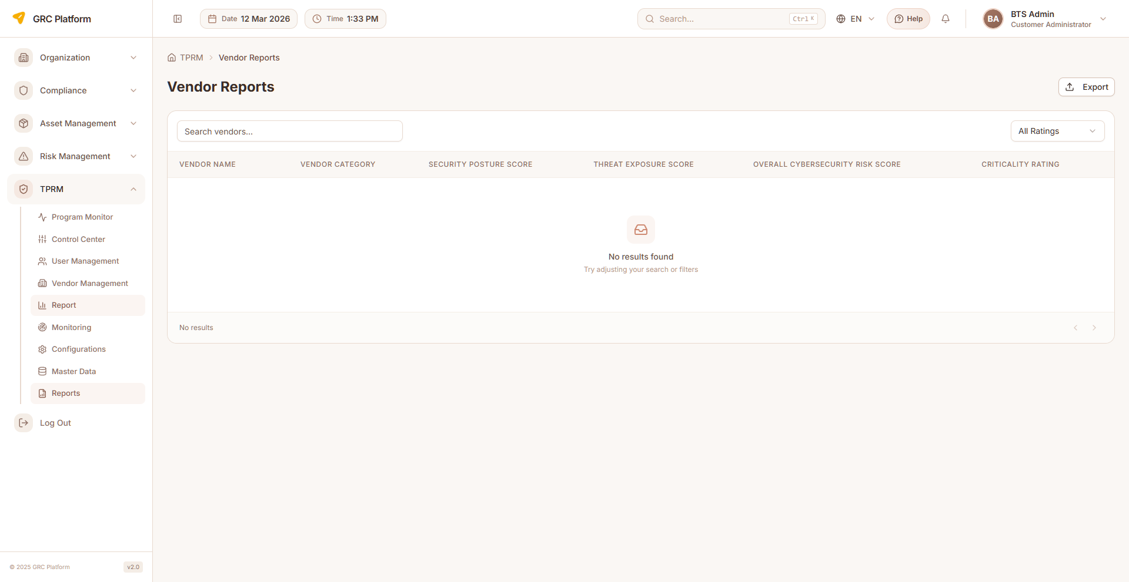
Figure: TPRM Reports page view

Features & Capabilities
- Vendor risk assessment reports
- Assessment completion summary reports
- Issue and remediation status reports
- Export reports for stakeholder distribution
- Historical trend analysis

Navigation Path
Sidebar → TPRM → Reports

Assessment Factory Reports
Reports on assessment factory history and batch assessment results.

Features & Capabilities
- Assessment factory batch history
- Batch assessment completion status
- Factory assessment analytics

Navigation Path
Sidebar → TPRM → Assessor → Assessment History

Notifications & Support
Role-specific notifications and support resources for all TPRM users.

Notifications
Role-specific notification center showing relevant alerts and updates for TPRM activities. Each role has its own notification page.

Features & Capabilities
- View unread notifications with badge count in header
- Assessment assignment notifications
- Status change alerts (assessment status, vendor status)
- Due date reminders for assessments and remediations
- Mark notifications as read
- Notification dropdown in header for quick access

Navigation Path
Header notification bell or Sidebar → TPRM → [Role] → Notifications

Contact Us / Support
Submit support requests and access help resources. Each role has its own support page.

Features & Capabilities
- Submit support/contact form
- View support team contact details
- FAQ and help resources

Navigation Path
Sidebar → TPRM → [Role] → Support

Permissions Reference
Each role has specific permissions that determine what actions they can perform. The permission system uses a resource:action pattern.

Actions
- view — Read-only access to see data
- create — Ability to create new records
- edit — Ability to modify existing records
- delete — Ability to remove records
- approve — Ability to approve/reject submissions

Permission Scopes
- Global — Access to all records across the organization
- Department — Access limited to records within the user's department
- Own — Access limited to records owned by or assigned to the user

How Permissions Work
When you log in, your assigned role determines which sidebar menu items are visible and which actions you can perform on each page. If a menu item or button is not visible, it means your role does not have the required permission.
Permissions are enforced at both the UI level (hiding unavailable options) and the API level (blocking unauthorized requests). This ensures data security regardless of how the application is accessed.

Glossary

TPRM
Third Party Risk Management — systematic process of analyzing and managing risks associated with outsourcing to third-party vendors.

VRR
Vendor Risk Rating — overall risk classification of a vendor, rated as Nominal, Low, Moderate, High, or Critical.

CAIQ
Consensus Assessments Initiative Questionnaire — standardized questionnaire for assessing cloud service provider security, organized by domains.

Assessment
Formal evaluation of a vendor's security and compliance posture through structured questionnaire-based review.

Remediation
Corrective action taken to address identified issues or vulnerabilities found during vendor assessments.

Monitoring Scan
Automated security assessment of a vendor using AI-powered web intelligence gathering across 17+ targeted searches.

KPI (Monitoring)
Key Performance Indicator in vendor monitoring — measures like Network Security, DNS Health, SSL/TLS Config, etc., scored 0-100.

Inherent Risk
Risk level before any controls or mitigations are applied.

Residual Risk
Risk level remaining after controls and mitigations are applied.

Domain
Specific area of assessment (e.g., Data Security, Access Control, Business Continuity).

Offboarding
Process of terminating a vendor relationship, including contract closure and final assessment.

Due Diligence
Systematic investigation of a vendor before and during the engagement to assess risk.

Scorecard
Quantitative summary of a vendor's security posture across multiple KPIs.

Assessment Factory
Batch mechanism for creating multiple vendor assessments simultaneously.

SME
Subject Matter Expert — specialist who provides domain-specific expertise during vendor assessments.

