Oxxy WhatsApp AI Chatbot — Full Development Plan (React · NestJS · Postgres · Redis)
Nov 6, 2026 · @manoj

1. What we are building
A WhatsApp AI assistant for Oxxy Health. A NestJS backend runs every rule in the revised Oxxy documents, and Oxxy's in-house CRM stays the record for customers, bookings, tasks and payments. The sales team works in the CRM and chats with customers in a React console, because the CRM has no WhatsApp inbox. Claude writes the chat replies; NestJS checks each reply and makes every decision. Work starts with a 3-day pilot (see the task Excel), then the full build runs in the 12-week phases of section 9.
This is the one plan to build from. Section 1.1 has the business rules, sections 2 to 11 the system and the build phases, and section 12 every bot workflow step by step. With it you get two files: the clickable prototype (every console screen plus a WhatsApp simulator) and the task Excel (the 3-day pilot, day by day).
The bot must: answer questions, find out what the customer needs, recommend one product (Oxxy by default), suggest up to 5 centres, take booking requests, send one official activation link, and hand off to a human safely.
The bot must never: offer both products, promise savings or discounts, call a booking confirmed, mention tie-ups, or ignore STOP or an emergency.

1.1 Business rules at a glance
Everything a developer needs from Oxxy's business documents (the Playbook and the Trigger & Conversion Layer) is summarised here and in section 12. A note such as "Playbook 7" names the source section for the business team; you do not need those documents to build.
Products and prices (prices exclude GST; GST is 18% [CONFIRM])
Product | Monthly | Yearly | Age limit | Illustration rate | Break-even yearly spend
Oxxy Everyday | ₹999 | ₹10,000 | Up to 70 | 20% | ₹59,000
Oxxy Vital | ₹1,999 | ₹20,000 | Up to 75 | 25% | ₹94,400
Oxxy Thrive | ₹2,999 | ₹30,000 | Up to 80 | 30% | ₹1,18,000
Oxxy Infinity | ₹3,999 | ₹40,000 | No limit | 30% (savings up to 40%) | ₹1,57,334
Cut Medi Bills | ₹4,999, renews monthly until cancelled | ₹19,999, one-time for one year | No limit | 30% | ₹19,664 in that month, or ₹78,664 a year
Cut Medi Bills activation takes 5 to 10 working days.
Hard rules the code must enforce
- One product per customer, Oxxy by default. Never offer both.
- Value check: illustrated saving = floor(spend × rate ÷ 500) × 500. Recommend a plan only if that saving is more than the yearly price × 1.18; otherwise give the honest answer and offer centre or booking help.
- Booking date: today + 3 days up to the same date + 6 months, in Asia/Kolkata. Every booking is saved as pending_confirmation; only the sales team confirms it, in the CRM.
- Never call Oxxy insurance, promise a saving or discount, call a booking confirmed, or mention centre tie-ups. Use the neutral savings line.
- Emergency signals get 112 / 108; self-harm gets Tele-MANAS 14416. These checks run before Claude and stop all sales messages.
- Show the DPDP health-data consent notice before the first health question.
- Proactive messages only 09:00–21:00 IST; outside the 24-hour reply window, approved templates only. STOP ends all automated messages.
- WhatsApp limits: up to 3 reply buttons of 20 characters, list rows of 24 characters; the opening list has 4 rows.
- Languages: English, Hindi, Hinglish.
Triggers A–R (at most one per customer turn; the engine is in 12.6)
Trigger | Fires when
A Trust and legitimacy pack | Trust or legitimacy doubt
B Health insurance vs Oxxy | Insurance comparison
C Why activate Oxxy? | "Why activate?" or no urgency
D Nearby healthcare centres | Provider or location question
E Plan recommendation and activation | Plan interest or activation readiness
F Personalised savings illustration | Bill amount or annual spend shared
G Booking request | Appointment or provider choice
H Booking saved | Booking request saved
I Cut Medi Bills route | One specific upcoming expense
J Insurance coordination | Has insurance for the planned service
K Medicines | Medicine requirement
L News and testimonials | Wants proof from others
M One objection, one resolution | Objection or hesitation
N Agreed follow-up | Asks for time or is busy
O Senior callback | A fact cannot be confirmed
P Payment completed | Says payment is done
Q Incomplete activation | Link sent, payment not completed
R Stop commercial flow | Refusal, opt-out, emergency or privacy request
Open decisions (Oxxy answers these before launch; until then use the values above and keep them in config marked [CONFIRM])
- Whether family members on separate numbers may each hold a different product
- Age rule at renewal
- Oxxy family or multi-member pricing
- Pre-existing condition terms for Everyday and Vital
- Oxxy plan activation timeline and renewal terms
- GST rate and current yearly prices
- Cut Medi Bills cancellation method
- Whether a booking-only message may be sent on WhatsApp after opt-out (legal)
- Data retention period, deletion timeline and privacy contact
- Quiet hours, team hours and callback target time
- Length of the decision-journey window (now 7 days)
- One grammatical voice for the agent name in Hindi

2. Tech stack
Four core technologies, all in TypeScript, plus two external APIs.
Layer | Technology | Used for
Sales console (frontend) | React 18 + Vite + TypeScript, TanStack Query, React Router, a UI kit such as Ant Design or MUI | Queues, live chats, human takeover, bookings, provider directory, plan catalogue, dashboards
Backend | NestJS 10 (Node.js 22, TypeScript) | WhatsApp webhook, rule engine, conversation pipeline, REST API for the console, WebSocket for live updates
Database | PostgreSQL 16 + PostGIS, with Prisma or TypeORM | Customers, consent, conversations, bookings, plan catalogue, centres, events, tasks
Cache and queues | Redis 7 + BullMQ (@nestjs/bullmq) | Per-customer message queue, follow-up and reminder jobs, locks, rate limits, dedupe
AI | Claude API, model Claude Opus 5.5 (claude-opus-5-5), official @anthropic-ai/sdk | Understanding messages and drafting replies as structured JSON
Messaging | WhatsApp Cloud API (Meta) or a Business Solution Provider | Receiving and sending messages, templates, buttons, lists
Hosting (suggested) | Docker on AWS Mumbai (ap-south-1): ECS or EC2, RDS Postgres, ElastiCache Redis | Keeps Indian health data in India
Claude settings to use: structured output (JSON schema), prompt caching on the long system prompt, effort low for chat turns (raise only if quality needs it), and the server-side refusal fallback (fallbacks: "default"). Always check stop_reason before reading the reply.

3. Architecture
WhatsApp messages enter NestJS, wait in a Redis queue, and run one ordered turn. Postgres stores everything, and the React console talks only to NestJS.
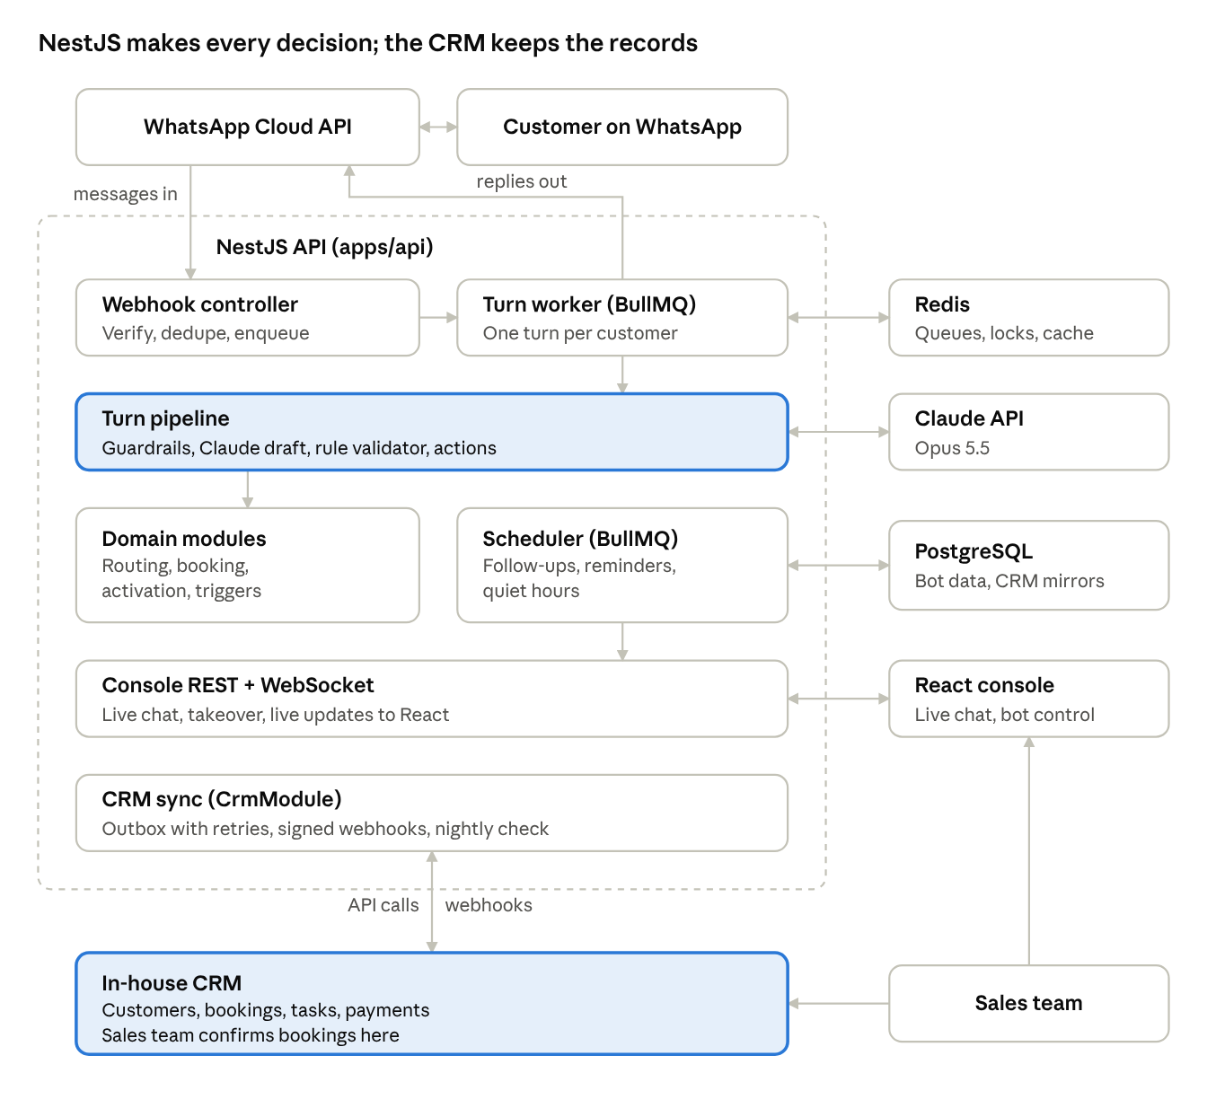
Architecture · React, NestJS, Postgres, Redis, Claude, WhatsApp, in-house CRM
The highlighted turn pipeline is the heart of the system: guardrails run before Claude, and the rule validator runs after it, so no unchecked text reaches a customer. The CRM sync module is the only link to the in-house CRM: calls go out through the outbox, and signed webhooks come back.

3.1 Who owns what (in-house CRM)
The CRM is the record for customers, bookings, tasks and payments; the bot owns the WhatsApp conversation and every Playbook rule. Each bot row keeps the CRM record's id, so nothing is typed twice.
Data | Record lives in | Bot keeps
Customer or lead | CRM | crm_customer_id, plus name, language and active product for fast checks
Booking requests | CRM; the sales team confirms them there | A mirror row with crm_booking_id and its status
Tasks and escalations | CRM; the sales team works them there | crm_task_id on the task mirror
Activations and payments | CRM (payment gateway reports to the CRM) | Status mirror, needed for the one-product lock
Conversations and messages | Bot | Full transcript; the CRM gets a summary and a console link
Consent (WhatsApp, marketing, health data) | Bot, copied to the CRM | The consents table
Triggers, follow-up schedule, validator results, audit | Bot | Everything
Plan catalogue and provider directory | Not decided yet | Ask the CRM team (3.5)
The sales team uses two tools: the CRM for records, bookings and tasks, and the React console for live chat and takeover.

3.2 Bot to CRM API
Because the CRM is in-house, we write this contract and the CRM team builds it. These are the Playbook 17.1 actions; paths are proposals to agree in Phase 0.
Action | Method and path | Bot calls it when | CRM returns
lookup_customer | GET /api/v1/customers?whatsapp=+91… | Every new conversation | Customer id, active product, open bookings and cases, opt-out flag
upsert_customer | PUT /api/v1/customers/{whatsapp} | Discovery fields change (need, city, age, selected product) | Customer id
create_booking_request | POST /api/v1/booking-requests | Booking capture is complete (Playbook 17.2 payload) | Booking id, status pending_confirmation
create_task | POST /api/v1/tasks | Emergency, payment issue, callback, DONE verification, Cut Medi Bills eligibility | Task id
create_activation | POST /api/v1/activations | Official activation link is sent | Activation id
log_event | POST /api/v1/customers/{id}/events | Trigger fired, consent changed, conversation summary | Nothing
set_opt_out | POST /api/v1/customers/{id}/opt-out | Customer says STOP | Nothing
- Every write sends an Idempotency-Key header (the outbox row id), so a retry never creates a second booking.
- Auth: a service token from the secrets manager, HTTPS only; 5-second timeout.
- Tasks carry activation_pitch_allowed (false when the customer declined activation), so the sales call follows Playbook 11.2.

3.3 CRM to bot webhooks
The CRM tells the bot when the sales team changes something, and the bot sends the matching WhatsApp message. All events go to one endpoint, POST /webhooks/crm.
Event | Sent when | Bot does
booking.confirmed | Sales confirms the slot with the centre | Sends the booking-confirmed template; sets confirmed_by to that sales user
booking.rescheduled | Sales moves the date or time | Checks the new date is in the 3-day to 6-month window, then tells the customer
booking.cancelled | Centre or customer cancels | Tells the customer; offers another centre once
activation.paid | Payment is verified | Fires Trigger P; product lock becomes active
activation.failed or activation.refunded | Payment fails or is refunded | Updates the lock; creates no new sales message
task.completed | Callback or escalation is closed | Lifts the Trigger O suppression; bot may resume
customer.opted_out | Customer asked by phone to stop | Suppresses all WhatsApp automation at once
customer.owner_changed | Lead moves to another sales person | Shows the new owner in the console
- Each request carries an HMAC-SHA256 signature and a timestamp; the bot rejects bad signatures and anything older than 5 minutes.
- The bot stores each event by event_id first, returns 200, then processes it in BullMQ, so a resend is harmless.

3.4 Reliability and hard rules
A CRM outage must never lose a booking or change what the customer is told. The bot writes first, then syncs.
- Outbox: every CRM call is saved in crm_outbox (6.2) in the same Postgres transaction as the bot's own change.
- Worker: a BullMQ job sends it, retrying after 1, 5, 15 and 60 minutes, then hourly for 24 hours.
- Dead letter: after 24 hours the row is marked dead, an alert fires, and it shows on the console's CRM sync screen for a manual retry.
- CRM down: the customer still gets "your booking request is recorded", because it is recorded in the bot; it is never called confirmed.
- Nightly check: a job compares open bookings, tasks and activations on both sides and lists any mismatch.
Hard rules are checked twice. The bot checks before it calls, and the CRM should reject the same cases itself:
- a second pending or active product for one customer;
- a booking date outside today + 3 days to + 6 months (Asia/Kolkata);
- a booking marked confirmed without a sales user.

3.5 Questions for the CRM team
Agree these in Phase 0 week 1; the API and webhook work cannot start without the first four.
- ☐ Base URL, sandbox environment and how the bot authenticates
- ☐ Field mapping for each Playbook section 17 group, and which custom fields the CRM must add
- ☐ Whether the CRM can reject the three hard rules in 3.4 itself
- ☐ Webhook signing secret, retry policy and the full event list
- ☐ Who owns the plan catalogue and provider directory: the CRM or the bot
- ☐ How sales users sign in to the console: single sign-on with the CRM, or separate logins
- ☐ Expected load: leads per day and peak messages per minute

4. Project structure
One monorepo (pnpm workspaces or Nx) with two apps and one shared package, so the console and API use the same types and rule constants.
oxxy-whatsapp/
├── apps/
│ ├── api/ # NestJS backend
│ │ ├── src/
│ │ │ ├── whatsapp/ # webhook controller, send client, templates
│ │ │ ├── pipeline/ # one conversation turn, end to end
│ │ │ ├── guardrails/ # STOP, emergency, privacy, complaint detection
│ │ │ ├── conversation/ # state machine, context loading
│ │ │ ├── llm/ # Claude client, system prompt, output schema
│ │ │ ├── rules/ # validator, routing, value check, date window
│ │ │ ├── triggers/ # trigger engine A–R, suppression
│ │ │ ├── centres/ # provider directory search
│ │ │ ├── booking/ # booking requests
│ │ │ ├── activation/ # plan catalogue, links, payment replies
│ │ │ ├── scheduler/ # follow-ups, reminders, quiet hours
│ │ │ ├── crm/ # customers, consent, events
│ │ │ ├── ops/ # tasks, takeover, console REST + WebSocket
│ │ │ └── auth/ # console login and roles
│ │ └── test/ # acceptance conversations
│ └── console/ # React sales console (Vite)
│ └── src/pages/ # queues, chat, bookings, directory, catalogue, reports
├── packages/
│ └── shared/ # types, enums (states, triggers), rule constants
├── prisma/ # schema and migrations
├── docker-compose.yml # Postgres + Redis for local dev
└── docs/ # the revised Playbook, Trigger layer, this plan

5. NestJS modules
Each folder in apps/api/src is one NestJS module. The golden rule: Claude only drafts; prices, links, dates and decisions come from code.
Module | Main classes | What it does | Playbook / Trigger refs
WhatsappModule | WebhookController, WhatsappClient, TemplateService | Verify Meta signature, drop duplicate message IDs, push to Redis queue; send text, buttons (max 3), lists, templates | P 1.1, 15.1
PipelineModule | TurnProcessor (BullMQ worker) | Runs one turn: guardrails, load context, Claude, validate, act, send | Workflow spec 2
GuardrailsModule | GuardrailService | Detect STOP, emergency, self-harm, privacy, complaint, payment issues before Claude; send fixed replies | P 16, T R
ConversationModule | StateMachineService, ContextService | States and allowed transitions; last unfinished question | P 3
LlmModule | ClaudeService, PromptBuilder, OutputSchema | Cached system prompt + context, call Claude, parse JSON, handle refusal and retries | P 2
RulesModule | ReplyValidator, RoutingService, ValueCheckService, DateWindowService, EligibilityService | Block bad drafts; pick one product and plan; savings caps; booking dates; Cut Medi Bills gate | P 2.1, 6, 7, 8.2, 9, 11
TriggersModule | TriggerEngine | Pick at most one trigger per turn; dedupe, caps, suppression | T 1, 11, 12
CentresModule | CentreSearchService | Search approved directory by location, radius, specialisation; up to 5 | P 10
BookingModule | BookingService | Create pending_confirmation requests; send to the CRM through the outbox | P 11
ActivationModule | PlanCatalogService, ActivationService | Current price/GST/renewal/link; disclosure; one link; DONE / payment issue handling | P 12
SchedulerModule | FollowUpProcessor | Delayed jobs: follow-ups, rescue, Trigger Q, quiet hours, 24-hour window check | P 15, T N/Q
CrmModule | CustomerService, ConsentService, EventService | Customer record, consent, opt-out, trigger events | P 17, T 13
OpsModule | TaskService, TakeoverService, OpsGateway (WebSocket) | Queues, assignment, takeover/hand-back, REST API for React | P 16.4
AuthModule | AuthService, roles guard | Console login (JWT), roles: agent, supervisor, admin | —
CrmModule | CrmClient, CrmOutboxWorker, CrmWebhookController, CrmMapper | Writes every CRM call to the outbox and sends it with retries; verifies, stores and applies CRM webhooks; maps bot fields to CRM fields (section 3.1 to 3.4) | P 17, 17.1, 17.2

6. PostgreSQL tables
Twelve core tables cover the chat, plus three support tables in 6.1; Postgres is the bot's source of truth; customer, booking, task and payment records belong to the CRM and are mirrored here (3.1, 6.2). Redis holds only temporary data.
Table | Holds | Rule enforced in the database
customers | WhatsApp number, name, language, age, active product | One row per person
consents | WhatsApp, marketing and health-data consent, notice version, opt-out time, retention date | Checked before every send
conversations | Current state, selected product, recommended plan, last question, rescue count | One open conversation per customer
messages | Every inbound and outbound message, template name, delivery status | Unique wa_message_id (dedupe)
needs | Discovery answers: beneficiary, need, city, locality, radius, date, bill, annual spend, insurance | Health details in encrypted columns
eligibility | Booking, registration, treatment and bill status per centre | Feeds the Cut Medi Bills gate
centres | Approved provider directory with location (PostGIS), type, specialisations, verified date | Only verified private centres are searchable
booking_requests | Centre, branch, specialisation, date, time, status | Status starts pending_confirmation; only ops can set confirmed
plan_catalog | Product, plan, prices, GST, renewal terms, max saving %, age limit, official link, version | Only place prices and links come from
activations | Product, link sent time, link version, payment and activation status | One active product per customer (unique index)
trigger_events | Trigger ID, reason, assets, CTA, response, suppression reason | Dedupe and analytics
tasks | Booking confirmation, activation verification, callbacks, escalations | Priority, assignee, due time

6.1 Full database schema (PostgreSQL 16)
Run this as the first migration (or translate it 1:1 into prisma/schema.prisma). It adds three support tables to the twelve above: ops_users for console login, follow_ups for scheduled messages, and audit_log. Rules that must never break are enforced in the database too, not only in NestJS.
-- ============ Extensions ============
CREATE EXTENSION IF NOT EXISTS postgis; -- centre radius search
CREATE EXTENSION IF NOT EXISTS pgcrypto; -- encryption helpers
-- ============ Enums ============
CREATE TYPE product_type AS ENUM ('oxxy', 'cut_medi_bills');
CREATE TYPE oxxy_plan AS ENUM ('everyday', 'vital', 'thrive', 'infinity');
CREATE TYPE billing_cycle AS ENUM ('monthly', 'yearly');
CREATE TYPE conversation_state AS ENUM (
'new', 'intent_menu', 'need_discovery', 'oxxy_explain', 'service_or_escalation',
'follow_up_time', 'discovery', 'routing', 'plan_fit', 'cut_medi_bills_fit',
'centre_search', 'booking_capture', 'booking_recorded', 'activation',
'awaiting_payment', 'follow_up', 'escalated', 'pause', 'closed', 'opted_out');
CREATE TYPE booking_status AS ENUM ('pending_confirmation', 'confirmed', 'changed', 'not_possible', 'cancelled');
CREATE TYPE payment_status AS ENUM ('link_sent', 'reported_done', 'verified', 'failed', 'cancelled');
CREATE TYPE activation_status AS ENUM ('pending', 'active', 'cancelled', 'expired');
CREATE TYPE message_direction AS ENUM ('inbound', 'outbound');
CREATE TYPE message_sender AS ENUM ('customer', 'bot', 'human_agent', 'system');
CREATE TYPE task_type AS ENUM ('confirm_booking', 'verify_activation', 'callback', 'escalation',
'activation_follow_up', 'privacy_request', 'safety_event', 'directory_verification');
CREATE TYPE task_status AS ENUM ('open', 'in_progress', 'done', 'cancelled');
CREATE TYPE task_priority AS ENUM ('urgent', 'high', 'normal', 'low');
CREATE TYPE ops_role AS ENUM ('agent', 'supervisor', 'admin');
-- ============ Console users ============
CREATE TABLE ops_users (
id uuid PRIMARY KEY DEFAULT gen_random_uuid(),
name text NOT NULL,
email text NOT NULL UNIQUE,
role ops_role NOT NULL DEFAULT 'agent',
password_hash text NOT NULL,
active boolean NOT NULL DEFAULT true,
created_at timestamptz NOT NULL DEFAULT now()
);
-- ============ Customers and consent ============
CREATE TABLE customers (
id uuid PRIMARY KEY DEFAULT gen_random_uuid(),
wa_number text NOT NULL UNIQUE, -- E.164, e.g. +9198xxxxxxxx
first_name text,
language text NOT NULL DEFAULT 'en' CHECK (language IN ('en', 'hi', 'hinglish')),
timezone text NOT NULL DEFAULT 'Asia/Kolkata',
age smallint CHECK (age BETWEEN 0 AND 130),
active_product product_type, -- set only after verified activation
active_plan oxxy_plan,
created_at timestamptz NOT NULL DEFAULT now(),
updated_at timestamptz NOT NULL DEFAULT now(),
CHECK (active_plan IS NULL OR active_product = 'oxxy')
);
CREATE TABLE consents (
customer_id uuid PRIMARY KEY REFERENCES customers(id) ON DELETE CASCADE,
whatsapp_consent boolean NOT NULL DEFAULT false,
whatsapp_consent_at timestamptz,
consent_source text, -- lead form, inbound chat, voice AI
marketing_consent boolean NOT NULL DEFAULT false,
health_data_consent boolean NOT NULL DEFAULT false,
consent_notice_version text,
opt_out_at timestamptz, -- set = no automated or marketing sends
privacy_request_at timestamptz,
retention_until date,
updated_at timestamptz NOT NULL DEFAULT now()
);
-- ============ Conversations and messages ============
CREATE TABLE conversations (
id uuid PRIMARY KEY DEFAULT gen_random_uuid(),
customer_id uuid NOT NULL REFERENCES customers(id) ON DELETE CASCADE,
state conversation_state NOT NULL DEFAULT 'new',
last_question text, -- unfinished question to return to
selected_product product_type,
recommended_plan oxxy_plan,
recommendation_reason text,
alternate_product_suppressed boolean NOT NULL DEFAULT false,
value_check_passed boolean,
rescue_attempts smallint NOT NULL DEFAULT 0 CHECK (rescue_attempts BETWEEN 0 AND 2),
soft_activation_offered boolean NOT NULL DEFAULT false, -- only once per journey
human_takeover_by uuid REFERENCES ops_users(id),
last_customer_message_at timestamptz, -- drives the 24-hour window
journey_started_at timestamptz NOT NULL DEFAULT now(),
closed_at timestamptz,
created_at timestamptz NOT NULL DEFAULT now(),
updated_at timestamptz NOT NULL DEFAULT now(),
CHECK (recommended_plan IS NULL OR selected_product = 'oxxy')
);
CREATE UNIQUE INDEX one_open_conversation ON conversations (customer_id) WHERE closed_at IS NULL;
CREATE TABLE messages (
id uuid PRIMARY KEY DEFAULT gen_random_uuid(),
conversation_id uuid NOT NULL REFERENCES conversations(id) ON DELETE CASCADE,
direction message_direction NOT NULL,
sender message_sender NOT NULL,
wa_message_id text UNIQUE, -- dedupe of webhook retries
body text,
template_name text,
payload jsonb, -- buttons, list rows, media
status text CHECK (status IN ('received', 'sent', 'delivered', 'read', 'failed')),
error_code text,
sent_by uuid REFERENCES ops_users(id), -- when a human replied
created_at timestamptz NOT NULL DEFAULT now()
);
CREATE INDEX messages_by_conversation ON messages (conversation_id, created_at);
-- ============ Provider directory ============
CREATE TABLE centres (
id uuid PRIMARY KEY DEFAULT gen_random_uuid(),
name text NOT NULL,
branch text NOT NULL,
locality text NOT NULL,
city text NOT NULL,
postcode text,
location geography(Point, 4326) NOT NULL,
centre_type text NOT NULL CHECK (centre_type IN ('specialist', 'multispeciality', 'clinic', 'diagnostic')),
specialisations text[] NOT NULL DEFAULT '{}',
is_private boolean NOT NULL,
verified boolean NOT NULL DEFAULT false,
verification_source text,
verified_at timestamptz,
active boolean NOT NULL DEFAULT true,
created_at timestamptz NOT NULL DEFAULT now(),
UNIQUE (name, branch, city)
);
CREATE INDEX centres_location ON centres USING gist (location);
CREATE INDEX centres_specialisations ON centres USING gin (specialisations);
-- ============ Discovery answers and eligibility ============
CREATE TABLE needs (
conversation_id uuid PRIMARY KEY REFERENCES conversations(id) ON DELETE CASCADE,
beneficiary_relationship text,
healthcare_need text,
specialisation text,
need_pattern text CHECK (need_pattern IN ('ongoing', 'single_expense')),
city text,
locality text,
postcode text,
travel_radius_km smallint CHECK (travel_radius_km BETWEEN 1 AND 200),
service_date date,
urgency text,
insurance_status text,
expected_bill numeric(12,2),
annual_medical_spend numeric(12,2),
condition_encrypted bytea, -- voluntary health detail, encrypted
preferred_centre_id uuid REFERENCES centres(id),
updated_at timestamptz NOT NULL DEFAULT now()
);
CREATE TABLE eligibility (
id uuid PRIMARY KEY DEFAULT gen_random_uuid(),
conversation_id uuid NOT NULL REFERENCES conversations(id) ON DELETE CASCADE,
centre_id uuid NOT NULL REFERENCES centres(id),
appointment_done boolean NOT NULL DEFAULT false, -- independent booking only
registration_done boolean NOT NULL DEFAULT false,
treatment_started boolean NOT NULL DEFAULT false,
bill_status text NOT NULL DEFAULT 'none' CHECK (bill_status IN ('none', 'generated', 'part_paid', 'paid')),
eligible boolean GENERATED ALWAYS AS (
NOT appointment_done AND NOT registration_done
AND NOT treatment_started AND bill_status = 'none') STORED,
checked_at timestamptz NOT NULL DEFAULT now(),
UNIQUE (conversation_id, centre_id)
);
-- ============ Booking requests ============
CREATE TABLE booking_requests (
id uuid PRIMARY KEY DEFAULT gen_random_uuid(),
customer_id uuid NOT NULL REFERENCES customers(id),
conversation_id uuid NOT NULL REFERENCES conversations(id),
centre_id uuid NOT NULL REFERENCES centres(id),
specialisation text NOT NULL,
preferred_date date NOT NULL,
preferred_time text NOT NULL, -- time or window, e.g. '10:00-12:00'
timezone text NOT NULL DEFAULT 'Asia/Kolkata',
status booking_status NOT NULL DEFAULT 'pending_confirmation',
selected_product product_type,
confirmed_by uuid REFERENCES ops_users(id),
confirmed_at timestamptz,
created_at timestamptz NOT NULL DEFAULT now(),
CHECK (status <> 'confirmed' OR confirmed_by IS NOT NULL) -- only a human can confirm
);
CREATE INDEX bookings_open ON booking_requests (status, preferred_date) WHERE status = 'pending_confirmation';
-- Date window: today + 3 days to today + 6 months, in Asia/Kolkata (month-end handled by Postgres)
CREATE FUNCTION check_booking_window() RETURNS trigger AS $$
DECLARE today date := (now() AT TIME ZONE 'Asia/Kolkata')::date;
BEGIN
IF NEW.preferred_date < today + 3
OR NEW.preferred_date > (today + interval '6 months')::date THEN
RAISE EXCEPTION 'preferred_date % is outside the booking window', NEW.preferred_date;
END IF;
RETURN NEW;
END $$ LANGUAGE plpgsql;
CREATE TRIGGER booking_window BEFORE INSERT ON booking_requests
FOR EACH ROW EXECUTE FUNCTION check_booking_window();
-- ============ Plan catalogue and activations ============
CREATE TABLE plan_catalog (
id uuid PRIMARY KEY DEFAULT gen_random_uuid(),
product product_type NOT NULL,
plan oxxy_plan, -- NULL for Cut Medi Bills
billing billing_cycle NOT NULL,
price numeric(10,2) NOT NULL CHECK (price > 0),
gst_rate numeric(5,4) NOT NULL, -- 0.1800 = 18% [CONFIRM]
auto_renews boolean NOT NULL,
renewal_terms text NOT NULL,
max_saving_pct numeric(5,2), -- 20, 25, 30, 40; NULL for Cut Medi Bills
age_limit smallint, -- NULL = no limit
activation_time text NOT NULL, -- e.g. '5 to 10 working days'
activation_link text NOT NULL,
version integer NOT NULL,
valid_from timestamptz NOT NULL DEFAULT now(),
valid_to timestamptz,
approved_by uuid REFERENCES ops_users(id),
second_approver uuid REFERENCES ops_users(id), -- two-person rule for price changes
UNIQUE (product, plan, billing, version),
CHECK ((product = 'oxxy') = (plan IS NOT NULL)),
CHECK (second_approver IS NULL OR second_approver <> approved_by)
);
CREATE TABLE activations (
id uuid PRIMARY KEY DEFAULT gen_random_uuid(),
customer_id uuid NOT NULL REFERENCES customers(id),
conversation_id uuid REFERENCES conversations(id),
catalog_id uuid NOT NULL REFERENCES plan_catalog(id), -- exact price and link version sent
product product_type NOT NULL,
plan oxxy_plan,
billing billing_cycle NOT NULL,
link_sent_at timestamptz NOT NULL DEFAULT now(),
payment_status payment_status NOT NULL DEFAULT 'link_sent',
payment_reference text,
activation_status activation_status NOT NULL DEFAULT 'pending',
activated_at timestamptz,
cancelled_at timestamptz,
verified_by uuid REFERENCES ops_users(id),
created_at timestamptz NOT NULL DEFAULT now()
);
-- One product per customer: at most one pending or active activation
CREATE UNIQUE INDEX one_product_per_customer ON activations (customer_id)
WHERE activation_status IN ('pending', 'active');
-- ============ Triggers, follow-ups, tasks, audit ============
CREATE TABLE trigger_events (
id bigserial PRIMARY KEY,
conversation_id uuid NOT NULL REFERENCES conversations(id) ON DELETE CASCADE,
trigger_id char(1) NOT NULL CHECK (trigger_id BETWEEN 'A' AND 'R'),
trigger_reason text NOT NULL,
conversation_source text NOT NULL CHECK (conversation_source IN ('voice_ai', 'whatsapp_inbound', 'whatsapp_outbound', 'human_agent')),
selected_product product_type,
asset_ids text[] NOT NULL DEFAULT '{}',
cta text,
customer_response text CHECK (customer_response IN ('clicked', 'replied', 'ignored', 'declined', 'opted_out', 'escalated')),
next_state conversation_state,
suppression_reason text CHECK (suppression_reason IN ('opt_out', 'active_complaint', 'active_product', 'emergency', 'duplicate', 'frequency_cap')),
created_at timestamptz NOT NULL DEFAULT now()
);
CREATE INDEX trigger_events_dedupe ON trigger_events (conversation_id, trigger_id);
CREATE TABLE follow_ups (
id uuid PRIMARY KEY DEFAULT gen_random_uuid(),
customer_id uuid NOT NULL REFERENCES customers(id) ON DELETE CASCADE,
conversation_id uuid NOT NULL REFERENCES conversations(id) ON DELETE CASCADE,
kind text NOT NULL CHECK (kind IN ('agreed_follow_up', 'rescue', 'trigger_q', 'booking_update')),
scheduled_for timestamptz NOT NULL,
template_name text,
status text NOT NULL DEFAULT 'scheduled' CHECK (status IN ('scheduled', 'sent', 'cancelled', 'skipped')),
skip_reason text, -- opt_out, quiet_hours, frequency_cap ...
bullmq_job_id text,
created_at timestamptz NOT NULL DEFAULT now()
);
CREATE INDEX follow_ups_due ON follow_ups (scheduled_for) WHERE status = 'scheduled';
CREATE TABLE tasks (
id uuid PRIMARY KEY DEFAULT gen_random_uuid(),
type task_type NOT NULL,
priority task_priority NOT NULL DEFAULT 'normal',
status task_status NOT NULL DEFAULT 'open',
customer_id uuid NOT NULL REFERENCES customers(id),
conversation_id uuid REFERENCES conversations(id),
booking_request_id uuid REFERENCES booking_requests(id),
activation_id uuid REFERENCES activations(id),
reason text NOT NULL,
summary text, -- transcript summary, no health details
callback_window tstzrange,
assignee_id uuid REFERENCES ops_users(id),
due_at timestamptz,
completed_at timestamptz,
outcome text,
created_at timestamptz NOT NULL DEFAULT now()
);
CREATE INDEX tasks_queue ON tasks (type, status, priority, due_at) WHERE status IN ('open', 'in_progress');
CREATE TABLE audit_log (
id bigserial PRIMARY KEY,
actor_id uuid REFERENCES ops_users(id), -- NULL = system or bot
action text NOT NULL, -- e.g. takeover, confirm_booking, price_change
entity text NOT NULL,
entity_id text NOT NULL,
details jsonb,
created_at timestamptz NOT NULL DEFAULT now()
);
How the tables connect: one customers row has one consents row, one open conversations row at a time, and many booking_requests, activations, tasks and follow_ups. Each conversation owns its messages, needs, eligibility checks and trigger_events. Bookings and eligibility point to centres; every activation points to the exact plan_catalog version that was shown.
Playbook rules the database enforces
Rule | Enforced by
One product per customer (P 6.2) | Unique index one_product_per_customer; to switch before payment, cancel the pending row first
Bot never confirms a booking (P 11) | Default pending_confirmation; confirmed needs confirmed_by (an ops user)
Booking date 3 days to 6 months ahead, Asia/Kolkata (P 11, 1.3) | booking_window trigger on insert
Cut Medi Bills eligibility gate (P 8.2) | Generated column eligibility.eligible; Oxxy-made bookings never set appointment_done
Prices and links only from the catalogue (P 12) | activations.catalog_id is required; price changes need two different approvers
At most 2 rescue attempts; one soft activation suggestion (P 15, 11.2) | rescue_attempts check; soft_activation_offered flag
No duplicate replies to webhook retries | Unique messages.wa_message_id
Trigger IDs A–R only, logged with reason (T 13) | Checks on trigger_events
Not yet run: this schema has not been executed against a database. Run it on a local Postgres 16 + PostGIS in Phase 0 and fix anything the migration reports. Values marked [CONFIRM] (GST rate, retention) come from Playbook section 22.2.

6.2 Schema changes for the CRM
Run this right after 6.1. It links bot rows to CRM records and adds the outbox and webhook tables from 3.4; sales users are mirrored into ops_users, so the confirmed_by rule in 6.1 still holds.
-- Link bot rows to CRM records
ALTER TABLE ops_users ADD COLUMN crm_user_id text UNIQUE; -- sales team, mirrored from the CRM
ALTER TABLE customers ADD COLUMN crm_customer_id text UNIQUE;
ALTER TABLE booking_requests ADD COLUMN crm_booking_id text UNIQUE;
ALTER TABLE activations ADD COLUMN crm_activation_id text UNIQUE;
ALTER TABLE tasks ADD COLUMN crm_task_id text UNIQUE;
CREATE TYPE crm_sync_status AS ENUM ('pending', 'sent', 'failed', 'dead');
-- Every CRM call, written in the same transaction as the bot change, then sent by a BullMQ worker
CREATE TABLE crm_outbox (
id uuid PRIMARY KEY DEFAULT gen_random_uuid(), -- also the Idempotency-Key header
action text NOT NULL, -- create_booking_request, create_task, set_opt_out, ...
customer_id uuid REFERENCES customers(id),
payload jsonb NOT NULL,
status crm_sync_status NOT NULL DEFAULT 'pending',
attempts int NOT NULL DEFAULT 0,
next_attempt_at timestamptz NOT NULL DEFAULT now(),
last_error text,
crm_record_id text, -- id the CRM returned
created_at timestamptz NOT NULL DEFAULT now(),
sent_at timestamptz
);
CREATE INDEX crm_outbox_due ON crm_outbox (next_attempt_at) WHERE status IN ('pending', 'failed');
-- Every CRM webhook, stored before processing; event_id makes a resend harmless
CREATE TABLE crm_webhook_events (
event_id text PRIMARY KEY,
event_type text NOT NULL,
payload jsonb NOT NULL,
received_at timestamptz NOT NULL DEFAULT now(),
processed_at timestamptz,
error text
);
The tasks, booking_requests and activations tables stay as mirrors: the bot needs them for the one-product lock, the booking-window check and Trigger suppression, even when the CRM is slow.

7. Redis usage
Redis does five jobs; if Redis restarts, nothing permanent is lost because Postgres keeps the record.
Use | How | Why
Inbound message queue | BullMQ queue inbound, job group per customer (or a per-customer lock) | Messages from one customer are processed strictly in order; the webhook returns 200 fast
Scheduled messages | BullMQ delayed jobs in queue scheduled | Follow-ups, rescue nudges, Trigger Q reminder; re-checked for consent and quiet hours at send time
Locks | SET key NX PX per customer and per takeover | No two workers reply to the same customer; bot stays silent during human takeover
Dedupe and caps | Short-lived keys for message IDs, trigger sends, daily marketing sends | Stops duplicate replies and trigger spam
Cache | Plan catalogue and approved templates, 5-minute TTL | Fast reads; always refreshed from Postgres
Also use Redis pub/sub (or the Socket.IO Redis adapter) so the React console gets live updates from every API instance.

8. React sales console
With the in-house CRM, the console shrinks to what the CRM cannot do: live WhatsApp chat and bot control. Task queues and customer records move to the CRM; the console only talks to the NestJS REST API and WebSocket, never to the database directly.
Screen | Who uses it | What they do
Login | Everyone | Sign in (single sign-on with the CRM if agreed in 3.5); role decides what they see
Live chat | Sales team | Read the full transcript and state; take over, reply, hand back with a note; urgent alerts (emergency, duplicate charge); open the customer in the CRM
Bookings | Sales team | Read-only list of pending_confirmation requests; they confirm in the CRM, and the booking.confirmed webhook sends the customer the template
CRM sync | Admin | Outbox queue, failed and dead calls, webhook log, manual retry
Provider directory | Ops admin | Add, verify and edit centres; import CSV; mark verified date and source (moves to the CRM if it owns the directory)
Plan catalogue | Admin | Edit prices, GST, renewal terms, links, versions; changes need a second approver
Triggers and templates | Admin | Trigger A–R results, suppression, quiet hours, WhatsApp template status
Reports | Supervisors | Bot KPIs: conversations, links sent, opt-outs, escalations, rule-violation count; sales and booking KPIs come from the CRM

9. Step-by-step build plan
For the 3-day pilot, follow the task Excel; it builds a first slice of phases 0 to 3. After the pilot, the full build runs in six phases over 12 weeks; phases overlap so backend, console and testing move together. Week 1 starts when section 10 is ready.
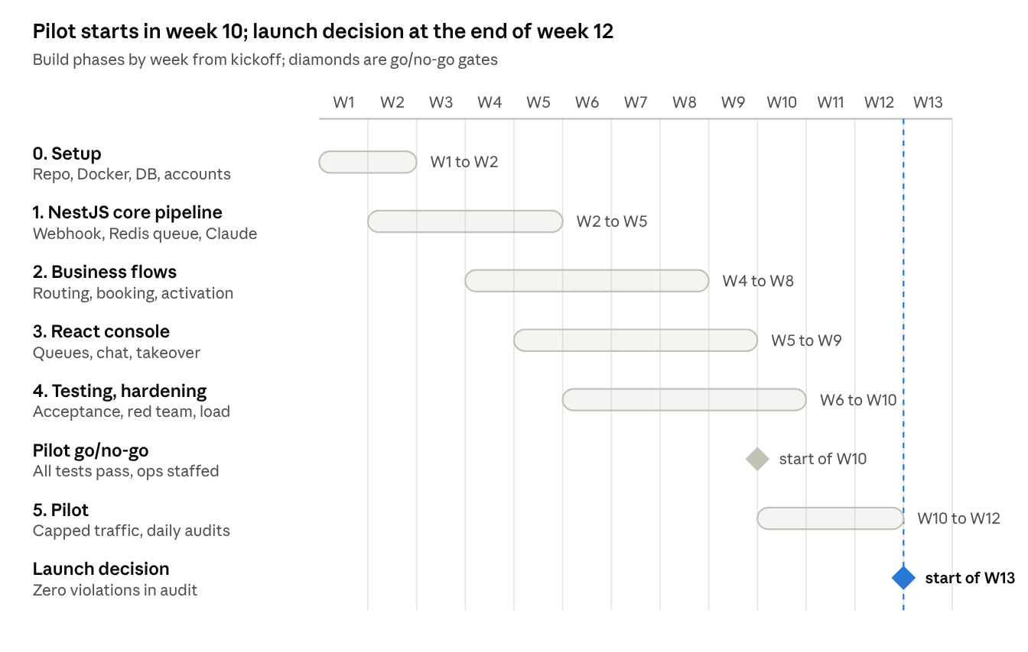
Build timeline · 6 phases, 2 gates, 12 weeks

Phase 0 — Setup (weeks 1–2)
- ☐ Create the monorepo: apps/api (NestJS), apps/console (React + Vite), packages/shared
- ☐ docker-compose.yml with Postgres 16 + PostGIS and Redis 7 for local dev
- ☐ Prisma schema for the 12 tables (section 6) and the first migration
- ☐ Seed plan_catalog from the official site (4 Oxxy plans + Cut Medi Bills monthly and annual)
- ☐ CI: lint, typecheck, unit tests on every push; staging environment
- ☐ Submit the first 8 WhatsApp templates (Playbook section 18) for approval
- ☐ Agree the CRM API and webhook contract (3.2, 3.3) with the CRM team; get sandbox access and answer 3.5
- ☐ Add the 6.2 CRM tables to the first migration

Phase 1 — NestJS core pipeline (weeks 2–5)
- ☐ WhatsappModule: webhook verify (GET), receive (POST), signature check, dedupe, push to BullMQ inbound
- ☐ WhatsappClient: send text, reply buttons (max 3, 20 chars), list messages, templates; enforce limits in code
- ☐ PipelineModule: BullMQ worker that runs one turn per customer in order
- ☐ GuardrailsModule: keyword + classifier for STOP, emergency (112/108), self-harm (Tele-MANAS 14416), privacy, complaint; fixed replies
- ☐ ConversationModule: all states from Playbook section 3 and the 5 entry states
- ☐ LlmModule: system prompt from Playbook section 2, JSON output schema, prompt caching, refusal fallback, retries
- ☐ RulesModule → ReplyValidator: blocks abbreviated Cut Medi Bills, "confirmed" bookings, tie-up talk, two products, savings above cap, numbers not in the catalogue
- ☐ End of phase: a test number can chat in English, Hindi and Hinglish, and STOP and emergency work

Phase 2 — Business flows (weeks 4–8)
- ☐ Discovery: one question per turn, field extraction (Playbook section 5)
- ☐ RoutingService + plan recommendation + ValueCheckService (Playbook sections 6, 7, 9.2)
- ☐ EligibilityService: Cut Medi Bills gate (Playbook 8.2)
- ☐ CentresModule: PostGIS radius search, up to 5, list message; any named centre accepted
- ☐ BookingModule: Asia/Kolkata date window (+3 days to +6 months), pending_confirmation, timing caution, one soft activation suggestion
- ☐ ActivationModule: disclosure templates, one official link, DONE / failed / charged-twice / not now / stop replies
- ☐ TriggersModule: triggers A–R, priority order, dedupe, suppression, caps
- ☐ SchedulerModule: follow-ups, rescue ladder, Trigger Q, quiet hours, 24-hour window → template
- ☐ FAQ and objection answers (Playbook sections 13, 14)
- ☐ CrmModule: outbox worker with retries, CrmClient for the 3.2 calls, signed webhook endpoint, nightly reconciliation; contract tests against the CRM sandbox

Phase 3 — React console (weeks 5–9)
- ☐ AuthModule (JWT, roles) and the Login screen
- ☐ Live chat screen for the sales team with WebSocket updates, takeover and hand-back
- ☐ Read-only Bookings screen; sales confirms in the CRM and the webhook sends the template
- ☐ CRM sync, Provider directory (CSV import), Plan catalogue (two-person approval), Reports

Phase 4 — Testing and hardening (weeks 6–10)
- ☐ Conversation test harness; automate all 27 Playbook and 20 Trigger acceptance tests
- ☐ Eval set of 300+ chats (English, Hindi, Hinglish) graded for tone and correctness
- ☐ Red-team set: prompt injection, "guarantee 40%", both products, fake emergencies
- ☐ Load test at 50 messages per second; reply time p95 under 8 seconds
- ☐ Security: secrets manager, encrypted health columns, role-based access, audit logs

Phase 5 — Pilot (weeks 10–12)
- ☐ Go live for 1–2 pilot cities with capped traffic
- ☐ Sales team works the CRM tasks daily; QA audits 100 transcripts a day
- ☐ Fix every rule violation found by adding a validator check and a test
- ☐ Launch review at the end of week 12 against section 11

10. Before starting
These must be ready before week 1; template approval and business verification can take days, so start them now.
Accounts
- ☐ Meta Business Manager verified; WhatsApp Business number and display name approved
- ☐ WhatsApp route chosen: Meta Cloud API direct or a Business Solution Provider
- ☐ Anthropic API organisation and key (stored in a secrets manager, never in code)
- ☐ AWS account in Mumbai region (or chosen cloud), Git repository, CI (GitHub Actions)
- ☐ In-house CRM: sandbox, API service token, webhook signing secret, and a named CRM developer for the API and webhooks
Business decisions
- ☐ All 12 [CONFIRM] items listed in section 1.1 (family pricing, age at renewal, pre-existing terms for Everyday and Vital, retention, quiet hours, cancellation method and more)
- ☐ Pilot cities and who verifies the first provider directory
- ☐ Payment provider, and whether it can send payment webhooks
- ☐ In-house CRM: API spec, sandbox and webhook secret from the CRM team
- ☐ Sales team hours and callback target time
Team
- ☐ 1 tech lead, 2 NestJS developers, 1 React developer, 1 conversation designer, 1 QA
- ☐ Oxxy product owner, sales lead and legal reviewer named

11. Definition of done for launch
The MVP is done when every item below is true in staging and the pilot.
- ☐ All 27 Playbook and 20 Trigger acceptance tests pass automatically in CI
- ☐ Zero hard-rule violations in the pilot transcript audit
- ☐ STOP, emergency, privacy and complaint flows tested end to end with ops on shift
- ☐ Every price, GST, renewal term and link comes from plan_catalog and matches the official site
- ☐ Booking messages always say pending confirmation; date window tested at boundaries in Asia/Kolkata
- ☐ One-product lock enforced in code and in the database
- ☐ All WhatsApp templates approved; quiet hours and 24-hour window respected
- ☐ Health-data consent notice live; retention deletion job running
- ☐ Reply time under 8 seconds (p95) at 50 messages per second
- ☐ Sales team trained on the React console and the CRM tasks; every task type has an owner

12. Bot workflows, step by step
How the bot handles each part of a conversation. Code means a fixed rule in NestJS; Claude means a drafted reply that the rule validator checks before it is sent. State names match the conversations.state column.

12.1 Inbound message pipeline
Every inbound message runs the same ordered turn. Guardrails act before Claude, and the rule validator acts after it.
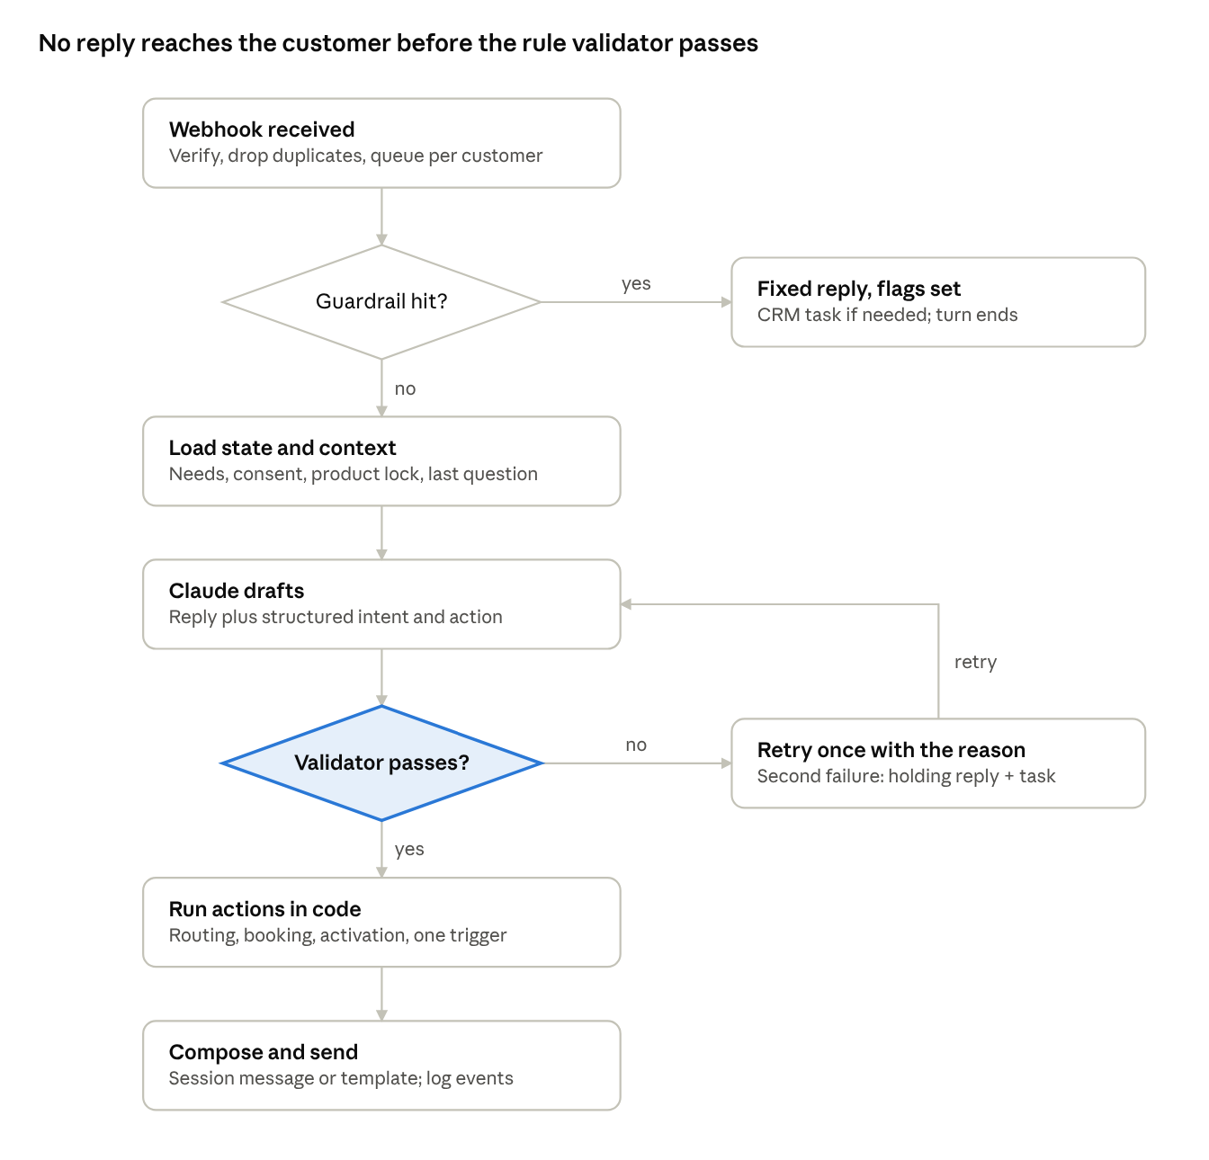
Inbound message pipeline · 6 steps, 2 decisions
- Webhook received (code): verify Meta's signature, return 200 within 1 second, ignore a repeated wa_message_id, queue the message on the customer's own queue so turns never overlap.
- Guardrail check (code): keyword match plus a fast classification for emergency, self-harm, STOP, privacy, complaint and payment issues. A hit sends the fixed reply from section 12.7 and ends the turn.
- Load context (code): state, needs, consent, active product, open booking, last unfinished question, last 20 messages.
- Claude drafts (Claude): cached system prompt + state summary + recent turns; returns JSON with reply_text, intent, extracted_fields, barrier, proposed_action and needs_human.
- Validate (code): reject any draft that breaks a hard rule; retry once with the reason, then fall back to a holding reply and a human task.
- Run actions (code): save extracted fields, apply routing, booking, activation and trigger selection; fill fixed templates for any price, link or disclosure.
- Send and log (code): session message inside 24 hours, approved template outside it; write messages and events; wait.

12.2 Conversation state machine
One conversation holds one state at a time. Booking and activation are separate paths, so a customer can finish with a recorded booking and no payment.
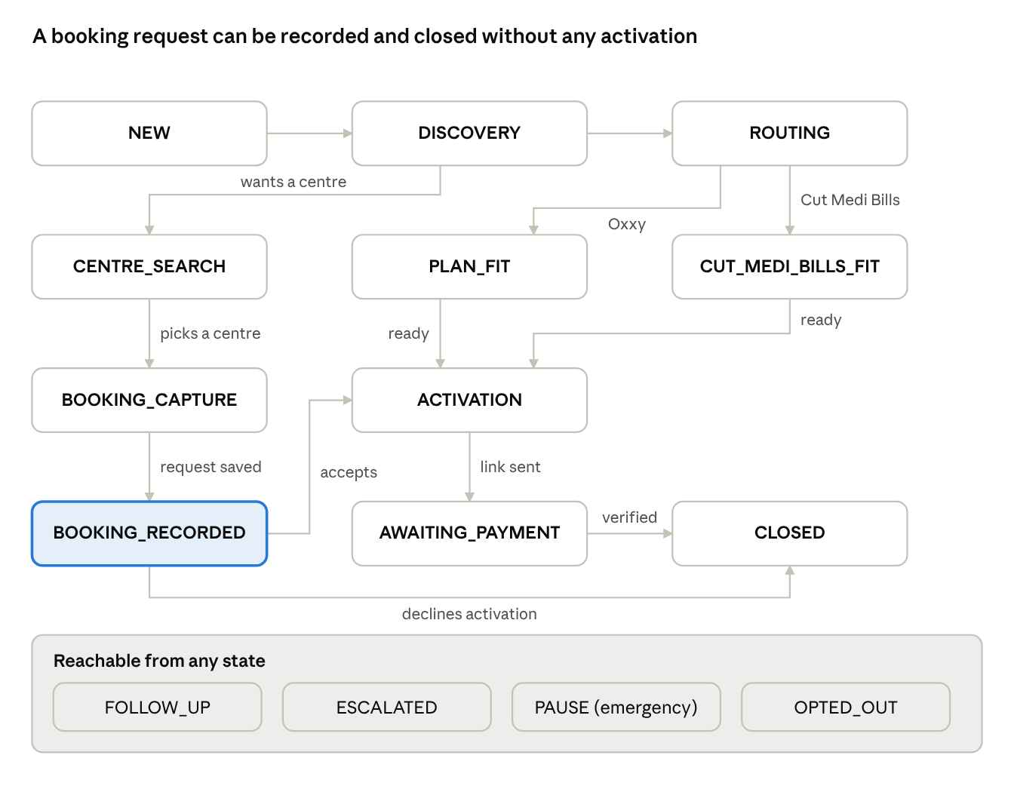
Conversation state machine · 11 main states, 4 global exits
Transition rules
- A customer question can interrupt any state: answer it, then return to the stored unfinished question.
- Entry menus map to states: INTENT_MENU and NEED_DISCOVERY lead into DISCOVERY; OXXY_EXPLAIN answers and returns to DISCOVERY; SERVICE_OR_ESCALATION runs lookup_customer, then servicing or ESCALATED; FOLLOW_UP_TIME stores a time and moves to FOLLOW_UP.
- A customer can ask for centres or a booking from any state; the engine moves to CENTRE_SEARCH or BOOKING_CAPTURE and keeps the selected product.
- OPTED_OUT is final until the customer opts back in. PAUSE lasts until the sales team closes the safety event. ESCALATED holds commercial prompts until the task is resolved.
- Two failed rescue attempts move the conversation to CLOSED or FOLLOW_UP (with agreement).

12.3 Discovery and product routing
Discovery asks one missing question per turn until routing has enough data; routing then picks exactly one product, Oxxy by default.
Discovery loop (state DISCOVERY)
- Code: read needs and list the missing fields in this order: beneficiary, need, need pattern, city/locality, preferred centre, service status, date, insurance, annual spend.
- Code: skip fields the customer already gave in free text (Claude extracts them into structured fields each turn).
- Claude: answer any question the customer asked first, then ask the next missing field in the customer's language.
- Code: store answers; when need pattern + location + need are known, move to ROUTING.
- Ask age only when choosing between Oxxy plans. Ask expected bill or annual spend only when a savings figure is needed.
Routing rules (code, state ROUTING)
Check, in order | Result
Customer already has an active product | Block the other product; route questions to servicing
Customer explicitly asks for Cut Medi Bills | Cut Medi Bills, if eligibility gate passes
One known upcoming expense, nothing done at the centre, and the 30% saving on it exceeds Cut Medi Bills price + GST | Cut Medi Bills
Anything else (broad support, family, elderly, several needs, unclear) | Oxxy
Customer asks for both | Ask the one routing question; keep one answer only
Plan choice for Oxxy (code, state PLAN_FIT)
- Pick by need: routine OPD = Everyday; OPD + hospitalisation = Vital; pre-existing or larger expense = Thrive; above age limits, major or recurring high expense = Infinity.
- Move up a plan if the age limit rules the chosen one out.
- Run the value check: illustrated saving at the plan's rate must exceed yearly price + GST. If not, try the next cheaper suitable plan; if none passes, give the honest answer and offer centre or booking help.
- Set selected_product and recommended_plan; suppress the other product (alternate_product_suppressed = true).

12.4 Centre search and booking request
A booking request is recorded for any verified private centre, with or without activation, and always stays pending_confirmation until a human confirms it.
Centre search (state CENTRE_SEARCH, Trigger D)
- Code: check city, locality, travel radius and specialisation are known; ask for the first missing one.
- Code: query centres within the radius, private and verified, matching the specialisation; rank by relevance, distance, recognisability.
- Code: take up to 5; if fewer exist, say so plainly.
- Composer: send a list message (name, locality, type, why relevant). Never mention tie-up, network or discount.
- Customer picks 1–5 or names another centre. For another centre, Code checks the directory; if not found, ask for address or landmark and create a directory-verification task. Never reject a centre just because it was not suggested.
Booking capture (state BOOKING_CAPTURE, Trigger G)
- Ask once: "May I do your booking at the healthcare centre of your choice?"
- Collect centre + branch, then specialisation/service, then date, then time window, one per turn.
- Code validates the date in Asia/Kolkata: earliest = today + 3 days; latest = same date + 6 months (month-end rule). Out of window = send the approved early or late message with the valid range.
- Code: insert booking_requests (status pending_confirmation) and a crm_outbox row (create_booking_request); the CRM then gives the sales team a "confirm booking" task.
- Move to BOOKING_RECORDED and send the pending-confirmation message (Trigger H).
After booking (state BOOKING_RECORDED)
- If the requested date is before the normal activation time, add the timing caution.
- Make one soft activation suggestion for the selected product with the neutral savings line.
- Customer declines = say the booking stays recorded; the CRM task covers confirmation only, no activation pitch. Customer accepts = go to section 12.5.
- Never send the suggestion again in this journey.

12.5 Activation and payment
One product, one link, with price, GST and renewal shown first; the bot never handles payment details.
Activation (state ACTIVATION)
- Code: confirm selected_product is set and no other active product exists; else block and open a servicing task.
- Code: fetch the current row from plan_catalog (price, GST rate, renewal terms, activation time, link, version). If the fetch fails or the row is stale, do not guess: send the callback message and open a task.
- Composer: send the approved disclosure template for that product (Oxxy plan, Cut Medi Bills monthly or annual). Monthly Cut Medi Bills includes auto-renewal, cancel-anytime and the pre-debit notice line.
- Ask: "Shall I send the official secure activation link?" On yes, send only that product's link; record link_sent_at and link_version. Move to AWAITING_PAYMENT.
Customer replies after the link (state AWAITING_PAYMENT)
Reply | Action | Next state
DONE | Trigger P message; open "verify activation" task; ask for a reference only if the sales team needs it | FOLLOW_UP until verified
Payment failed | Ask whether money was debited; never ask for credentials; escalate to payment support | ESCALATED
Charged twice | Apologise, ask for dates/references, urgent escalation | ESCALATED
A question | Answer it, then return to the open step | AWAITING_PAYMENT
Not now | Offer a short summary or a specific follow-up time | FOLLOW_UP
Stop | Opt-out workflow (section 12.7) | OPTED_OUT
No reply | Scheduler sends Trigger Q once, if consent, window and quiet hours allow | AWAITING_PAYMENT
Switching before payment: if the customer changes product before paying, clear the first selection, keep only the new one, and send a new disclosure. After activation, no switching in chat; open a servicing task.

12.6 Trigger engine
At most one trigger fires per customer turn, and only after the direct question is answered; never chain triggers automatically.
Selection, every turn (code)
- Collect candidate triggers from Claude's detected barrier (trust, understanding, relevance, provider, plan choice, action readiness) and backend events (booking saved, payment reported, link unpaid).
- Drop candidates that fail a firing condition: no consent and no open session; not relevant to the latest message; already sent in this decision journey; conflicts with the product lock; more than one call to action.
- Apply suppression (table below).
- Pick the highest priority left: safety > opt-out/privacy > complaint/payment > direct question > booking/provider > trust/education > plan/activation > follow-up/recovery.
- Render its approved content, send one message, write a trigger_events row with reason, asset IDs, CTA and next state.
- Wait for the customer. The response sets the next candidate list.
Suppression and caps
Rule | Blocks | Until
Opt-out | Every automated and marketing message | Customer opts back in
Emergency | All commercial triggers | Safety event closed by the sales team
Open complaint, payment or privacy case | Activation triggers (E, Q) | Case resolved
Senior callback pending (O) | Persuasion on that issue | Callback done
Product selected | Other product's triggers (E or I) | Customer switches before payment
Duplicate | Same asset, comparison or link | Customer asks again or content changes
Post-booking | Second soft activation suggestion | New journey
Recovery caps | Third rescue attempt; second Trigger Q reminder | Customer replies or agrees to follow-up
Quiet hours | Any proactive or template send 21:00–09:00 customer time | 09:00 next morning
Typical sequences: sceptical lead A then L if asked; insurance B then C or D; searching for care D, G, H, one soft E; ready customer E then link then P.

12.7 Safety, opt-out, privacy and escalation
These six workflows run before any commercial logic and always win; each reply is a fixed approved text, not an LLM draft.
Workflow | Detected by | Reply (fixed text) | Data written | Hand-off
Medical emergency | Keyword list + Claude classifier (chest pain, breathing difficulty, stroke signs, bleeding, seizure, etc.) | Emergency reply with 112 / 108; pause plan talk | Safety event with minimum data; state PAUSE | Urgent alert to the sales team; commercial triggers off until the sales team closes it
Suicidal thoughts or self-harm | Same, plus self-harm terms | Emergency reply + Tele-MANAS 14416 | Safety event | Urgent alert to the sales team
Opt-out (STOP, unsubscribe, do not contact) | Keyword match first, then Claude for paraphrases | Opt-out reply; booking variant if a request is open; no question | opt_out_at; all marketing and follow-up flags false; pending jobs cancelled | CRM task only for an open booking or payment case
Privacy or deletion request | Keywords + Claude | Privacy reply with privacy contact | privacy_request; activation stopped | Privacy team task with due date
Complaint, legal, refund dispute, duplicate charge | Claude intent + keywords | Escalation message with callback options | Task with priority, reason, transcript summary | Senior callback (Trigger O); activation suppressed
Anything not confidently known (exact discount, provider, activation date, family eligibility, conflicting facts) | Rule validator or Claude flags uncertainty | "I want to give you a precise answer rather than guess" + callback options | Task with the exact question | Authorised human answers
Order inside one turn: emergency, then self-harm, then opt-out, then privacy, then complaint/payment, then the normal pipeline. A message that hits two (for example STOP plus chest pain) gets the emergency reply and is then opted out.

12.8 Follow-up, rescue and template scheduling
Every proactive message goes through one scheduler that checks consent, the 24-hour window, quiet hours and caps at send time, not just when the job was created.
Scheduling a job
- A workflow asks for a follow-up: agreed time (Trigger N), rescue nudge, Trigger Q reminder, or sales-requested message.
- Code: store the job with customer, reason, selected product and the exact template or message key.
- Agreed follow-ups use the customer's chosen time; system nudges move into the next allowed window (09:00–21:00 customer time).
At send time (code)
- Reload consent: opted out or privacy request = cancel the job.
- Reload suppression: emergency, complaint, callback pending, product already activated = cancel or skip.
- Check caps: no more than 2 rescue attempts in a row; 1 Trigger Q reminder; no duplicate content.
- Inside 24 hours of the customer's last message = session message. Outside = approved template only.
- Send. If Meta blocks it for a marketing limit, log frequency_cap; do not retry the same day.
Rescue ladder (state any, after silence or low-engagement replies)
Signal | First attempt | Second attempt | Then
No reply | Short check-in inside the window | "I will pause here so I do not disturb you" | Close; wait for the customer
One-word replies | Benefit or price first? | Trust, price or usage concern? | Offer summary, follow-up or close
Busy | 3-line summary or later? | Ask for a time or close | Schedule N or close
Need to think | What would help decide? | Summary and pause | Follow-up only with agreement
After two failed attempts, rescue_attempts stops further nudges until the customer writes again.

12.9 Human operations
The sales team works these four queues as tasks in the in-house CRM, which the bot creates through the outbox (sections 3.2 to 3.4). Chat takeover happens in the console, because the CRM has no WhatsApp inbox. When a human takes over a chat, the bot stops sending until they hand it back.
Queue | Created when | Agent steps | Customer message on completion | Target time
Confirm booking | Booking request saved | Call centre, confirm slot or agree alternative, mark it confirmed / changed / not possible in the CRM; the CRM webhook tells the bot | Confirmation or alternative via Utility template | [CONFIRM]
Verify activation | Customer replies DONE | Check payment system, mark paid or failed in the CRM, note activation date | Activation status message | [CONFIRM]
Callback / escalation | Trigger O, complaint, payment issue, uncertain fact | Call in the chosen window, resolve or re-route, write outcome | Only what the agent chooses to send | [CONFIRM]
Activation follow-up | Booking saved, activation not done, customer did not decline | One call; say plainly it covers the booking and activation questions | None automatic | [CONFIRM]
Takeover rules
- Agent clicks Take over: state locks, bot replies stop, customer sees no change in number.
- Agent replies from the console; messages log as human_agent.
- Agent clicks Hand back with a note; the bot resumes from the stored state and the note is added to the next prompt.
- Opt-out still wins during takeover: the console blocks sends after STOP.

12.10 Error handling and fallbacks
When something fails, the customer gets a short honest message and a human task; the bot never guesses a fact to fill a gap.
Failure | Detection | Automatic handling | Customer sees
Claude timeout, 429 or 5xx | SDK error class | Retry twice with backoff | After 2 failures: "Give me a moment, a team member will reply shortly" + human task
Claude refusal (stop_reason: refusal) | Response check | Server-side fallback model; if still refused, holding reply | Holding reply + human task
Draft fails the rule validator | Validator result | Retry once with the violated rule named | After 2 failures: holding reply + human task; violation logged
Malformed structured output | Schema check | Retry once | Holding reply if it repeats
Plan catalogue missing or stale | Version / date check | Block activation | Callback message
Centre search returns nothing | Empty result | Ask to widen radius or name a centre | "I could not find a verified option in that area"
WhatsApp send fails | Meta error code | Retry for temporary errors; template fallback outside 24 h; log permanent errors | Nothing, or the template later
Duplicate inbound message | wa_message_id exists | Ignore | Nothing
Messages arrive out of order | Per-customer queue | Process strictly in order | Normal replies
CRM unavailable | Outbox send fails | Retry 1, 5, 15, 60 min, then hourly for 24 h; then dead letter and alert | Nothing; the booking is already saved
Database unavailable | Health check | Queue holds messages; alert on-call | Delayed reply
Every fallback writes an event, so the daily audit can count holding replies and fix the cause.

