 | Smart Shop  Technical Design Document
 | Prepared By / Last Updated By | Reviewed By | Approved By
Name | Arun P M/Abhishek/Kavitha/Vidhya/Dhana Prabha/Kavi Priya
Role | Project Owners
Signature
Date

Table of Contents

1.0 Introduction 3
1.1 Purpose of this document 3
1.2 Project overview 3
2.0 Solution Summary 3
2.1 Scope 3
2.2 Assumptions 3
2.3 Dependencies 3
2.4 Risks 3
3.0 Schematic Diagram 3
4.0 System Design 4
4.1 Proposed design 4
4.2 Component inventory 4
5.0 Database Design 4
5.1 Data Model 4
5.2 Tables Structure 4
6.0 Appendices 4
6.1 Glossary 4
6.2 Other 5
7.0 Terms & Conditions 5
8.0 Change Log 5

Introduction

Purpose of this document
This document is aimed at:
- Providing the necessary inputs to the detailed requirements gathering phase and further on for the SDLC processes.
- This document also serves to establish the traceability between the Business Objectives and the requirements identified in the proposed solution and how they satisfy the stated objectives.
- Provide expectation traceability in terms of the requirements and the user expectation
- Serves as a formal template for documenting the Business Requirements that also includes statutory and regulatory requirements.
The purpose of this document is to systematically capture requirements for the project and the system to be developed. Functional requirements are captured in this document. It also serves as the input for the project scoping.

Project overview
Below are the objectives that shall be fulfilled post the execution of this project:
- User registration & credential authentication
- Shop manager registration & credential authentication.
- Search available products
- Stock Management

Solution Summary

Scope
Smart Shopping System has the ability to register many users and makes easier to find the products and give information about the product.
- User registration & credential authentication
- Searching the product by any registered user
- Fetching product information and product availability information according to the user’s requirement.
- Also displaying the searched product for a user.

Assumptions

Dependencies
- MySQL is needed for database operations.
- Tomcat server the application will not run.
- We need Eclipse software, we will not be able to run the application.

Risks
As we are using HTTP Session objects, the data is transferred using http, which is less secured than https, so there is a possibility of data corruption. As we are using HTTP Session objects, the data is transferred using http, which is less secured than https, so there is a possibility of data corruption.

Schematic Diagram
Below is the overall functional flow of the project including the components of interaction.
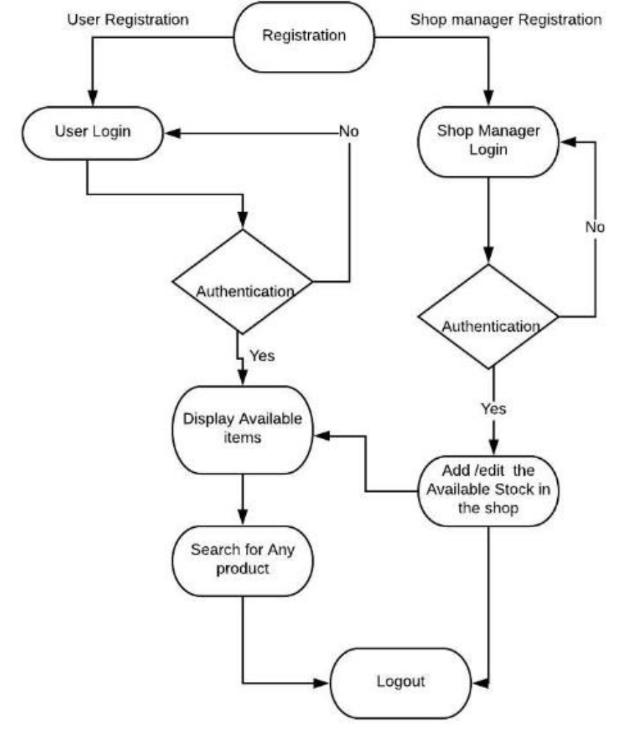

System Design

Proposed design
Considering the anomalies in the existing system computerization of the whole activity is being suggested after initial analysis. The “Smart Shop” is an Online Shopping application that helps in managing various shopping operations effectively. This is a web application allows you to access the whole information about smart shop management software, readily scalable and adaptable to meet the need of shopping who are facilitator for the Shopping Sector, it also supports all functionalities of Smart Shop Data Model.

Component inventory

Model Components
- Product.java
- Purchase.java
- Purchase History.java
- User.java
- Quantity.java

Controller
- AuthenticationController.java
- PurchaseController.java
- UserController.java
- SuperUserController.java
- ProductController.java

Service
- Purchase.java
- ProductService.java
- UserService.java

Repository
- QuantityRepository.java
- ProductRepository.java
- PurchaseHistoryRepository.java
- UserRepository.java
- PurchaseRepository.java

UI-Angular-Components
- login
- register
- pending-managers
- pending-managers-details
- services- user-service,site-service,product-service,purchase-service,purchase-history-service
- interfaces-user,product,purchase,quantity
- product-add
- product-edit
- product-details
- product-info
- search
- Billing

Database Design

Data Model
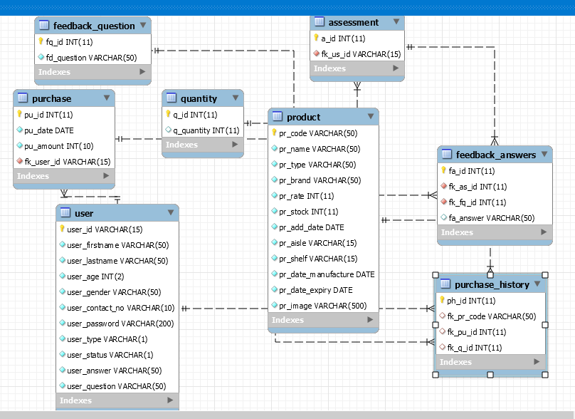

Tables Structure

Table Name: assessment
Column Name | Data Type | Length | Nulls
a_id | Int | auto_increment | Not Null
fk_us_id | Varchar | 50 | Not Null

Table Name: purchase
Column Name | Data Type | Length | Nulls
pu_id | Int | auto_increment | Not Null
pu_date | Date | - | Not Null
pu_amount | Int | 11 | Not Null
fk_q_id | Int | 11 | Not Null

Table Name: purchase history
Column Name | Data Type | Length | Nulls
ph_id | Int | auto_increment | Not Null
fk_pr_code | Varchar | 50 | Not Null
fk_pu_id | Int | - | Not Null
fk_bill_id | Int | - | Not Null

Table Name: feedback questions
Column Name | Data Type | Length | Nulls
fq_id | Int | auto_increment | Not Null
fd_question | Int | 11 | Not Null

Table Name: feedback answers
Column Name | Data Type | Length | Nulls
fq_id | Int | auto_increment | Not Null
fk_as_id | Int | - | Not Null
fk_fq_id | Int |  | Not Null
fa_answer | Varchar | 50 | Null

Table Name: product
Column Name | Data Type | Length | Nulls
pr_code | Varchar | 50 | Not Null
pr_name | Varchar | 15 | Not Null
fk_pr_type | Int | 2 | Not Null
pr_brand | Varchar | 50 | Not Null
pr_rate | Decimal | 15,2 | Not Null
pr_stock | Decimal | 15,2 | Not Null
pr_add_date | Date | - | Not Null
pr_aisle | Varchar | 15 | Not Null
pr_shelf | Varchar | 15 | Not Null
pr_date_manufacture | Date | - | Not Null
pr_date_expiry | Date | - | Not Null
pr_image | Varchar | 500 | Not Null

Table Name: user
Column Name | Data Type | Length | Nulls
user_id | Varchar | 15 | Not Null
user_firstname | Varchar | 50 | Not Null
user_lastname | Varchar | 50 | NotNull
user_age | Int | 2 | NotNull
user_contact_no | Varchar | 10 | NotNull
user_password | Varchar | 15 | NotNull
user_type | Varchar | 1 | NotNull
user_status | Varchar | 1 | NotNull
user_answer | Varchar | 50 | NotNull
Fk_sq_id | Int | 2 | NotNull

Table Name: quantity
Column Name | Data Type | Length | Nulls
q_id | Int | auto_increment | Not Null
q_quantity | Varchar | 11 | Not Null

Appendices

Glossary
Acronyms | Definitions

Terms & Conditions
Interns shall be solely responsible for all its acts and omissions under this program. Interns will comply at all times with all applicable laws. Interns shall not use Cognizant’s name, logo and trademark in any promotional materials or other communications with third parties without the prior written consent of Cognizant. Any materials used by interns in relation to program will not infringe the copyrights, trademarks, patents, trade secrets or other intellectual property rights, privacy or similar rights of any person or entity. Interns agrees not to post, draw, make, display any content that is threatening, libelous, obscene, defamatory, abusive, pornographic, or advocates/encourages any conduct that could constitute a criminal offence or give rise to any civil liability. Cognizant its associates’ personal details including but not limited to name, address, contact number shall not be shared or forwarded to any third party, without prior written consent of Cognizant, its associates. All intellectual property provided by Cognizant, as part of program shall be owned exclusively by Cognizant. Intern shall indemnify, defend and indemnify Cognizant its associates, officers, directors from and against any claims, demands, loss, damage, liability, causes of action, judgments, or costs and expenses of every nature (including attorney’s fees and expenses) incurred by Cognizant based on any claim that any breach of terms and conditions of this program

Change Log
Please note that this table needs to be maintained even if a Configuration Management tool is used.
Version Number | Changes made
V<n.n> | <If the change details are not explicitly documented in the table below, reference should be provided here>
V<n.n> | Page no | Changed by | Effective date | Changes effected

