**NAME**

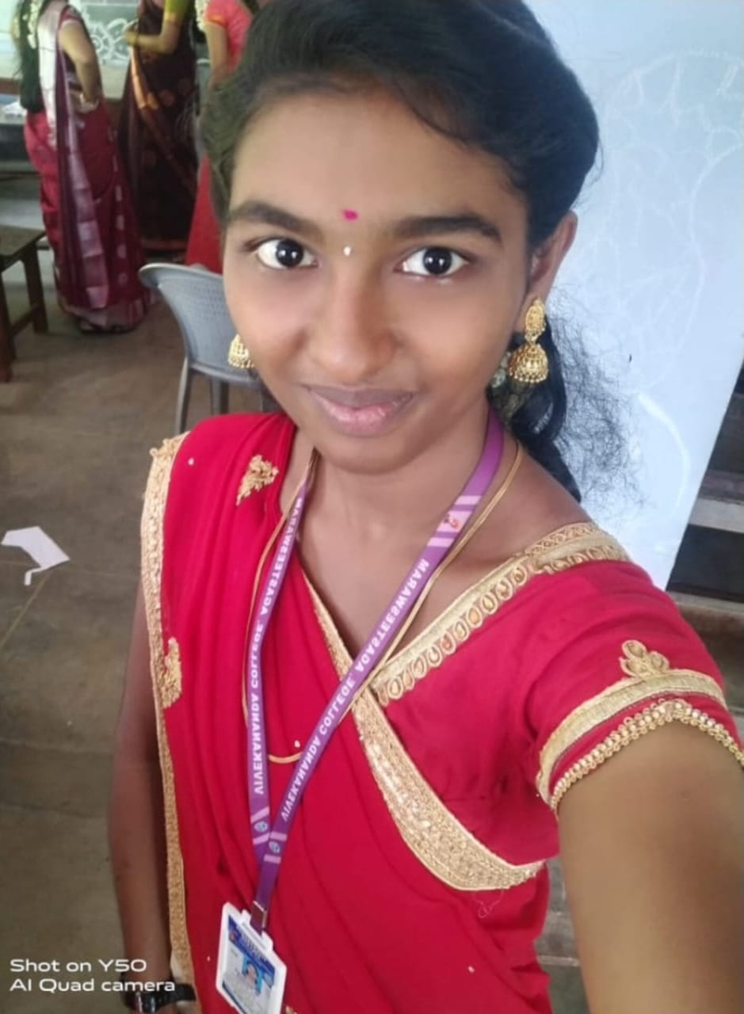

Name : Kavi Priya.M

Department : BCA( Bachelor of Computer Applications )

Reg No : 06

Mail Id :572004kavipriya@gnail.com

Contact No :6374546638

Career Objective:

To achieve a challenging opportunities in relevant field where my problems solving and application knowledge and skill can be put in for the successful completion of the project and growth of the organization, which enhances individual talent and creativity.

Academic Qualification:

|  |  |  |  |  |
| --- | --- | --- | --- | --- |
| **Course** | **Name Of Institution** | **Board/ University** | **Year Of Passing** | **% of marks** |
| Under Graduation | Vivekananda college | MSU | - | - |
| 12th | Government Higher Secondary School | - | 2021 | 78.50% |
| 10th | Government Primary School | - | 2019 | 65.40% |

*CGPA out of 10

Professional Skillset :

* Programming Language
* HTML
* CSC
* Python

Co-Curricular Activities:

* Creativity
* Photography
* Time management
* Independence

Extra-Curricular Activities:

* Sports
* Arts
* Student council

Personal Information:

* Father’s Name: K Muthu Nagamani
* Mother’s Name: M. Indhu Rani
* Date of birth : 05-07-2004
* Blood Group: A1 positive
* Sex : Female
* Status : single
* Nationality : Indian
* Hobbies : Hearing songs
* Address: 14/55B,Vellayan thooppu, Kanyakumari (dist), pincode:629701, Tamil Nadu.

Language Proficiency :

|  |  |  |  |  |
| --- | --- | --- | --- | --- |
| **Language** | **Understand** | **Read** | **Write** | **Speak** |
| English | x | × | × | × |
| Tamil | × | - | - | × |
| Hindi | × | - | - | × |

Declaration :

I hereby declare that all the information which is furnished above is true to my knowledge and belief.

Date:27-10-2023

Place: Vellayan thooppu Signature

(Kavi Priya.M)