**IoT Air Quality Monitoring**

**Designing an IoT-based air quality monitoring system requires several steps. Here's an innovative approach to the design:**

1. Sensor Selection: Choose high-quality sensors for monitoring various air pollutants, including particulate matter (PM2.5 and PM10), volatile organic compounds (VOCs), carbon dioxide (CO2), carbon monoxide (CO), nitrogen dioxide (NO2), ozone (O3), and temperature and humidity. Opt for low-power, accurate sensors.

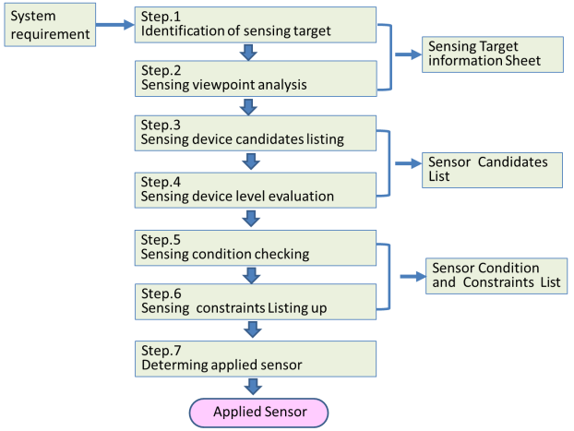

1. IoT Hardware: Select IoT hardware components, including a microcontroller (e.g., Raspberry Pi, Arduino, or specialized IoT module), connectivity options (Wi-Fi, LoRa, NB-IoT), and a power source (battery or solar). Ensure the hardware can support the sensors and required data transmission.



1. Data Aggregation: Set up a data aggregation and preprocessing layer to collect data from sensors. Use edge computing to process and filter data at the device level to reduce data transmission overhead. 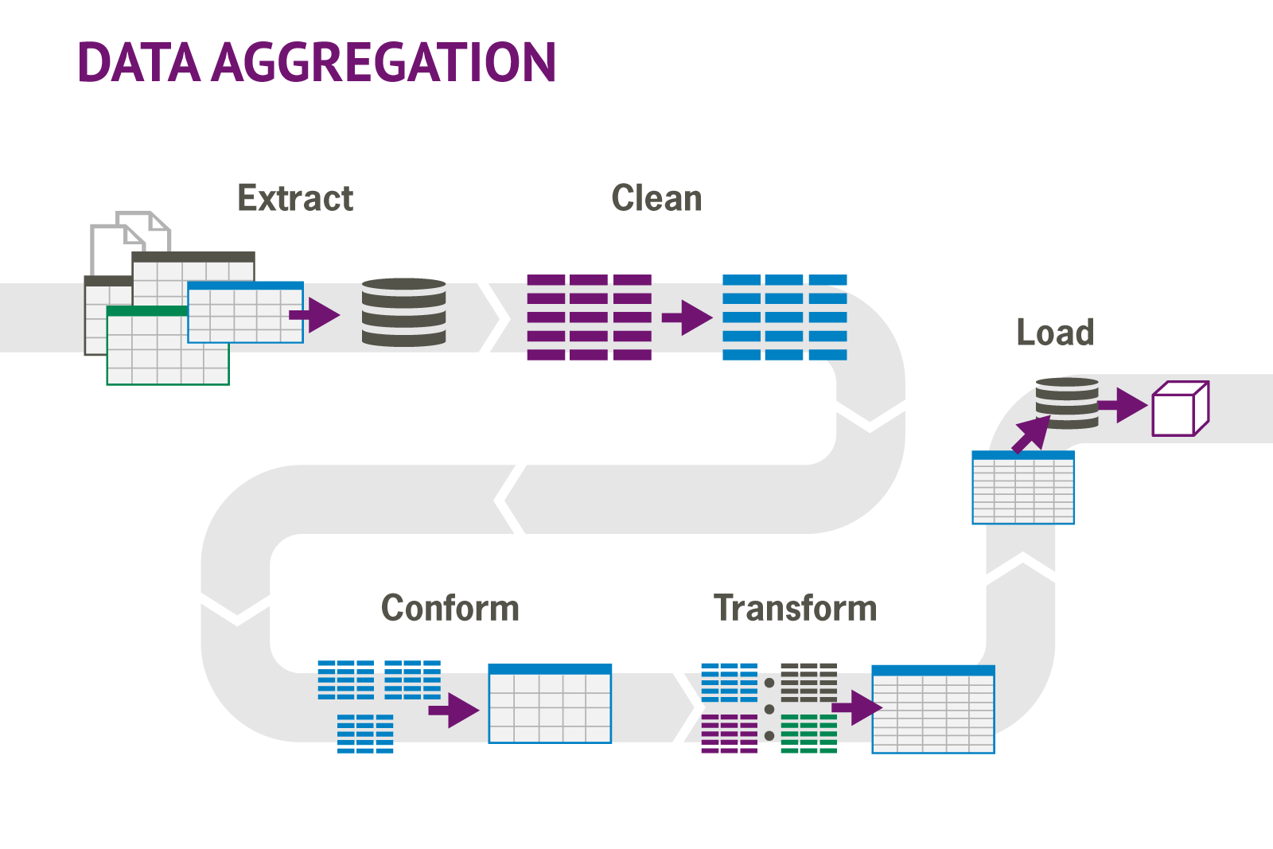
2. Data Transmission: Implement secure data transmission protocols to send sensor data to a central server or cloud platform. MQTT and HTTPS are common options. Ensure data security and encryption.

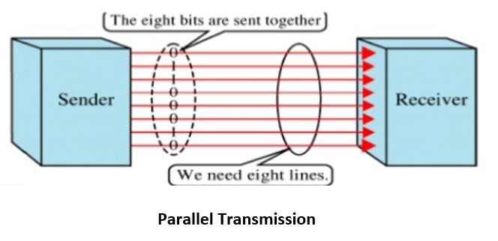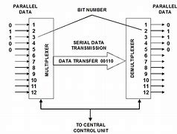

1. Cloud Platform: Develop or use a cloud-based platform (e.g., AWS, Azure, or Google Cloud) to store, analyze, and visualize the air quality data. Leverage IoT services and data storage capabilities.

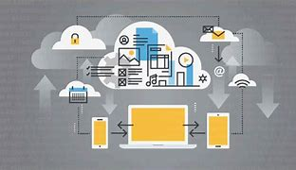

1. Data Analysis: Implement real-time data analysis to detect air quality anomalies and trends. Use machine learning algorithms to predict pollution levels and provide insights.

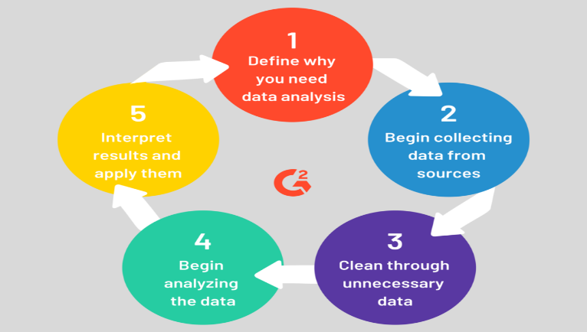

1. User Interface: Create a user-friendly dashboard or mobile app that allows users to access real-time air quality information, historical data, and personalized alerts. Provide visualizations, such as heatmaps and graphs, to make the data meaningful.
2. Alerts and Notifications: Set up alert mechanisms to inform users about critical air quality levels. Send notifications via email, SMS, or push notifications to mobile devices.



1. Geospatial Mapping: Incorporate geospatial data to provide location-specific air quality information. Use GPS coordinates to map air quality data and compare it with environmental factors.
2. Integration and API: Create an open API that allows integration with other IoT devices, smart home systems, and public environmental monitoring networks. Enable data sharing and collaboration.
3. Sustainability: Consider using renewable energy sources, such as solar panels, to power IoT devices. Promote sustainable practices in the system's design.



1. Community Engagement: Encourage community involvement by allowing users to contribute data from their own IoT devices. Implement gamification and rewards to incentivize participation.
2. Data Accessibility: Promote data accessibility and open data policies to benefit researchers, policymakers, and the public. Ensure data privacy and compliance with regulations.
3. Continuous Improvement: Regularly update and improve the system by adding new sensors, optimizing algorithms, and enhancing the user experience based on feedback and emerging technologies.
4. Education and Awareness: Educate users about the importance of air quality and the role they play in improving it. Raise awareness about the environmental impact of pollutants.



**This innovative approach to IoT-based air quality monitoring combines technology, data analysis, and community engagement to provide a comprehensive solution for monitoring and improving air quality.**

**PROJECT SUMBITTED BY:**

**Name:V.Kavipriya**

**Email id:kavipriyavenkateswaran10@gmail.com**

**NMReg.no :au713921106021**

**College code:7139**