# EX.12 Generating Charts

## Date: Aim:

To create various types of charts in Power BI.

## Concepts:

Power BI offers a diverse array of visualizations to present data effectively.

1. Line charts portray trends an d variations over time, ideal for tracking continuous data.
2. Bar charts compare categorical data, making it easy to discern differences between items.
3. Scatter plots showcase relationships between two variables, useful for identifying correlations, and classifying data points.
4. Area charts display cumulative data trends, ideal for visualizing accumulated values over time.
5. Pie charts showcase proportions of a whole, suitable for representing percentages or portions of a dataset.
6. Treemap charts illustrate hierarchical data with nested rectangles, enabling users to comprehend the distribution and hierarchical relationships within the data.

## Procedure:

1. Connect the sample superstore data source Excel file to power BI environment.
2. From the Visualizations pane on the right-hand side, explore various types of charts available in the Power BI.

## Sample Input/Output:

1. **Line Chart:**
   1. From the visualization pane select the “line chart”.
   2. Drag “Order Date” into X axis, “Sales” into Y axis and “Region” into legend.

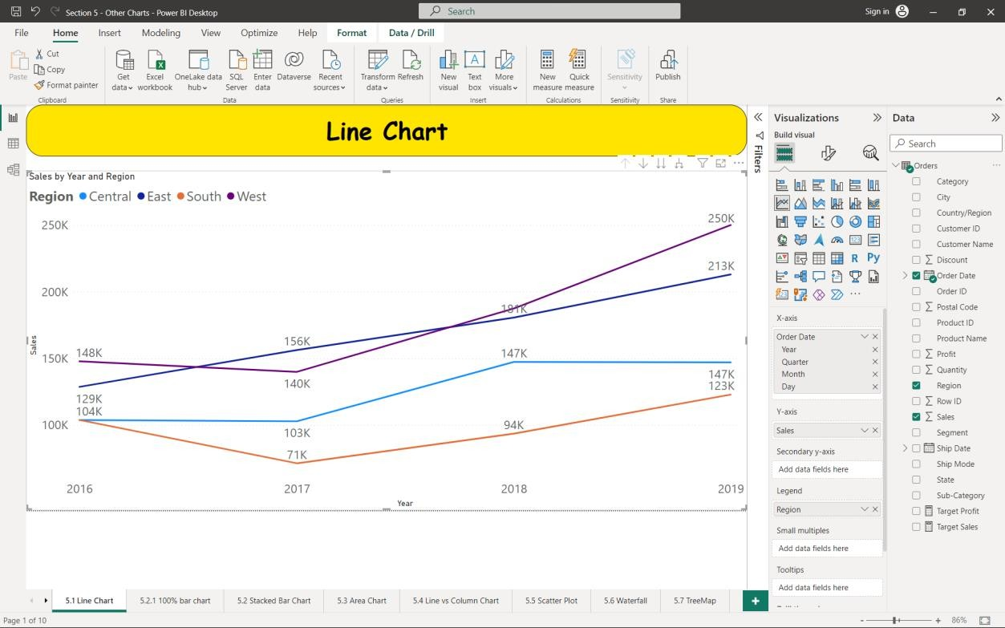

## Stacked Bar Chart:

* 1. From the visualization pane select the “Stacked Bar chart”.
  2. Drag “Sub-Category” into X axis, “Sales” into Y axis and “Region” into legend.

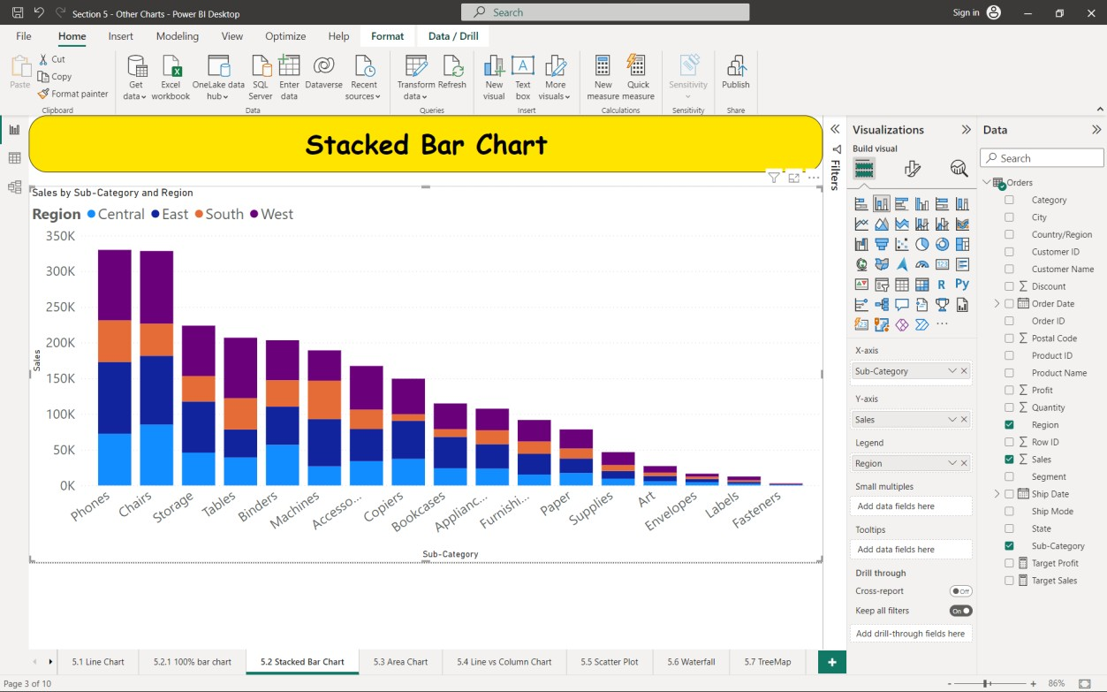

## Area Chart:

* 1. From the visualization pane select the “Stacked Bar chart”.
  2. Drag “Sub-Category” into X axis, “Sales” into Y axis and “Region” into legend.

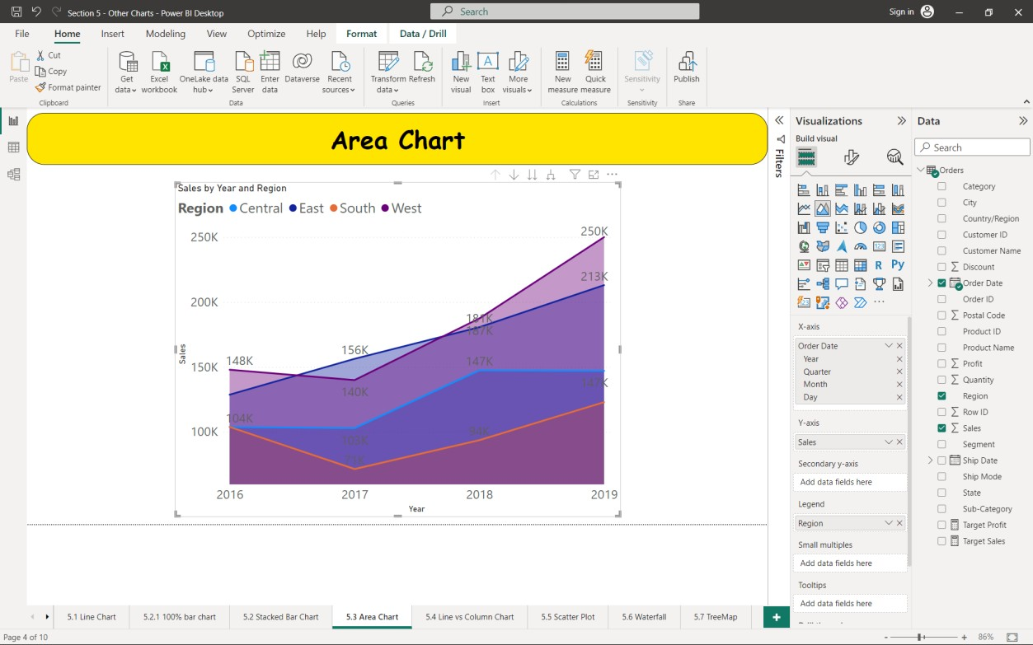

## Line Vs Column Chart:



1. **Scatter Plot:**

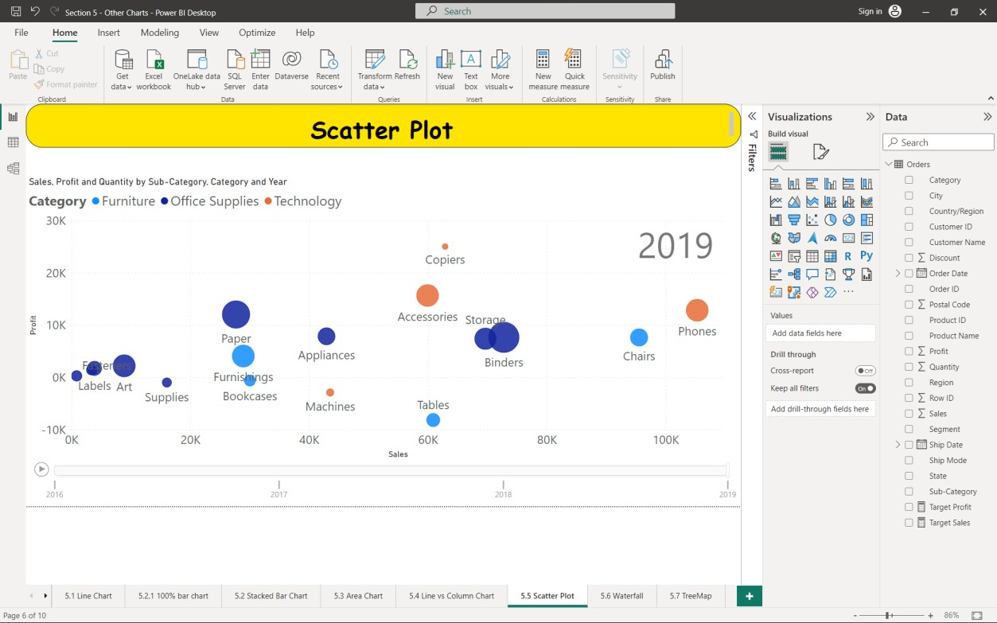

## Waterfall Chart:

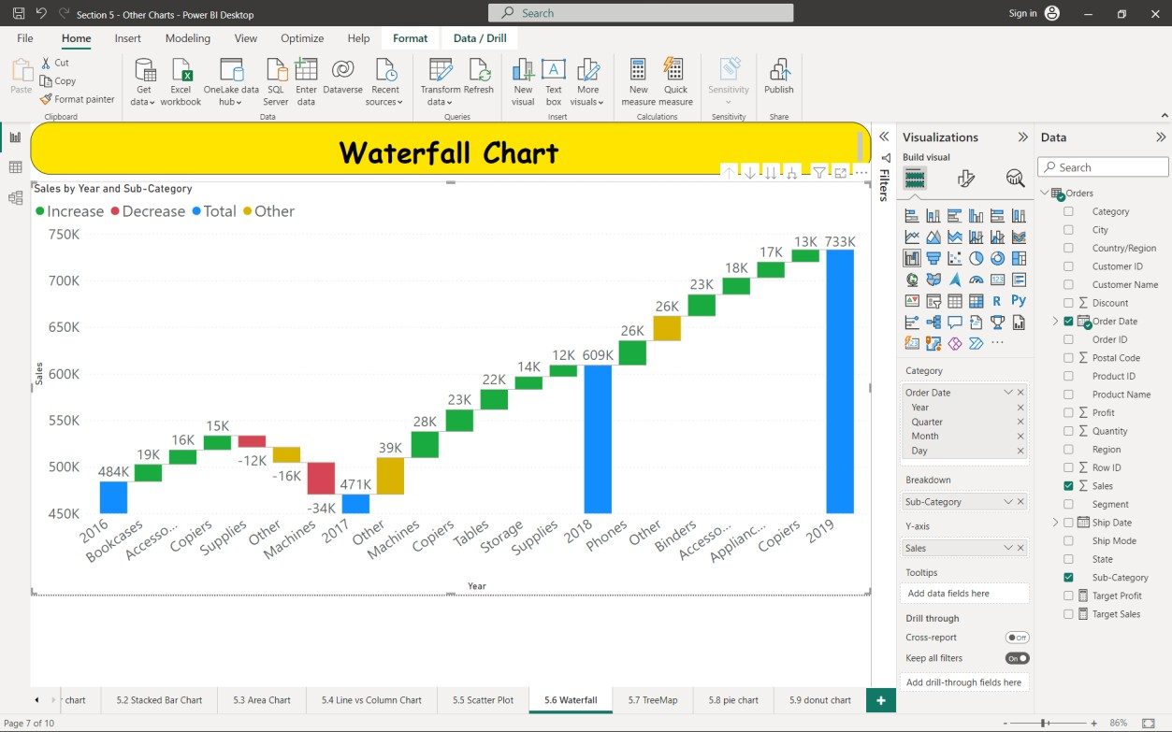

1. **TreeMap Chart:**

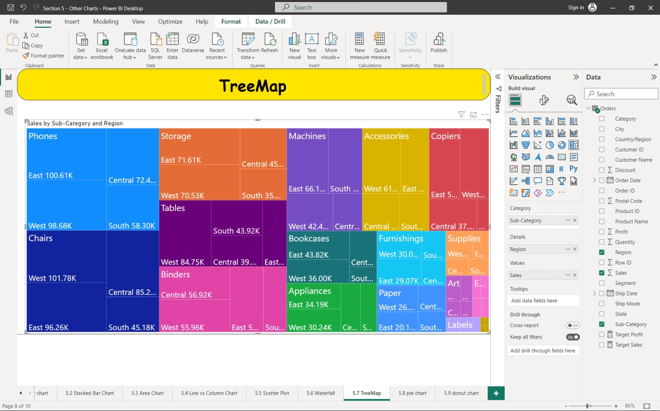

## Pie and Donut Chart:

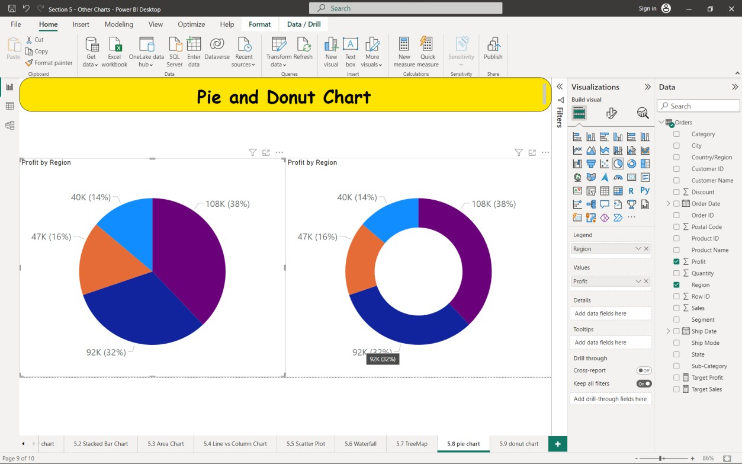

**Result:**

Thus, various are implemented and visualised in Power BI.

**EX. 13 Creating Table and Matrix Visuals**

## Date: Aim:

To understand the concept of Table and matrix in Power BI and build them.

## Concepts:

Table and matrix are the fundamental data visualization components in Power BI, presenting information in a structured format for easy comprehension.

1. Tables display data in rows and columns, suitable for showcasing raw data or detailed information. Users can perform sorting, filtering, and formatting operations to present data precisely as required.
2. Matrix are similar to tables but provide additional hierarchical grouping, enabling users to create pivot table-like layouts. Matrices are ideal for summarizing data, presenting subtotals, and facilitating cross-tabulation.

Both tables and matrices empower users to explore and analyse data efficiently, offering valuable insights and supporting data-driven decision-making.

## Procedure:

1. Connect the sample superstore data source Excel file to power BI environment.
2. From the Visualizations pane on the right-hand side, Tables and matrix are present.

## Sample Input/Output:

1. Creating a Table:
   1. Select the Table icon from the visualization pane.
   2. Add columns by simply dragging the fields into it.

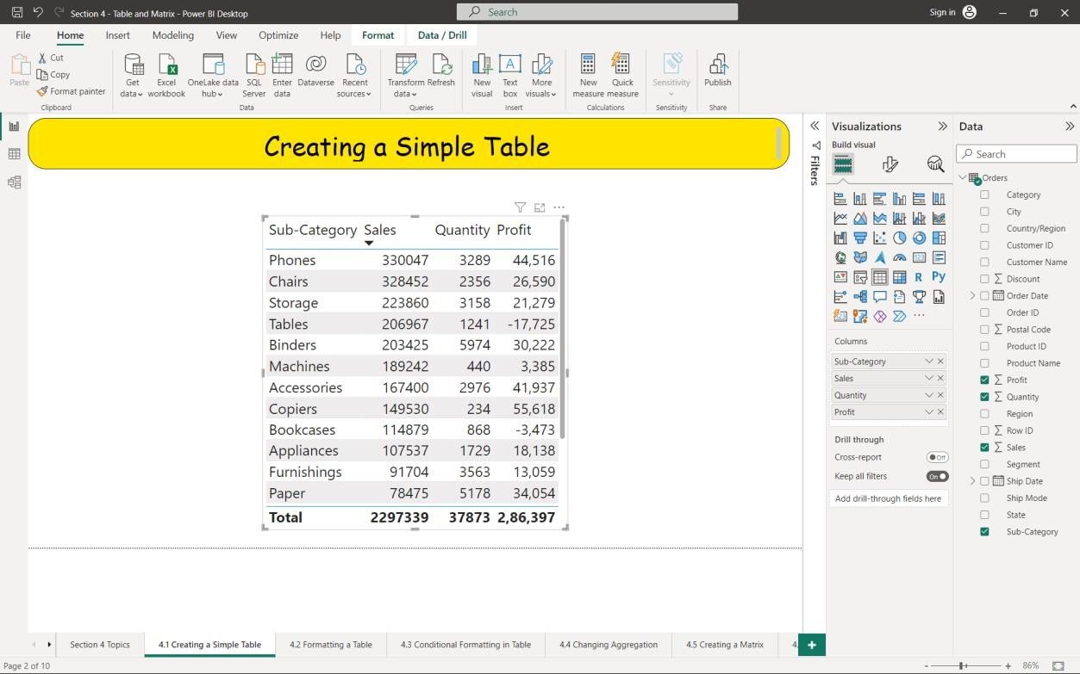

1. Number and Conditional Formatting a Table:
   1. In the Visualization pane choose “Format your visual”.
   2. Click on style presets field to quickly customize your table from the given options.
   3. To apply Number formatting to your table
      1. Click on “Specific Column”.
      2. Select “Sales” from the Series box.
      3. Click on “values” field.
      4. Set the Display units as “Thousands”.
   4. To apply Conditional formatting to your table
      1. Click on “Cell Elements” field
      2. In the “Series” drop down box select which column you want to

apply customization.

* 1. Select “Sales” from the Series box and turn on the “background color”

option.

* 1. Select “Profit” from the Series box and turn on the “icons” option.
  2. Select “Quantity” from the Series box and turn on the “Data bars” option.



1. Creating Matrix
   1. Select the matrix icon from the Visualization pane.
   2. Drag “Sub Category” into Rows, “Region” into Columns and “Sales” into

Values

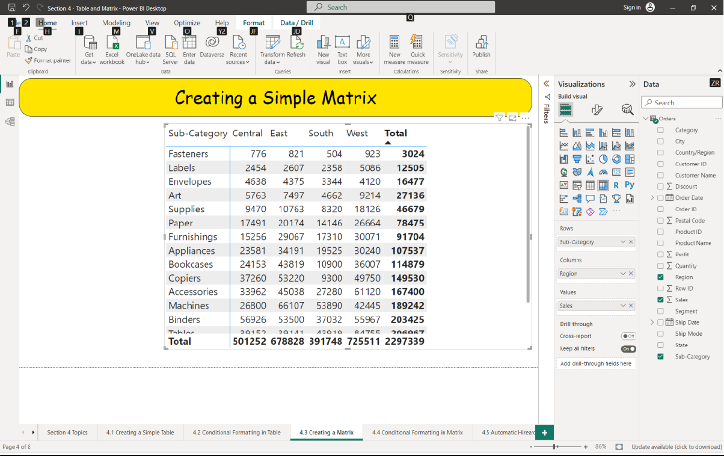

1. Conditional Formatting of the matrix
   1. By using the same logic applied above to format a table create a customize the matrix.

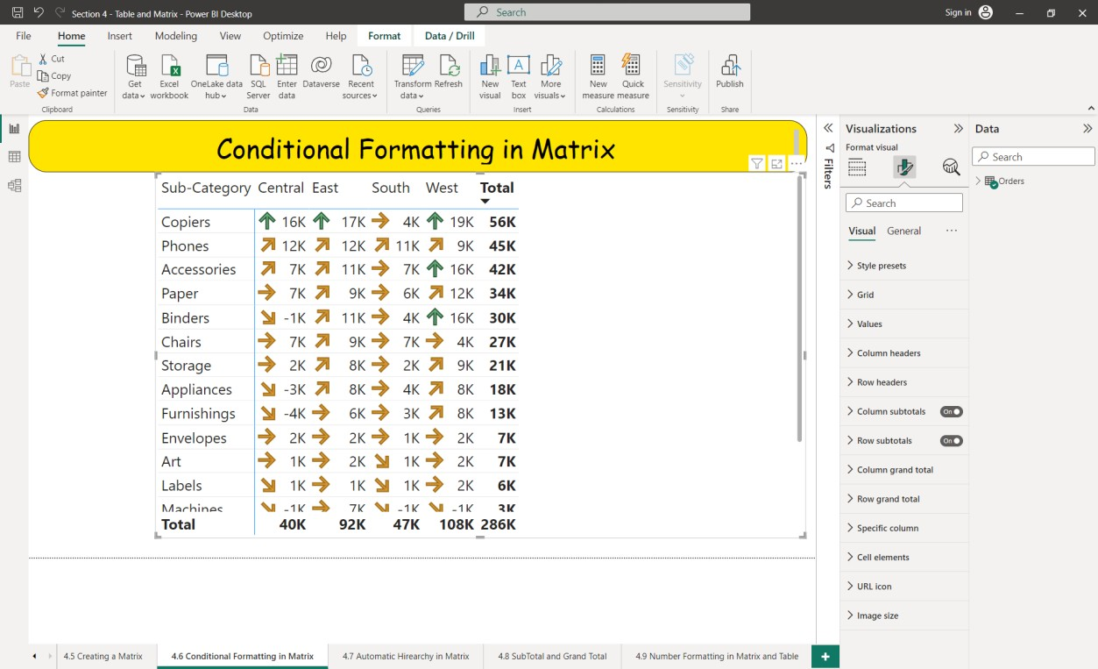

## Result:

Thus, the concept of Table and Matrix have been implemented to organize and visualize the data effectively.

**EX. 14 Working with DAX Queries**

## Date: Aim:

To work with different inbuilt DAX functions and perform tasks in Power BI.

## Concepts:

DAX (Data Analysis Expression) is a library of functions and operators that can be combined to build formulas and expression used by Microsoft Power BI. DAX is also known as function language, where the full code is kept inside a function.

By using DAX, you can add three types of calculations to the model:

* + 1. Calculated columns
    2. Measures

|  |  |
| --- | --- |
| **Calculated Column** | **Measure** |
| Expands table by creating new column | Summarize the data into a single value. |
| Stored along with the table. Consumes Memory | Calculate at runtime / Stores temporarily. |
| Less analytical capacity | Rich analytical capacity. |
| Eg:  Profit = [Sales amount] – [cost amount] | Eg:  Total profit = Sum([Sales amount]) – Sum ([cost amount]) |

Syntax of DAX Query:

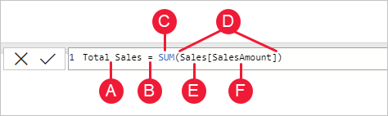

1. The name of the measure or calculated column
2. The equal-to operator (“=”) indicates the start of the formula
3. A DAX function
4. Opening (and closing) parentheses (“()”)
5. Table references
6. Parameter or Column of the table.

Note that each subsequent parameter in a function is separated by a comma

(“,”)

## Sample Input/Output:

To create a measure or calculated Column

* + Click on Modelling on top bar of power BI.
  + Select ‘New Measure’ for creating measure and ‘New Column’ for creating a new column

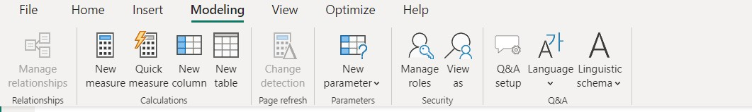

## Find Minimum sales from each category

* 1. Create a **new measure** and name it Minimum sales
  2. Now in the editor that opens up type in Minimum Sales = MIN(‘Order’[Sales])
  3. When finished click on tick mark or press Enter.



* 1. Select ‘Category’ and ‘Minimum Sales’ from the Data pane.

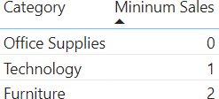

## Find out how many orders were placed for every year

* 1. Create a **new measure** and name it total count.
  2. Now in the editor that opens up type in Total count = COUNT (‘Order’[Order ID])



* 1. Create a column chart with ‘Order Year’ in Y-axis and ‘Total Count’ in Y-axis and set ‘data labels’ On.

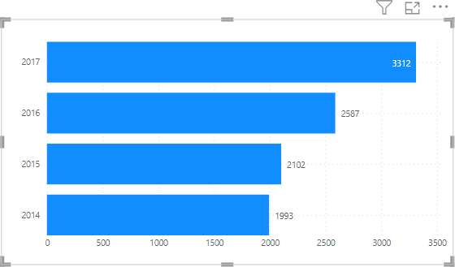

## Find the states which has profit or loss and visualise it in different colours

* 1. Create a **new measure** and name it KPI.
  2. Now in the editor that opens up type in KPI = SUM(‘Order’[Profit])>0

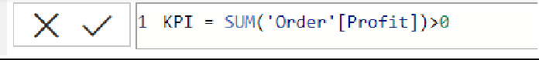

* 1. This KPI gives return a Boolean value for the given field.
  2. Now create colour measure to give red to negative value and green to positive value



* 1. Create a column clustered chart with ‘State’ in Y-axis, ‘Sales’ in X-axis and ‘Profit’ in tooltip.
  2. Now go to ‘Format your visuals’ in the visualisation pane.
  3. Click on Bars field and select conditional formatting by clicking on 𝑓𝑥

icon.

* 1. Select ‘Format style’ to Field value.
  2. Select ‘colour’ measure in ‘What field should we base this on?’.

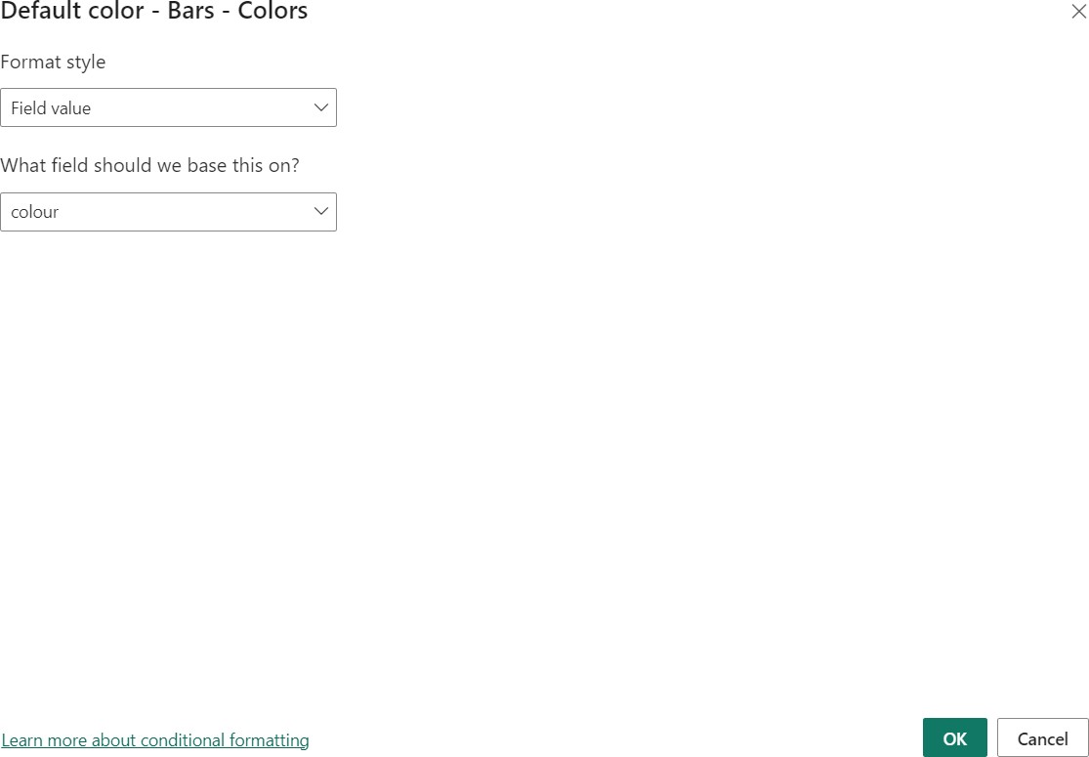

* 1. Click ok to get the final output.

## Find out the average ship time for various states.

* 1. Create a **new column** and name it Date Difference.
  2. Now in the editor that opens up type in

Date Difference = DATEDIFF(‘Order’[Order Date], ‘Order[Ship Date], DAY)



* 1. Select ‘States’ category and ‘Date Difference’ from the Data pane.

## Filter the order number from the Order ID

* 1. Create a **new column** and name it ID.
  2. Now in the editor that opens up type in ID = RIGHT(‘Order’[Order ID], 6)

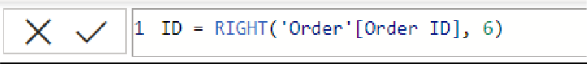

* 1. Select ‘ID’ from Data pane to view unique Order number

## Result:

Thus, various DAX Functions have been used and outputs are verified successfully.

**EX. 15 Creating Storyboard**

## Date: Aim:

To create a storyboard in power BI to visualize data insights effectively.

## Concepts:

A storyboard is a feature that allows you to create a sequence of report pages to tell a data-driven story. It's a way to organize and present your data visualizations in a logical order to communicate insights effectively. Here are the key concepts of storyboard in Power BI:

1. Sequential Presentation: A storyboard in Power BI enables you to arrange report pages in a specific sequence to create a narrative flow.
2. Narration and Annotations: You can add text boxes, titles, and annotations to each report page to provide context, explanations, and key takeaways.
3. Interactive and Exploratory: Even though a storyboard has a defined sequence, it retains the interactive nature of Power BI reports. Users can still explore and interact with the data visuals on each page.
4. Navigation Controls: Storyboards come with built-in navigation controls, allowing viewers to move forward and backward through the pages and explore the data story at their own pace.

## Procedure:

1. Open Power BI and load ‘Salaries.csv’ file to it.
2. On the empty page select ‘Format your visuals’ in the visualization pane and select 'Canvas Background’
3. Select any Background colour of your choice and set ‘Transparency’ to 0 (Colour used for the output is ‘#083E58’).
4. Select ‘Insert’ option on the top bar and select ‘Rounded rectangle’ from ‘Shapes’

menu.

1. Resize the shape by stretching the shape and reducing the size (Look output for reference).
2. After selecting the shape visual you can customize the visual in a way that it suits your dashboard.
   1. In the Format pane change the shape to ‘Parallelogram’.
   2. Change the colour of the visual from the ‘Fill’ menu of the ‘Style’ option, choose a matching colour to the background (Colour used in the output ‘#609CA7’).
   3. In the Style option, On the ‘Text’ Menu and type ‘Dashboard’ in the text

field.

* 1. Increase the font size and bold the letters.

1. In the bottom you will have the ‘page1’ tab right click on it and select ‘Duplicate Page’
2. Now rename ‘Duplicate of Page1’ to ‘Page 2’ by simply right clicking the

‘Duplicate of Page1’ tab.

1. In the Page1 add ‘Blank button’ by
   1. select the ‘Insert’ option
   2. Select ‘Blank’ from ‘Buttons’ menu
   3. Place the button to the top right corner.
2. Click the button and in the ‘Format’ pane open ‘Style’ menu.
3. Select Text value ‘On’ and fill in ‘Go to page 2’.
4. Copy and paste the button in the Page2 and change text value as ‘Go to page 1’.

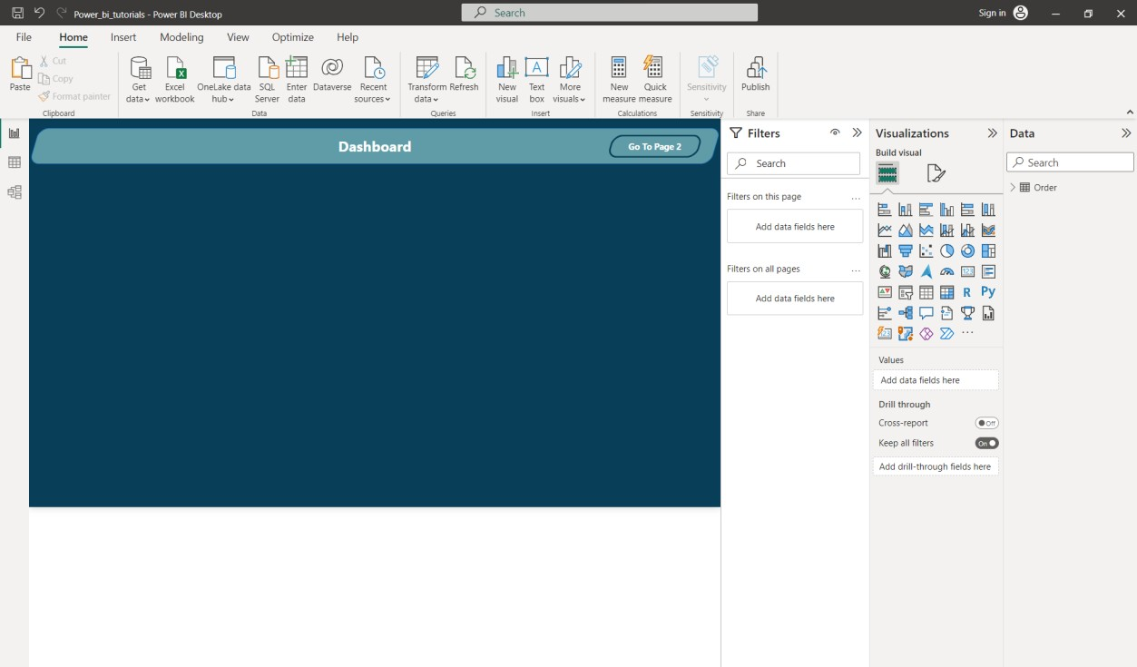

1. Click on the button on the page 1
   1. Turn On the Action menu
   2. Select Type as ‘Page Navigation’.
   3. Select Destination as Page 2.
2. Click on button on the Page 2
   1. Turn On the Action menu
   2. Select Type as ‘Page Navigation’.
   3. Select Destination as Page 1.
3. Now create charts and graphs suited for every page based on your analysis, here are the steps performed to get the output image
   1. Visuals in Page 1
      1. Create a filled map visual with ‘Region’ as legend.
      2. Create a stacked bar chart with ‘Sub category’ in X axis and ‘Sales’

in Y axis.

* + 1. Create a pie chart with ‘Profit’ in Values and ‘Region’ as legend
  1. Visuals in page 2
     1. Create a Waterfall chart with ‘Order Date’ in Category, ‘Sub Category’ as breakdown and ‘Sum of Sales’ in Y axis.
     2. Create a Line chart with ‘Order date’ in X axis, ‘Sum of profit’ in Y axis and ‘Region’ as legend.
     3. Create a Line and Clustered column chart with ‘Order Date’ in X axis (remove ‘quarter’, ‘month’ and ‘day’ from the X axis), ‘Sales’ in column Y axis and Profit in Line Y axis.
     4. Create a Scatter chart with ‘Sub category’ in X axis, ‘Profit’ in Y

axis, ‘Sales’ in size and ‘Region’ as Legend.

1. The Final step is to format our graphs to make it look cleaner and more matched to our background.
   1. Select any one of the visual.
   2. In the ‘Format your visual’ option from the Visualization pane, select

‘Values’ option from the X axis menu and set colour to be white

* 1. Similarly change colour of Y axis values to white.
  2. In ‘Format your visual’ option select ‘General’ Menu.
  3. Select Background option from Effects menu.
  4. Select the Background colour to be same as your shape colour (In this

case the colour is ‘#609CA7’) and set transparency to 70%.

* 1. From ‘Home’ Tab on the top select ‘Format painter’ option present as little paint brush icon.
  2. After selecting ‘Format painter’ click on another visual present in the

page.

* 1. Repeat the above step to all other graphs and charts.

## SAMPLE INPUT/OUTPUT:

1. **Page 1**

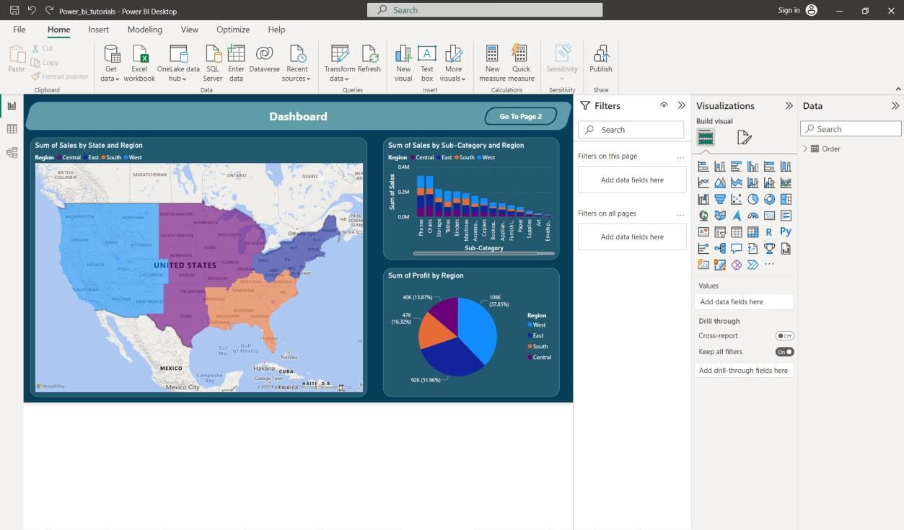

## Page 2

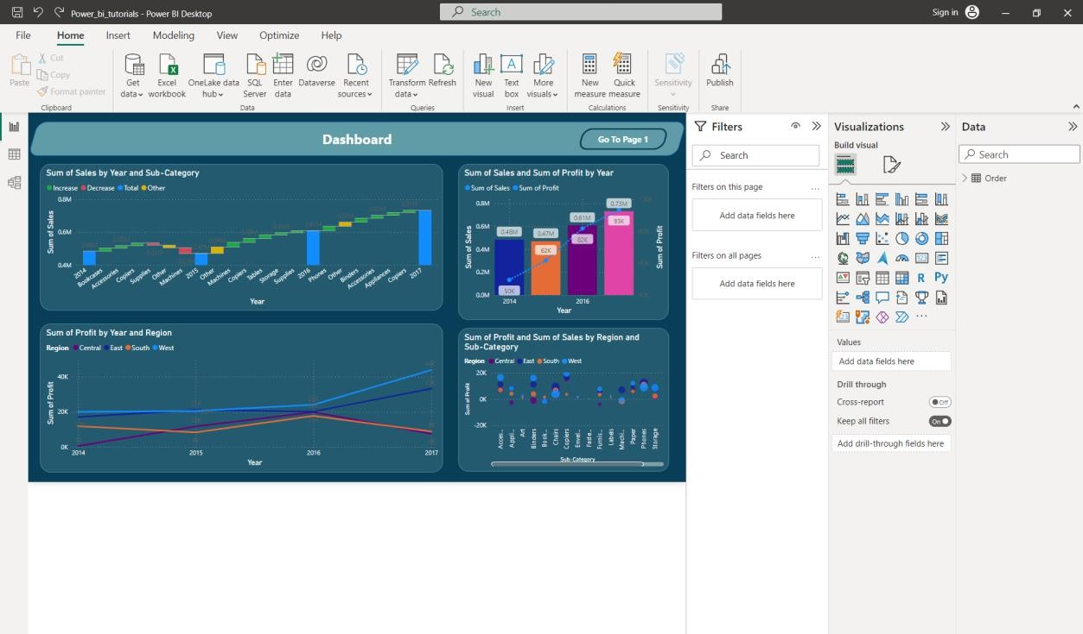

**Result:**

Thus, an interactive storyboard has been created for presentation purpose.