Web Application Penetration Testing Report

1. Introduction
Web Application Penetration Testing is performed to identify security vulnerabilities in web applications. The goal is to detect issues such as Cross‑Site Scripting (XSS), SQL Injection, and other security misconfigurations that may compromise the application.

2. Tool Used
OWASP ZAP (Zed Attack Proxy) was used to perform the automated vulnerability scan. It is an open‑source web application security scanner developed by the Open Worldwide Application Security Project (OWASP).

3. Target Application
Target Website: http://demo.testfire.net

4. Testing Methodology
- Installed and launched OWASP ZAP.
- Started a new session.
- Selected the 'Automated Scan' option.
- Entered the target URL.
- Initiated the scan using the 'Attack' button.
- OWASP ZAP performed spider crawling and active vulnerability scanning.
- Alerts and vulnerabilities were analyzed after scan completion.

5. Scan Summary
Scan Status: Completed
Total Requests: 7805
Total Alerts Detected: 162

6. Vulnerabilities Detected
- Cross‑Site Scripting (XSS)
- SQL Injection
- Absence of Anti‑CSRF Tokens
- Content Security Policy (CSP) Header Not Set
- Missing Anti‑Clickjacking Header
- Cookie Without SameSite Attribute
- Server Information Disclosure

7. Impact
These vulnerabilities may allow attackers to execute malicious scripts, access sensitive data, bypass authentication mechanisms, or gather information about the server configuration.

8. Recommendations
- Implement proper input validation and output encoding.
- Use parameterized queries to prevent SQL Injection.
- Enable Content Security Policy headers.
- Implement Anti‑CSRF tokens for sensitive operations.
- Configure cookies with Secure and SameSite attributes.
- Disable unnecessary server information disclosure.

8. PICTURES OF THE REPORT

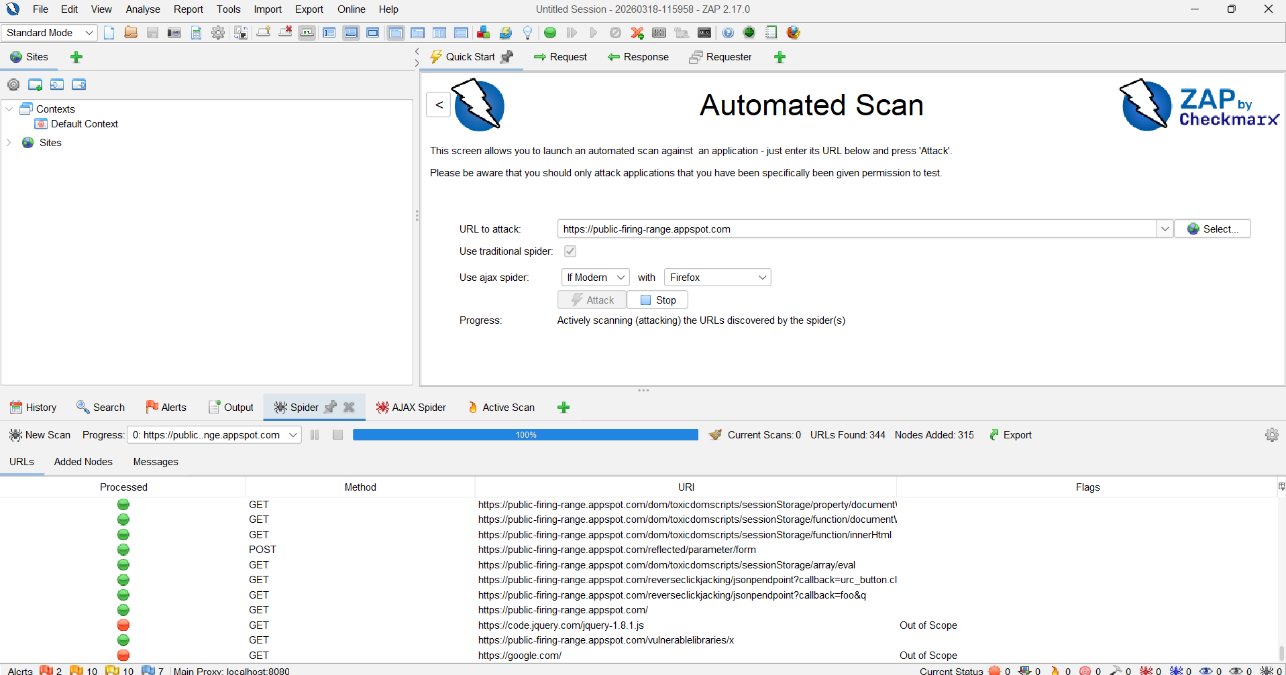

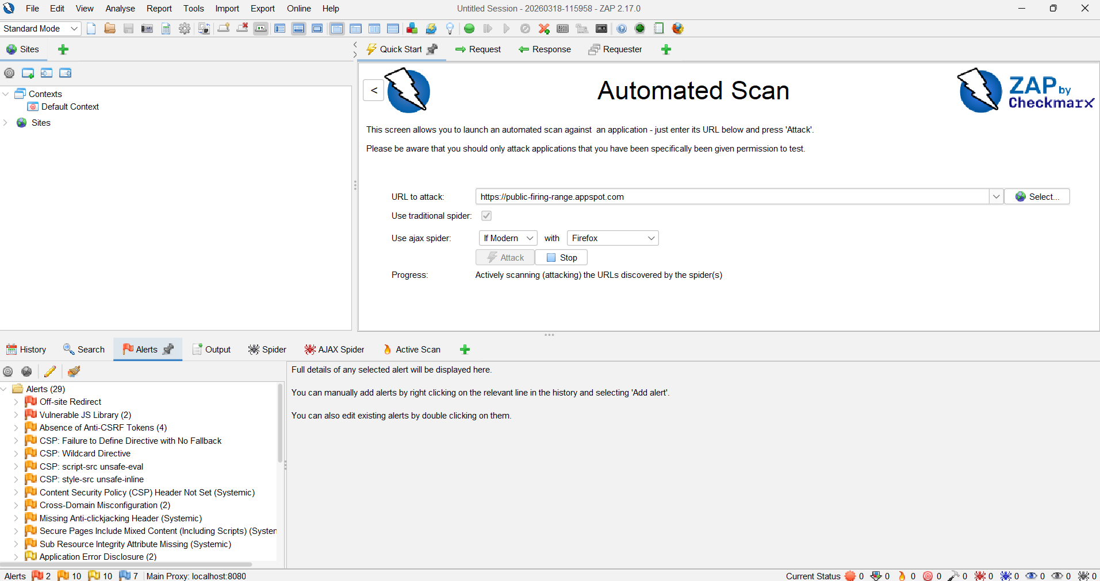

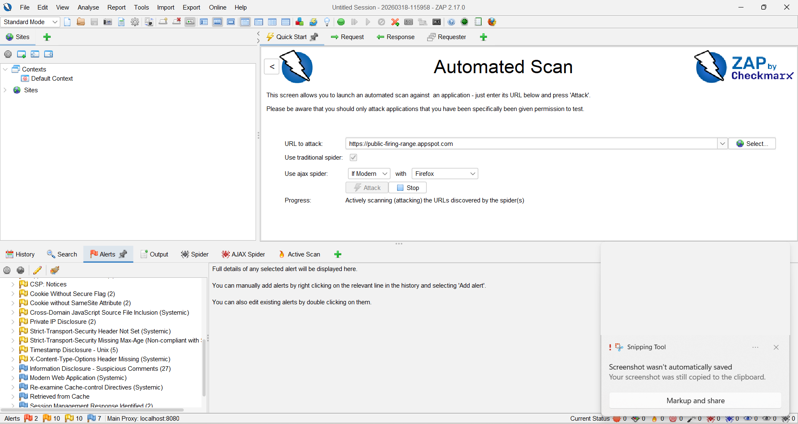

9. Conclusion
The penetration test using OWASP ZAP identified several vulnerabilities in the tested web application. Addressing these issues will significantly improve the overall security posture of the application.

