

Automated Text Classification

Kavish Sharma
a1896438

The University of Adelaide
4533_COMP_SCI_7417_7717 Applied Natural Language Processing
Lecturer: Dr. Orvila Sarker

Table of Contents
1. Abstract 2
2. Introduction 2
2.1. Data Collection Process 2
2.2. SBERT Description 3
3. Preprocessing and cleaning…………………………………………………………………….4
3.1. Cleaning description and accepted answer…………………………………………………4
3.2. Removing punctuation marks and symbols ……………………………………………….4
3.3. Lowercaing text 4
3.4. Tokenization ……………………………………………………………………………….4
3.5. Stop word remova ……………………………….…………………….…………………..5
4. Data Visualization 5
4.1. Word cloud 5
4.2. Posts with and without accepted answers 6
4.3. Median and average time taken for reply ………………………………………………….6
4.4. Average number of views on post …………………………………………………………………..7
4.5. Most frequent tags in post without an accepted asnwer ……………………………………………7
5. Data Categorisation 8
5.1. Definition of the Categories 8
5.2. Categorisation using SBERT 8
5.3 Model evaluation …………...………………………………………………………………9
6. Conclusion 9
7. References 11

Abstract
This project implements the Sentence-BERT (SBERT) model to categorize the questions posted on Stack Overflow that are tagged with “nlp”. The dataset was collected from Stack Exchange Data Explorer and consists of 20,430 posts. These posts were categorized based on titles and descriptions using sentence embeddings generated by the SBERT model. Cosine similarity was calculated between each sentence and a set of categories. Each post was categorized under the category with the highest cosine similarity. Manual evaluation was performed to check whether the posts were categorized properly based on the semantic similarity present in the sentences. Manual evaluation concluded that the approach yields satisfactory results.

Introduction
With the rapid advancement in the field of Natural Language Processing, numerous practical applications have emerged. One of the NLP-related applications that is particularly useful in the software development industry is the creation of a domain-specific knowledge base. The purpose behind creating such a domain-specific knowledge base is to organize expert knowledge so that it can be retrieved when a problem arises, and pre-existing information can be effectively applied to address the issue. This project focuses on categorising questions on Stack Overflow that are related to natural language processing. To perform categorisation, Sentence BERT (SBERT) is employed to generate sentence embeddings that capture the semantic meaning of each question. This model is based on BERT (Bidirectional Encoder Representations from Transformer) which uses a Masked Language Model which masks some words to predict them based on the surrounding context (Devlin et. al. 2019, p. 1). This model generates dense vector representations for sentences which help with various tasks like semantic search, clustering and information retrieval (Nils & Iryna 2019, p. 1).
The dataset for this project was collected from the Stack Exchange website which has 20,430 questions in total related to nlp. The dataset consists of the following column: ID, Post Title, Description, Creation Date, Views, Tags, Accepted Answer ID, Accepted Answer Creation Date, Accepted Answer Body.

  - Dataset Collection
To perform categorisation on nlp related Stack Overflow posts, the data was extracted from Stack Exchange Data Explorer (Prosus N. V. n.d.). This website provides data access to publicly available data for various stack exchange websites. A SQL query was passed to the composed query section to extract the following columns:
- ID: unique ID for the question also known as post id
- Post Title: title of the post which is a summary of the topic problem described in post
- Description: complete body of the post which discusses in detail the problem
- Creation Date: the date on which the post was created
- Views: total number of views on the post
- Tags: these are keywords of the topics discussed in the post
- Accepted Answer ID: unique ID for the accepted answer on the post, if the post does not have an accepted answer, it will be NULL
- Accepted Answer Creation Date: the date on which the accepted answer was posted, if the post does not have an accepted answer, it will be NULL
- Accepted Answer Body: The description of the accepted answer which provides a solution to the question posted, NULL if there is no accepted answer
The SQL query shown in the first cell of the code file was used to extract the dataset from Stack Exchange website. The query selects the columns mentioned above and adds the information under the title mentioned in the square brackets. Tags were created by separating them using commas. The main table used here is Posts. The PostTags and Posts table were joined based on the ID’s and the second join command joins the PostTags with the Tags table based on ID’s matching and having tag “nlp”. Additionally, there is one LEFT JOIN command that joins the accepted answer to the posts table, ensuring the posts without accepted answers are retained. Only the PostTypeId which have 1 are selected, meaning only questions are selected. This query extracts dataset which has 20430 posts with the tag “nlp”. The dataset can be found on dataset link.

SBERT Description
The architecture for Sentence BERT network is shown in Figure. 1. SBERT model uses pre-trained BERT model and fine tunes it to generate a useful sentence embedding (Nils & Iryna 2019, p. 3). It uses a pooling layer at the output of both the BERT model as shown in figure 1 to create a fixed size sentence embedding (Nils & Iryna 2019, p. 3). Then it calculates cosine similarity between the sentences to understand the semantic similarity between the sentences. In this way SBERT is trained to understand semantic similarity between sentences.
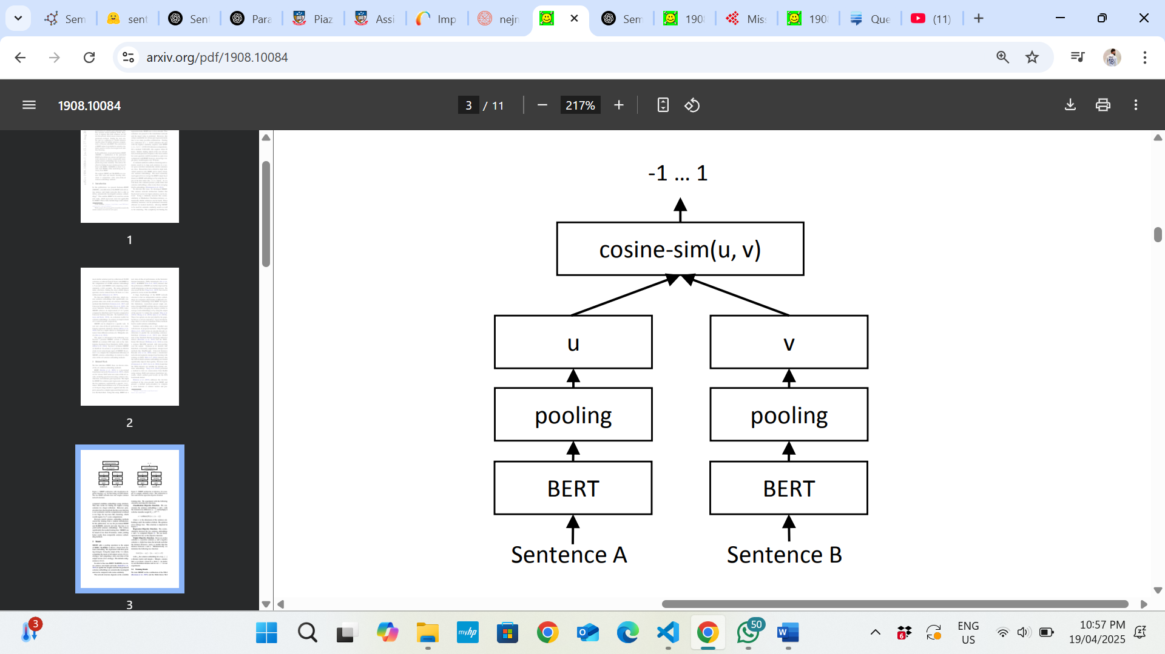
Figure 1. Sentence BERT architecture

Preprocessing and cleaning

Cleaning description and accepted answer
The post description and accepted answer were in HTML format and contained tags such as code, table, image, script, style, etc. which are not useful for further NLP processing, as these contain code and numerical values that do not contribute to linguistic content and can increase the time for categorisation. So, using beautiful soup library these tags were removed, and the text was cleaned by only keeping the text that is in the paragraph text.

Removing punctuation marks and symbols

Punctuation marks and symbols used in the text were removed using regular expression library. Only alphabets and numbers were kept, except everything was removed. This operation was performed on description and accepted answer column

Lowercase text
Lowercasing text is an important preprocessing step because machine consider two words to be different if they have different case even if both are same word. Hence, lowercasing is an important preprocessing step and can help in enhancing the results (Jakhotiya et al. 2022, page 2)

Tokenization
Tokenization is process of converting string of sentences into tokens. This was performed on title, description, and accepted answer columns. This is important as the text contain keywords with some stop words and other unwanted words. To filter unwanted words, we need to have tokens.

Stop word removal
Stop words from English language and custom domain specific stop words that are not important were removed as shown under the stop word removal section. They need to be removed from data to visualize the important keywords.

Data Visualization

Word cloud
Word cloud shown in Figure. 1 was produced from a list of important keywords that were obtained after text preprocessing performed on title column. These words highlight the key words discussed in the titles of the questions posted on Stack Overflow.
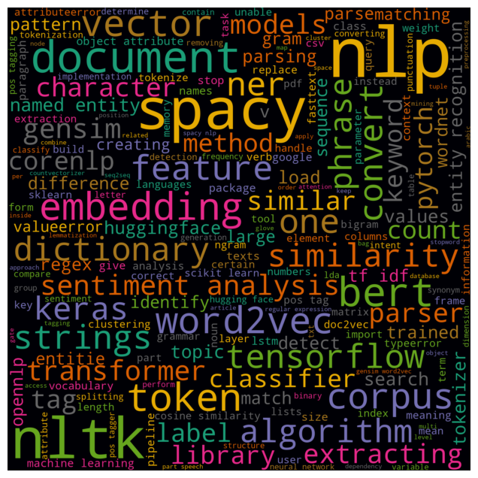

Figure. 1 Word cloud showing important key terms extracted from post title

Posts with and without accepted answers
Figure. 2 shows the counts of posts with and without accepted answers. This was generated by filtering the posts that do not have any accepted answer from the ones that have one and then calculating the total number of posts in both the categories. In total there are 8509 posts that have an accepted answer while the rest 11921 do not have an accepted answer.

Median and average time to reply to a post
Using the date and time column of the created time of question and accepted answer the individual times in seconds were calculated. A statistical summary was generated, and it revealed that the median time to get a reply on post is 14,962 seconds, which is approximately 4 hours 9 minutes, while the average time to get a reply is 1456615.455 seconds, which is roughly 404 hours 37 minutes. The median value shows that 50 percent of the posts got the accepted answer in less than or equal to 4 hours 9 minutes, and the average values is very high and shows that there are many questions that take very long to answer which skews the whole distribution of reply time.

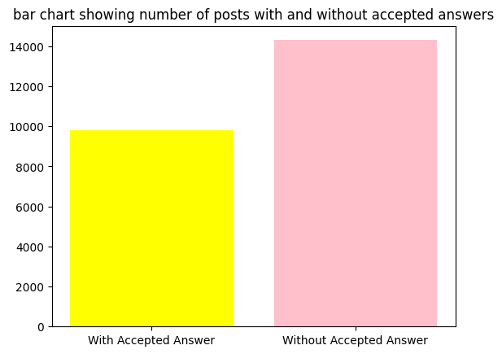

Figure. 2 counts of posts with and without accepted answers

Average number of views on posts
A statistical summary was generated of the number of views, which showed that the average number of views on posts is 2091.34. The post with the least number of views has 8 views, while the post with the highest number of views has 472715 views.

Most frequent tags in posts without any accepted answer
Figure. 3 shows the most 10 frequently occurring tags in the stack overflow posts related to nlp. Besides the expected tag nlp, which occurs in all the posts, other commonly occurring tags are python, machine-learning, nltk, spacy, Stanford-nlp, etc.
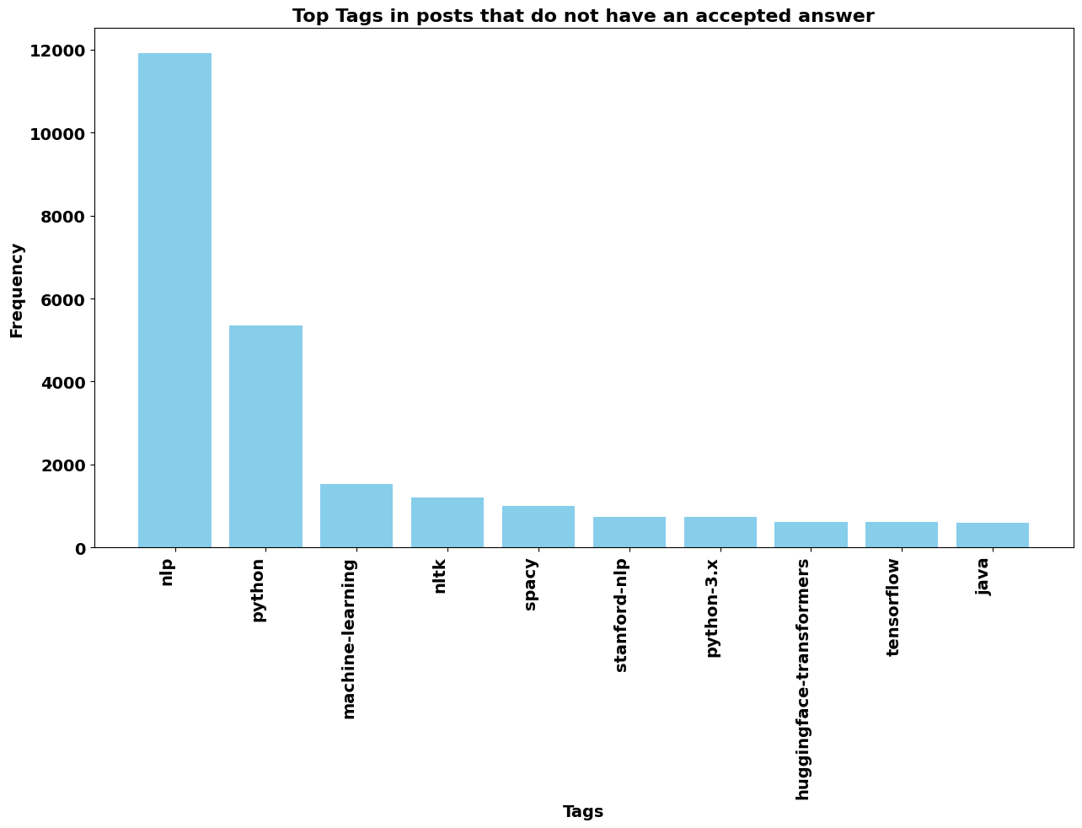

Figure. 3 10 most frequent tags in posts without any accepted answer

Data Categorisation

Categories
The following are the categories used for categorisation:
- implementation issues
- conceptual understanding
- model evaluation optimization
- data preprocessing
- feature extraction-based questions
- tool or library recommendation
- error resolution
- asking for learning resources or advice

The following categories were decided based on looking at some questions and then thinking about what the category can be assigned for the following question.

Categorisation using SBERT
For data categorisation, the titles are combined with description, as title and description contain useful information about the question that is put on stack overflow to get an accepted answer. The accepted answer column was neglected as more than 50 percent of observations do not have an accepted answer. Hence, the decision was made to drop that column for modelling (Hyun, K p. 404). Also, the title and description column provide enough context about the problem being discussed in the question, so dropping the accepted answer column will not contribute to significant loss of information. The titles combined with description and question categories were encoded using sentence transformers and the description was cleaned by only extracting the sentences that are present in the paragraph tag. The SBERT model, which is used here, considers semantic similarity between sentences, which is not done by traditional techniques like TF-IDF and bag of words. No preprocessing is required before SBERT model as removing punctuation marks and stop words can lead to change in semantic information and the online documentation takes raw string of textual data. Hence, no preprocessing was performed.
Here we have used SBERT with some custom categories passed along with post title and description to the model to form sentence embeddings for both and then calculated the cosine similarity and assigned the category that has the highest cosine similarity using the argmax function.
After performing categorisation, the number of posts categorized under each category are shown in Table 1.
Category | Total number of posts
feature extraction-based questions | 7916
tool or library recommendation | 3825
model evaluation optimization | 3773
data preprocessing | 2369
data loading file handling | 1012
conceptual understanding | 773
implementation issues or error related questions | 569
asking for learning resources or advice | 193
Table 1. Distribution of posts by category

Model evaluation
To evaluate the model, manual evaluation method is used by looking and question and descriptions which are categorized under each category and then deciding whether the assigned category is best match for the question. Under the category of “feature extraction-based questions” we found that one question which has title “How do you implement a "Did you mean"?” and it asks about how to implement a google like Did you mean algorithm. According to the question and description it should be categorized under “asking for resources or advice”. Here, the question asks how to implement, and he is seeking resources or advice and not discussing about and feature extraction techniques. Hence it is incorrect categorisation of question. Apart from this the other questions look like they fall under the right category. The questions categorized under “tool or library recommendation” were all relevant. Similarly, no irrelevant questions were categorized under the remaining categories. Hence, the model is working very well.

Conclusion
This project successfully implemented the Sentence-BERT model to categorise the Stack Overflow questions related to “nlp”. Manual evaluation showed that the model accurately categorised most posts, with very few misclassifications. One key limitation of the approach used is that there are some questions that are semantically aligned with multiple categories, and can be categorized into multiple categories, but are classified into only a single category because the approach used is to find the most semantically relevant category. However, the method performs well and can greatly help to create a domain-specific knowledge base. To address this limitation, a more complex method that implements multi-label classification can be used to create a strong foundation for developing a knowledge base.

References

[1] Devlin, J, Chang, MW, Lee, K, Tautanova, K 2019, “BERT: Pre-training of Deep Bidirectional Transformers for Language Understanding”, EMNLP,
Ithaca: Cornell University Library
[2] Hyun, K 2013, “
The prevention and handling of the missing data”, Korea (South): The Korean Society of Anesthesiologists, pp.402-406.
[3] Jakhotiya, A, Jain, H, Jain, B, Chaniyara, C 2022, “Text Pre-Processing Techniques in Natural Language Processing: A Review”, International Research Journal of Engineering and Technology, vol. 9, viewed 18 April 2025, < https://www.irjet.net/archives/V9/i2/IRJET-V9I2150.pdf>
[4] Nils, R, Iryna, G 2019, “
Sentence-BERT: Sentence Embeddings using Siamese BERT-Networks” , EMNLP,
Ithaca: Cornell University Library
[5] Prosus N. V. n.d., Stack Exchange Data Explorer, Stack Exchange, viewed 21 April 2025, < https://data.stackexchange.com/stackoverflow/query/new>

