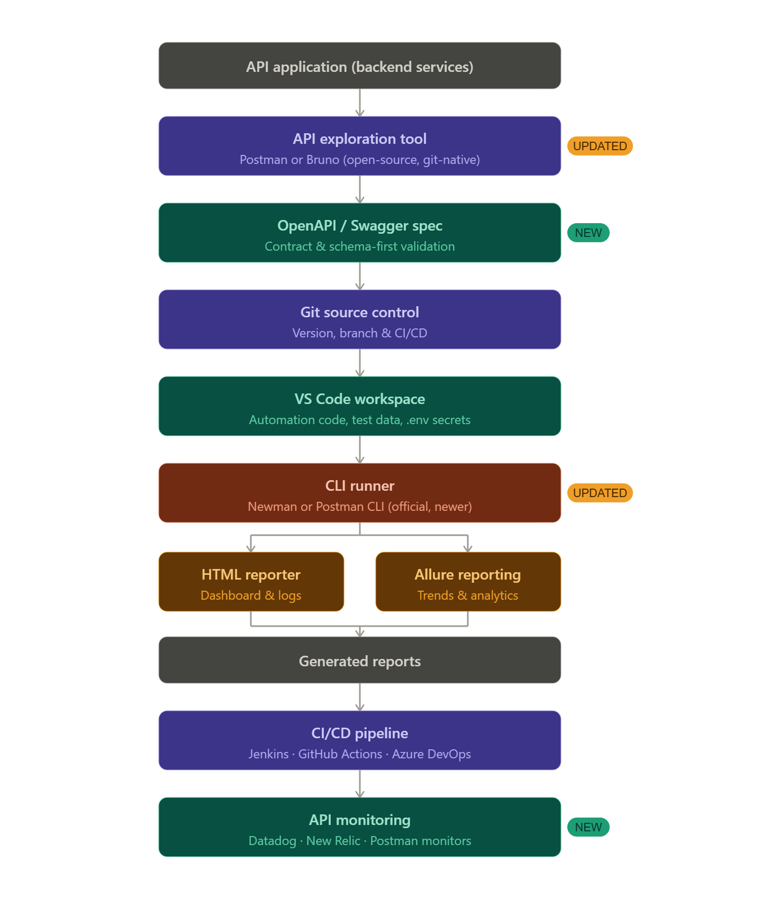

Step 1 — API Application: This is the actual app or server you're testing. It could be a login service, a payment gateway, anything that has API endpoints.
Step 2 — API exploration tool (Postman/Bruno): You open Postman or Bruno, fire some requests manually at the API, and see what it responds with. You write assertions ("the status code should be 200") and save everything as a Collection.
Step 3 — OpenAPI / Swagger spec: Your team has a YAML/JSON file describing what the API is supposed to do. Your test assertions should match this spec. This protects you when the backend team changes something without telling you.
Step 4 — Git: You commit your Postman/Bruno collection files, environment files, and test data to a Git repository. This way the whole team has the same copy, you can track changes, and CI/CD can pull from it.
Step 5 — VS Code: This is your main workspace. You write scripts, manage your folder structure, and store secrets like API keys in a .env file (which never gets committed to Git).
Step 6 — CLI runner (Newman/Postman CLI): Instead of clicking "Run" in Postman, you now run tests from the terminal with a single command. Newman reads your collection file and executes every request automatically. This is what CI/CD will call.
Step 7 — Reporters: Newman produces two types of reports. The HTML reporter (htmlextra) gives you a visual webpage with pass/fail results and full request/response logs. Allure gives you an enterprise dashboard with trend graphs showing whether your failure rate is going up or down over time.
Step 8 — Generated reports: These are the files saved to your reports/ folder — the HTML file and the Allure result files.
Step 9 — CI/CD pipeline: Every time a developer pushes code to Git, GitHub Actions (or Jenkins or Azure DevOps) automatically pulls the code, runs Newman, generates reports, and optionally sends your team a Slack message with the results. Zero manual effort.
Step 10 — API monitoring: Even in production, your tests keep running automatically on a schedule. If the live API starts returning errors or slows down, your team gets alerted immediately.

