U23AI016
BDA
Assignment 1

Q1.Create SparkSession and create an RDD from a Python list of integers using PySpark.
- Display all elements of the RDD
- Find the total number of elements
- Explain why RDDs are immutable and fault tolerant
Output :
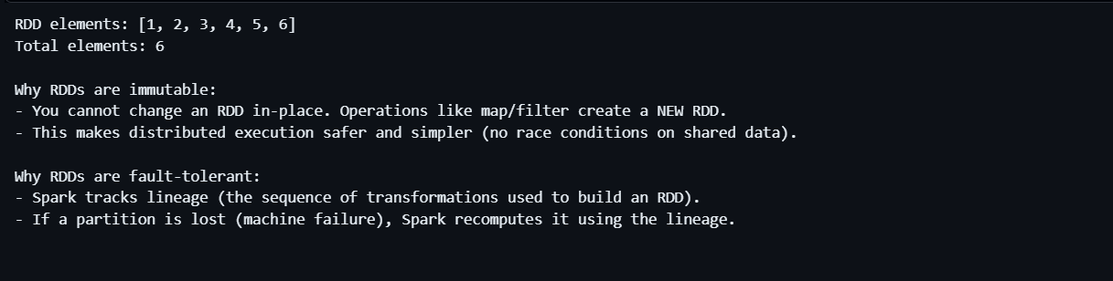

Q2.Using an RDD created from numbers 1 to 10:
- Use map() to find the square of each number
- Use filter() to extract only even numbers
- Display the transformed results

OUTPUT:
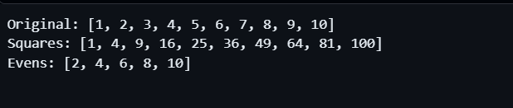
Q3. Using the same RDD:
- Use reduce() to find the sum of all elements
- Use count() to find the total number of elements
- Use take(5) to display the first five elements
OUTPUT :
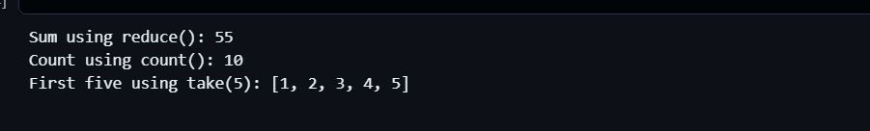
Q4. Load a text file into an RDD and perform the following:
- Count the total number of lines
- Count the total number of words
- Find the longest word in the file
OUTPUT:
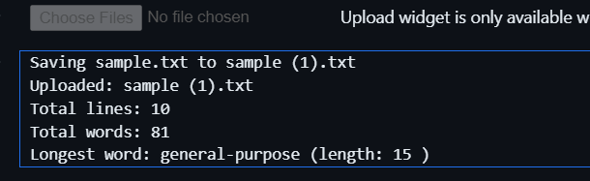
Q5.Write a PySpark program to implement Word Count using RDD:
- Convert all words to lowercase
- Count frequency of each word
- Display the top 10 most frequent words
OUTPUT:
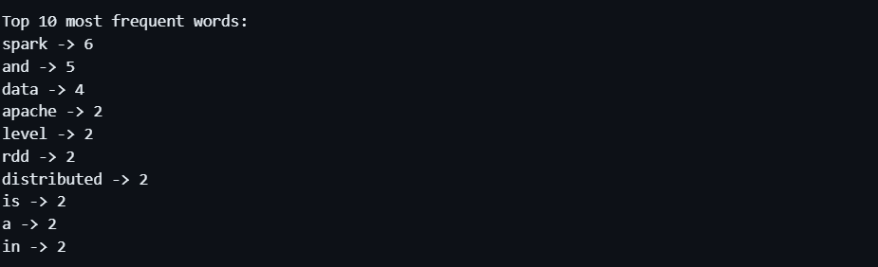
Q6 Analyze the searchterm.csv file (link:
https://cf-courses-data.s3.us.cloud-object-storage.appdomain.cloud/IBM-DB0321EN-SkillsNetwork/Big
data%20and%20Spark/searchterms.csv ) to find the following data using spark.
- Plot the frequency distribution for search terms appearing more than a threshold (e.g., >100
times).
- Find the average length of search terms.
- Find our how many times was the term `gaming laptop` searched?
OUTPUT :
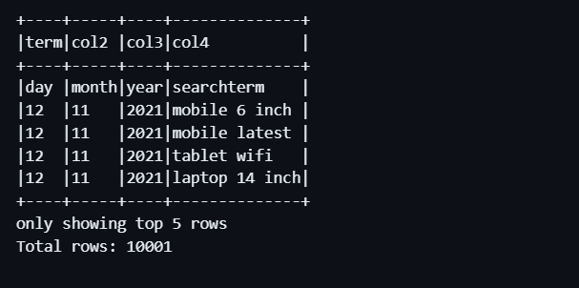
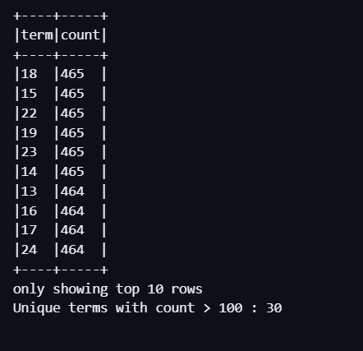

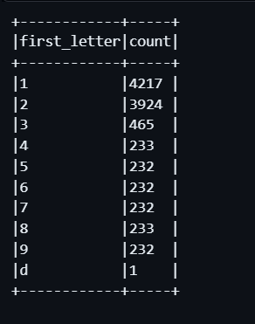

This assignment was useful in understanding the basics of PySpark and the operations that can be performed on RDDs, such as map, filter, and reduce. It also helped in understanding how big data is processed efficiently through distributed computing.
(The code is attached in the folder with the sample.txt)

