U23AI016
BDA
Assignment 6

Ques 1. Create a table named user_settings with a single Column Family (CF) called
metadata.
1. Set the VERSIONS attribute for the metadata CF to 3.
2. Insert a row for user01 with the column metadata:theme set to "Light". Update the
same row/column to "Dark", then again to "High Contrast".
3. Run a get command with {COLUMN => 'metadata:theme', VERSIONS => 3}.

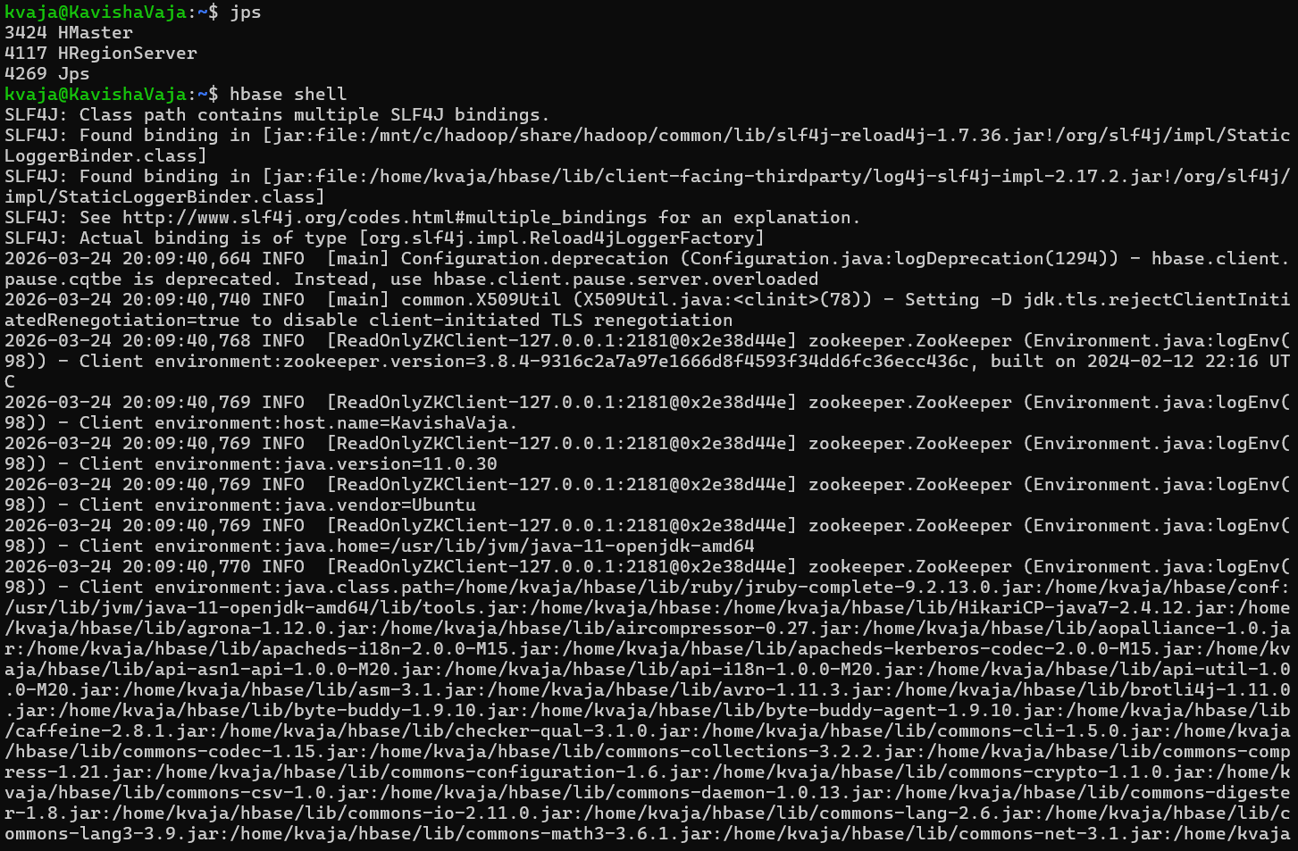
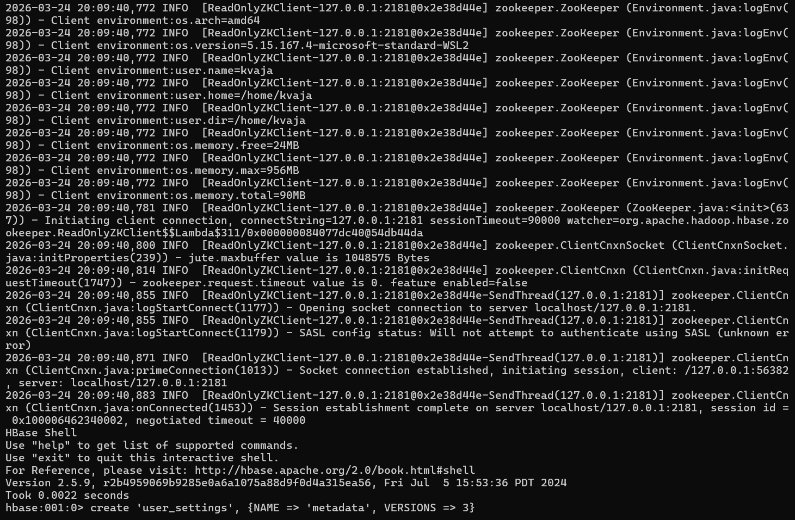
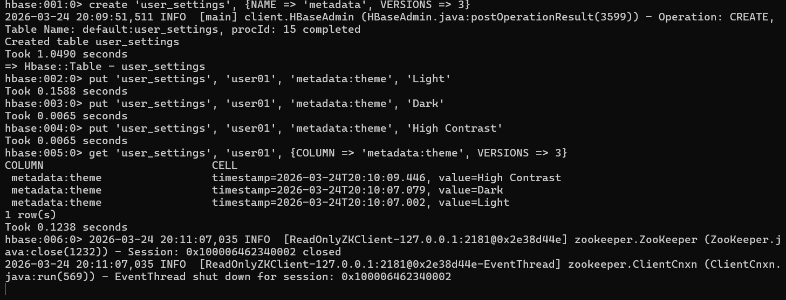
Ques 2. Store sensor data (Temperature, Humidity) collected every minute.
1. Tall Table Design: * Row Key: sensorID_timestamp
○ Columns: data:temp, data:humid
2. Wide Table Design: * Row Key: sensorID_date
○ Columns: data:t_01:00, data:t_01:01, etc.
Use the HBase Shell to insert 5 minutes of data for both designs.
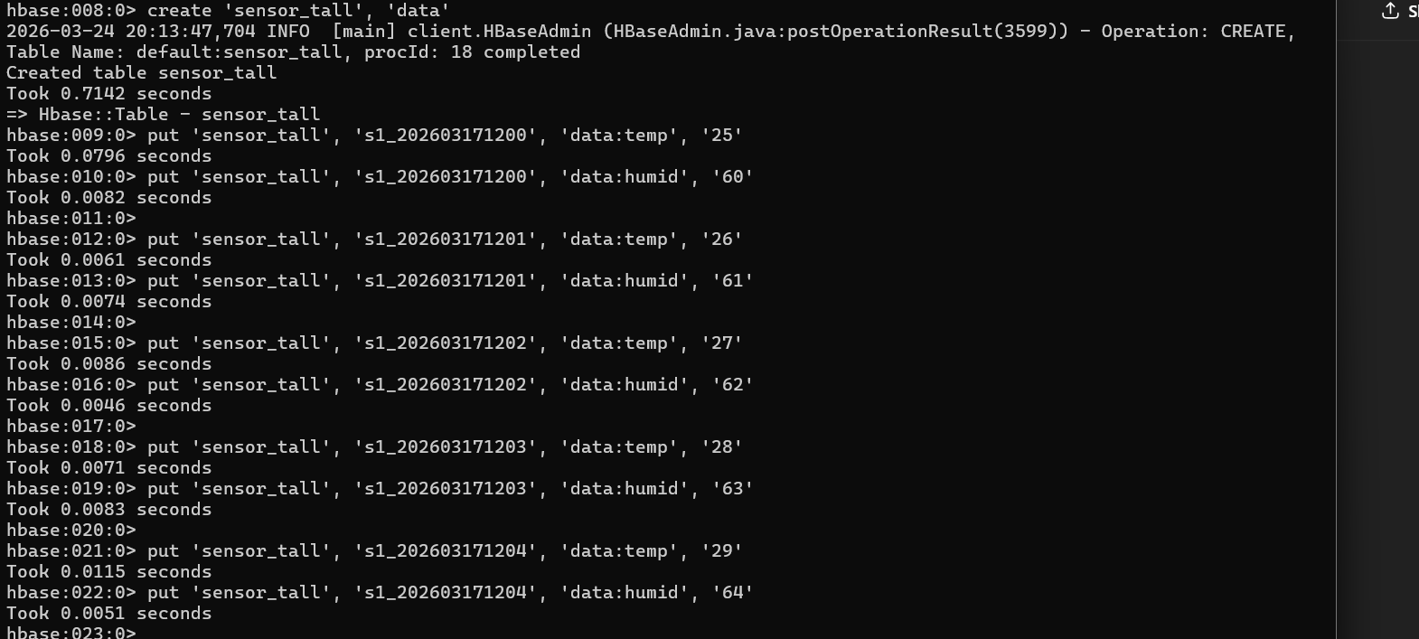
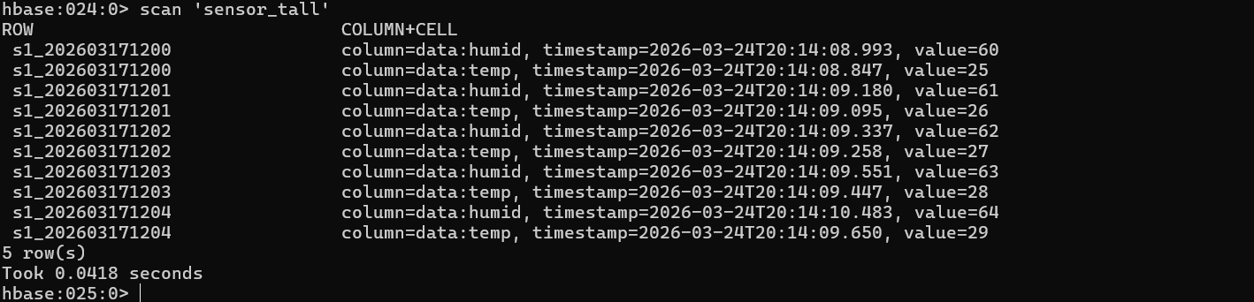
2. Wide Table Design: * Row Key: sensorID_date
○ Columns: data:t_01:00, data:t_01:01, etc.
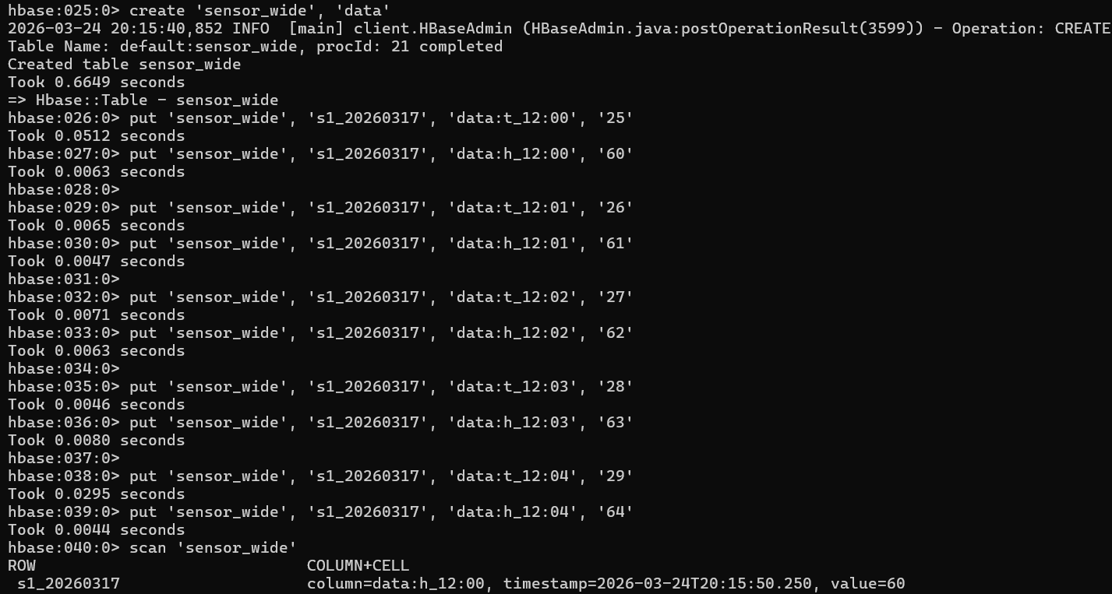
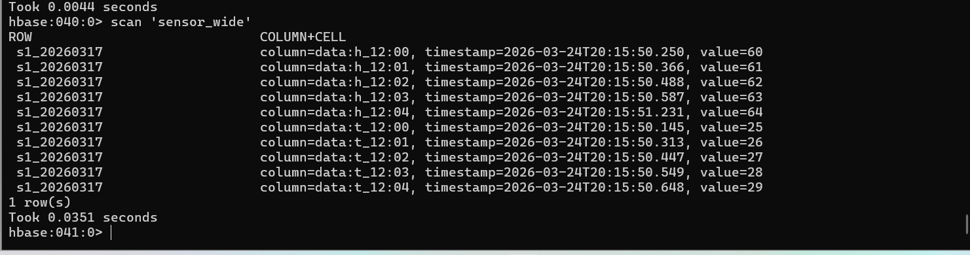
Ques 3. Observe how row key design affects data distribution across RegionServers.
1. Create a table web_logs with a pre-split strategy (e.g., splitting on hex keys 0-9,
a-f).
2. Generate row keys using a sequential timestamp (e.g., 20260317120001).
3. Generate row keys using a salted/hashed timestamp (e.g.,
hash(timestamp)_timestamp).
Use the HBase Web UI (port 16010) to monitor the "Requests" per region.
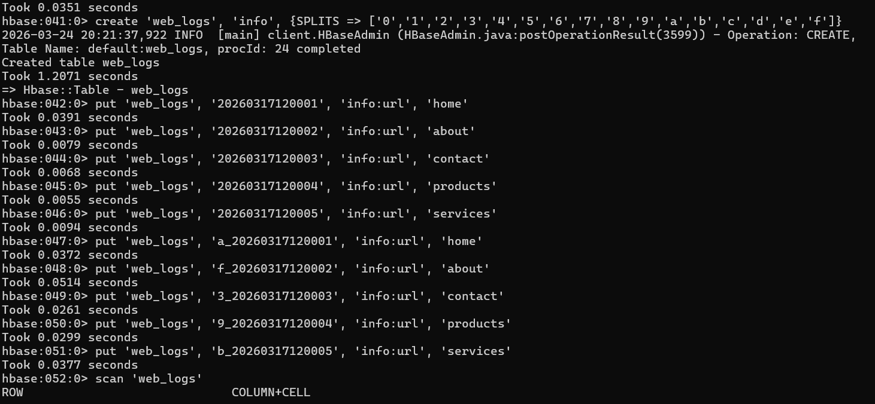
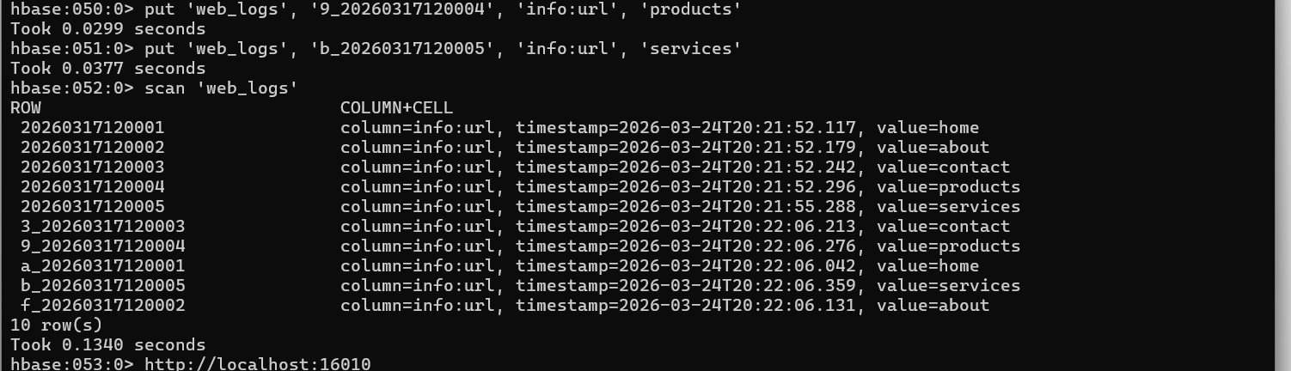
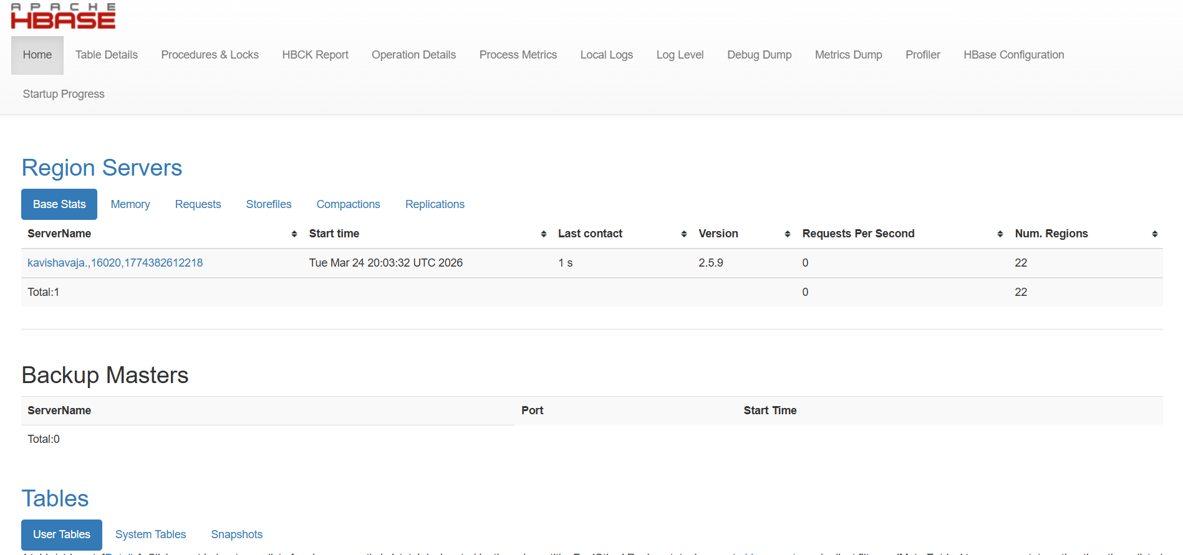
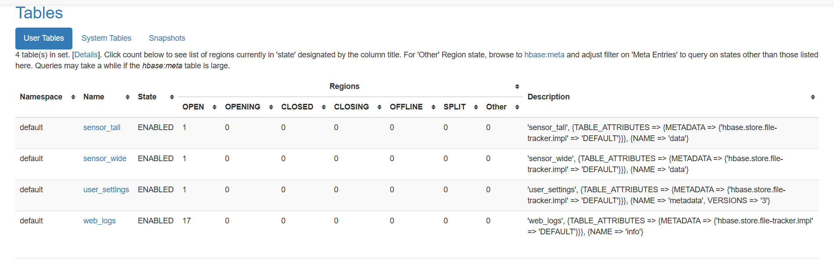
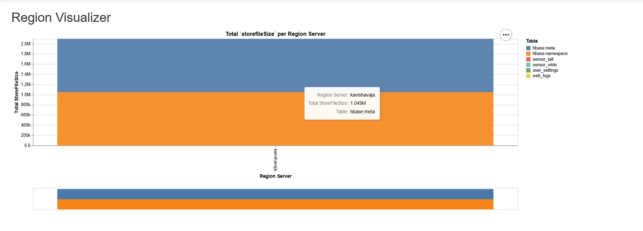
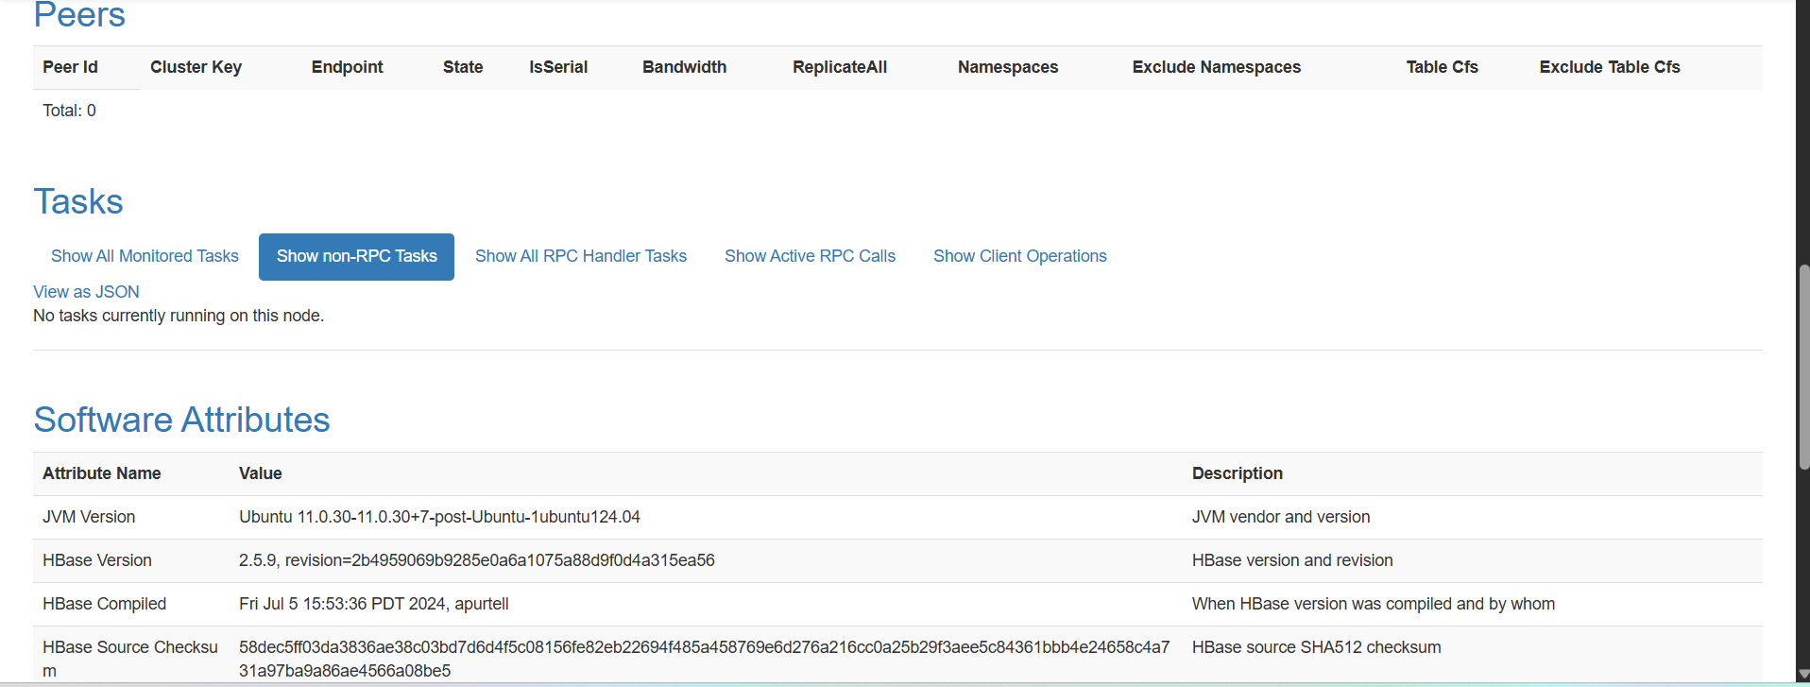
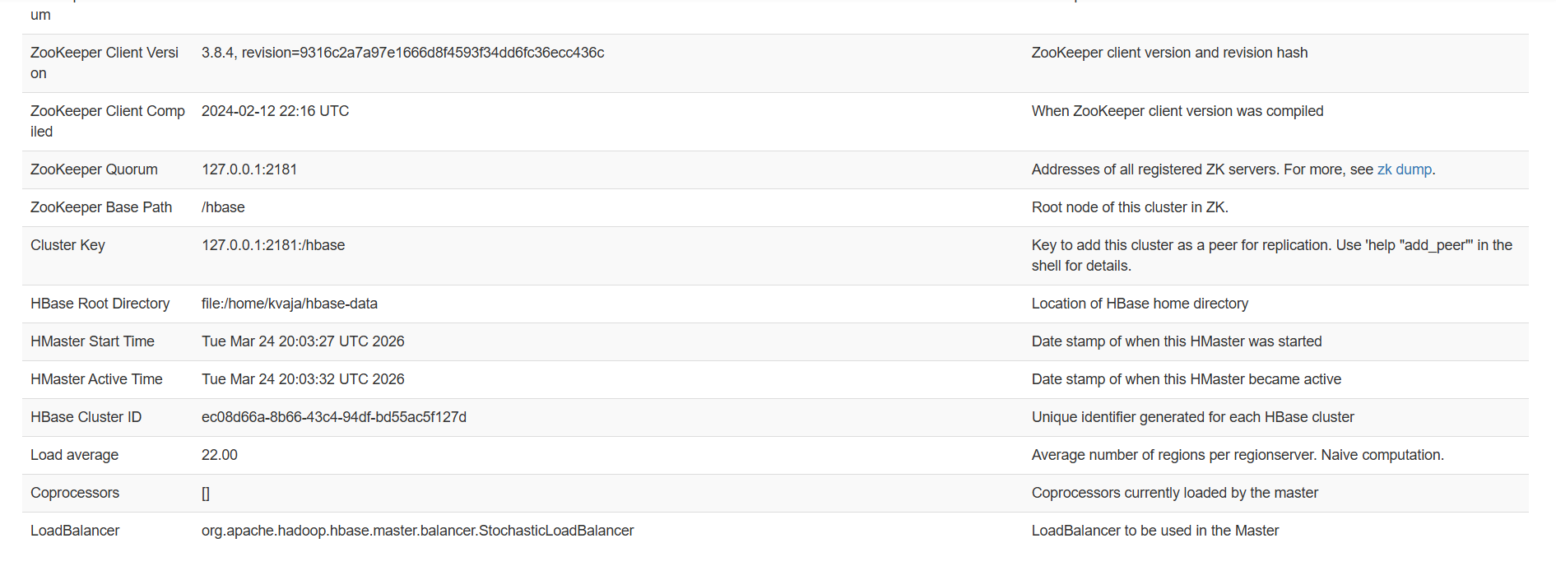

Ques 4. Define an Avro schema for a ProfessionalProfile (containing Name, Skills List,
and Years of Experience).
1. Coding: Write a Java or Python script to:
○ Serialize a profile object into a byte array.
○ Store that byte array in an HBase table employees under the column
content:p_data.

2. Retrieval: Fetch the row, deserialize the Avro bytes, and print the "Skills List".
