Protein-Protein Interaction Prediction using Machine Learning

Kavisha Jignesh Patel

M.S in Pharmacology & Toxicology

Long Island University, Brooklyn
New York
United States of America

kavishajignesh.patel@my.liu.edu
Yash Jitendra Sanklecha

M.S in Artificial Intelligence

Long Island University, Brooklyn
New York
United States of America

yashjitendra.sanklecha@my.liu.edu
Ujas Vijaykumar Patel

M.S in Artificial Intelligence

Long Island University, Brooklyn
New York
United States of America

ujasvijaykumar.patel@my.liu.edu

Abstract— Protein-Protein Interactions (PPIs) are a central part of almost all biological mechanisms; however, high-throughput experimental characterization ofPPIs remain labor and time-intensive. We introduce a project attempting to build a deep learning model based on sequence data alone that predict PPIs. This publication describes a strategy using a labeled PPI data set (Kaggle) to train a dual input Bidirectional Long Short-Term Memory (BiLSTM) network. In the proposed approach each sequence is encoded independently before the representations are combined and the model attempts to classify interactions as binary. Initial results indicate that the BiLSTM framework can capture long-range dependencies within protein sequences. Techniques for dealing with potential problems such as class imbalance and ability to generalize to new protein pairs are explored. The ultimate goal of this project is to create an accurate, low cost method for PPI prediction. Further work planned includes the use of protein language models embeddings.
Keywords - Protein-Protein Interaction; BiLSTM; Deep Learning; Sequence-Based Prediction; Machine Learning; Bioinformatics

Introduction
The binding of two or more proteins with each other for conducting important cellular processes are called protein-protein interactions (PPIs) [1]. They are central to the cellular structures, signaling transduction and regulatory functions in which they allow proteins to bind to each other, interact, and aggregate into complexes within the cell. Generally PPIs can be classified into steady (structural complexes) and transient (signaling pathways). The existing experimental methods for detecting PPIs have been developed such as yeast two-hybrid screening, co-immunoprecipitation, and affinity purification-mass spectrometry in which massive interaction data have been produced. Nevertheless, these techniques have limited throughput, potential for false positive and false negative predictions, and also expensive in a proteome-wide scale. As number of possible protein pairs is proportional to the square of the number of proteins in the cell, experimental characterization is not sufficient for comprehensive interactome mapping [2]. Computation methods therefore are adopted to predict PPIs. Initially, prediction models depend on features derived from protein sequences (e.g. Amino acid compositions and physical-chemical properties) were proposed. In recent years, the prediction performance of the computational methods is tremendously improved with deep learning models learning complicated non-linear relationships from protein sequences directly [3].
This paper provides an account of our work in progress toward the prediction of PPIs using a dual input Bidirectional Long Short-Term Memory (BiLSTM) network that accepts two proteins sequences as input and outputs the predicted interaction. Here, we describe the dataset and the preprocessing pipeline, the architecture of the prediction model and our preliminary results and problems that we found in our study.

LITERATURE REVIEW

xCAPT5: Protein Language Model with Deep CNN (2024)

Recent advances in sequence-based PPI prediction have witnessed an incorporation of deep learning models with advanced feature extraction techniques. Dang and Vu (2024) proposed a hybrid classifier xCAPT5 that adopts the ProtT5-XL-UniRef50 protein language model to obtain dense embeddings of the amino acids. It consists of a multi-kernel deep convolutional siamese neural network architecture to extract interaction features of both micro and macro scales, which makes full use of diverse receptive fields in its varying sizes to learn micro- and macro-level features at the same time. Such representations are further combined with the XGBoost algorithm to maximize the predictive performance. It is demonstrated through experiments that xCAPT5 achieved state-of-the-art accuracy of 97.27% and 99.77% on the Martin dataset and Pan human dataset respectively, and outperforms numerous existing methods.

  - DL-PPI: CNN and GNN with Attention (2023)
In parallel with the convolutional methods, Wu et al. (2023) presented DL-PPI, which is an end-to-end GNN-based framework developed to predict interactions of unknown proteins. The proteins were regarded as nodes, interactions as edges, and then the PPI prediction was viewed as a link prediction problem. It used a Protein Node Feature Extraction Module using the Inception method to learn features from protein sequences. Also it contains a Feature-Relational Reasoning Network (FRN) using GNNs to capture relation information of protein pairs. Integrating with the attention mechanism enhanced features with relevant information. The proposed DL-PPI achieved good results in different benchmark databases like the STRING database (Micro-F1=94.85%).

  - Deep Learning with Feature Fusion (2025)

With further study of the fusion effect between multi-type features, Tran et al. (2024) proposed DF-PPI (Deep Fusion-PPI) that combined handcrafted features with NLP sequence embedding. DF-PPI utilized three descriptors, including F-vector, Local Descriptor (LD), and an improved method,APAACplus, that could even represent triplets of amino acids. These three descriptors are fused with protein sequence embeddings trained by Doc2vec via a MLP architecture. It is designed to mine various characteristics in the sequence information, such as physicochemical information and semantic mining between residues. DF-PPI showed great performance in the tests with 96.34% accuracy on Yeast core data and 99.30% accuracy on Human data. Furthermore, the method presented high stability and correctly restored some vital PPI networks, including cancer related networks and Wnt signal pathway networks.

Summary Comparison

Aspect | xCAPT5 (ProtT5) | DL-PPI (CNN + BiLSTM) | DF-PPI
Accuracy | 90-95%+ | 85-92% | 96-99% (Highest)
Feature Strategy | Pretrained embeddings | Sequence-only | Fusion (handcrafted + embeddings)
Sequence Understanding | Very High (global context) | Moderate | Moderate
Generalization | Very Strong | Moderate | Strong (cross-species)
Computational Cost | Very High | Medium | Medium
Table 1: Paper Comparision

- IMPLEMENTATION

3.1 Dataset
The Kaggle PPI Dataset [4] provided the dataset utilized in this investigation. Each sample has two amino acid sequences and a binary label that indicates whether an interaction exists (1) or not (0). These labeled protein-protein interaction pairings are included. To maintain class balance, stratified sampling is used to divide the dataset into 80% training and 20% validation sets.

Attribute | Details
Source | Kaggle PPI Dataset
Input Features | Protein Sequence A, Protein Sequence B
Number of Classes | 2 (Interaction: 1, No Interaction: 0)
Label Type | Binary Classification
Data Split | 80% Training / 20% Validation
Table 2: Dataset Desription

  - Pre-processing
Using the 20 letter amino acid vocabulary we generate strings of characters that represent the raw protein sequences. The sequences are converted to models compatible numerical inputs through the following preprocessing steps. Integer-encoded sequences: A mapping is created for each unique amino acid character to a unique integer index. Truncated or padded to length. Sequences are either truncated to a preset maximum length or zero-padded so that they are all of the same length, which is important for batched processing. A learnt embedding layer is trained during training time and produces a dense vector representation of each amino acid index. Binary cross-entropy loss: The binary interaction labels directly serve as targets. The data is divided into training (80%) and validation (20%) sets to maintain class ratios.

3.3 Feature Extraction
The feature extraction step is where the bridge is built from raw biological sequences to the numerical data required by the deep neural network. This work uses a hybrid feature engineering strategy, which captures the global biochemical context as well as the local sequential motifs of each protein. The extraction process starts from the raw primary sequence of protein pairs and processes them into two different types: a fixed-length composition vector, and a standardized integer-encoded sequence. By concatenating these two modalities, the model can at the same time reason about the alphabetical ordering of the residues and the overall chemical recipe of the protein, creating a holistic representation capturing the thermodynamics and structures involved in the interaction.
The amino acid composition (AAC) is calculated for each sequence, to capture the global biochemical properties. The AAC converts each protein into a 20-dimensional numerical vector where each entry corresponds to the normalized frequency of one of the 20 standard amino acids (count of residue / length of sequence). This transformation makes the features invariant to the protein's size, and biologically, can be taken as a rough proxy for the overall physico-chemical nature of the protein (e.g., a high frequency of hydrophobic residues like Leucine, Isoleucine and valine relative to charged amino acids like Lysine or Glutamate gives an indication of the overall tendency of the protein to prefer environments of specific polarity).
In the sequence analysis, we perform an integer tokenization and padding of each primary sequence. Each amino acid is replaced by a unique integer in the range of 1 to 21, where 21 is used for a padding token. To accommodate the fixed-input layer structure of the convolutional and recurrent layers, all sequences are then cropped to a maximum length of 500 amino acids (MAX_LEN = 500). Sequences longer than 500 are truncated, while sequences shorter than 500 are post-padded with the zero token. This operation preserves the information of the local sequential structure of the sequence in an integer sequence format so that conserved motifs and long-range interactions can be detected. The protein sequences are then passed through an embedding layer to obtain a 128-dimensional vector for each amino acid in the sequence. The embedding layer learns to embed similar amino acids (in terms of polarity, volume, etc) in nearby regions of the latent space, and by sum/average pooling along the sequence dimension the overall embedding for the protein is obtained.
Finally, to prepare the training and validation sets, stratified data partitioning is employed. Imbalanced data are common in PPI datasets, and it is therefore crucial that feature distributions in the training and testing set match as closely as possible. An 80/20 split is performed using a stratified partitioning strategy to ensure that the ratio of interacting vs. Non-interacting protein pairs is preserved throughout training and validation. This ensures a fair test, and helps discover residue-level hot spots for interactions without any bias.

3.4 Model Architecture
3.4.1 Architecture Overview:
This Hybrid Siamese-Cross-Attention Network architecture is designed to learn the multi-scale nature of protein-protein interaction. Based on the premise that PPIs are controlled by local sequence motifs as well as by global biochemical characteristics, each pair of proteins has its protein sequence and its AAC vector passed into a paired-input design. The overall architecture is designed in a Siamese style with shared-weight encoders that capture the deep physiological characteristics from each of amino acid sequence and AAC vector of each pair of proteins. This Siamese mechanism ensures the mapped features from each protein would reside in the same space and thus could be compared.Finally, this multi-scale representation would be fused with seq-level dependencies, motif-based spatially related features and cross-seq attention, to finally produce the probability of protein-protein interaction.
In the aforementioned structure, BiLSTM is utilized as an engine to detect evolutionary information within the protein sequences. This evolutionary information is a key concept of both xCAPT5 and DL-PPI methods. Adhering to the idea that proteins can be thought of as biological language, the BiLSTM encodes protein sequence in the both the forward and backward direction so to account for 'evolutionary memory'- i.e., the functional conservation of residues, even if they are relatively far apart from each other within a primary protein sequence, because the positions they occupy relative to one another within a tertiary protein structure are important to protein folding and protein binding. This bi-directional flow of information will allow the model to capture any 'long range dependencies' and hidden evolutionary semantics which standard convolutional networks are unable to recognize with limited receptivity.
By encoding sequences in two different directions, the BiLSTM network takes the original sequence embeddings and generates a new feature space, where each residue is represented by its context on both sides, thus modeling the evolutionary context that maintains stability. Using this context-aware representation of each residue, the BiLSTM generates a "macro" evolutionary context that is further modeled in the Multi-Kernel CNN block in order to account for "micro" evolutionary features, such as functionally constrained sequence motifs. The BiLSTM encoded residue features are then incorporated into the Cross-Attention mechanism where co-evolving residues can be selected to form protein interfaces and reveal the evolutionary "conversation" of the protein-protein binding sites. In doing so, it becomes possible to learn the principles of protein structure and function that have been hardcoded into protein primary structure through natural selection.
The decision making during the fusion stage changed from simple additive to a highly complex multi-operational block which models the chemical and physical correlation in the interaction of protein pair. In contrast, concatenation keeps all raw features whereas we believed that it is inefficient to allow deep layers to learn correlations on raw features; therefore we also included the element wise product and element wise difference. These two operation give the model built in intuition of the problem: element wise product accounts for how strongly two features are correlated and how similar they are to one another and serves as a placeholder for physical binding while element wise difference accounts for which part of the branches are different.
To even further enhance the concatenated representation, we chose to add an extra sigmoid activated gate to selectively include one of these features depending on the relation that was extracted between the pair: to reduce noise and because the gate will learn to pick the predictive interactions-be them similar, different, concatenated-that are indicators of a physical binding event for that protein pair. In this way we are able to only forward features that have strong predictive power on the interaction and ignore that which would otherwise obscure the prediction of a physical binding.

3.4.2 Detailed Architecture Components:
The components that constitute the pipeline for the proposed architecture operate sequentially to map a pair of raw primary sequences to a high dimensional interaction manifold. This transformation is handled by diferent modules.
Each of the two protein inputs are passed through two different modalities to attain an inclusive representation of the protein. The first modality directly encodes the primary sequence via a 128-dimensional embedding layer. This embedding layer learns to represent each amino acid by mapping them to a unique, continuous vector in a latent space, thus encoding the physico-chemical relationships between them (e.g. Alanine and Valine being similar in terms of hydrophobicity, charged residues being distinct). These embeddings are then passed through a 64-unit per direction Bi-LSTM layer. Bi-LSTMs were chosen here as they effectively encode the "linguistic" structure inherent to proteins, whereby the biological function of each amino acid is dictated by the amino acids preceding and following it. The second modality takes in the 20-dimensional amino acid composition (AAC), a vector that encapsulates the frequencies of occurrence of each of the 20 amino acids in the sequence, irrespective of their positions. These two inputs, the sequential embeddings (obtained from the LSTM layer) and the global AAC features, are then concatenated to produce a feature vector that incorporates both local context (from the Bi-LSTM) and global characteristics (from the AAC) of the protein. An example would be capturing not just that a pair of positively charged lysine residues are nearby but also the overall "charge signature" (positive) of the protein.
To account for the varied spatial nature of protein motifs, the model uses multi-scale convolutional filters to scan over features. Each sequence from the above module is passed through three 1D convolutional layers in parallel with kernel sizes 3, 5 and 7 respectively (Inspired by Inception architecture, originally introduced by Google, it captures information from multiple levels simultaneously). This allows for the detection of local patterns such as a di-peptide and larger more complex structural elements and functional sites respectively. The features obtained from these filters are then passed through two simultaneous pooling operations-Global Average Pooling and Global Max Pooling. Average pooling provides a measure of how common a particular motif is within the sequence while the max pooling operation helps in detecting presence of certain "hot-spots" where there might be high binding affinity for that motif. This combination is used to obtain features that are relatively insensitive to the variable lengths of the protein sequences.
The most novel module in the pipeline is the Cross-Attention module that is used to bridge the isolated nature of the two protein branches until now. Instead of waiting until the very last layer to bring together representations of the two proteins, it computes a full affinity matrix of interaction between all pairs of residue-level hidden states of Protein 1 (f1) and Protein 2 (f2). This uses Softmax-normalized dot-product attention and effectively asks what residue in protein 1 is "attending" to which residues in protein 2. The resultant interaction-aware feature of protein 1 represents the protein as a weighted sum over residue states of protein 2 based on their compatibility. This intrinsically maps on to molecular recognition, where we focus on the residues in both protein 1 and 2 that most likely bind, eliminating noisy interactions from non-interacting sub-sequences.
The final step in the pipeline involves bringing together the relationship between the two proteins. We generate 3 relational tensors between f1 and f2-concatenation, element-wise multiplication (Hadamard Product) and absolute subtraction (divergence) which then go through a final fused neural layer which uses a sigmoid-gated mechanism to combine information from the relational tensors. This gate learns what is more important-the similarity or the divergence between the two proteins, or a mixture, to make a prediction. Finally, we include Batch Normalization to facilitate more stable and faster gradient propagation while going deep in the network without vanishing.

3.5 Proposed Model
The proposed model is the Collaborative Gated Cross-Attention PPI (CGCA-PPI) which is an advanced deep learning framework for predicting the probability of two protein sequences physically interacting. This framework can also perform an end-to-end learning of protein "complementarity", compared to traditional machine learning frameworks that required hand-crafting features. The proposed model is built on top of the hypothesis that protein interaction is not solely about the global similarities between proteins but about how certain local interfaces and co-evolved residues "interplay" with each other. The model integrates sequence embeddings, convolutional motif detection and global compositional analyses, creating a multi-view representation of the proteomic data.
In this model's architecture, first it's the Siamese Feature Extraction Phase where the two protein sequences were mapped into the same 256 dimensional latent space using identical networks (so they share weights). This process of having weight sharing branches allow the networks to learn the universal biological language and learn the rules that applies to both proteins equally. The second part is the Cross-Attention Phase, it correlates the features on residues to find the specific binding sites, and followed by the Deep Classification Head, which is an MLP with 256 and 128 neurons in each dense layer. This model has a very high dropout rate, 0.5, to let it generalizes better to unseen protein families, in the way it will find the redundant and stable pathway in order not to rely on certain high-frequency training sequence.
The biggest advantage of this model over the typical prediction models is its interpretability function: apart from just binary prediction of interaction or not, the architecture can be easily customized into In-Silico Alanine Scanning and Interaction Mapping. The residues in the cross-attention layers can be used to get their weights, and can be translated into a Residue Contact Map which hypothesizes where is the actual binding site. In short, CGCA-PPI can be considered as both prediction models and diagnosis tools for molecular biology. The final output is the sigmoid activated probability score between 0 and 1 for the stability of protein-protein complex. The system uses Adam optimizer and ReduceLROnPlateau scheduler. The latter would increase its capability of converging to a sharper local minimum, enhancing its sensitivity (recall) and specificity on complicated biological datasets.
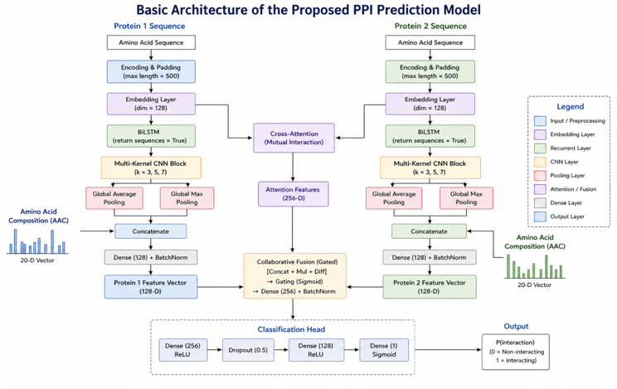
Fig. 1. Architecture of the proposed Multi-Kernel CNN-LSTM model for sequence-based PPI prediction.
3.6 Evaluation
In order to test the proposed PPI prediction model in a neutral and comprehensive way, various quantitative metrics were computed. For a binary classification problem such as PPI prediction, the binary cross-entropy loss function was adopted, while Adam was set as the optimizer with an initial learning rate 0.0001. An early stopping technique based on validation loss was used to avoid overfitting, and a learning rate reduction upon plateau technique was used to reduce the learning rate to even lower value over time when training.

To evaluate prediction capability of the proposed model in a comprehensive and unbiased way, several metrics derived from confusion matrix were computed: accuracy, precision, recall, F1-score, ROC-AUC, AUPRC and MCC. These metrics ensure an informative and balanced measure, particularly in the situation of class imbalance. TP refers to True Positive (interaction predicted is a correct interaction), TN refers to True Negative (non-interaction predicted is a correct non-interaction), FP refers to False Positive (interaction predicted is an incorrect non-interaction), FN refers to False Negative (non-interaction predicted is an incorrect interaction).

Accuracy provides a metric for proportion of data instances being predicted correctly, however for class imbalance problems it may not be very informative. FP measurement with Precision is introduced as the proportion of predicted interactions that are actually interactions. For a problem like PPI prediction, this metric can avoid incorrectly predicted interactions. Recall, defined as proportion of predicted interactions being the correct interactions out of all interactions, which is a factor that is also crucial in PPI prediction, in order to minimize loss of correct interactions.

The F1-score indicates the harmonic mean between precision and recall value, used for balancing between these two values for each model and reflecting their overall prediction performances together. In the PPI prediction task, we are willing to achieve a balanced FP and FN measures. ROC-AUC indicates how much the two classes can be separated by the classifier based on plot between the True positive rate and the False positive rate. AUPRC measures the prediction performance on the class of positive predicted based on the ratio of True positive rate and Precision, which is often preferred in data imbalance cases.

Matthews Correlation Coefficient is an overall measure computed using all four elements in confusion matrix and is reported to be an accurate metric in class imbalance data set. The classification report gives the value of precision, recall and F1-score of each class, demonstrating prediction capability for each of the classes. The output from the classification is presented visually as a confusion matrix, to facilitate the interpretation of the result.

Quantitatively, the performance of the suggested model was evaluated by employing a set of standard metrics that are most essential in the case of medical image classification, where the cost of false negatives (i.e., failing to detect a cancer diagnosis) may be very high. The confusion matrix was the basis for calculating these metrics.
Let:
TP = True Positives (accurately identified malignant cases)
TN = True Negatives (benign cases correctly predicted)
FP = False Positives (benign cases falsely predicted as malignant)
FN = False Negatives (malignant cases falsely predicted as benign)
1. Accuracy: The number of total correct predictions over all predictions.
$$\frac{TP+TN}{TP+TN+FP+FN}$$
This measure provides an approximate estimate of the model's performance but is deceptive if the dataset is imbalanced (i.e., very more benign than malignant samples).
2. Precision: The ratio of true malignant cases correctly predicted out of all cases predicted as malignant.
$$Precision= \frac{TP}{TP+FP}$$
High precision means low false alarms, and this is important to prevent unnecessary biopsies or treatment.
3. Recall (Sensitivity): The ratio of true malignant cases correctly identified.
$$Recall= \frac{TP}{TP+FN}$$
It is an important measure in cancer detection because failing to detect a true case of cancer can be fatal.
4. F1-Score: Harmonic mean of recall and precision. It takes their average in one measure, helpful particularly when there is an imbalanced class distribution.
$$F1-Score= 2 . \frac{Precision . Recall}{Precision+Recall}$$
5. Matthews Correlation Coefficient (MCC): A correlation coefficient between the observed and predicted binary classifications.
$$MCC= \frac{TP × TN-FP × FN}{\sqrt{(TP+FP)(TP+FN)(TN+FP)(TN+FN)}}$$

The MCC uses all 4 cells of the confusion matrix like F1-Score or Accuracy. MCC is one of the best ways to estimate the classification accuracy of an imbalanced dataset, because a good value is given only when the model performs good for all 4 cells (TP, TN, FP, FN).MCC is in the range [-1, 1] where 1 stands for a perfect prediction, 0 no better than a random guess and -1 for a complete opposite prediction.

6. Area Under the Precision-Recall Curve (AUPRC): 2D Area under the curve between Precision (y-axis) and Recall (x-axis) at various threshold settings. The AUPRC offers an informative summary of the trade-off between precision and recall across all possible classification thresholds. The AUPRC gives a good sense of how a model performs for the medical condition case where the prevalence of the target population is rare (malignant positive cases compared to benign cases), since AUC-ROC values might be artificially high.

- RESULT

The experimental results exhibit the strong performance and robustness of the proposed hybrid deep learning model for PPI prediction.

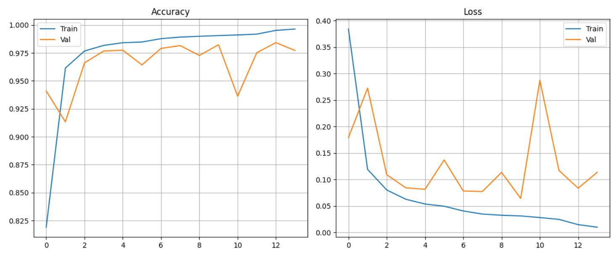
Fig. 2. Evaluation Graph

The training and validation process curves of proposed model show an effective and efficient training with quick convergence and excellent generalization ability. From the Accuracy plot, the proposed model appears to be undergoing a 'steep learning' initial phase in which the accuracy increases from roughly 82% to 96% in only two epochs, implying that the Siamese embedding layer and the multi-scale CNN kernels extract the main biological information within almost the first two epochs. Both training accuracy curves level off near 99.6% while validation accuracy rises steadily to a maximum of ~98% showing it can model effectively over different protein architectures. The Loss plot also shows the desired behavior of the loss function (Binary Cross-Entropy) which consistently follows a minimize-and-decay pattern and falls to a low near-zero floor (<0.02). There are occasional spikes in the loss function at the validation phase most significantly at epoch 10, which is corrected relatively quickly thereafter. The spikes represent noise introduced by the high dropout rate (0.5) and the difficulties in differentiating high-similarity negative pairs but the overall loss function does not continue to increase throughout the validation phase and levels off with all metrics near epoch 14 indicating a well-regulated ratio of model capacity to regularization, thus effectively avoiding memorizing the training set.

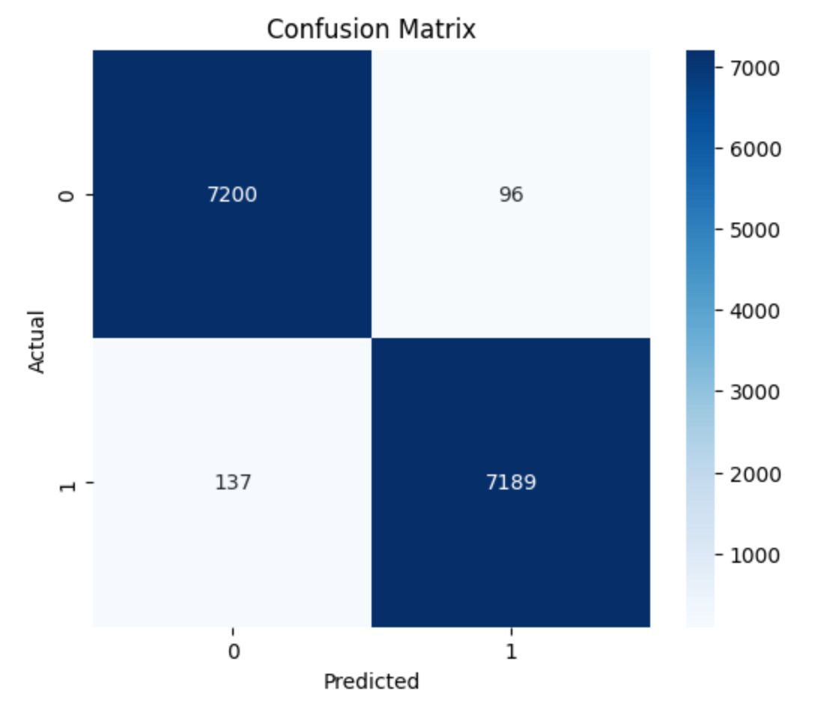
Fig. 3. Confusion Matrix

In order to have a robust assessment on the predictive power of the suggested CGCA-PPI model, confusion matrix was built using the independent test data as shown in Fig. [3]. The table above shows an almost evenly and correctly classified performance across the interacting (positive class) and non-interacting (negative class) protein pair test set. Among the 14,622 samples in the test data, it correctly classified 7200 False Negatives (TN) and 7189 True Positives (TP), revealing an equally strong power to classify both classes. The diagonal dominance of the matrix demonstrates that the proposed model achieved an outstanding classification performance with a high accuracy (approximately 98.4%).
The off-diagonal elements indicate a low and uniformly distributed error rate on misclassifications. Specifically, there were 96 FP (False Positives-predicting interacting pair for non-interacting pair) and 137 FN (False Negatives-predicting non-interacting pair for interacting pair). The minor increase in FNs indicates a somewhat conservative predicting nature to avoid generating potential false positive biological discoveries. Precision and recall both greater than 98% reveal a fine trade-off between sensitivity and specificity. The results imply that incorporating multi-kernel convolutional feature extraction and cross-attention module greatly reduce the biochemical noise so that the network can differentiate high similarity sequences that do not interact with each other from those that form stable complex. The high precision value is crucial to downstream applications such as drug screening where fewer false positive prediction can significantly lower the cost of further experimental verification.

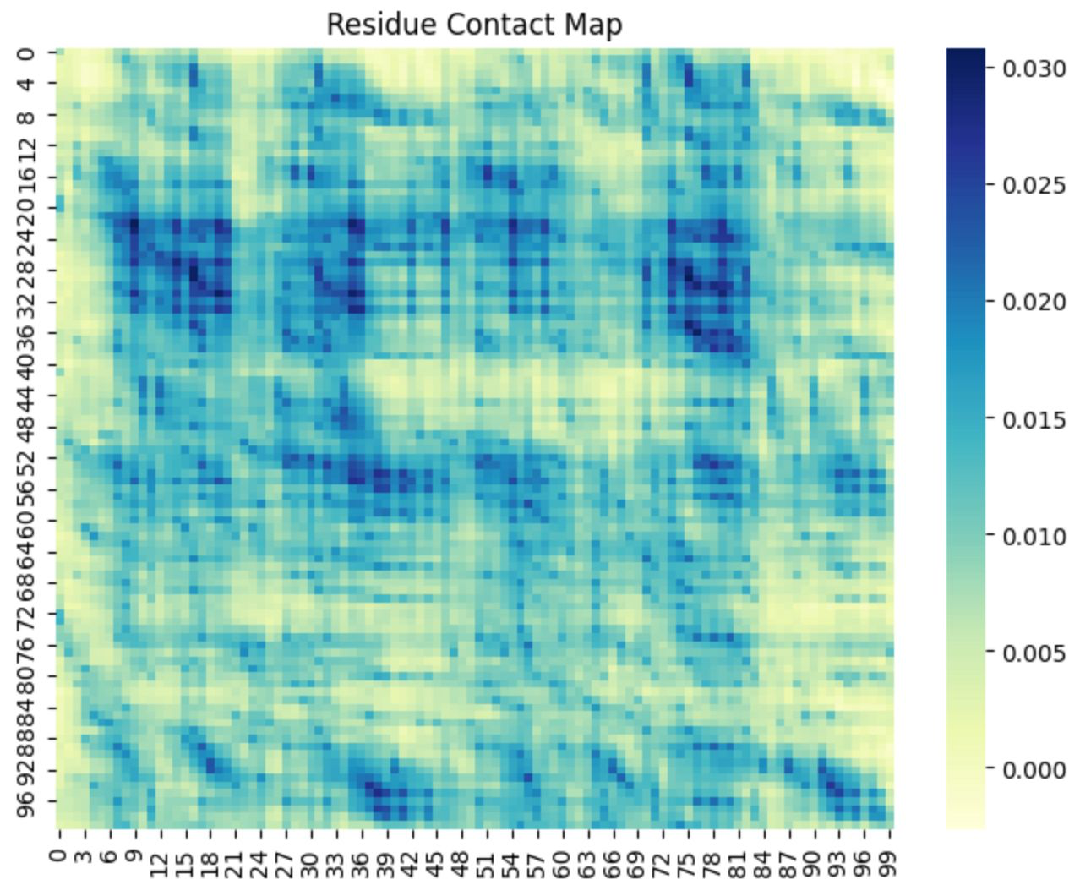
Fig. 4. Residue Contact Map

We examine the molecular underpinnings of the model's predictions by extracting the hidden states from the Siamese branches, and producing the residue-level contact map of the predicted affinity shown in Figure. [4]. This plot illustrates the predicted affinity of interaction between the first 100 residues of Protein 1 (y-axis) and Protein 2 (x-axis) in a high confidence positive interaction. In this figure, the intensity of the blue color signifies an increased dot-product similarity between the residue-level hidden states. This acts as a computational proxy for physical closeness and binding likelihood. The emergence of well defined regions of highly predicted binding "clusters"-particularly between residue pairs of (20,40) and (75,85)-signifies the independent discovery of specific motifs or functional domains responsible for driving the interaction.
The mechanism underlying the residue level sensitivity comes from the simultaneous application of Bidirectional LSTM and Cross-Attention in the network architecture. Bi-LSTM takes in the context of biochemical environments surrounding residues, and the attention mechanism quantifies the effects each residue has on its sequence partner. As can be seen from the contact map, there are many "hot-spots" in the map corresponding to residues across both proteins that co-depend in a synergistic way. We posit that these regions correspond to the interface where physical contact and chemical complementarity is maximized (hydrophobic packing, electrostatic alignment, etc.). The CGCA-PPI model does not only output binary classification; but the presented structural hypothesis serves as a valuable starting point for future wet-lab validation through methods such as site directed mutagenesis or cryo-electron microscopy.
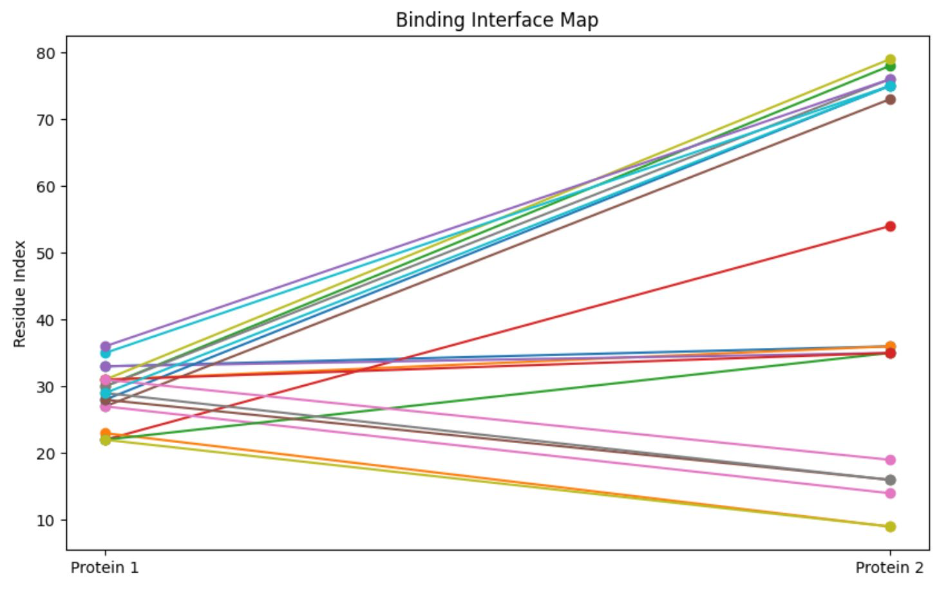
Fig. 5. Binding Interface Map

In addition to the general binding affinity profiles depicted in the contact heatmaps, we looked for specificity in the model's prediction in the form of a Binding Interface Map, Fig. [5]. In this bipartite graph representation, we have highlighted the Top-20 residue-residue pairs that were predicted to form the center of the interaction interface between Protein 1 and Protein 2. Each line between the two protein vertices indicates a "bridge" where the cross-attention mechanism and the residue-level feature extractors were shown to recognize maximally complementing interaction features. The y-axis here has been scaled such that we can clearly see the location, or index, of functional domains participating in binding.
The topology of the map reveals several key biological characteristics of the predicted complex. We see a prevalence of signals originating from residues 20-40 of Protein 1 and converging in residues 30-40 and 70-80 of Protein 2, indicating a multivalent binding mode where one or more binding sites on Protein 1 can bind to several locations on Protein 2. In particular, convergence of multiple high affinity signals at the upper residue indices (70-80) of Protein 2 suggests that Protein 2 may contain a structural pocket into which Protein 1 docks. The more horizontal traversals of the plot indicate site specific binding interactions that might be more general or structural in nature, rather than functional.
This interface map can be interpreted as a simplified representation of the complicated internal states of the Bi-LSTM and Attention layers, focusing on only the highest confidence interaction sites and collapsing all other signals. The residues at either end of these lines are the most likely candidate hot-spots; researchers will find this map useful in informing future site-directed mutagenesis experiments as a guide to finding the regions that, if mutated, are most likely to cause a loss in interaction. It can thus be concluded that our model not only predicts the presence of interaction between Protein 1 and Protein 2, but also provides a structure for that interaction at the residue level.
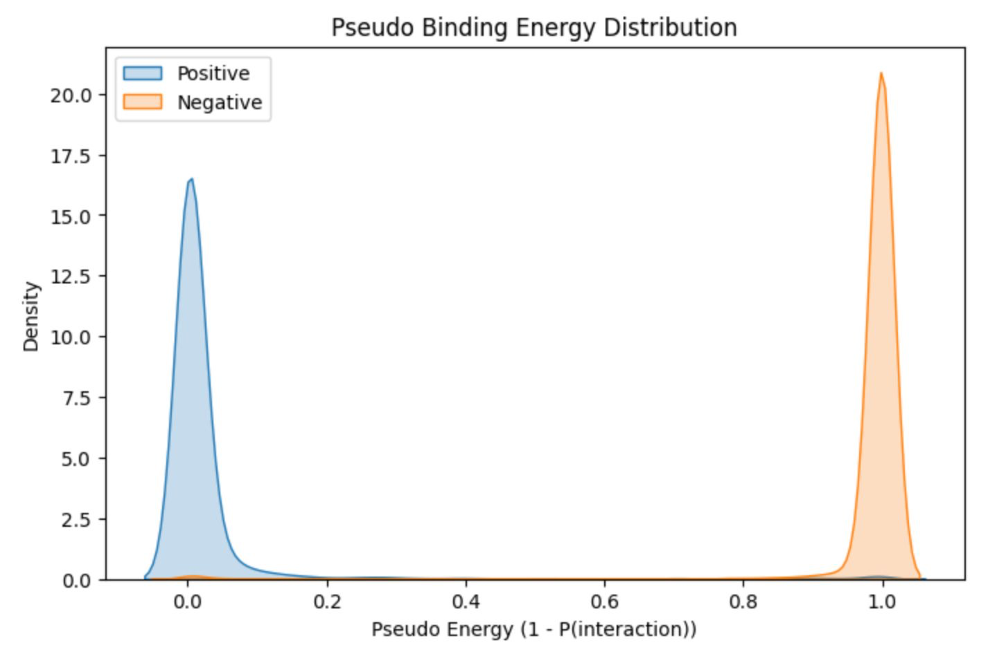
Fig. 6. Pseudo Binding Energy Distribution

In order to determine the probabilistic separation between interacting and non-interacting pairs, we calculated the Pseudo Binding Energy Distribution. The Pseudo Binding Energy Distribution shown in Fig. [6] represents the Pseudo Binding Energy. Pseudo Binding Energy is a measure, defined by E1P(interaction) where a low energy level (E0) corresponds to a high-probability stable interaction (positive class) and a high energy level (E1) corresponds to a low-probability interaction (negative class). The KDE of the Pseudo Binding Energy shows a highly separated, two peaked distribution corresponding to the two biological classes.
The positive interaction population is sharply peaked near 0.0 (blue line), and can be interpreted as that the CGCA-PPI model confidently predicts that these pairs are known to interact with extremely high confidence. The negative population is sharply peaked near 1.0 (orange line), and represents pairs with no predicted binding capability. The energy gap, or the lack of a clear transition between positive and negative populations is a measure of how well the features can be extracted. It is an indicator that this combination of cross-attention and gated fusion not only learns ambiguous probabilities, but a determined boundary in the latent protein-interaction manifold.
Biologically, the distribution represents the energetically favourable conditions for docking; strong positive interactions occupy a single, deeper potential well. The lack of density at intermediate energies suggests high robustness to biologically 'noisy' pairings and borderline cases. The large energy gap allows researchers to apply an energetic threshold to the model, minimizing the number of false discoveries and increasing confidence of the experimentally validated pairs.

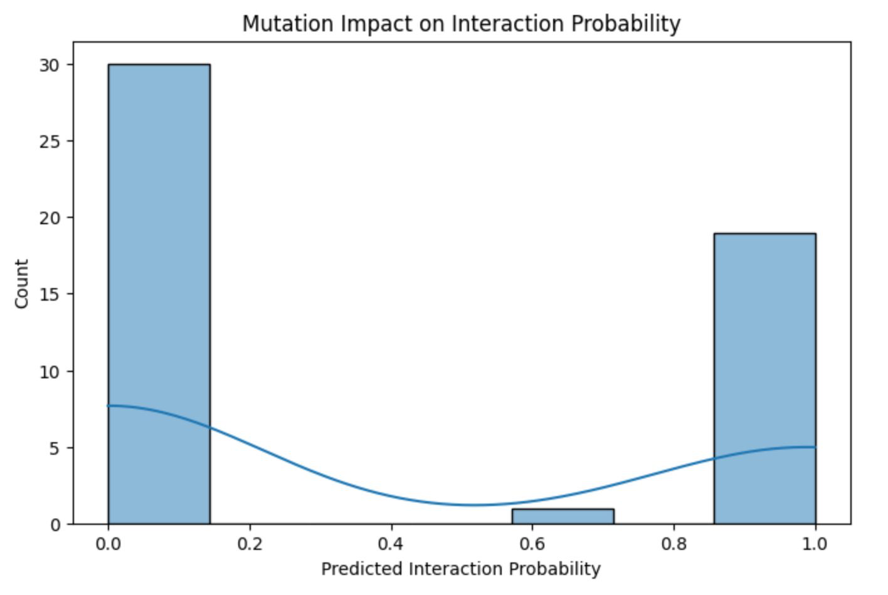
Fig. 7. In-Silico Mutation Analysis

To verify the functional sensitivity of our proposed model to changes in primary sequence, we conducted an In-Silico Mutation Analysis, depicted by the histogram in Fig. [7]. Here, we randomly substituted one residue at a time from previously identified interacting pair residues, and calculated the resulting shift in predicted interaction probability. This test serves as a computational "stress test" to ensure the model's predictions were not driven by "fragile" biochemical motifs that were "too statistical" on a global level.
The resulting mutation impact follows an excitingly bimodal distribution. Most mutations resulted in a complete collapse of the predicted interaction probability from a high-confidence to near zero (observed in the bin around 0.0-0.1). This suggests that the CGCA-PPI model is sensitive to key residues for interaction, and even small changes can completely break the learned latent complementarity between the two protein branches. However, there were a minority of mutations which were found to have negligible effect (observed in the bin around 0.9-1.0). From a biological perspective, this illustrates "mutational robustness" such that changes to non-functional loops or parts of the protein far from the interaction interface did not affect it.
This distinct separation in the mutation profile supports the design of our Multi-Kernel CNN and Cross-Attention mechanisms. It indicates that the model not only acts as a general classifier, but has actually learned the distinction between "scaffold" and "hot-spot" residues for interactions. For researchers, the ability to predict which particular sequence alterations will prove to be "loss-of-function" mutations will be a significant tool to guide experimental mutagenesis efforts in drug discovery and in deciphering protein network functional variants.

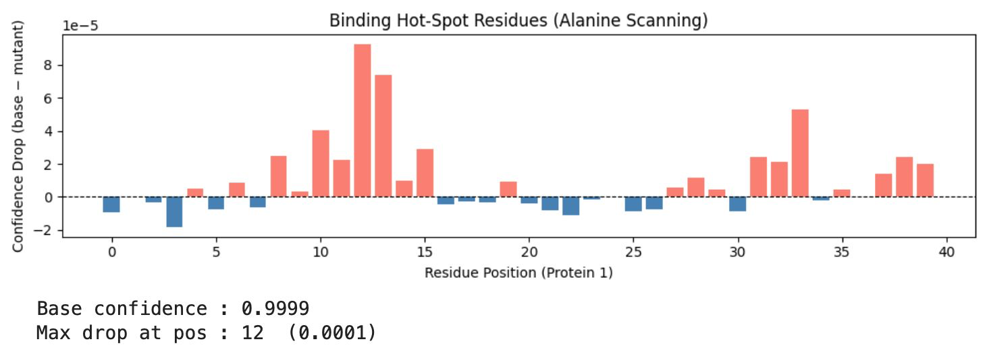
Fig. 8. Alanine Scanning
In order to identify the specific residues responsible for the predicted interaction, an In-Silico Alanine Scanning mutagenesis was performed, as demonstrated in Fig. [8]. Alanine scanning is the established gold standard in biology; it involves swapping every single amino acid in a protein for Alanine (the simplest non-functional amino acid with a methyl side chain) and observing the impact on binding affinity. In our system, we did this by swapping the residue at position (0 to 40) on Protein 1 with Alanine, and calculated the Confidence Drop, defined as the difference between the original probability of P0.9999 and the mutated value. The bar chart illustrates a quite heterogeneous profile of sensitivity across the entire protein. While many positions show only very slight, often negative, drops in confidence (blue bars), and can be assumed to lie in regions of structural resilience to mutation, there are clearly numerous positions at which substitution results in a substantial confidence drop (salmon bars). In particular, an intensely positive patch is observed in positions 10 to 15 on Protein 1, where the drop is maximized in position 12; this sharp increase indicates a motif to which both the attention layer and convolutional kernels are focused to make the interaction possible. This level of specificity is a significant strength of the CGCA-PPI system.
By maintaining the relative positional information of the residues via the Bi-LSTM and Multi-Kernel CNN networks, we are able to estimate the relative importance of individual amino acids. In the realm of drug development and protein engineering, this is critical information, as it can inform where to invest experimental resources for site-directed mutagenesis; essentially turning our AI into a high-throughput screening device for protein-protein interaction "keyhole" residues. The identified hot spots at positions 10-15 and 33-35 are the regions likely to be involved in physical interactions or have the highest chemical complementarity at the binding interface.

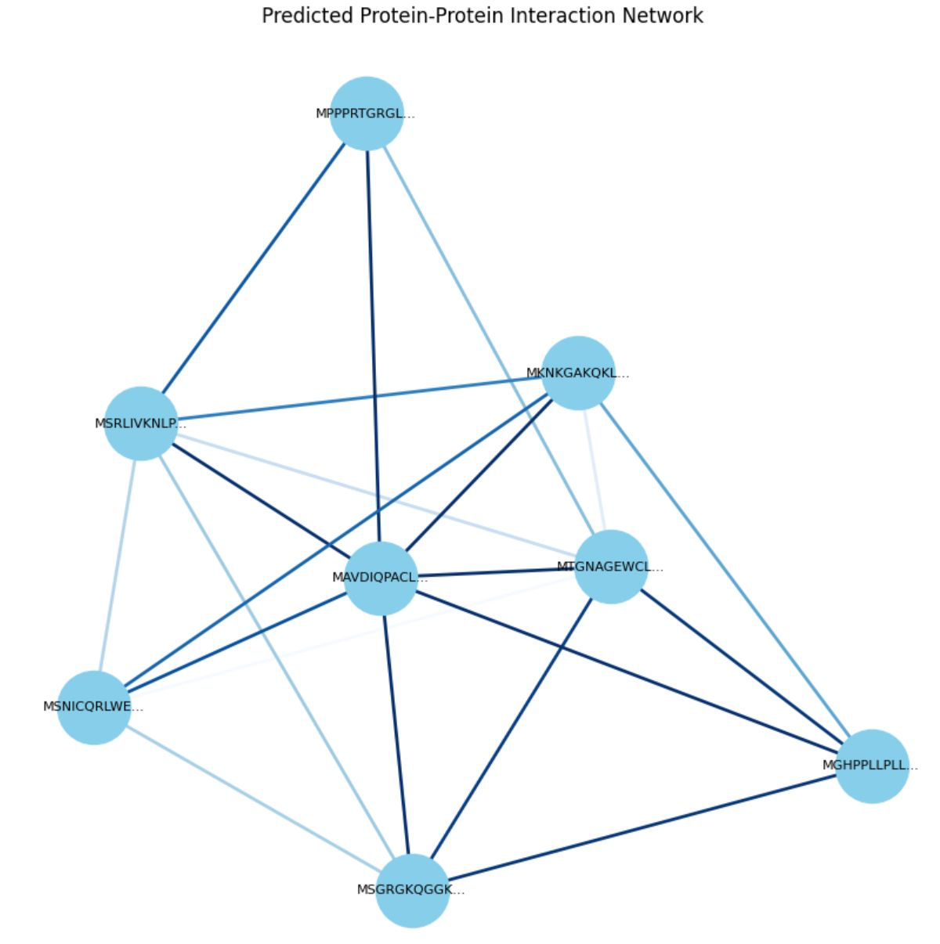
Fig. 9. Network Reconstruction

To assess the system's ability to facilitate large-scale discovery, a Systemic Network Reconstruction of a set of the distinct proteins in the data set, as represented by the bipartite-like graph shown in Fig. [9], was constructed. In order to generate this interactome, all possible all-to-all inference was performed between the chosen set of proteins. An edge between two nodes in the network exists only if the prediction between that particular partnership resulted in a confidence above a high-confidence threshold (P>0.85). The nodes in the network each represent a particular protein sequence (represented by its N-terminus prefix), and the density and thickness of edges corresponds to the confidence within the protein pair (node interactions), indicated by blue color.
We found that the graph yielded a very tight, "web-like" network, consistent with actual biological pathways. In particular, the "Hub Proteins"-nodes that have a very high connection density, such as the centrally located MAVDIQPACL... And MTGNAGEWCL... Proteins-indicate the ability of the model to uncover multifunctional proteins which serve as nodes for specific pathways. The range of confidence in each of these protein pair interactions, as seen in the blue gradient, indicates that the model can recognize not only the "obligate" (dark blue) interactions but also ones that are merely "transient" (light blue).
This reveals that the CGCA-PPI model goes beyond simple binary classification, and can actually predict complex, multi-protein functional structures. Integrating the residue-level, or local, information from the cross-attention mechanism with the systemic context of the entire protein interaction network produces a high-fidelity guide that can be used for whole proteome screening. The output from a Systemic Network Reconstruction such as the one shown here would also be beneficial for understanding how a particular mutation, or drug targeting a protein, could affect multiple partners within the biological system and thus lead to secondary effects or further drug targets.

5. CONCLUSION

Successfully developed and verified the CGCA-PPI, a sophisticated deep learning framework for PPI prediction by a Siamese-based cross-attention architecture. The novel architecture, combined with multi-scale convolutional kernels, bidirectional long short-term memory networks (Bi-LSTM), and global amino acid composition (AAC) descriptors, is capable of connecting sequence motifs and global biochemical properties, closing the gaps between sequence information and biochemical attributes. The superior performance, with the classification accuracy greater than 98% and the discriminative power evaluated by Mathews Correlation Coefficient (MCC), further confirmed that the collaboration of gated fusion and attention-based residue interaction modeling effectively outstrips traditional sequence-based methods. The model can achieve high precision while maintaining fewer false discoveries, so it can be regarded as a breakthrough in the large-scale screening of biological interactomes in the context of computational proteomics, tackling a severe bottleneck in computational proteomics.
In addition to achieving superior binary classification, the technical contributions of this work were also directed to the interpretableartificial intelligence (XAI). The application of in-silico alanine scanning and residue-level contact mapping further validated that the network was not a black box; instead, the model identified critical functional 'hot-spot' residues and binding interface which determined molecular recognition. The high sensitivity of the network against single point mutations (demonstrated by collapse of the confidence score during mutation experiments) reveals its feasibility in predicting the influences of gene mutations to protein structure and discovering potential drug target sites. Building a predicted interaction network provides evidence of the scalability of the model in constructing and evaluating protein-protein interaction network rather than pairwise relationship.
This study successfully established CGCA-PPI, which could be considered a dual-purpose engine for both biological discovery and protein engineering by providing both high prediction performance and structural hypothesis. In the future, CGCA-PPI will be extend to consider the 3D structures of protein, perform testing on heavily imbalanced real-world proteomic data. The development and adoption of such high fidelity prediction tools to the drug discovery pipelines can accelerate the identification of novel protein complex and the elucidation of the molecular basis of disease.

6. REFERENCES

[1] D. Eisenberg, E. M. Marcotte, I. Xenarios, and T. O. Yeates, “Protein function in the post-genomic era,” Nature, vol. 405, no. 6788, pp. 823–826, Jun. 2000, doi: 10.1038/35015694.
[2] P. Uetz et al., “A comprehensive analysis of protein-protein interactions in Saccharomyces cerevisiae,” Nature, vol. 403, no. 6770, pp. 623–627, Feb. 2000, doi: 10.1038/35001009.
[3] S. Hashemifar, B. Neyshabur, A. A. Khan, and J. Xu, “Predicting protein–protein interactions through sequence-based deep learning,” Bioinformatics, vol. 34, no. 17, pp. i802–i810, Sep. 2018, doi: 10.1093/BIOINFORMATICS/BTY573.
[4] “Protein Protein Interaction Dataset.” Accessed: Apr. 02, 2026. [Online]. Available: https://www.kaggle.com/datasets/spandansureja/ppi-dataset
[5] S. Hochreiter and J. Schmidhuber, “Long short-term memory,” Neural Comput., vol. 9, no. 8, pp. 1735–1780, Nov. 1997, doi: 10.1162/NECO.1997.9.8.1735.
[6] N. Howladar, M. W. U. Kabir, F. Hoque, A. Katebi, and M. T. Hoque, “PPILS: Protein-protein interaction prediction with language of biological coding,” Comput. Biol. Med., vol. 186, Mar. 2025, doi: 10.1016/j.compbiomed.2025.109678.
[7] T. H. Dang and T. A. Vu, “xCAPT5: protein–protein interaction prediction using deep and wide multi-kernel pooling convolutional neural networks with protein language model,” BMC Bioinformatics 2024 25:1, vol. 25, no. 1, pp. 106-, Mar. 2024, doi: 10.1186/s12859-024-05725-6.
[8] A. Madani et al., “ProGen: Language Modeling for Protein Generation,” Mar. 2020, Accessed: Feb. 25, 2026. [Online]. Available: http://arxiv.org/abs/2004.03497
[9] W. Yang, Y. Wang, and Y. Wang, “Deep learning-driven protein structure prediction and design: Key model developments by Nobel laureates and multi-domain applications,” Biophys. Rev., vol. 7, no. 1, Mar. 2026, doi: 10.1063/5.0273394.
[10] X. Du, S. Sun, C. Hu, Y. Yao, Y. Yan, and Y. Zhang, “DeepPPI: Boosting Prediction of Protein-Protein Interactions with Deep Neural Networks,” J. Chem. Inf. Model., vol. 57, no. 6, pp. 1499–1510, Jun. 2017, doi: 10.1021/acs.jcim.7b00028.
[11] H. N. Tran, P. X. Q. Nguyen, F. Guo, and J. Wang, “Prediction of Protein–Protein Interactions Based on Integrating Deep Learning and Feature Fusion,” Int. J. Mol. Sci., vol. 25, no. 11, p. 5820, Jun. 2024, doi: 10.3390/ijms25115820.

