CarePathAI

1. Project Description

CarePathAI is a multilingual, voice-first healthcare triage system built to help patients quickly understand their symptoms and find the right local medical specialist. It is specifically designed for users in India, supporting both English and Hindi (including natural conversational Hinglish).

The Problem It Solves

When people get sick or feel sudden pain, two big challenges usually arise:

1. Navigating Specialist Care: Patients experiencing distress rarely know which specific doctor to visit. For instance, a patient with sharp abdominal pain often struggles to decide whether they should see a general physician, consult a gastroenterologist, or rush to an emergency room. This leads to wasted time, unnecessary medical expenses, and delayed care.

2. Language & Input Barriers: Typing long clinical symptoms on a mobile keyboard while sick is frustrating. Furthermore, conventional AI chatbots regularly misinterpret spoken accents, lossy microphone audio, and code-mixed local dialects (such as Hinglish), leading to inaccurate clinical assessments.

3. Incomplete Symptom Communication & Lost Clinical Context: When patients finally meet a doctor, they frequently forget critical details such as exact symptom onset due to stress or brief consultation times. CarePathAI automatically generates a structured Clinical Summary Report directly from the patient’s intake conversation. Patients can download or print this summary and hand it directly to their doctor. This provides the clinician with a clean, pre-organized intake history in seconds, saving valuable consultation time and preventing miscommunication.

Key Functional Capabilities

1. Voice-First Intake & Acoustic Denoising: Patients simply tap a microphone and speak naturally. Raw audio is converted to text via Google Speech-to-Text (`latest_long`) and immediately cleaned using Gemini Flash acoustic denoising. This fixes phonetic STT misrecognitions (such as converting *"climbing D stears"* to *"climbing the stairs"*) before clinical processing.

2. Bounded Multi-Turn Intake (Max 3 Turns): To avoid long, exhausting chat interactions, intake is capped at 3 turns. The system asks targeted follow-up questions to gather necessary clinical slots (onset, duration, severity, location) quickly.
Note: This value is configurable, another major reason is because MedGemma is deployed on Cloud Run powered by CPU rather than GPU (free tier account restrictions) leading to long wait time for a response, hence for demo purposes, it is capped at 3 only (for now).
3. Deterministic Red-Flag Safety Intercept: Critical medical symptoms trigger a hardcoded safety intercept. The app bypasses the AI model entirely and instantly displays a full-screen Emergency Overlay with direct one-touch dials for emergency helplines (`112`, `108`, `102`, `104`, `1056`).

4. Clinical Triage Engine (MedGemma 4B): Non-emergency symptoms are evaluated by MedGemma 4B (running as a CPU-optimized GGUF microservice on Cloud Run). The engine determines clinical urgency (Low, Moderate, High, Emergency) and recommends the exact specialist department needed.

5. Real-Time Local Specialist Search: Using the patient's live GPS coordinates, the system queries the Google Places API to present top-rated, real-world specialist clinics with distance, ratings, direct phone links and Google Maps navigation.

6. Automated Clinical Report Generation: At the end of triage, the app compiles the full transcript and structured medical slots into a printable, professional PDF clinical summary report.

7. Dual-Language Toggle: Users can switch between English and Hindi at any time with instant UI updates backed by Firestore translation caching.

2. Project Use Cases & Real-World Impact

A. Primary Patient Workflows

1. Red-Flag Emergency Intercept (Cardiac / Stroke Scenario)

- User: A 55-year-old patient speaking into their mobile browser in Hinglish.
- Flow: The patient says, "Mere chest mein bohot tez pain ho raha hai aur left arm mein fail raha hai." The backend Red-Flag engine catches the keywords ("chest pain", "left arm") before calling the LLM.
- Outcome: The app immediately launches the high-visibility Emergency Overlay, disabling navigation and offering one-touch call buttons for National Emergency (112) and Ambulance (108).

2. Non-Emergency Triage & Specialist Booking

- User: A patient with persistent upper abdominal pain after meals.
- Flow: The patient speaks their symptoms into the app. CarePathAI asks 1–2 short follow-up questions to clarify duration and severity, then outputs:
- Urgency: Moderate
- Recommended Specialist: Gastroenterologist
- Summary: 2-day duration, sharp upper abdominal pain, mild post-meal nausea.
- Outcome: The patient views nearby top-rated Gastroenterology clinics on a map and exports Printable Clinical Report to hand to the doctor at the clinic.

B. High-Impact Operational & Real-World Use Cases

1. Reducing Front-Desk & OPD Queues at Public / Government Hospitals

- The Problem: Large public and government hospitals in India experience massive morning registration queues where hundreds of patients wait for general intake just to figure out which Outpatient Department (OPD) counter to stand in.
- CarePathAI Solution: Patients can perform a 60-second voice triage on their phone (or at a hospital entrance self-service kiosk) while traveling to or entering the facility. The app identifies the exact target department (e.g., Orthopedics, ENT, Gastroenterology) and guides the patient straight to the correct department registration counter or specialist OPD cabin. This bypasses long general intake lines, drastically cuts front-desk queue congestion, and speeds up patient throughput.

2. Empowering Community Health Workers (ASHA / ANM Workers)

- The Problem: Rural health workers (such as ASHA workers in India) visit door-to-door and need a structured tool to evaluate patient symptoms, detect red flags early, and refer patients to the appropriate Primary Health Centre (PHC) or district hospital specialist.
- CarePathAI Solution: Health workers can speak the patient's symptoms in their local language. The app provides a structured triage recommendation and printable/shareable report that the worker can forward to the PHC doctor via WhatsApp or present at the district hospital.

3. Streamlining Hospital Emergency Room (ER) Triage

- The Problem: Emergency departments at government hospitals are often overcrowded with non-urgent cases because patients lack a reliable way to assess whether their symptoms require an ER or a regular clinic visit.
- CarePathAI Solution: By accurately categorizing non-emergency cases (Low/Moderate urgency) and suggesting local outpatient specialists, the app diverts non-critical cases away from overwhelmed ERs, reserving critical emergency care beds for true life-threatening cases.

4. Enhancing Telemedicine & Pre-Consultation Intake

- The Problem: Telemedicine platforms lose substantial doctor time during online consultations while physicians manually type down basic patient histories.
- CarePathAI Solution: Patients complete the voice triage prior to starting an online video consult. The structured report is automatically attached to the doctor’s EMR (Electronic Medical Record) view, enabling the physician to review chief complaints, timeline, and severity in 5 seconds before initiating the call.

3. Architecture Diagram

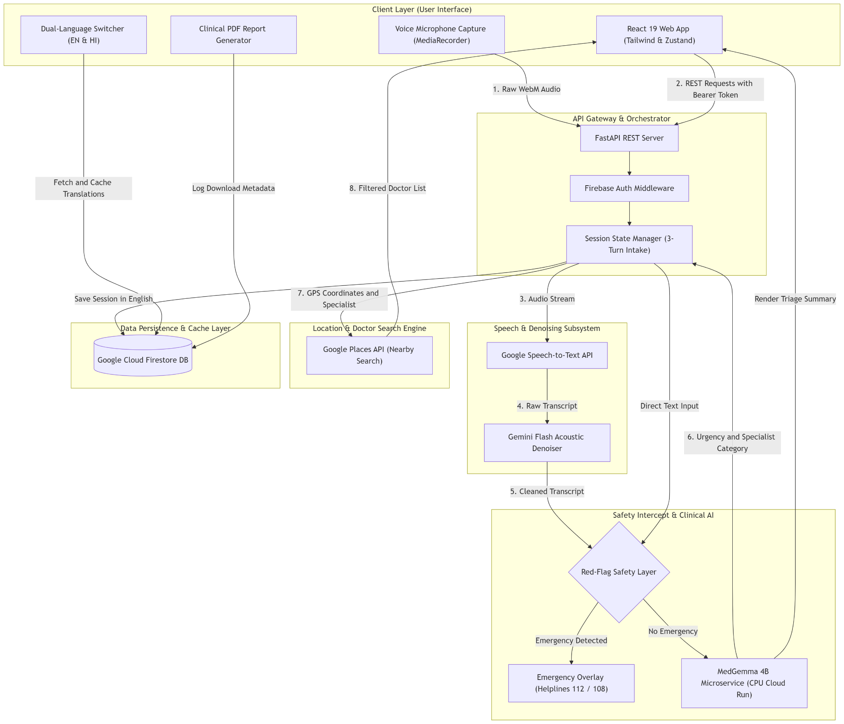

4. Component Breakdown & System Layering

1. Frontend Web Application (Client Layer)
- Tech Stack: React 19, Vite, Tailwind CSS v4, Zustand state management, React Router v7.
- Role: Serves as the interactive single-page application (SPA). It handles live microphone audio recording (MediaRecorder API), renders conversation history, manages state transitions across the 3-turn intake process, and executes instant client-side language switching between English and Hindi using a dual-language in-memory store.
2. Backend API Gateway & Orchestrator
- Tech Stack: FastAPI, Python 3.11, Pydantic v2, Firebase Admin SDK.
- Role: Exposes high-performance REST endpoints (/transcribe, /triage, /doctors, /translate-results, /save-report-trace). It authenticates requests via Firebase ID tokens, coordinates parallel processing calls, enforces structured input/output validation, and manages session state.
3. Speech-to-Text & Denoising Subsystem
- Tech Stack: Google Speech-to-Text API (latest_long model) + Gemini Flash.
- Role: Decodes raw web audio into text. Because medical terms and accents can easily be misread over microphone recordings, the text passes through a second-stage acoustic denoiser powered by Gemini Flash to restore clinical accuracy without altering user intent.
4. Safety Intercept & MedGemma Clinical AI Engine
- Tech Stack: Deterministic Red-Flag Matcher + MedGemma 4B GGUF (Q5_K_M) hosted on Google Cloud Run CPU.
- Role:
  - Safety Engine: Runs immediate regex and string pattern checks for critical symptoms. If matched, it bypasses the LLM to eliminate hallucination risks and latency during life-threatening emergencies.
  - Clinical Engine: When safe, symptoms pass to the MedGemma 4B microservice running llama-cpp-python. The model analyzes the conversation history, populates structured clinical slots, determines urgency, and recommends standard specialist categories.
5. Provider Search & Location Subsystem
- Tech Stack: Google Places Nearby Search & Place Details APIs.
- Role: Sanitizes AI specialist outputs (mapping terms like "heart doctor" to "cardiologist") and queries Google Places using the user's live GPS coordinates. Returns verified clinic lists with ratings, open status, direct call capability, and turn-by-turn navigation links.
6. Persistence & Caching Layer
- Tech Stack: Google Cloud Firestore.
- Role: Stores clinical session logs grounded strictly in English (maintaining clinical consistency regardless of user display language), caches translated string pairs in a translation_cache collection to eliminate repetitive Google Translate costs, and audits PDF report downloads in session trace logs.

